Learning Disability - Health Check Action Plan

Details of the person completing form: | Name: Free Text Prompt  Date form completed: Short date letter merged Position: Free Text Prompt
About Me:  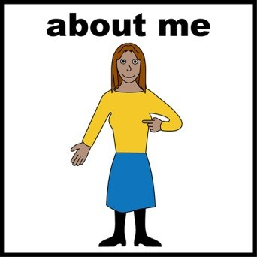 | Name: Title Calling Name Surname  DoB: Date of Birth Gender: Gender(full) Registered GP: Free Text Prompt
Health goals for my doctor to do | Single Code Entry: Learning disabilities health action plan completed  Single Code Entry: Learning disabilities health action plan reviewed
Help for me at the end of my life | Single Code Entry: End of life advance care plan EPACCS Further details EPACCS Click for further information  Comments

Other people my doctor wants me to see  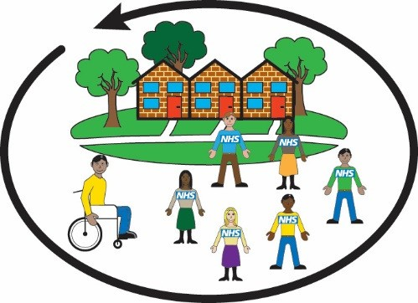 | Single Code Entry: Referral to learning disability team  Single Code Entry: Referral to mental health team Single Code Entry: Referral to specialist children's service
Health goals for me to do: | Comments:
Health goals for me to do:  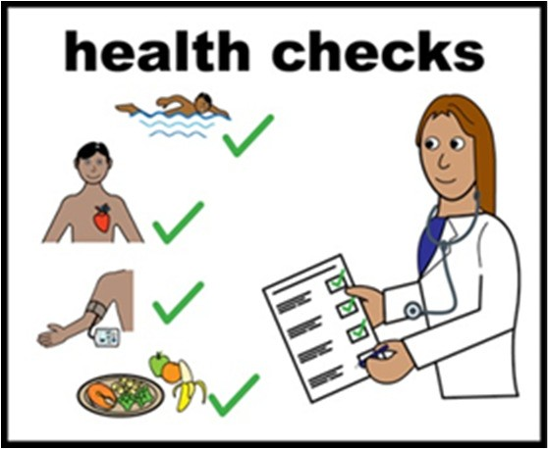 | Comments:
Allergies:  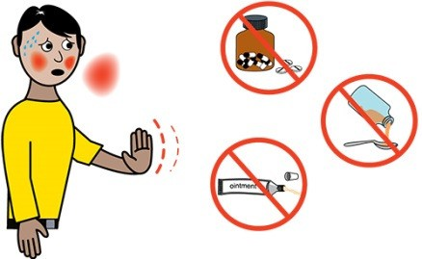 | Allergies

