WaitLess Social Media Posts – draft posts

Timing | Copy | Image
Launch Post | Need urgent care for a minor illness or injury?  Skip the wait ⏱️  Download the FREE WaitLess app to check live waiting times and find the quickest place to be seen across Shropshire, Telford and Wrekin.  📍 MIUs | UTCs | Pharmacies  📲 Available on App Store & Google Play | 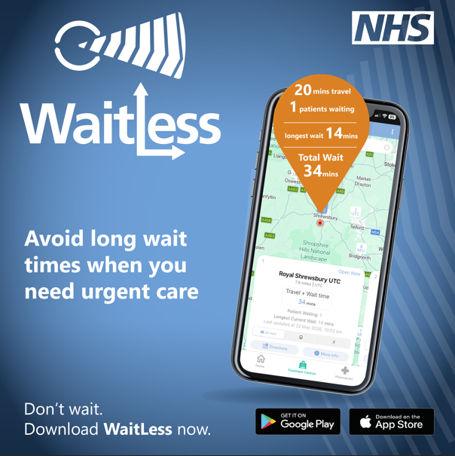
Alternative launch post | New app launch: WaitLess  WaitLess helps you find the quickest urgent care service near you.  - Live waiting times  - Travel information  - Local services  Download now - search “WaitLess”.
Queue-focused post | Don’t wait longer than you need to.  WaitLess shows real-time waiting times so you can choose the quickest place for urgent care.  Includes:  - Minor Injury Units (MIUs)  - Urgent Treatment Centres (UTCs)  - Pharmacies  Download today; Available on App Store & Google Play. Search WaitLess
Pharmacy angle | Did you know your local pharmacy can treat many minor illnesses?  The WaitLess app helps you:  - Check urgent care waiting times  - Find nearby pharmacies  - Choose the best place for care  Download for free today. Available on App Store & Google Play – search WaitLess
Education post (where to go) | Not sure where to go for urgent care?  WaitLess helps you choose the right service:  - Urgent Treatment Centres (UTCs) for non-life-threatening conditions  - Minor Injury Units (MIUs) for minor injuries  - Pharmacies for advice and treatment  Find the quickest option near you.  Available for FREE on App Store & Google Play. Search WaitLess to download now!
Partner-share version | We’re supporting the WaitLess app to help people across Shropshire, Telford and Wrekin get urgent care more quickly.  Download the FREE app to check waiting times and find the best place for treatment.  Available on App Store & Google Play. Search WaitLess.  Please share with your networks.
Link to website | Avoid long waits for urgent care.  Download the free WaitLess app and find the quickest place to be seen near you.  Find out more: https://www.shropshiretelfordandwrekin.nhs.uk/your-health/where-to-get-advice-and-help/download-the-waitless-app-urgent-care/

