The concept
What?
The idea behind the thunderclap is everyone posting the same thing at the same time.

Why?
To amplify the ‘Think Which Service’ campaign messages, increase reach and maximise impact across Shropshire, Telford and Wrekin.

When?
We're inviting all partners to take part during the ‘Think Which Service’ launch week: Wednesday 12 November to Tuesday 18 November 2025 and again February 2026 (date tbc).

How it will work
- A week prior to launch, Wednesday 5 November, we will share a ‘Think Which Service’ thunderclap social media toolkit. The toolkit will provide agreed social media content, including graphics, hashtags and, importantly, a schedule.

- We are proposing that during the launch week, three nominated time slots will be devoted to the ‘Think which service’ campaign messages each day. During this time, we are proposing that 2x social media messages will be issued at 9:05am and 3:05pm each day.

- For the thunderclap to work, it will be critical that all system comms colleagues schedule the posts on the day and time provided in the schedule. This will maximise the impact.

Wednesday 12 November 2025 - Launch Day
Time | Image | X (Twitter) copy | Facebook / LinkedIn copy | Instagram
9:05 AM | VIDEO  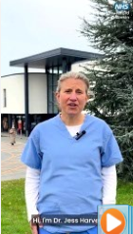 | ❄️ Winter is here – Think Which Service!  As coughs, colds, and winter bugs rise, it’s more important than ever to use the right NHS service at the right time.  👉 Visit thinkwhichservice.co.uk for local advice and support. | ❄️ Winter is here – Think Which Service!  As coughs, colds, and winter bugs rise, it’s more important than ever to use the right NHS service at the right time.  - Self-care: stay warm, eat well, and stock up on essentials for minor symptoms/illness  - Pharmacists for expert advice  - Minor Injury Units for sprains, cuts & burns  - NHS 111 for urgent help, 24/7  - 999/A&E for life-threatening emergencies only  !! Don’t forget to get your flu and COVID-19 vaccines if you are eligible.  Let’s keep our NHS running smoothly this winter.  👉 Visit thinkwhichservice.co.uk for local advice and support.  #ThinkWhichService #NHSSTW | ❄️ Winter is here – Think Which Service!  As coughs, colds, and winter bugs rise, it’s more important than ever to use the right NHS service at the right time.  - Self-care: stay warm, eat well, and stock up on essentials for minor symptoms/illness  - Pharmacists for expert advice  - Minor Injury Units for sprains, cuts & burns  - NHS 111 for urgent help, 24/7  - 999/A&E for life-threatening emergencies only  !! Don’t forget to get your flu and COVID-19 vaccines if you are eligible.  Let’s keep our NHS running smoothly this winter.  #ThinkWhichService #NHSSTW
3:05pm | STATIC  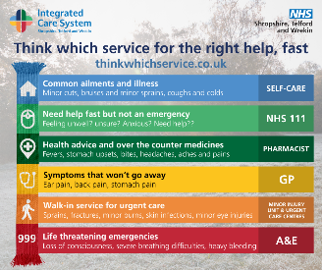 | Knowing where to go when you’re unwell can save you time and help you get the care you need, faster. 🏥  Choosing the right service means quicker care for you and helps the NHS help everyone. 💙  Find out more ➡️ www.thinkwhichservice.co.uk  #NHSSTW #ThinkWhichService | Knowing where to go when you’re unwell can save you time and help you get the care you need, faster. 🏥  Different NHS services are here for different needs 👇  - NHS 111 – for urgent advice if you’re unsure what to do  - Pharmacies – for quick help with minor illnesses  - GPs – for ongoing or long-term health concerns  - Minor Injury Units (MIUs) – for sprains, small cuts, or broken bones  - 999 / A&E – for life-threatening emergencies only  Choosing the right service means quicker care for you and helps the NHS help everyone. 💙  Find out more ➡️ www.thinkwhichservice.co.uk  #NHSSTW #ThinkWhichService | Knowing where to go when you’re unwell can save you time and help you get the care you need, faster. 🏥  Different NHS services are here for different needs 👇  - NHS 111 – for urgent advice if you’re unsure what to do  - Pharmacies – for quick help with minor illnesses  - GPs – for ongoing or long-term health concerns  - Minor Injury Units (MIUs) – for sprains, small cuts, or broken bones  - 999 / A&E – for life-threatening emergencies only  Choosing the right service means quicker care for you and helps the NHS help everyone. 💙  #NHSSTW #ThinkWhichService

Thursday 13 November – Self-care
Time | Image | X (Twitter) copy | Facebook / LinkedIn copy | Instagram
9:05 am | Video  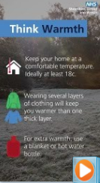 | Self-care goes a long way in keeping you healthy through the colder months.  Dr Jess Harvey, local GP, shares simple ways to help you stay well and warm this winter 💙  More information at ➡️ www.thinkwhichservice.co.uk  #ThinkWhichService  #NHSSTW #SelfCare | Think Self-Care this winter ❄️  Self-care goes a long way in keeping you healthy through the colder months.  Dr Jess Harvey, local GP, shares simple ways to help you stay well and warm this winter 💙  Find more information at ➡️ www.thinkwhichservice.co.uk  #NHSSTW #ThinkWhichService | Think Self-Care this winter ❄️  Self-care goes a long way in keeping you healthy through the colder months.  Dr Jess Harvey, local GP, shares simple ways to help you stay well and warm this winter 💙  #ThinkWhichService #NHSSTW #SelfCare
3:05 pm | 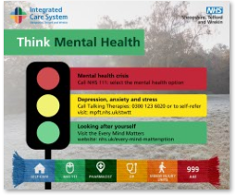 | You’re Not Alone 💙 Mental Health Support is just a Call or Text Away:  NHS 111: Select the mental health option  Samaritans: 116 123 (24/7)  Papyrus: 0800 068 4141 (phone) / 88247 (text)  #YouAreNotAlone #NHSSTW #MentalHealth | You’re Not Alone 💙 Mental Health Support is just a Call or Text Away:  If you’re struggling or in emotional distress, support is available right now:  24/7 Urgent Mental Health Support  - NHS 111: For urgent mental health support, select the mental health option (option 2)  - Email access.shropshire@mpft.nhs.uk (Midlands Partnership University NHS Foundation Trust)  Online Support  - Every Mind Matters: Visit www.nhs.uk/every-mind-matters for expert advice and practical tips to support your mental wellbeing.  Specialist Support  - Samaritans: Call 116 123 – free and available 24/7  - Papyrus HOPELINEUK: If you’re under 35 or supporting someone who is, call 0800 068 4141, text 88247, or email pat@papyrus-uk.org  Someone is always ready to listen 💙  #NHSSTW #ThinkWhichService | You’re Not Alone 💙 Mental Health Support is just a Call or Text Away:  If you’re struggling or in emotional distress, support is available right now:  - NHS 111: For urgent mental health support, select the mental health option (option 2)  - Email access.shropshire@mpft.nhs.uk (Midlands Partnership University NHS Foundation Trust)  - Every Mind Matters: Visit www.nhs.uk/every-mind-matters for expert advice and practical tips to support your mental wellbeing.  - Samaritans: Call 116 123 – free and available 24/7  - Papyrus HOPELINEUK: If you’re under 35 or supporting someone who is, call 0800 068 4141, text 88247, or email pat@papyrus-uk.org  Someone is always ready to listen 💙

Friday 14 November 2025 – Pharmacist
Time | Image | X (Twitter) copy | Facebook / LinkedIn copy | Instagram
9:05 am | 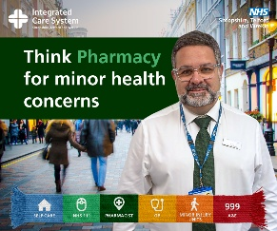 | Feeling unwell? 🤧 Think #PharmacyFirst  Pharmacists can treat many minor illnesses with no GP appointment needed!  More info ➡️ www.thinkwhichservice.co.uk  #ThinkWhichService #NHSSTW #ThinkPharmacyFirst | Feeling unwell? 🤧 Your local pharmacist can help!  Get fast, expert advice for common illnesses at your local pharmacy, without the need for a GP appointment.  Your local pharmacist can now treat 7 common conditions with prescription meds:  • Sinusitis (12+)  • Sore throat (5+)  • Earache (1–17)  • Infected insect bite (1+)  • Impetigo (1+)  • UTI (women 16–64)  • Shingles (18+)  Fast, expert help—no appointment needed.  📍 Visit your local pharmacy today.  Learn more ➡️ www.thinkwhichservice.co.uk  #ThinkWhichService #NHSSTW | Feeling unwell? 🤧 Your local pharmacist can help!  Get fast, expert advice for common illnesses at your local pharmacy, without the need for a GP appointment.  Your local pharmacist can now treat 7 common conditions with prescription meds:  • Sinusitis (12+)  • Sore throat (5+)  • Earache (1–17)  • Infected insect bite (1+)  • Impetigo (1+)  • UTI (women 16–64)  • Shingles (18+)  Fast, expert help—no appointment needed.  📍 Visit your local pharmacy today.  #ThinkWhichService #ThinkPharmacyFirst #NHSSTW
3:05 pm | VIDEO  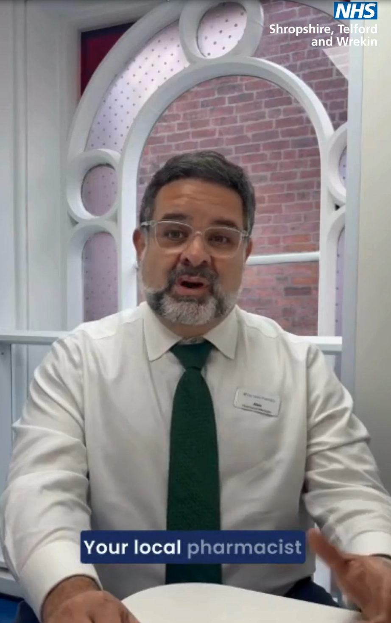 | Think #PharmacyFirst for day-to-day illnesses and minor health concerns 💙  Local community pharmacist Alex explains how your pharmacy can offer expert advice and treatment - often without an appointment.  Fast, local, and here when you need them.  #ThinkWhichService | Think #PharmacyFirst for day-to-day illnesses and minor health concerns 💙  Local community pharmacist Alex explains how your pharmacy can offer expert advice and treatment - often without an appointment.  Pharmacists are trained healthcare professionals who can help with coughs, colds, rashes, stomach upsets, and much more.  Fast, local, and here when you need them.  Find out more ➡️ www.thinkwhichservice.co.uk  #ThinkWhichService #NHSSTW | Think #PharmacyFirst for day-to-day illnesses and minor health concerns 💙  Local community pharmacist Alex explains how your pharmacy can offer expert advice and treatment - often without an appointment.  Pharmacists are trained healthcare professionals who can help with coughs, colds, rashes, stomach upsets, and much more.  Fast, local, and here when you need them.  #ThinkWhichService #NHSSTW #ThinkPharmacyFirst

Saturday 15 November 2025 – NHS 111
Time | Image | X (Twitter) copy | Facebook / LinkedIn copy | Instagram
9:05 AM | Video  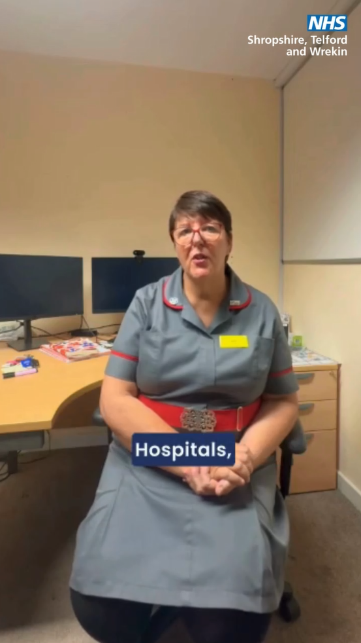 | Feeling unwell and unsure where to turn? 🤧  Visit 111.nhs.uk or call 111 for advice on your symptoms and the best care for you 💻  Getting the right help, in the right place, can help us keep our NHS running smoothly this winter 💙  #ThinkWhichService #NHSSTW #NHS111 | Feeling unwell and unsure where to turn? 🤧 Think NHS111.  Visit 111.nhs.uk for advice on your symptoms and the best care for you 💻  You can also call 111 📞 to speak to someone who can help.  Getting the right help, in the right place, can help us keep our NHS running smoothly this winter 💙  #ThinkWhichService #NHSSTW | Feeling unwell and unsure where to turn? 🤧  Visit 111.nhs.uk for advice on your symptoms and the best care for you 💻  You can also call 111 📞 to speak to someone who can help.  Getting the right help, in the right place, can help us keep our NHS running smoothly this winter 💙  #ThinkWhichService #NHSSTW #NHS111 #WinterCare #HelpUsHelpYou
3:05 pm | 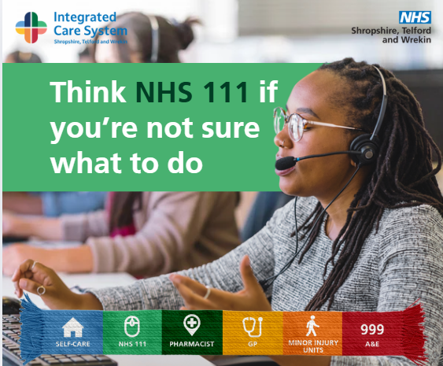 | Need advice this winter? 🤔 Think NHS 111!  Online or by phone, 111 can:  - Check symptoms  - Give dental advice  - Mental health help  - Help with prescriptions & medicines  Get the right help, in the right place 💙  ➡️www.thinkwhichservice.co.uk | Need advice this winter? 🤔 Think NHS 111!  Whether it’s checking your symptoms, getting dental advice, mental health help or finding information about prescriptions and medicines, NHS 111 is here to help.  You can access support online or by phone, 24 hours a day, 7 days a week.  By using NHS 111, you’ll get the right help, in the right place and keep A&E free for those who need it most.  Find out more ➡️ www.thinkwhichservice.co.uk  #ThinkWhichService #NHSSTW | Need advice this winter? 🤔 Think NHS 111!  Whether it’s checking your symptoms, getting dental advice, mental health help or finding information about prescriptions and medicines, NHS 111 is here to help.  You can access support online or by phone, 24 hours a day, 7 days a week.  By using NHS 111, you’ll get the right help, in the right place and keep A&E free for those who need it most.  #ThinkWhichService #NHSSTW #NHS #Winter #NHS111 #NHS111Online

Sunday 16 November 2025 - GP
Time | Image | X (Twitter) copy | Facebook / LinkedIn copy | Instagram
9:05 AM | 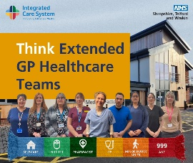 | Your GP practice is more than just GPs.  Behind the scenes, a whole team is working to keep you well including:  - mental health practitioners  - clinical pharmacists  - care coordinators  - and more!  Find out more ➡️ www.thinkwhichservice.co.uk  #ThinkWhichService #NHSSTW | Your GP practice is more than just GPs.  Behind the scenes, a whole team is working to keep you well including:  - mental health practitioners  - clinical pharmacists  - care coordinators  - and more!  💙 It’s all about getting the right support at the right time.  Find out more ➡️ www.thinkwhichservice.co.uk  #ThinkWhichService #NHSSTW | Your GP practice is more than just GPs.  Behind the scenes, a whole team is working to keep you well including:  - mental health practitioners  - clinical pharmacists  - care coordinators  - and more!  💙 It’s all about getting the right support at the right time.  #ThinkWhichService #NHSSTW #NHS #GPTeam #WinterCare #HealthcareTeam
3:05 pm | VIDEO  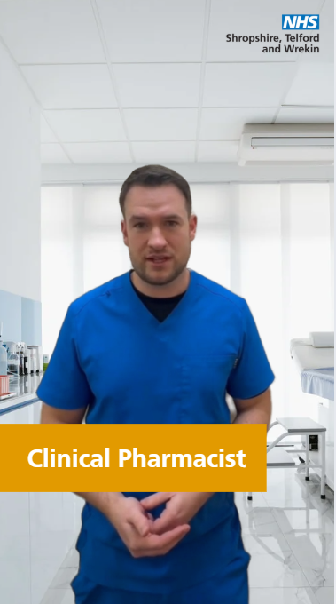 | Extended healthcare teams are made up of highly skilled and qualified professionals that work alongside GPs to ensure you get the right care, from the right person, at the right time 💙  More info ➡️ www.thinkwhichservice.co.uk  #NHSSTW #GPTeam #NHS | Extended healthcare teams are made up of highly skilled and qualified professionals that work alongside GPs to ensure you get the right care, from the right person, at the right time.  You’ll find mental health practitioners, clinical pharmacists, care coordinators and other professionals working together to help you stay well. 💙  Find out more ➡️ www.thinkwhichservice.co.uk  #ThinkWhichService #NHSSTW | Extended healthcare teams are made up of highly skilled and qualified professionals that work alongside GPs to ensure you get the right care, from the right person, at the right time.  You’ll find mental health practitioners, clinical pharmacists, care coordinators and other professionals working together to help you stay well. 💙  #ThinkWhichService #NHSSTW #NHS #GPTeam #WinterHealth #PrimaryCare

Monday 17 November 2025 – Minor Injury Unit
Time | Image | X (Twitter) copy | Facebook / LinkedIn copy | Instagram
9:05 AM | Video  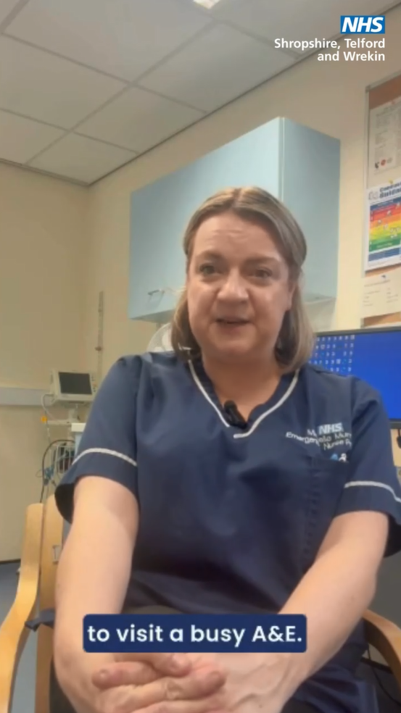 | Save A&E for emergencies and visit your local Minor Injury Unit for quick care with burns, sprains, or minor fractures.  More information ➡️ www.thinkwhichservice.co.uk  #ThinkWhichService #NHSSTW #MIU #NHS | Save A&E for emergencies - Think Minor Injury Unit first!  Your local Minor Injury Unit can treat:  - Burns and scalds  - Sprains and strains  - Minor fractures  - Wounds needing stitches  - Minor head injuries  You’ll be seen quicker and get the care you need.  MIUs are in Bridgnorth, Ludlow, Oswestry & Whitchurch.  Find out more ➡️ www.thinkwhichservice.co.uk  #ThinkWhichService #NHSSTW | Save A&E for emergencies - Think Minor Injury Unit first!  Your local Minor Injury Unit can treat:  - Burns and scalds  - Sprains and strains  - Minor fractures  - Wounds needing stitches  - Minor head injuries  You’ll be seen quicker and get the care you need.  MIUs are in Bridgnorth, Ludlow, Oswestry & Whitchurch.  #ThinkWhichService #NHSSTW #MIU #NHS
3:05 pm | 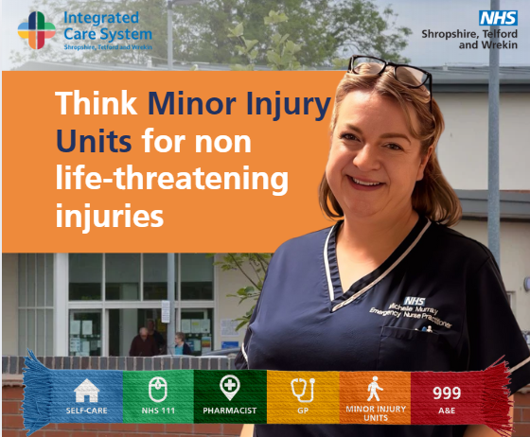 | If you have a minor injury that isn’t life-threatening, head to your closest #MinorInjuryUnit for urgent treatment or advice, without the long A&E wait times ⏰  For more information, visit➡️ www.thinkwhichservice.co.uk  #ThinkWhichService #NHSSTW #NHS #Winter #MIU #MinorInjuryUnit | If it’s not life-threatening, head to your closest #MinorInjuryUnit for fast, expert care – no appointment needed  📍 Minor Injury Units are located at:  - Bridgnorth community hospital  - Ludlow community hospital  - Whitchurch community hospital  - Oswestry Health Centre  Get seen quicker and help keep A&E free for emergencies.  Learn more➡️ www.thinkwhichservice.co.uk  #ThinkWhichService #NHSSTW | If it’s not life-threatening, head to your closest #MinorInjuryUnit for fast, expert care – no appointment needed  📍 Minor Injury Units are located at:  - Bridgnorth community hospital  - Ludlow community hospital  - Whitchurch community hospital  - Oswestry Health Centre  Get seen quicker and help keep A&E free for emergencies.  Learn more, visit➡️ www.thinkwhichservice.co.uk  #ThinkWhichService #NHSSTW #MinorInjuryUnit

Tuesday 18 November 2025 – A&E / 999
Time | Image | X (Twitter) copy | Facebook / LinkedIn copy | Instagram
9:05 AM | 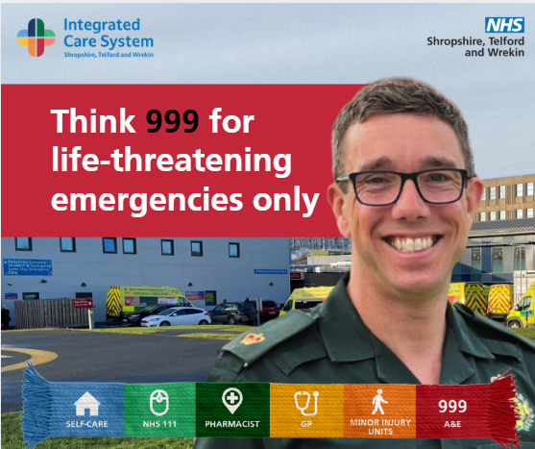 | ☎️ Only call 999 for life-threatening emergencies.  - Think NHS 111 for urgent advice  - Think Pharmacy First for minor illnesses  - Think MIU for non-life-threatening injuries  Get the right care, in the right place ➡️ www.thinkwhichservice.co.uk  #ThinkWhichService #NHSSTW #999 | ☎️ Only call 999 for life-threatening emergencies.  For everything else, think before you act:  - Think NHS 111 for urgent advice  - Think Pharmacy First for minor illnesses  - Think Minor Injury Unit for non-life-threatening injuries  Get the right care, in the right place.  Find out more ➡️ www.thinkwhichservice.co.uk  #ThinkWhichService #NHSSTW | ☎️ Only call 999 for life-threatening emergencies.  For everything else, think before you act:  - Think NHS 111 for urgent advice  - Think Pharmacy First for minor illnesses  - Think Minor Injury Unit for non-life-threatening injuries  Get the right care, in the right place.  #ThinkWhichService #NHSSTW #NHS #999
3:05 pm | 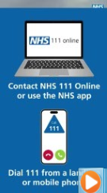 | Think Which Service this winter for the right care, fast.  - Self-care for minor symptoms/illnesses  - NHS 111 for urgent advice  - Pharmacies for minor illnesses  - GPs for ongoing care  - MIUs for minor injuries  - A&E for life-threatening emergencies  ➡️ www.thinkwhichservice.co.uk | Think Which Service this winter for the right care, fast.  Think:  - Self-care for minor symptoms/illnesses  - NHS 111 if you’re not sure what to do or for urgent advice  - Pharmacies for minor illnesses  - GPs for ongoing care/issues  - MIUs for minor injuries  - A&E for life-threatening emergencies  Get the right care, at the right time.  ➡️ www.thinkwhichservice.co.uk  #NHSSTW #ThinkWhichService | Think Which Service this winter for the right care, fast.  Think:  - Self-care for minor symptoms/illnesses  - NHS 111 if you’re not sure what to do or for urgent advice  - Pharmacies for minor illnesses  - GPs for ongoing care/issues  - MIUs for minor injuries  - A&E for life-threatening emergencies  #NHSSTW #ThinkWhichService

