The concept
What?
The idea behind the thunderclap is everyone posting the same thing at the same time.

Why?
To amplify the ‘Think which service’ campaign messages, increase reach and maximise impact across Shropshire, Telford and Wrekin.

When?
We're inviting all partners to take part from Monday, 12 to Sunday, 18 February 2024.

How it will work
- A few days prior to launch, we will share a ‘Think which service - thunderclap’ social media toolkit. The toolkit will provide agreed social media content, including graphics, hashtags and, importantly, a schedule.

- We are proposing that a nominated 3-hour window is devoted to the ‘Think which service’ campaign messages each day. During this time x3 social media messages will be issued (i.e. one per hour). A different 3-hour period will be chosen through the week - hitting different peak times and audiences e.g. Wednesday, 9am to noon, Thursday 6am to 9am, Friday 4pm to 7pm etc.

- For the thunderclap to work, it will be critical that all system comms colleagues schedule the posts on the day and time provided in the schedule. This will maximise the impact.

Monday, 12 February 2024 – 111.co.uk
Time | Image | X (Twitter) copy | Facebook / LinkedIn copy
4pm | Video - GP when to use NHS 111 | ❗ If you need urgent medical help, #NHS 111 online can tell you what to do next, helping to keep #GP appointments and A&E free for those who need them most.  For more information visit ➡️️ www.thinkwhichservice.co.uk #ThinkWhichService | ❗ Think #NHS 111 for urgent medical help or advice that isn't life-threatening.  If you need urgent medical help, NHS 111 online can tell you what to do next, helping to keep #GP appointments and A&E free for those who need them most.  For more information visit ➡️️ www.thinkwhichservice.co.uk #ThinkWhichService
5.30pm | Resident Case Study Mia | If your little one is feeling unwell, visiting 111.nhs.uk is a fast way to get treated by the right service, without the wait times 🤒  For more information visit ➡️️ www.thinkwhichservice.co.uk #ThinkWhichService | If your little one is feeling unwell, visiting 111.nhs.uk is a fast way to get treated by the right service, without the wait times 🤒  For more information visit ➡️️ www.thinkwhichservice.co.uk #ThinkWhichService
7pm | Resident Case Study Ed | NHS 111 online is a fast way to get you treated by the right service, without the wait times and from the comfort of your own home 🏠  For more information visit ➡️️ www.thinkwhichservice.co.uk #ThinkWhichService | NHS 111 online is a fast way to get you treated by the right service, without the wait times and from the comfort of your own home 🏠  For more information visit ➡️️ www.thinkwhichservice.co.uk #ThinkWhichService

Tuesday, 13 February 2024 – Pharmacist
Time | Image | X (Twitter) copy | Facebook / LinkedIn copy
10am | Graphic – Think Pharmacy First 7 Common Conditions | Think #PharmacyFirst.  Did you know your local pharmacy can now prescribe medicines for sinusitis, sore throat, earache, infected bites, impetigo, shingles, and UTIs in women?  For more information visit ➡️️ www.thinkwhichservice.co.uk #ThinkWhichService | Think #PharmacyFirst.  Did you know your local pharmacy can now prescribe medicines for sinusitis, sore throat, earache, infected bites, impetigo, shingles, and UTIs in women?  For more information visit ➡️️ www.thinkwhichservice.co.uk #ThinkWhichService
11am | Resident Case Study Holly | You don't always have to see your #GP for treatment and advice. Think #PharmacyFirst for help with uncomplicated UTIs in women 🤒💊  For more information visit ➡️️ www.thinkwhichservice.co.uk #ThinkWhichService | You don't always have to see your #GP for treatment and advice. Think #PharmacyFirst for help with uncomplicated UTIs in women 🤒💊  For more information visit ➡️️ www.thinkwhichservice.co.uk #ThinkWhichService
12pm | Graphic – Think Pharmacy First Consultation Room | Do you want to talk in private? All pharmacies now have a private consultation room.  For faster treatment without the need for an appointment, Think #PharmacyFirst.  For more information visit ➡️️ www.thinkwhichservice.co.uk #ThinkWhichService | Do you want to talk in private? All pharmacies now have a private consultation room.  Do you want to talk in private? All pharmacies now have a private consultation room.  For faster treatment without the need for an appointment, Think #PharmacyFirst.  For more information visit ➡️️ www.thinkwhichservice.co.uk #ThinkWhichService

Wednesday, 14 February 2024 –Self-care / Valentines Day
Time | Image | X (Twitter) copy | Facebook / LinkedIn copy
6am | Video – GP talking staying active and eating well Valentines | Think self-care this Valentines Day 💗 By taking small steps during the colder months, you can help keep yourself and your loved ones well this #winter  For more information visit ➡️️ www.thinkwhichservice.co.uk #ThinkWhichService | Think self-care this Valentines Day 💗 By taking small steps during the colder months, you can help keep yourself and your loved ones well this #winter  For more information visit ➡️️ www.thinkwhichservice.co.uk #ThinkWhichService
7am | Video - GP talking Medicine cabinet | It's important to keep your medicine cabinet well-stocked so you can treat yourself at home to avoid becoming seriously unwell 💊  For more information visit ➡️️ www.thinkwhichservice.co.uk #ThinkWhichService | It's important to keep your medicine cabinet well-stocked so you can treat yourself at home to avoid becoming seriously unwell 💊  For more information visit ➡️️ www.thinkwhichservice.co.uk #ThinkWhichService
8.30am | Vaccination | As #flu and #COVID-19 cases are likely to increase over the winter months, getting extra protection will help you and others around you from becoming seriously unwell 💉  For more information visit ➡️️ www.thinkwhichservice.co.uk #ThinkWhichService | As #flu and #COVID-19 cases are likely to increase over the winter months, getting extra protection will help you and others around you from becoming seriously unwell 💉  For more information visit ➡️️ www.thinkwhichservice.co.uk #ThinkWhichService

Thursday, 15 February 2024 – GP
Time | Image | X (Twitter) copy | Facebook / LinkedIn copy
6pm | Video – GP advice on how to stay well this winter | Think self-care. We recommend you check your medicine cupboard is well-stocked, with everything in date, so you can treat minor health problems at home 🤒💊  For more information visit ➡️️ www.thinkwhichservice.co.uk #ThinkWhichService | Think self-care. We recommend you check your medicine cupboard is well-stocked, with everything in date, so you can treat minor health problems at home 🤒💊  For more information visit ➡️️ www.thinkwhichservice.co.uk #ThinkWhichService
7pm | GP graphic Importance of self-care eat well, stay active and stay warm  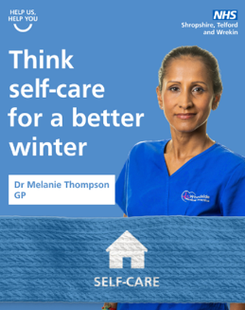 | With the colder weather & darker evenings drawing in, motivation to look after ourselves can be low. However, eating well, staying active & keeping warm can help lower your risk of becoming seriously unwell this #winter ❄️➡️️ www.thinkwhichservice.co.uk #ThinkWhichService | With the colder weather and darker evenings drawing in, motivation to look after ourselves can be low. However, eating well, staying active and keeping warm can help lower your risk of becoming seriously unwell this #winter. ❄️  If you are worried about money, struggling to pay bills or buy food, contact your local council for support.  For more information visit ➡️️ www.thinkwhichservice.co.uk #ThinkWhichService
8.30pm | Video - GP importance of flu and covid vaccination  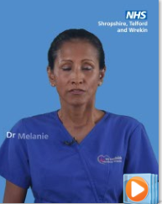 | Think #vaccinations for complete protection 💉 If eligible, getting extra protection from the #flu and #COVID-19 will stop you and others around you from becoming seriously unwell.  For more information visit ➡️️ www.thinkwhichservice.co.uk #ThinkWhichService | Think #vaccinations for complete protection 💉 If eligible, getting extra protection from the #flu and #COVID-19 will stop you and others around you from becoming seriously unwell.  For more information visit ➡️️ www.thinkwhichservice.co.uk #ThinkWhichService

Friday, 16 February 2024 – Minor Injury Unit
Time | Image | X (Twitter) copy | Facebook / LinkedIn copy
1pm | Video - MIU Nurse when to use a MIU | ❗ Think Minor Injury Units (MIU) before A&E. If you have a non-life-threatening injury or illness and need urgent care with short waiting times, visit your nearest minor injury unit (MIU).  For more information visit ➡️️ www.thinkwhichservice.co.uk #ThinkWhichService | ❗ Think Minor Injury Units (MIU) before A&E. If you have a non-life-threatening injury or illness and need urgent care with short waiting times, visit your nearest minor injury unit (MIU).  For more information visit ➡️️ www.thinkwhichservice.co.uk #ThinkWhichService
3pm | Resident Case Study Oli  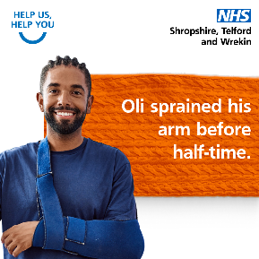 | Your local #MinorInjuryUnit (MIU) can help you get the treatment you need, avoiding the long wait times in A&E ⏰  For more information visit ➡️️ www.thinkwhichservice.co.uk #ThinkWhichService | Your local #MinorInjuryUnit (MIU) can help you get the treatment you need, avoiding the long wait times in A&E ⏰  For more information visit ➡️️ www.thinkwhichservice.co.uk #ThinkWhichService
4pm | Video - MIU Nurse benefit of MIU | If you have a non-life-threatening matter, head to your local MIU for urgent treatment or advice, without the long A&E wait times ⏰ MIUs are located at our community hospitals in Bridgnorth, Ludlow, Whitchurch, and Oswestry Health Centre.  ➡️️ www.thinkwhichservice.co.uk | If you have a non-life-threatening matter, head to your local MIU for urgent treatment or advice, without the long A&E wait times ⏰  MIUs are located at our community hospitals in Bridgnorth, Ludlow, Whitchurch, and Oswestry Health Centre.  For more information visit ➡️️ www.thinkwhichservice.co.uk #ThinkWhichService

Saturday, 17 February 2024 – 999 / A&E
Time | Image | X (Twitter) copy | Facebook / LinkedIn copy
12pm | Video - A&E consultant when to use A&E | ❗ Think 999 and A&E for life-threatening emergencies only. Help us keep A&E free for genuine emergencies.  For more information visit ➡️️ www.thinkwhichservice.co.uk #ThinkWhichService | ❗ Think 999 and A&E for life-threatening emergencies only. Help us keep A&E free for genuine emergencies.  For more information visit ➡️️ www.thinkwhichservice.co.uk #ThinkWhichService
2pm | Paramedic Graphic When to dial 999  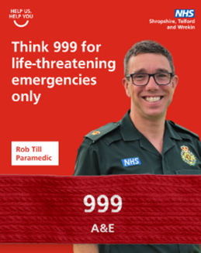 | ☎️ Please only call 999 for genuine life-threatening emergencies and use NHS 111 online or by phone or a Minor Injury Unit (MIU) for other urgent care needs.  For more information visit ➡️️ www.thinkwhichservice.co.uk #ThinkWhichService | ☎️ Please only call 999 for genuine life-threatening emergencies and use NHS 111 online or by phone or a Minor Injury Unit (MIU) for other urgent care needs.  For more information visit ➡️️ www.thinkwhichservice.co.uk #ThinkWhichService
3pm | Graphic A&E consultant when to use A&E  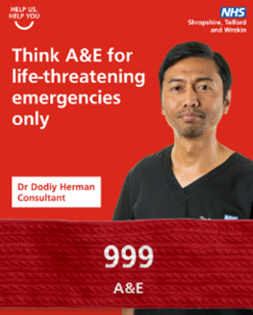 | ❗ Please keep our emergency departments available for life-threatening emergencies only, such as severe bleeding, loss of consciousness, suspected heart attack or stroke and breathing difficulties.  For more information visit ➡️️ www.thinkwhichservice.co.uk #ThinkWhichService | ❗ Please keep our emergency departments available for life-threatening emergencies only, such as severe bleeding, loss of consciousness, suspected heart attack or stroke and breathing difficulties.  For more information visit ➡️️ www.thinkwhichservice.co.uk #ThinkWhichService

Sunday, 18 February 2024 – Winter Health
Time | Image / File name | X (Twitter) copy | Facebook / LinkedIn copy
7am | Graphic Falls prevention - Advice on how to avoid falls and local services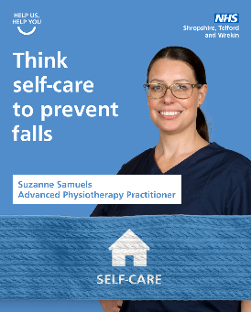 | Taking care of your overall health & staying active can lower your chance of falling. Strength conditioning exercises such as #Yoga, Pilates & tai chi can improve your muscles, balance & #MentalHealth 🧘‍♂️  ❗ Take extra caution in wet & icy weather.  ➡️️ www.thinkwhichservice.co.uk | Taking care of your overall health and staying physically active may lower your chance of falling and badly hurting yourself.  Strength conditioning exercises such as Yoga, Pilates and tai chi are all great for improving your muscles and balance as well as your mental health 🧘‍♂️🌿  ❗ Take extra caution when walking on wet or icy surfaces, wear shoes with a good grip and consider staying inside when the weather is bad.  For more information visit ➡️️ www.thinkwhichservice.co.uk #ThinkWhichService
8am | Graphic: GP Mental Health Nurse graphic How to look after your Mental Health this winter | It’s normal for your #MentalHealth to change with the seasons ❄️🧠 To help your mental health & beat #WinterBlues, keep active, get outside & keep in touch with family/friends. Contact friends, family or a professional for help if you're struggling.  ➡️️ www.thinkwhichservice.co.uk | It’s ok and normal for your #MentalHealth to change with a change in season 🧠  To help boost your mental health and beat the #WinterBlues, try to keep active, get outside and keep in touch with family and friends.  If you do feel like you’re struggling, reach out to friends or family or a professional for help.  For more information visit ➡️️ www.thinkwhichservice.co.uk #ThinkWhichService
10am | Graphic Physio from RJAH Importance of self-care – MSK message  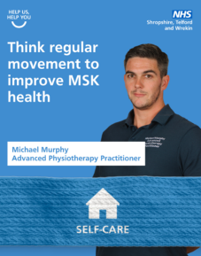 | Regular movement is key to preventing musculoskeletal (MSK) conditions, which affect your joints, bones and muscles 🦴 Adults should aim to be active every day. A daily brisk walk can boost your body, mood & make activities easier ➡️️ www.thinkwhichservice.co.uk #ThinkWhichService | Regular movement is an important part of an overall healthy lifestyle and key to preventing musculoskeletal (MSK) conditions which affect your joints, bones and muscles 🦴  Adults should aim to be active every day. Some is good – more is better still. A daily brisk walk can give your body a boost, lift your mood and make everyday activities easier.  For more information visit ➡️️ www.thinkwhichservice.co.uk #ThinkWhichService

