Date | Image | Alt Text
Wednesday 12 November | 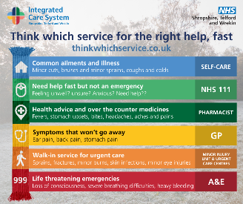 | An infographic titled “Think which service for the right help, fast”  It uses coloured bands resembling a scarf to show which NHS service to choose based on symptoms:  - Blue – Self-care: Common ailments and illnesses such as minor cuts, bruises, sprains, coughs, and colds.  - Light green – NHS 111: For when you need help fast but it’s not an emergency; feeling unwell, unsure, anxious, or needing advice.  - Dark green – Pharmacist: For health advice and over-the-counter medicines for fevers, stomach upsets, bites, headaches, aches, and pains.  - Yellow – GP: For symptoms that won’t go away, such as ear pain, back pain, or stomach pain.  - Orange – Minor Injury Unit & Urgent Care Centres: For walk-in urgent care for sprains, fractures, minor burns, skin infections, and minor eye injuries.  - Red – A&E / 999: For life-threatening emergencies such as loss of consciousness, severe breathing difficulties, or heavy bleeding.
Thursday 13 November | 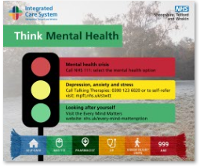 | An infographic titled “Think Mental Health.” It uses a traffic light design to show different levels of mental health support:  - Red light – Mental health crisis: Call NHS 111 and select the mental health option.  - Amber light – Depression, anxiety and stress: Call Talking Therapies on 0300 123 6020 or self-refer at mpft.nhs.uk/stwtt.  - Green light – Looking after yourself: Visit the Every Mind Matters website at nhs.uk/every-mind-matters.  At the bottom, a multicoloured scarf represents NHS services — self-care (blue), NHS 111 (light green), pharmacist (dark green), GP (yellow), minor injury units (orange), and A&E/999 (red).
Friday 14 November | 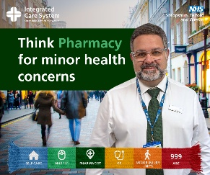 | A male pharmacist smiling. At the bottom, a multicoloured scarf represents NHS services — self-care (blue), NHS 111 (light green), pharmacist (dark green), GP (yellow), minor injury units (orange), and A&E/999 (red).  Text reads: Think Pharmacy for minor health concerns.
Saturday 15 November | 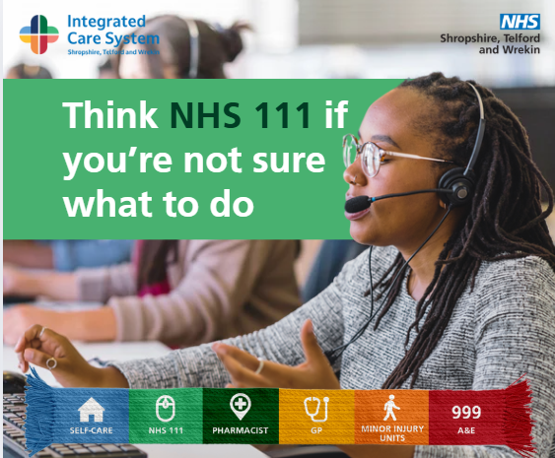 | A woman working in a call centre. At the bottom, a multicoloured scarf represents NHS services — self-care (blue), NHS 111 (light green), pharmacist (dark green), GP (yellow), minor injury units (orange), and A&E/999 (red).  Text reads: Think NHS 111 if you’re not sure what to do.
Sunday 16 November | 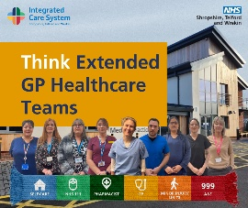 | A group of healthcare workers smiling. At the bottom, a multicoloured scarf represents NHS services — self-care (blue), NHS 111 (light green), pharmacist (dark green), GP (yellow), minor injury units (orange), and A&E/999 (red).  Text reads: Think Extended GP Healthcare Teams.
Monday 17 November | 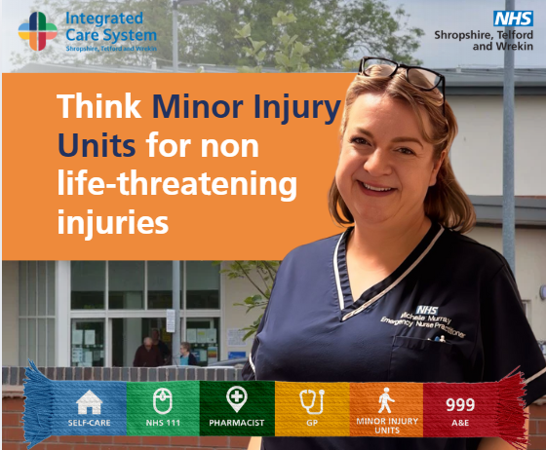 | A female healthcare worker smiling. At the bottom, a multicoloured scarf represents NHS services — self-care (blue), NHS 111 (light green), pharmacist (dark green), GP (yellow), minor injury units (orange), and A&E/999 (red).  Text reads: Think Minor Injury Units for non life-threatening injuries.
Tuesday 18 November | 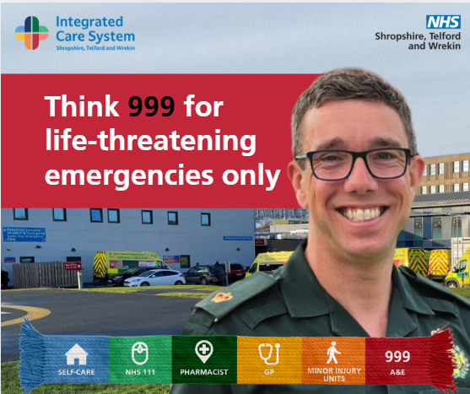 | A male paramedic. At the bottom, a multicoloured scarf represents NHS services — self-care (blue), NHS 111 (light green), pharmacist (dark green), GP (yellow), minor injury units (orange), and A&E/999 (red).  Text reads: Think 999 for life-threatening emergencies only.

