General
Image | X (Twitter) copy | Facebook / LinkedIn copy
Motion video: Scarf | Remember to look after yourself and others this #winter. #ThinkWhichService is right for your needs. To find out more and for self-care tips visit ➡️️ www.thinkwhichservice.co.uk | Remember to look after yourself and others this winter. #ThinkWhichService is right for your needs.  To find out more and for self-care tips visit ➡️️ www.thinkwhichservice.co.uk
Scarf Graphic  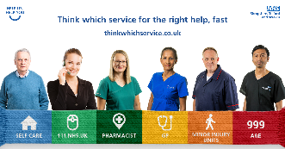 | Shropshire, Telford and Wrekin #NHS and local #councils join forces ahead of winter, to help residents know how to find support and which service to use at the right time for help & advice ➡️️ www.thinkwhichservice.co.uk #ThinkWhichService | Shropshire, Telford and Wrekin #NHS and local #councils join forces ahead of winter to help ensure residents know how to find support and which service to use at the right time for help and advice.  For more information visit ➡️️ www.thinkwhichservice.co.uk #ThinkWhichService

Self-care
Image | X (Twitter) copy | Facebook / LinkedIn copy
Video – GP talking staying active and eating well  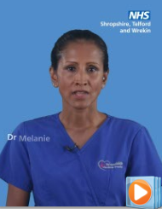 | Think self-care. By taking small steps during the colder months, you can help keep yourself and your loved ones well this #winter 💙  For more information visit ➡️️ www.thinkwhichservice.co.uk #ThinkWhichService | Think self-care. By taking small steps during the colder months, you can help keep yourself and your loved ones well this #winter 💙  For more information visit ➡️️ www.thinkwhichservice.co.uk #ThinkWhichService
Video - GP talking Medicine cabinet  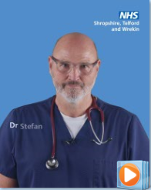 | It's important to keep your medicine cabinet well-stocked so you can treat yourself at home to avoid becoming seriously unwell 💊  For more information visit ➡️️ www.thinkwhichservice.co.uk #ThinkWhichService | It's important to keep your medicine cabinet well-stocked so you can treat yourself at home to avoid becoming seriously unwell 💊  For more information visit ➡️️ www.thinkwhichservice.co.uk #ThinkWhichService
Vaccination | As #flu and #COVID-19 cases are likely to increase over the winter months, getting extra protection will help you and others around you from becoming seriously unwell 💉  For more information visit ➡️️ www.thinkwhichservice.co.uk #ThinkWhichService | As #flu and #COVID-19 cases are likely to increase over the winter months, getting extra protection will help you and others around you from becoming seriously unwell 💉  For more information visit ➡️️ www.thinkwhichservice.co.uk #ThinkWhichService

Graphic Falls prevention - Advice on how to avoid falls and local services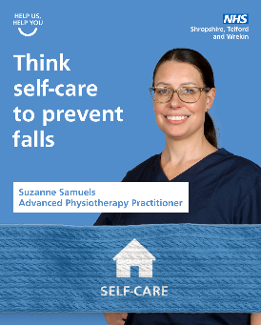 | Taking care of your overall health & staying active can lower your chance of falling. Strength conditioning exercises such as #Yoga, Pilates & tai chi can improve your muscles, balance & #MentalHealth 🧘‍♂️  ❗ Take extra caution in wet & icy weather.  ➡️️ www.thinkwhichservice.co.uk | Taking care of your overall health and staying physically active may lower your chance of falling and badly hurting yourself.  Strength conditioning exercises such as Yoga, Pilates and tai chi are all great for improving your muscles and balance as well as your mental health 🧘‍♂️🌿  ❗ Take extra caution when walking on wet or icy surfaces, wear shoes with a good grip and consider staying inside when the weather is bad.  For more information visit ➡️️ www.thinkwhichservice.co.uk #ThinkWhichService
GP Mental Health Nurse graphic How to look after your Mental Health this winter  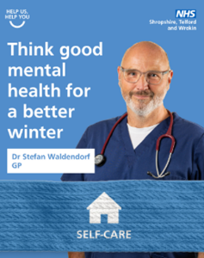 | It’s normal for your #MentalHealth to change with the seasons ❄️🧠 To help your mental health & beat #WinterBlues, keep active, get outside & keep in touch with family/friends. Contact friends, family or a professional for help if you're struggling.  ➡️️ www.thinkwhichservice.co.uk | It’s ok and normal for your #MentalHealth to change with a change in season 🧠  To help boost your mental health and beat the #WinterBlues, try to keep active, get outside and keep in touch with family and friends.  If you do feel like you’re struggling, reach out to friends or family or a professional for help.  For more information visit ➡️️ www.thinkwhichservice.co.uk #ThinkWhichService
Graphic Dr from RJAH Importance of self-care – MSK message  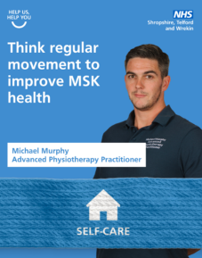 | Regular movement is key to preventing musculoskeletal (MSK) conditions, which affect your joints, bones and muscles 🦴 Adults should aim to be active every day. A daily brisk walk can boost your body, mood & make activities easier ➡️️ www.thinkwhichservice.co.uk #ThinkWhichService | Regular movement is an important part of an overall healthy lifestyle and key to preventing musculoskeletal (MSK) conditions which affect your joints, bones and muscles 🦴  Adults should aim to be active every day. Some is good – more is better still. A daily brisk walk can give your body a boost, lift your mood and make everyday activities easier.  For more information visit ➡️️ www.thinkwhichservice.co.uk #ThinkWhichService

NHS 111
Image | X (Twitter) copy | Facebook / LinkedIn copy
Video - GP when to use NHS 111  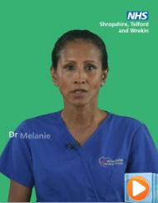 | ❗ If you need urgent medical help, #NHS 111 online can tell you what to do next, helping to keep #GP appointments and A&E free for those who need them most.  For more information visit ➡️️ www.thinkwhichservice.co.uk #ThinkWhichService | ❗ Think #NHS 111 for urgent medical help or advice that isn't life-threatening.  If you need urgent medical help, NHS 111 online can tell you what to do next, helping to keep #GP appointments and A&E free for those who need them most.  For more information visit ➡️️ www.thinkwhichservice.co.uk #ThinkWhichService
Resident Case Study Mia  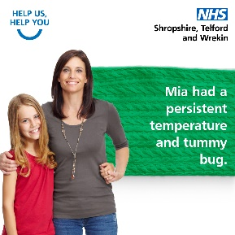 | If your little one is feeling unwell, visiting 111.nhs.uk is a fast way to get treated by the right service, without the wait times 🤒  For more information visit ➡️️ www.thinkwhichservice.co.uk #ThinkWhichService | If your little one is feeling unwell, visiting 111.nhs.uk is a fast way to get treated by the right service, without the wait times 🤒  For more information visit ➡️️ www.thinkwhichservice.co.uk #ThinkWhichService
Resident Case Study Ed  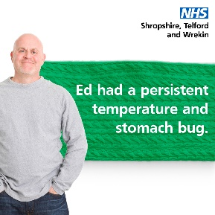 | NHS 111 online is a fast way to get you treated by the right service, without the wait times and from the comfort of your own home 🏠  For more information visit ➡️️ www.thinkwhichservice.co.uk #ThinkWhichService | NHS 111 online is a fast way to get you treated by the right service, without the wait times and from the comfort of your own home 🏠  For more information visit ➡️️ www.thinkwhichservice.co.uk #ThinkWhichService

Pharmacy
Image | X (Twitter) copy | Facebook / LinkedIn copy
Video – Pharmacy What can you use a local pharmacist for | Think #pharmacy for day-to-day ailments 💊 With late opening hours, your local community pharmacist can help you with a range of day-to-day ailments.  For more information visit ➡️️ www.thinkwhichservice.co.uk #ThinkWhichService | Think #pharmacy for day-to-day ailments 💊  With late opening hours, your local community pharmacist can help you with a range of day-to-day ailments.  For more information visit ➡️️ www.thinkwhichservice.co.uk #ThinkWhichService
Resident Case Study Lisa  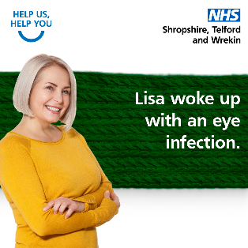 | You don't always have to see your #GP for treatment and advice. Your local pharmacists can help you with a range of minor illnesses 🤒💊  For more information visit ➡️️ www.thinkwhichservice.co.uk #ThinkWhichService | You don't always have to see your #GP for treatment and advice. Your local pharmacists can help you with a range of minor illnesses 🤒💊  For more information visit ➡️️ www.thinkwhichservice.co.uk #ThinkWhichService
Video - Pharmacy benefit of pharmacy | Your local pharmacists are available to help you with a range of day-to-day ailments 🤒  For more information visit ➡️️ www.thinkwhichservice.co.uk #ThinkWhichService | Your local pharmacists are available to help you with a range of day-to-day ailments 🤒  For more information visit ➡️️ www.thinkwhichservice.co.uk #ThinkWhichService

GP
Image | X (Twitter) copy | Facebook / LinkedIn copy
Video – GP advice on how to stay well this winter  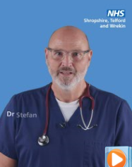 | Think self-care. We recommend you check your medicine cupboard is well-stocked, with everything in date, so you can treat minor health problems at home 🤒💊  For more information visit ➡️️ www.thinkwhichservice.co.uk #ThinkWhichService | Think self-care. We recommend you check your medicine cupboard is well-stocked, with everything in date, so you can treat minor health problems at home 🤒💊  For more information visit ➡️️ www.thinkwhichservice.co.uk #ThinkWhichService
GP graphic Importance of self-care eat well, stay active and stay warm  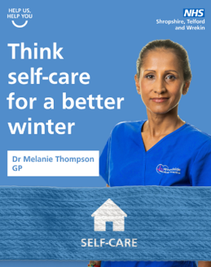 | With the colder weather & darker evenings drawing in, motivation to look after ourselves can be low. However, eating well, staying active & keeping warm can help lower your risk of becoming seriously unwell this #winter ❄️➡️️ www.thinkwhichservice.co.uk #ThinkWhichService | With the colder weather and darker evenings drawing in, motivation to look after ourselves can be low. However, eating well, staying active and keeping warm can help lower your risk of becoming seriously unwell this #winter. ❄️  If you are worried about money, struggling to pay bills or buy food, contact your local council for support.  For more information visit ➡️️ www.thinkwhichservice.co.uk #ThinkWhichService
Video - GP importance of flu and covid vaccination  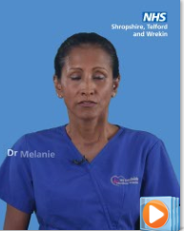 | Think #vaccinations for complete protection 💉 If eligible, getting extra protection from the #flu and #COVID-19 will stop you and others around you from becoming seriously unwell.  For more information visit ➡️️ www.thinkwhichservice.co.uk #ThinkWhichService | Think #vaccinations for complete protection 💉 If eligible, getting extra protection from the #flu and #COVID-19 will stop you and others around you from becoming seriously unwell.  For more information visit ➡️️ www.thinkwhichservice.co.uk #ThinkWhichService

Minor Injury Unit
Image | X (Twitter) copy | Facebook / LinkedIn copy
Video - MIU Nurse when to use a MIU  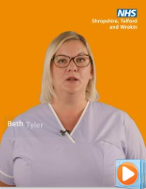 | ❗ Think Minor Injury Units (MIU) before A&E. If you have a non-life-threatening injury or illness and need urgent care with short waiting times, visit your nearest minor injury unit (MIU).  For more information visit ➡️️ www.thinkwhichservice.co.uk #ThinkWhichService | ❗ Think Minor Injury Units (MIU) before A&E. If you have a non-life-threatening injury or illness and need urgent care with short waiting times, visit your nearest minor injury unit (MIU).  For more information visit ➡️️ www.thinkwhichservice.co.uk #ThinkWhichService
Resident Case Study Oli  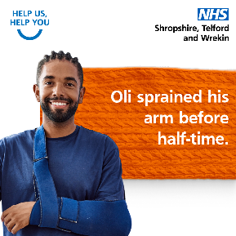 | Your local #MinorInjuryUnit (MIU) can help you get the treatment you need, avoiding the long wait times in A&E ⏰  For more information visit ➡️️ www.thinkwhichservice.co.uk #ThinkWhichService | Your local #MinorInjuryUnit (MIU) can help you get the treatment you need, avoiding the long wait times in A&E ⏰  For more information visit ➡️️ www.thinkwhichservice.co.uk #ThinkWhichService
Video - MIU Nurse benefit of MIU  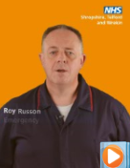 | If you have a non-life-threatening matter, head to your local MIU for urgent treatment or advice, without the long A&E wait times ⏰ MIUs are located at our community hospitals in Bridgnorth, Ludlow, Whitchurch, and Oswestry Health Centre.  ➡️️ www.thinkwhichservice.co.uk | If you have a non-life-threatening matter, head to your local MIU for urgent treatment or advice, without the long A&E wait times ⏰  MIUs are located at our community hospitals in Bridgnorth, Ludlow, Whitchurch, and Oswestry Health Centre.  For more information visit ➡️️ www.thinkwhichservice.co.uk #ThinkWhichService

A&E / 999
Image | X (Twitter) copy | Facebook / LinkedIn copy
Video - A&E consultant when to use A&E  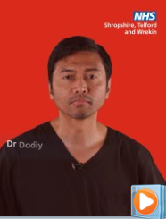 | ❗ Think 999 and A&E for life-threatening emergencies only. Help us keep A&E free for genuine emergencies.  For more information visit ➡️️ www.thinkwhichservice.co.uk #ThinkWhichService | ❗ Think 999 and A&E for life-threatening emergencies only. Help us keep A&E free for genuine emergencies.  For more information visit ➡️️ www.thinkwhichservice.co.uk #ThinkWhichService
Paramedic Graphic When to dial 999  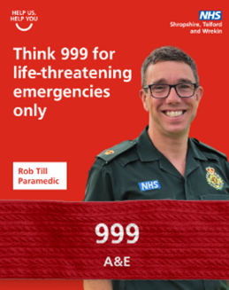 | ☎️ Please only call 999 for genuine life-threatening emergencies and use NHS 111 online or by phone or a Minor Injury Unit (MIU) for other urgent care needs.  For more information visit ➡️️ www.thinkwhichservice.co.uk #ThinkWhichService | ☎️ Please only call 999 for genuine life-threatening emergencies and use NHS 111 online or by phone or a Minor Injury Unit (MIU) for other urgent care needs.  For more information visit ➡️️ www.thinkwhichservice.co.uk #ThinkWhichService
Graphic A&E consultant when to use A&E  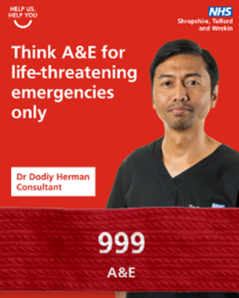 | ❗ Please keep our emergency departments available for life-threatening emergencies only, such as severe bleeding, loss of consciousness, suspected heart attack or stroke and breathing difficulties.  For more information visit ➡️️ www.thinkwhichservice.co.uk #ThinkWhichService | ❗ Please keep our emergency departments available for life-threatening emergencies only, such as severe bleeding, loss of consciousness, suspected heart attack or stroke and breathing difficulties.  For more information visit ➡️️ www.thinkwhichservice.co.uk #ThinkWhichService

