Image | Copy
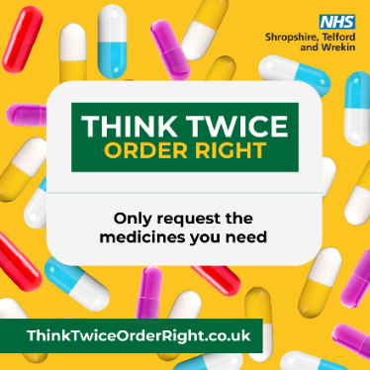 | Think Twice, Order Right  Only request the medicines you need.  ✅ Check what you already have  ✅ Don’t stockpile  ✅ Help reduce medicines waste in Shropshire, Telford and Wrekin  💬 Speak to your pharmacy team if you’re unsure  To find out more, visit: ThinkTwiceOrderRight.co.uk  #ThinkTwiceOrderRight #MedicinesWaste #NHSSTW
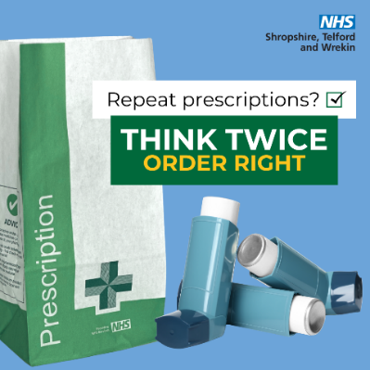 | Think Twice, Order Right  Only request the medicines you need.  ✅ It’s safer.  🌍 It’s greener.  🧾 It’s still there for next time.  📞 Talk to your pharmacy team if you’re unsure.  To find out more, visit: ThinkTwiceOrderRight.co.uk  #ThinkTwiceOrderRight #MedicinesWaste #NHSSTW
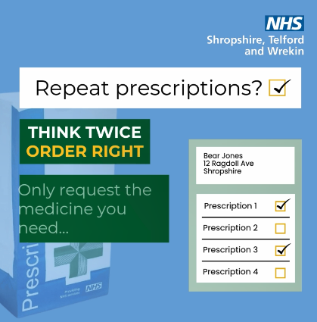 | A huge amount of medicines are wasted unnecessarily in Shropshire, Telford and Wrekin each year. We need your help to reduce this. Find out why it’s important to #ThinkTwiceOrderRight  To find out more, visit: ThinkTwiceOrderRight.co.uk
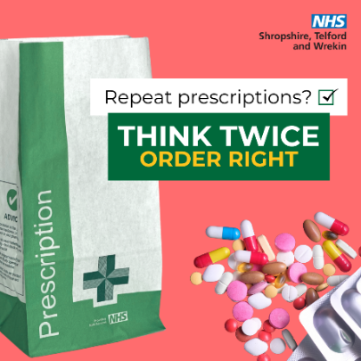 | Did you know that 2.6 million medicine items are wasted in Shropshire, Telford and Wrekin each year – many are from repeat prescriptions that weren’t actually needed?  Let’s work together to reduce waste and protect your NHS  To find out more, visit: ThinkTwiceOrderRight.co.uk  #ThinkTwiceOrderRight
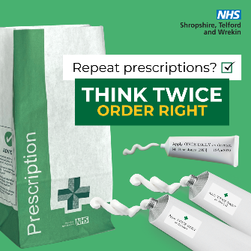 | NHS medicine waste costs Shropshire, Telford and Wrekin £2.6 million a year! Check your medicines 7–10 days before your prescription is due and ‘Think Twice, Order right’ and only request the medicines you need — you can always get more later. Let’s reduce waste and help the NHS.  To find out more, visit: ThinkTwiceOrderRight.co.uk  #ThinkTwiceOrderRight
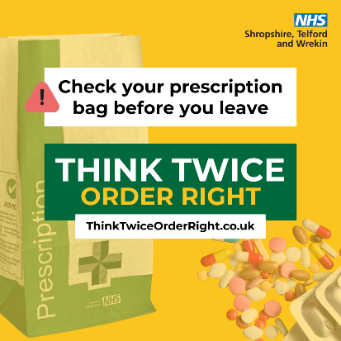 | Time to pick up your prescription? #ThinkTwiceOrderRight, and check your prescription bag before leaving the pharmacy to make sure that there’s nothing extra in there. If you return an item before you leave the pharmacy, the medicines can be reused.  To find out more, visit: ThinkTwiceOrderRight.co.uk
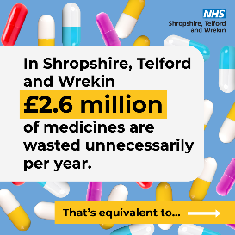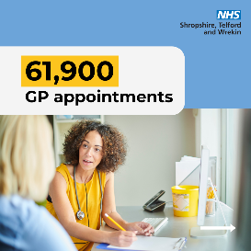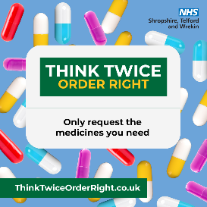 | In Shropshire, Telford and Wrekin £2.6 million of medicines are wasted unnecessary per year.  This is equivalent to 61,900 GP appointments.  Let’s work together to reduce waste and protect your NHS. Think Twice, Order Right.  To find out more, visit: ThinkTwiceOrderRight.co.uk  #ThinkTwiceOrderRight
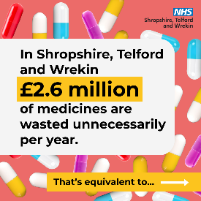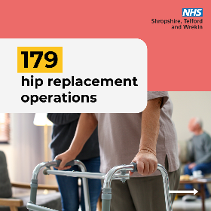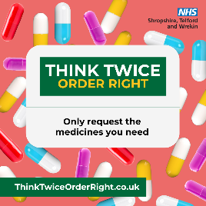 | In Shropshire, Telford and Wrekin £2.6 million of medicines are wasted unnecessary per year.  This is equivalent to 179 hip replacement operations.  Only request the medicines you need — you can always get more later.  To find out more, visit: ThinkTwiceOrderRight.co.uk  #ThinkTwiceOrderRight
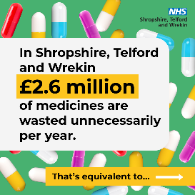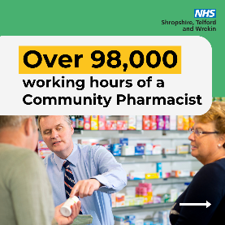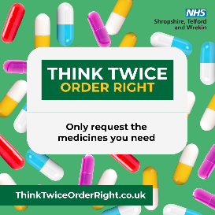 | In Shropshire, Telford and Wrekin £2.6 million of medicines are wasted unnecessary per year.  This is equivalent to over 98,000 working hours of a Community Pharmacist.  Let’s work together to reduce waste and protect your NHS. Think Twice, Order Right.  To find out more, visit: ThinkTwiceOrderRight.co.uk  #ThinkTwiceOrderRight

Secondary messages: Environmental

Image | Copy
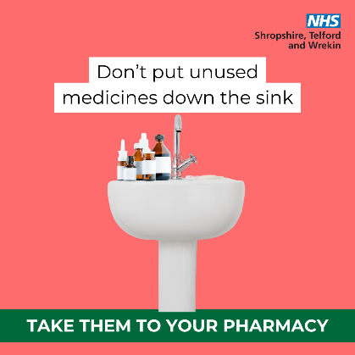 | Don't put unused medicines down the sink, toilet or in your household waste.  Your pharmacist can safely dispose of unused and expired medicines. Stay green and request the medicines you need.  👉ThinkTwiceOrderRight.co.uk  #ThinkTwiceOrderRight #MedicinesWaste #NHSSTW
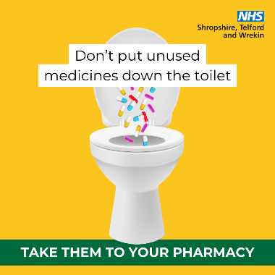 | Don't put unused medicines down the sink, toilet or in your household waste.  Your pharmacist can safely dispose of unused and expired medicines. Stay green and request the medicines you need.  👉 ThinkTwiceOrderRight.co.uk  #ThinkTwiceOrderRight #MedicinesWaste #NHSSTW
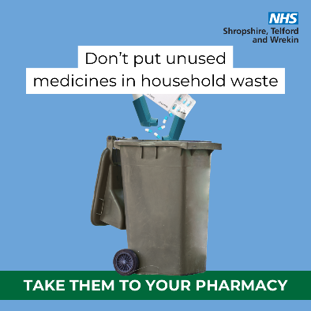 | Don't put unused medicines down the sink, toilet or in your household waste.  Your pharmacist can safely dispose of unused and expired medicines. Stay green and request the medicines you need.  To find out more, visit:ThinkTwiceOrderRight.co.uk  #ThinkTwiceOrderRight #MedicinesWaste #NHSSTW

Secondary messages: Safety
Image | Copy
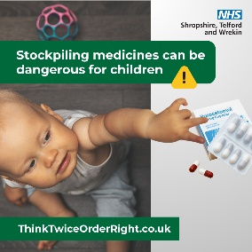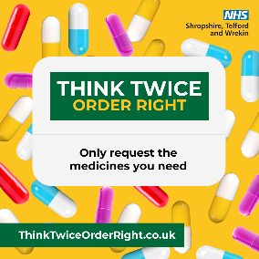 | Help your family #StaySafe – don’t stockpile unnecessary amounts of medicines at home where they could be found by children. #ThinkTwiceOrderRight and return any unused items to your pharmacy for safe disposal.  👉 ThinkTwiceOrderRight.co.uk

