Image | File Name | Twitter | Facebook / LinkedIn
 | STW Winter Health landscape 3 new URL.png | You don't always have to see your GP for treatment and advice. Your local pharmacists can help you with a range of minor illnesses 💊  Think pharmacy first, pharmacies provide an important first point of contact for a range of minor concerns.  ➡️ https://www.shropshiretelfordandwrekin.nhs.uk/your-health/think-which-service/ | You don't always have to see your GP for treatment and advice. Your local pharmacists can help you with a range of minor illnesses 💊  Choose your services wisely this year. Think pharmacy first, pharmacies provide an important first point of contact for a range of minor concerns such as sore throats, colds and flu, stomach, skin, ear, eye and nose problems. They can also advise if you should seek further medical help.  Think which service ➡️ https://www.shropshiretelfordandwrekin.nhs.uk/your-health/think-which-service/
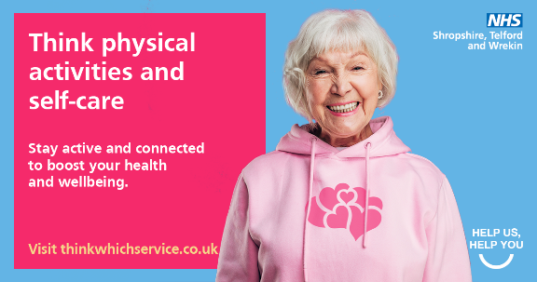 | STW Winter Health landscape 4 new URL.png | Eating, drinking, and keeping moving is even more important during the colder months🍎🚶‍♂️👪Setting yourself some daily goals, routines and structure will help to keep you well and ensure you have the energy to do the things you enjoy.  Think which service➡️ https://www.shropshiretelfordandwrekin.nhs.uk/your-health/think-which-service/ | Eating, drinking, and keeping moving is even more important during the colder months. Setting yourself some easy daily goals, routines and structure will help to keep you well this year and ensure you have the energy to do the things you enjoy.  Tips for staying well:  🥛 Stay hydrated with liquids and hot drinks  👨‍👩‍👦 Keep in touch with family, friends, and neighbours – even if it’s a quick hello over the fence!  🚶‍♂️Try to move throughout the day and get some fresh air  🍎 Eat a balanced diet with tasty but simple foods – fresh, tinned, frozen, it’s all the same!  Think which service ➡️ https://www.shropshiretelfordandwrekin.nhs.uk/your-health/think-which-service/
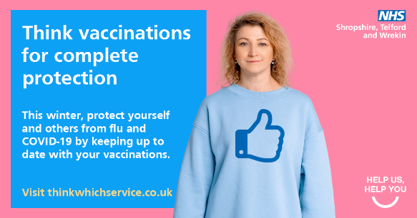 | STW Winter Health landscape 5 new URL.png | As #flu and #COVID-19 cases are likely to increase over the colder months, getting extra protection will help prevent you and others around you from becoming seriously unwell. 💉  Think which service ➡️ https://www.shropshiretelfordandwrekin.nhs.uk/your-health/think-which-service/ | As flu and COVID-19 cases are likely to increase over the colder months, getting extra protection will help prevent you and others around you from becoming seriously unwell.  Free flu vaccines are available to:  🤰 Pregnant women  👴 Anyone aged 50 and over  💊 People with a weakened immune system or long-term health condition  🏥 Are a frontline health care worker or social care staff  Think which service ➡️ https://www.shropshiretelfordandwrekin.nhs.uk/your-health/think-which-service/
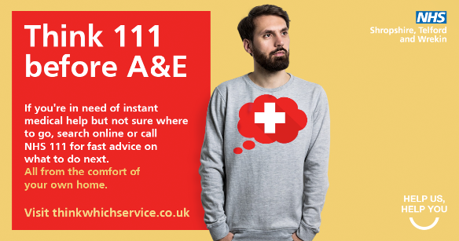 | STW Winter Health landscape 1 new URL.png | If you need urgent medical help but are unsure where to go, contact NHS online to get help quickly and safely.  NHS 111 online can offer you a booked time to an appropriate service, from the comfort of your own home 💻 🏡  Think which service ➡️ https://www.shropshiretelfordandwrekin.nhs.uk/your-health/think-which-service/ | If you need urgent medical help but are unsure where to go, contact NHS online to get help quickly and safely.  NHS 111 online can offer you a booked time to an appropriate service, from the comfort of your own home 💻 🏡  ➡️https://www.shropshiretelfordandwrekin.nhs.uk/your-health/think-which-service/
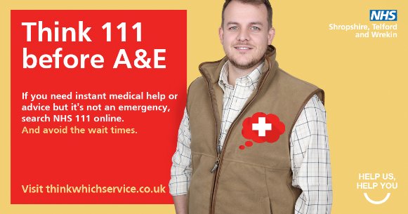 | STW Winter Health landscape 2 new URL.png | Are you or a family member concerned or worried about your health? Unsure what to do? Before going to A&E, think NHS 111 online first.  Contact 111 online if you need medical help but it’s not an emergency to get the right care, right place, right time - first time.  Available 24 hours a day, 7 days a week.  Think which service ➡️ https://www.shropshiretelfordandwrekin.nhs.uk/your-health/think-which-service/ | Are you or a family member concerned or worried about your health? Unsure what to do? Before going to A&E, think NHS 111 online first.  Contact 111 online if you need medical help but it’s not an emergency to get the right care, right place, right time - first time.  Available 24 hours a day, 7 days a week.  Think which service: ➡️https://www.shropshiretelfordandwrekin.nhs.uk/your-health/think-which-service/
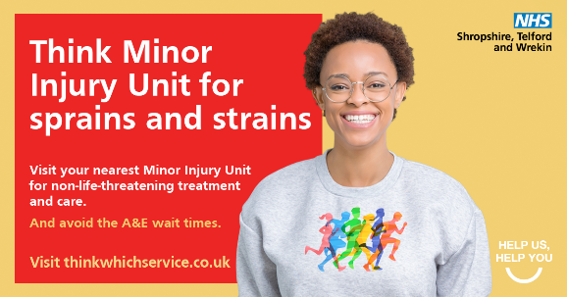 | STW Winter Health landscape 6 new URL.png | If you need urgent treatment for a minor injury, no matter your age, think Minor Injury Unit 🏥  Our Minor Injury Units are open every day, offering advice and treatments for a range of minor injuries.  Find out more: https://www.shropshiretelfordandwrekin.nhs.uk/your-health/think-which-service/ | If you need urgent treatment for a minor injury, no matter your age, think Minor Injury Unit 🏥  Our Minor Injury Units are open every day, offering advice and treatments for a range of minor injuries.  Find out more: https://www.shropshiretelfordandwrekin.nhs.uk/your-health/think-which-service/

Case Studies:
Image | Image Link | Twitter | Facebook / LinkedIn
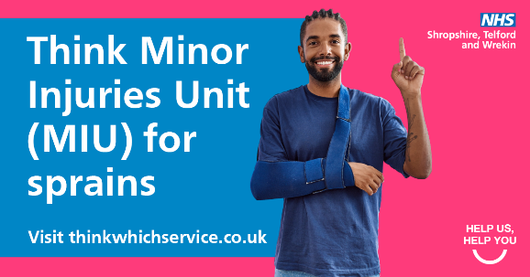 | oli STW Winter Health landscape new 1.png | Meet Oli👋  Oli has played #rugby most of his life and has spent many hours in A&E waiting rooms🏉Oli attended an Minor Injury Unit after hurting his wrist, where they confirmed it was a sprain.  They bandaged it up, & Oli was home before the game ended #ThinkWhichService  ➡️https://www.shropshiretelfordandwrekin.nhs.uk/your-health/think-which-service/ | Meet Oli 👋  Oli has played #rugby most of his life and has suffered a few bumps resulting in a lot of time being spent in many A&E waiting rooms 🏉🏥  In a recent match, Oli got caught up in a nasty tackle and landed on his wrist. He attended the Minor Injury Unit in Bridgnorth where they confirmed it was a sprained wrist. They bandaged it up, and Oli was on my way home before the game had even finished 👍  Find out more about how Minor Injury Units can help you ➡️ https://www.shropshiretelfordandwrekin.nhs.uk/your-health/think-which-service/  #ThinkWhichService #NHS #Shropshire #Telford
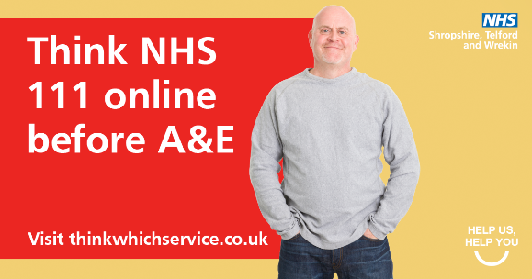 | ed STW Winter Health landscape new 3.png | Meet Ed 👋  Ed recently discovered NHS111 online is a fast alternative to A&E after having a persistent stomach bug & temperature that left him dehydrated🌡️ NHS111 online immediately directed him to the right service; a GP appointment  #ThinkWhichService  ➡️ https://www.shropshiretelfordandwrekin.nhs.uk/your-health/think-which-service/ | Meet Ed 👋  Ed recently discovered that NHS 111 online is a fast alternative to heading to A&E 🏥  Ed recently had a persistent stomach bug and temperature that left him dehydrated 🌡️ He thought he should go to A&E. Instead, he put his symptoms into NHS 111 online, and it immediately directed him to the right service – which was a next-day GP appointment.  Be more like Ed and use NHS 111 online 👍  Find out more about how NHS 111online can help you ➡️ https://www.shropshiretelfordandwrekin.nhs.uk/your-health/think-which-service/  #ThinkWhichService #NHS #Shropshire #Telford
 | lisa STW Winter Health landscape new 4.png | Meet Lisa 👋 Lisa recently had an eye infection & was told she would have to wait one week to see her GP  👁️ Lisa visited her local pharmacy, & she was back home with some cream & eye drops within the hour! #ThinkWhichService  ➡️ https://www.shropshiretelfordandwrekin.nhs.uk/your-health/think-which-service/ | Meet Lisa 👋  Lisa recently had an eye infection that wouldn’t go away with any of the at-home remedies 👁️ Lisa called her GP and was told she would have to wait one week for an appointment but could visit her local pharmacy instead.  Within an hour of making the initial phone call to her GP, she was back home with some cream and eye drops from the pharmacy!  Find out more about how your pharmacy could help you ➡️ https://www.shropshiretelfordandwrekin.nhs.uk/your-health/think-which-service/  #ThinkWhichService #NHS #Shropshire #Telford
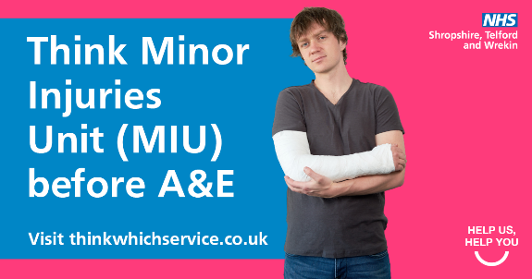 | HARRY STW Winter Health landscape new 2.png | Meet Harry👋  Harry is a keen hiker ⛰️  He recently tripped over a rock while walking up a steady incline & landed badly on his arm. Harry went to a Minor Injury Unit instead of A&E. The Minor Injury Unit took an x-ray & put a cast on his confirmed broken arm  👍#ThinkWhichService  ➡️ https://www.shropshiretelfordandwrekin.nhs.uk/your-health/think-which-service/ | Meet Harry 👋Harry is a keen hiker ⛰️ He recently tripped over a rock while walking up a steady incline and landed badly on his arm. He thought it might be broken.  Harry went to a Minor Injury Unit instead of A&E. The staff at the Minor Injury Unit in Whitchurch took an x-ray and put a cast on his confirmed broken arm – Harry was home in time for his dinner.👍  Find out more about how Minor Injury Unit can help you ➡️ https://www.shropshiretelfordandwrekin.nhs.uk/your-health/think-which-service/  #ThinkWhichService #NHS #Shropshire #Telford

