
Information About the Learning Disability and Autism Support Service (Transforming Care Partnership)
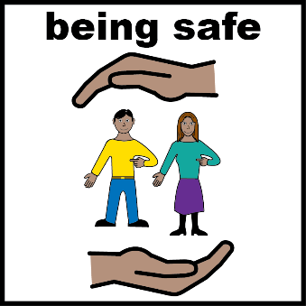 | Our service is for people with a learning disability and/or autism. It supports people to  - Have a home within their community  - Get the support they need to live a healthy, safe and fulfilling life
      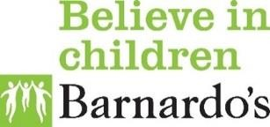 | How do we do this?  - We keep a register called the Dynamic Support Register which has information about people who need support  - We organise meetings to make sure the right support from our partner organisations is in place  - Partner organisations are the NHS, Shropshire Council, Telford Council and Barnardo’s
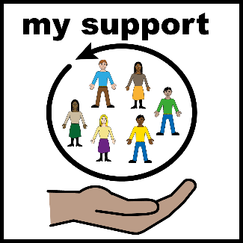 | Who is the Dynamic Support Register for?  - People of any age with a learning disability and/or autism  - People who are having a difficult time with where they live and their current support  - People who need extra support to live a healthy, safe and fulfilling life in the community and not go to hospital if they do not need to.

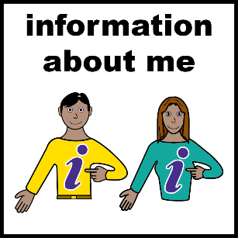  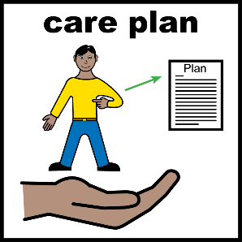 | The Dynamic Support Register is an online form that includes:  - Your name  - Where you live  - Who is working with you  - What support you have now to make things easier  - Your birthday  - NHS Number  - How you are doing and if you have any difficulties at the moment  - A plan about how everyone is going to help you
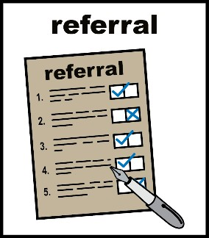 | The Register will get information about you from the referral form filled in by the professional referring you.
 | We need to collect your information to make sure you get the right care and treatment in your community whenever possible.
 | Your information will only be shared with professionals who need to know about you because they are from services who can support you.  It will not be shared with professionals who do not need to know your information. Your information may be shared with the Care Quality Commission (CQC) and Ofsted for audit, inspection and regulatory purposes

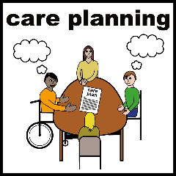 | Meetings will happen every two weeks to look at the online form, to see how you are doing and how we can help.
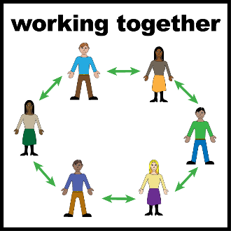 | How does the Dynamic Support Register help?  - It helps the people supporting you to work together  - It helps to give you support when you need it with no delays  - It helps you to stay in the community and out of hospital if you don’t need it
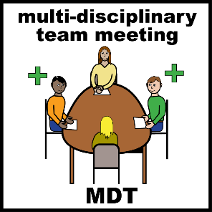 | The people running the Register may call a meeting called a Care Education & Treatment Review (CETR), or a Local Area Emergency Protocol (LAEP) meeting.  You and your parents or carers will be invited to attend if you want to.
 | If you are under 25 years old, you may be offered a Keyworker. Your keyworker can  - Help you to get the right support  - Help you to have your say about what you want
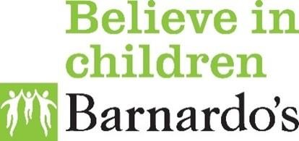 | Our Shropshire and Telford Keyworkers are based within a charity called Barnardo’s.

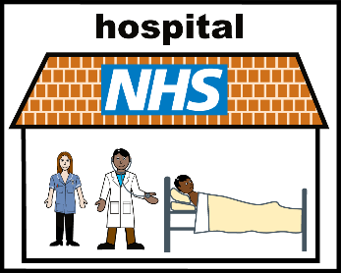 | What happens if you go to hospital?  - Sometimes if people are unwell they might need to go to hospital to get the help they need to feel better  - The Dynamic Support Register will help people who are working with you to make a plan to help you to move back to the community with the support you need.
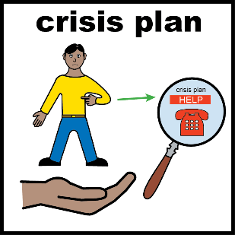 | What happens if you are not on the Register?  - People working with you will still give you support if you need it but being on the Register means that more services will know about your needs.  - If services are aware of your needs, they will be able to make a support plan more quickly in an emergency.
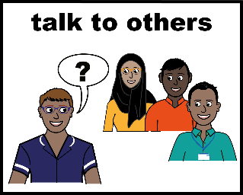 | Is the Register right for you?  - It is a good idea to talk to people who understand your support needs.  - They will help you understand what the register is about and help you decide if it’s right for you.
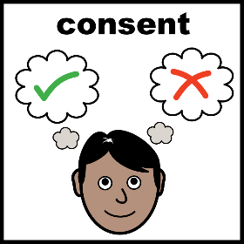

Your details only go on the Register if you give your consent.
- Consent is about understanding the facts so you can decide what is right for you.
- You have the right to say no.
- If you change your mind, you can ask the people who run the Register to remove your details.
- If you decide you no longer want to be on the register or it is felt that you no longer require to be on it because your needs are being well met. We will keep your details for a minimum of 12 months.

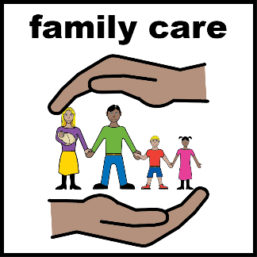 | If you are under 16 your parents or guardian must give their consent for you.  If you are an adult over 18 or aged 16 -18 years and do not have the capacity to decide, people involved in your care will follow the Mental Capacity Act to decide if it is in your best interest to join the register.
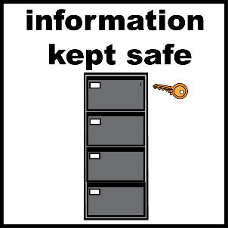 | The Dynamic Support Register will keep your information safe.  It will only keep your information while you need support.
 | If you would like to see a copy of the information that is being held about you, you can request this.
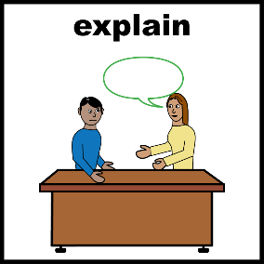 | If you find it hard to understand this information you can ask for it to be explained in a different way.
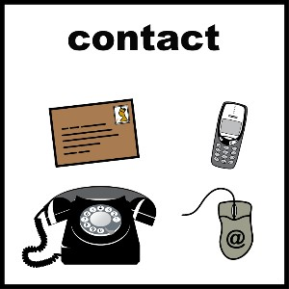 | You can contact the people who run the Dynamic Support Register if you have any questions or worries.  Email: mlscu.tcpshropshire@nhs.net  Address: Bennett House, Town Road, Hanley, Stoke-on-Trent, ST1 2QB.

