Image | Twitter | Facebook / LinkedIn
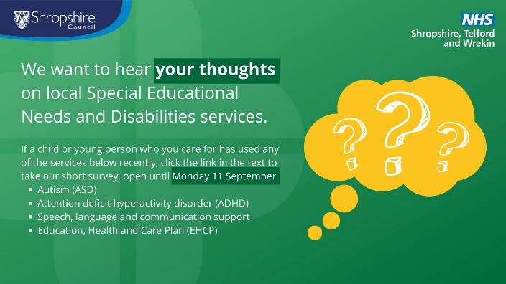 | @ShropCouncil and @NHSSTW want to hear the views of people who use SEND services for children and young people.  To have your say, visit www.smartsurvey.co.uk/s/STWSEND before Monday 11 September | Shropshire Council and NHS Shropshire, Telford and Wrekin have launched a new survey, aimed at understanding local people’s experiences of accessing Special Educational Needs and Disability services for children and young people  Your feedback will help the local health and care organisations to improve local services.  To complete the #survey, please visit ➡️: www.smartsurvey.co.uk/s/STWSEND  The survey closes Monday 11 September 2023
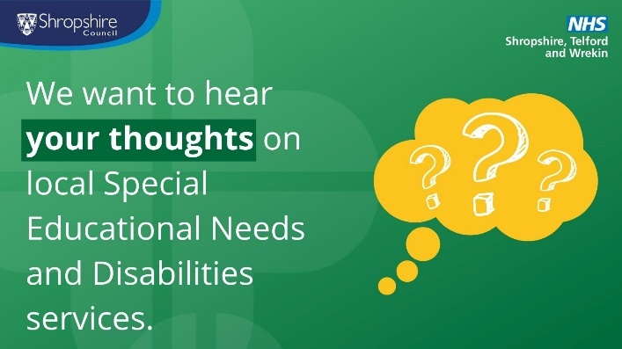 | Have your say on local autism, ADHD and speech & language support services for children and young people!  Visit www.smartsurvey.co.uk/s/STWSEND to complete a short survey | Shropshire Council and NHS Shropshire, Telford and Wrekin have launched a new survey, aimed at understanding local people’s experiences of accessing Special Educational Needs and Disability services for children and young people. These include autism, ADHD, and speech, language and communications support.  Your feedback will help the local health and care organisations to improve local services.  To complete the #survey, please visit ➡️: www.smartsurvey.co.uk/s/STWSEND  The survey closes Monday 11 September 2023
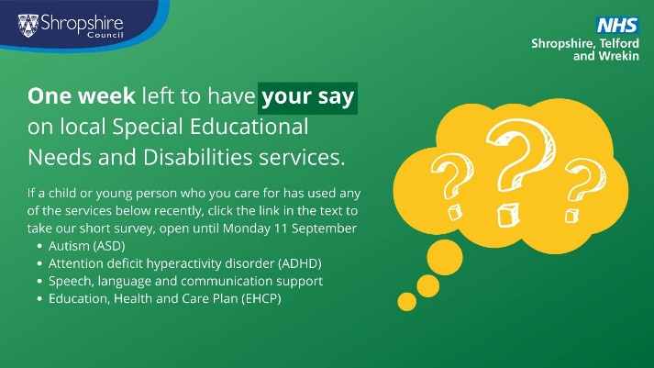 | One week left to have your say on local SEND services for children and young people!  Visit www.smartsurvey.co.uk/s/STWSEND to complete a short survey from @ShropCouncil and @NHSSTW | One week left to complete a new survey from Shropshire Council and NHS Shropshire, Telford and Wrekin, aimed at understanding local people’s experiences of accessing Special Educational Needs and Disability services for children and young people  Your feedback will help the local health and care organisations to improve local services.  To complete the #survey, please visit ➡️: www.smartsurvey.co.uk/s/STWSEND  The survey closes Monday 11 September 2023

