Everyone Belongs Here September 2025

Graphics | Copy
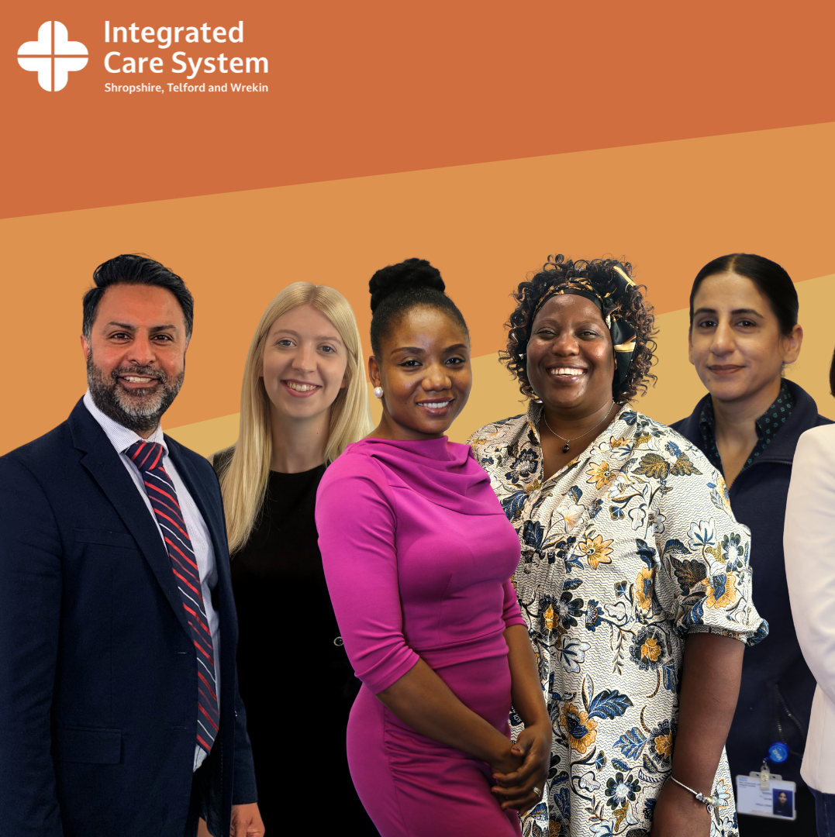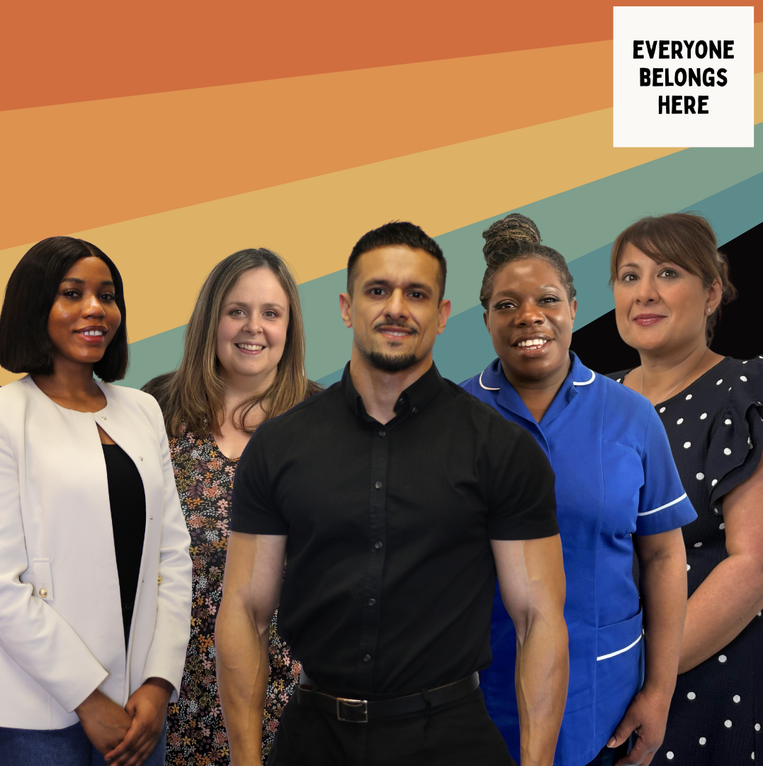 | Colleagues from every corner of our health and care system are stepping forwards to lead the way on inclusion, sharing their stories and speaking up for equality and belonging.  Inspiring others to create workplaces where everyone feels seen, heard and valued.  These colleagues are at the centre of ‘Everyone Belongs Here’, helping to shape a more inclusive future for everyone.  See more: www.everyonebelongshere.co.uk
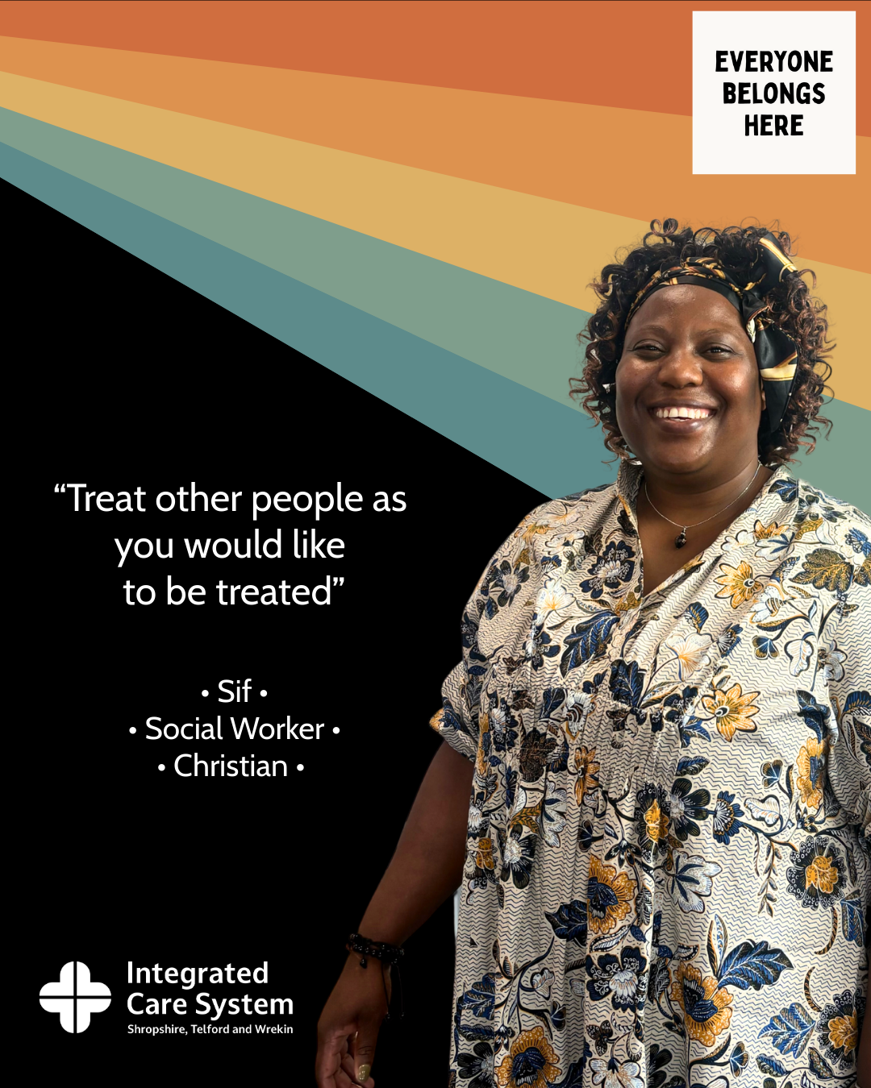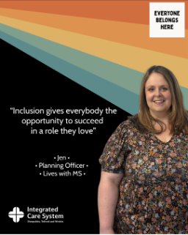  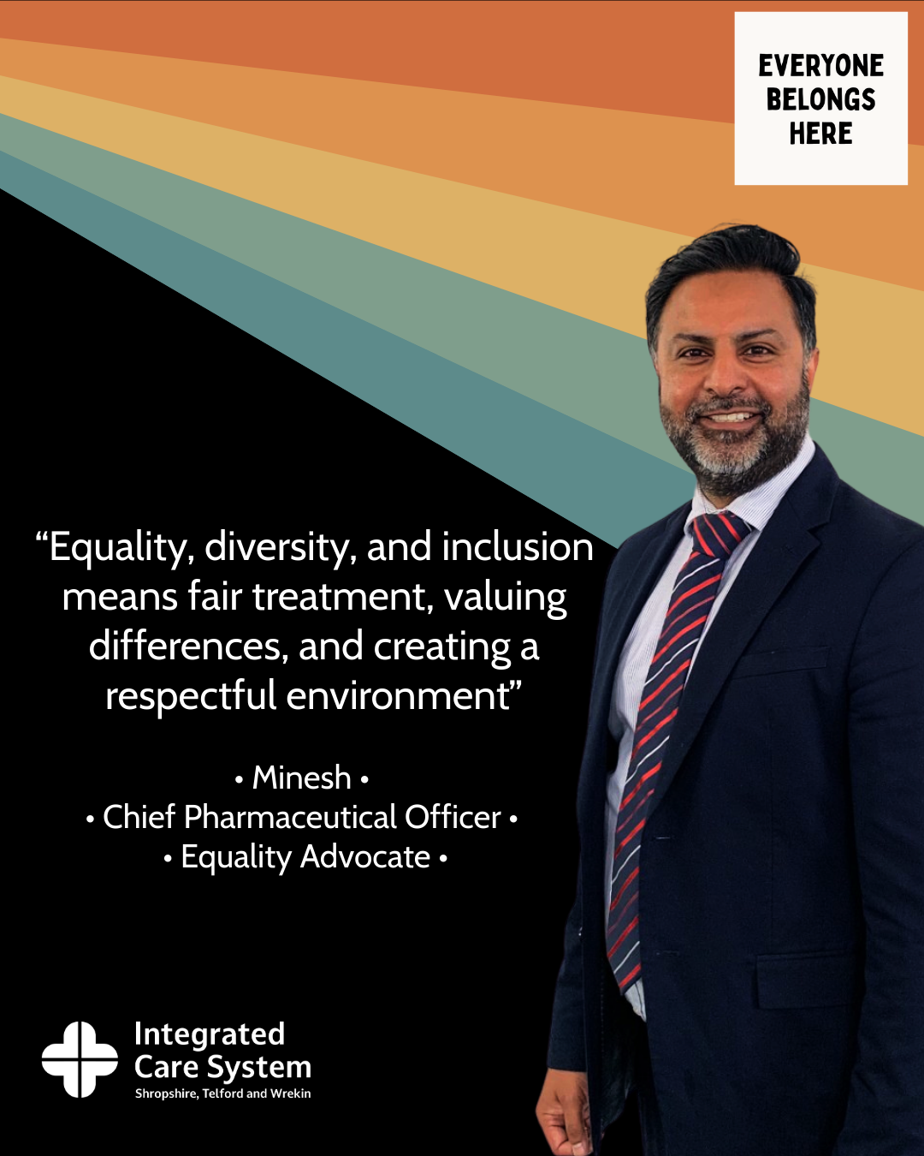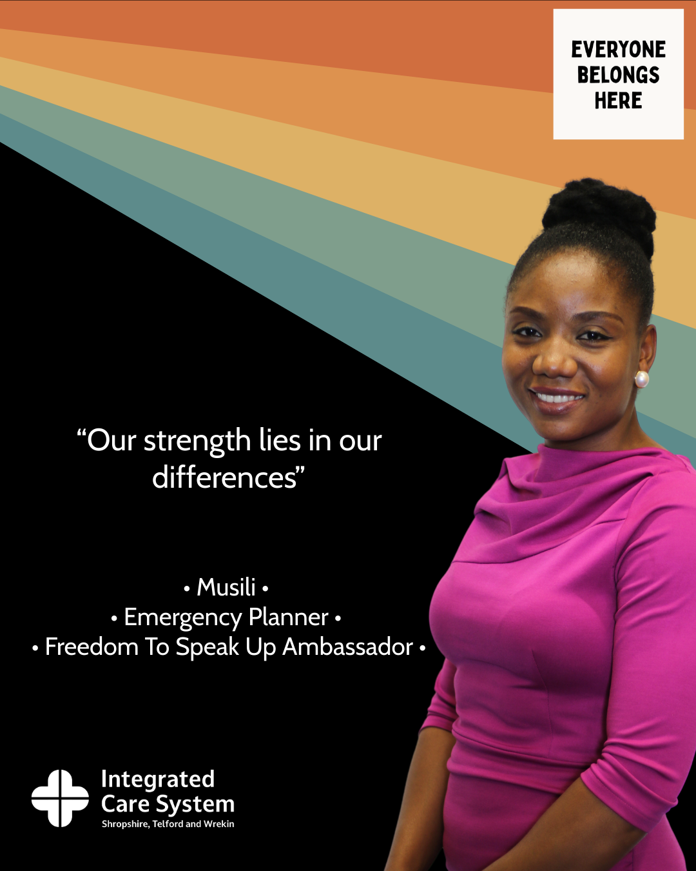 | From the frontline to the boardroom, meet the voices standing up for inclusion in our ‘Everyone Belongs Here’ campaign.  Their roles may differ, but their message is united; diversity makes us stronger, and belonging starts with inclusion.  ➡️ Swipe through to hear what inclusion means to some of our equality advocates.  See more: www.everyonebelongshere.co.uk

