Mental Health Text Support Service

Social Media Posts

Young Adults:
Graphic | Copy
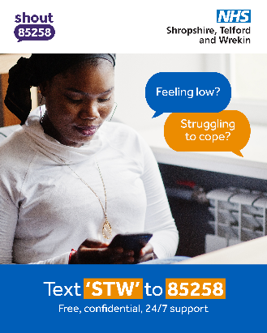 | Feeling low, stressed or overwhelmed? You don’t have to face it alone.  Text ‘STW’ to 85258 for free, confidential support, 24/7 from Shout.  Someone is always ready to listen. 💙  Learn more: https://bit.ly/STWShout
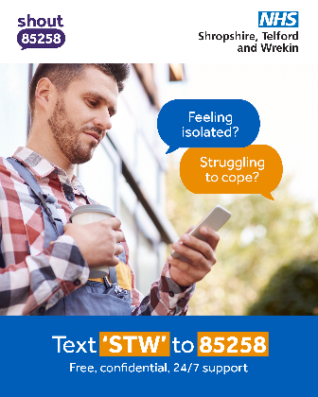 | If things feel heavy right now - reach out.  Text ‘STW’ to 85258 to talk silently and anonymously with a trained volunteer from Shout, any time.  Free. Confidential. Here for you.  Learn more: https://bit.ly/STWShout

Older adults:
Graphic | Copy
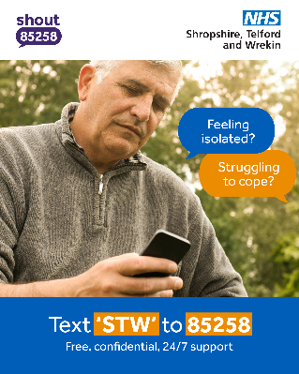 | Feeling isolated or finding things tough at home? ️  Text ‘STW’ to 85258 for free, private support no matter the time of day or night.  We’re proud to offer this service in partnership with Shout. You’re never alone.  Learn more: https://bit.ly/STWShout
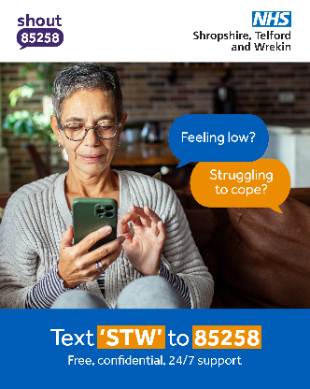 | If you’re feeling cut off, low in mood, or simply need someone to talk to, support is just a text away.  Text ‘STW’ to 85258 for free, confidential help from trained Shout volunteers.  Learn more: https://bit.ly/STWShout

Anxiety or stress:
Graphic | Copy
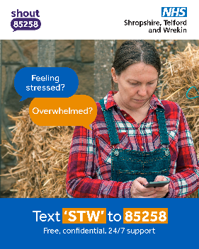 | Worried, stressed or trying to cope with a tough moment?  Text ‘STW’ to 85258 for free, confidential support available 24/7 provided by Shout in partnership with NHS Shropshire, Telford and Wrekin.  You don’t have to struggle in silence.  Learn more: https://bit.ly/STWShout
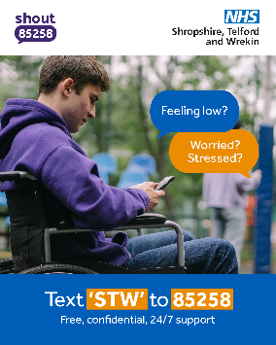 | If anxiety is creeping in or you’re finding the day overwhelming, reach out. 🫂  Text ‘STW’ to 85258 for quiet, confidential support whenever you need it.  Learn more: https://bit.ly/STWShout

Carers:
Graphic | Copy
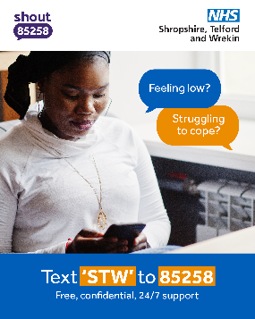 | Feeling stressed, overwhelmed, or juggling too much?  Text ‘STW’ to 85258 for free, confidential support day or night from Shout.  You deserve support too. 💙  Learn more: https://bit.ly/STWShout

Work related:
Graphic | Copy
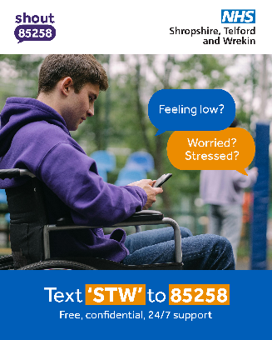 | Working long hours? Feeling isolated? Struggling to cope?  Help is just a text away.  Text ‘STW’ to 85258 for non-judgemental, confidential support, 24/7 from Shout.  Learn more: https://bit.ly/STWShout

Students:
Graphic | Copy
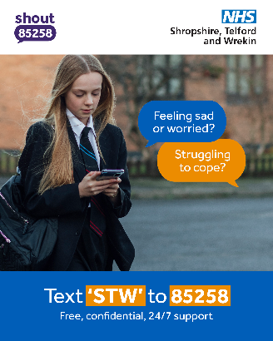 | Feeling sad, worried, or struggling to keep up with everything?  Text ‘STW’ to 85258 for free mental health support.  Shout is private, confidential and always open.  Learn more: https://bit.ly/STWShout
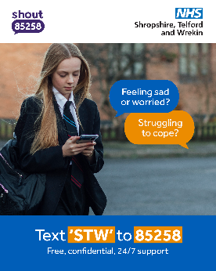 | Stress, exams, friendships, life… if it all feels too much, you’re not alone.  Text ‘STW’ to 85258 for instant, confidential help from Shout.  Reach out, any time. 💙  Learn more: https://bit.ly/STWShout

Men:
Graphic | Copy
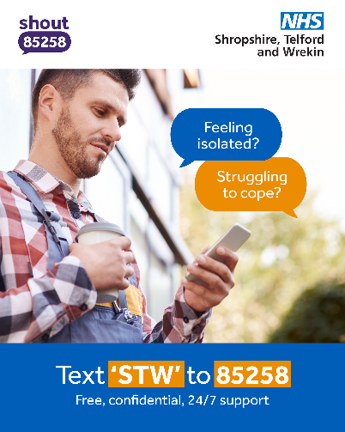 | Finding it hard to talk? You don’t have to pick up the phone.  Text ‘STW’ to 85258 for confidential support that fits around you.  Shout is free and available 24/7.  Learn more: https://bit.ly/STWShout
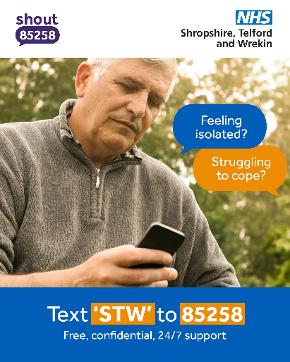 | Struggling but keeping it to yourself? Many men do, but you don’t have to. ‍️‍️‍️  If you’re feeling low, stressed or finding it hard to cope, support is just a text away.  Text ‘STW’ to 85258 for free, anonymous, confidential help. Shout is available 24/7 and easy to use when talking feels tough.  Learn more: https://bit.ly/STWShout

