Pain Diary

Your doctor, nurse or pharmacist will tell you how to take your pain medicine.

This diary is a tool to help you and your healthcare team see if your pain medicine is working well for you.

How to use this diary
- Fill it in every time you take your pain medicine, or at least twice a day.
- When you write down your pain level, use the pain scale to help you choose the number that best matches how you feel.
- First, write down your pain level just before you take your medicine.
- Then take your medicine as you were told.
- After 30–60 minutes, check your pain again and write down your new pain level.

This helps you and your healthcare team understand how your pain changes and what support you might need next.

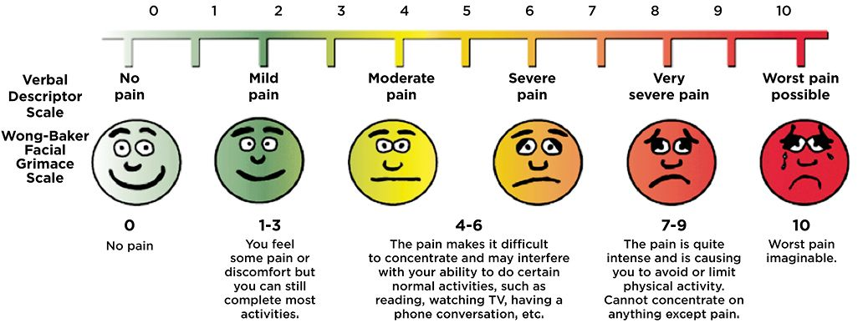

Keep a note of any side effects you notice from your pain medicine. Side effects are changes in your body that happen because of the medicine, such as feeling sick, feeling sleepy, or getting a headache.

Also write down how your pain affects your everyday activities. This could include things like:
- Stopping you from doing something you enjoy
- Making it hard to walk as far as you normally do
- Making school, hobbies or chores more difficult

Bring your diary to your next appointment
Take your completed pain diary to your next pain appointment. You and your doctor, nurse or pharmacist will look at what you have written. This helps them decide if your pain medicine is working well for you or if anything needs to change.

Date and time | Medicine name and amount taken | Pain level before medicine | Pain level after medicine | Any side effects? What are they? | Is pain stopping me doing things? How? | Did pain wake me up or stop me sleeping?
/ /

____am

____pm
/ /

____am

____pm
/ /

____am

____pm
/ /

____am

____pm
/ /

____am

____pm
/ /

____am

____pm
/ /

____am

____pm
/ /

____am

____pm

Date and time | Medicine name and amount taken | Pain level before medicine | Pain level after medicine | Any side effects? What are they? | Is pain stopping me doing things? How? | Did pain wake me up or stop me sleeping?
/ /

____am

____pm
/ /

____am

____pm
/ /

____am

____pm
/ /

____am

____pm
/ /

____am

____pm
/ /

____am

____pm
/ /

____am

____pm
/ /

____am

____pm

Date and time | Medicine name and amount taken | Pain level before medicine | Pain level after medicine | Any side effects? What are they? | Is pain stopping me doing things? How? | Did pain wake me up or stop me sleeping?
/ /

____am

____pm
/ /

____am

____pm
/ /

____am

____pm
/ /

____am

____pm
/ /

____am

____pm
/ /

____am

____pm
/ /

____am

____pm
/ /

____am

____pm

