Referring patients to Community Pharmacy via EMIS Web Local Services

Why this matters:

High blood pressure is often symptomless, yet early detection significantly reduces the risk of stroke, heart disease, and kidney damage.

Community pharmacies are embedded in local neighbourhoods, close to where people live and work. They provide patients with an additional, convenient option for accessing healthcare services outside of the GP practice.

Consultations take place in private rooms with trained healthcare professionals, giving patients a comfortable and professional setting. Referring through EMIS also means patients can be booked in directly, reducing unnecessary waits and easing demand on GP appointments.

How to make a referral:

Referring patients is quick and simple:

Use the ’Local Services’ button in EMIS Web.

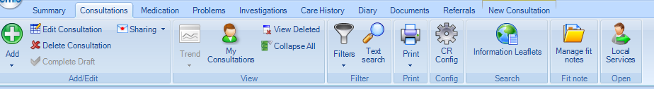

Select the service you wish to refer to.

The patient’s postcode will be pre-populated and will display local pharmacy providers that offer that service. Select the patient’s preferred pharmacy.

The ‘Create referral’ template will appear pre-populated. Enter the condition the referral relates to e.g. blood pressure check. The optional more details box can be used to add further details such as *‘advised to attend pharmacy’*. Click ‘Create referral’.



The referral is sent electronically to the chosen community pharmacy.

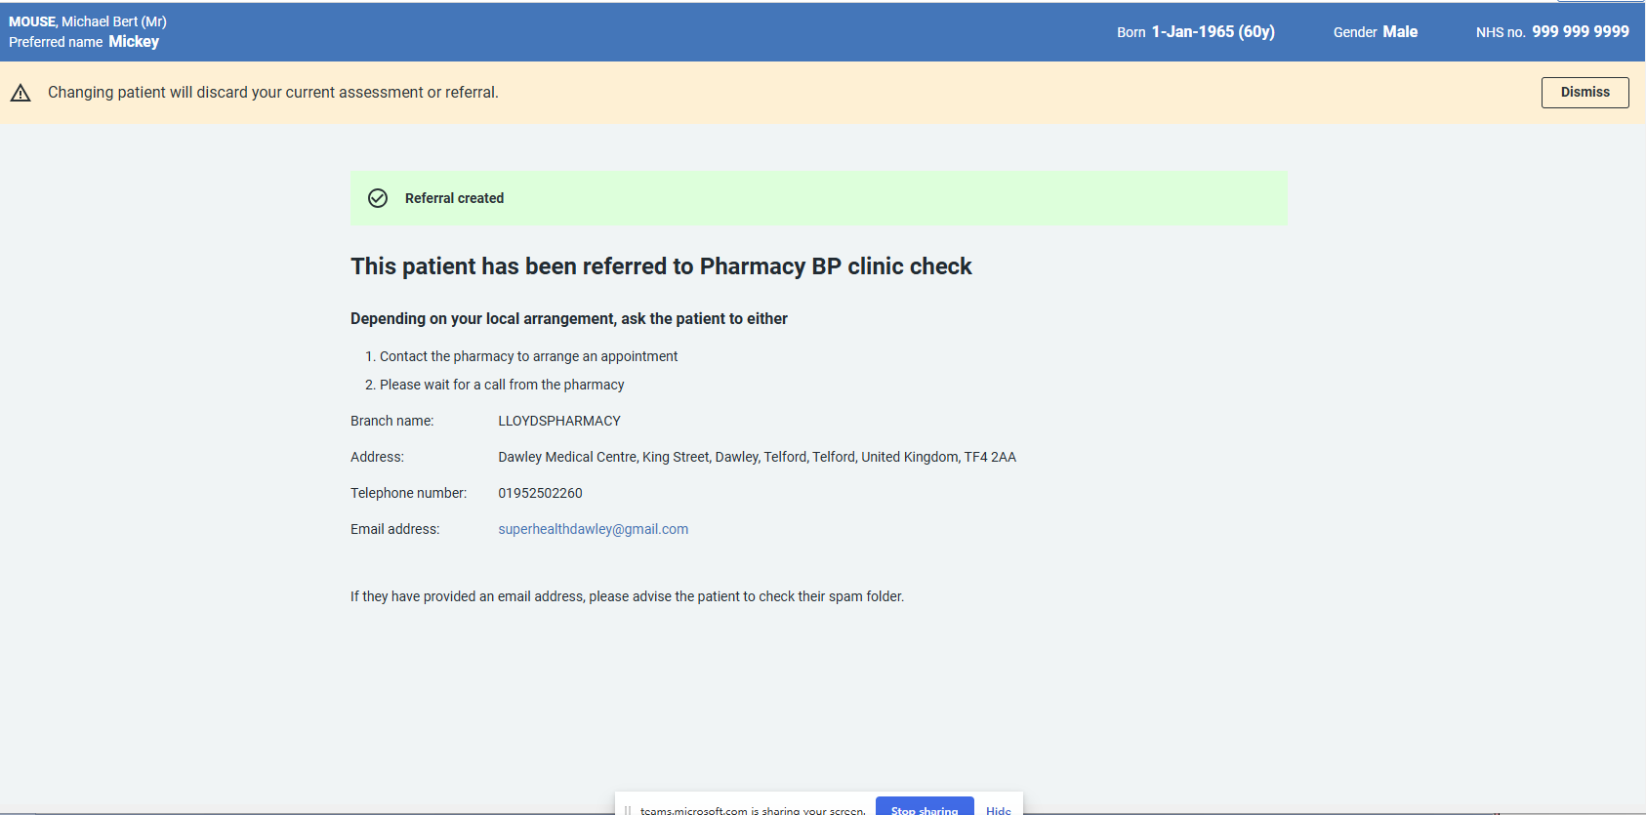

What happens next

* Patients should be informed about the referral — see note below.
* After referral, patients attend their chosen community pharmacy.
* From 1 October, results will flow back automatically flow back to EMIS Web as structured data via GP Connect. Until then, results may be shared using existing local processes.

**Note:** Practices should link in with their local pharmacy teams, so everyone is clear on the agreed referral process.

Practices and pharmacies should also agree locally how patients will be informed about referrals, to ensure communication is clear and consistent. For example, some practices may choose to send an AccuRx message to the patient, while in other cases the pharmacy may contact the patient directly if there is a clinical need.

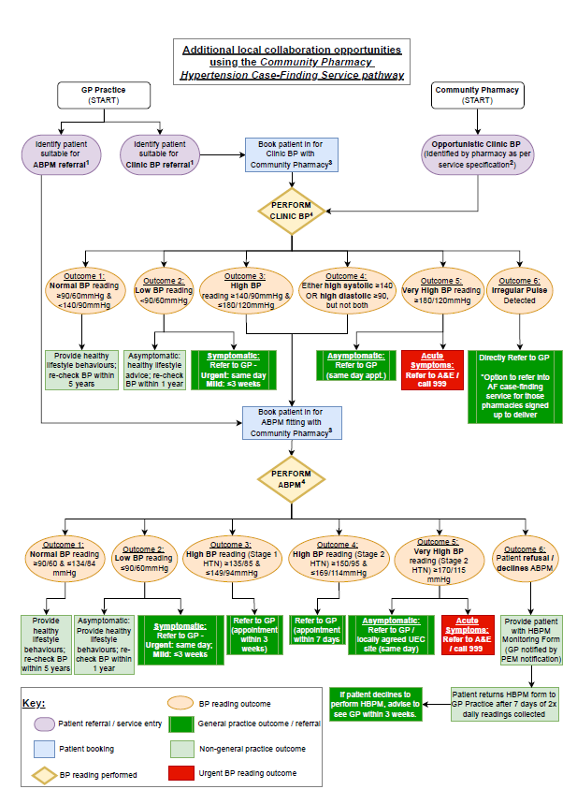

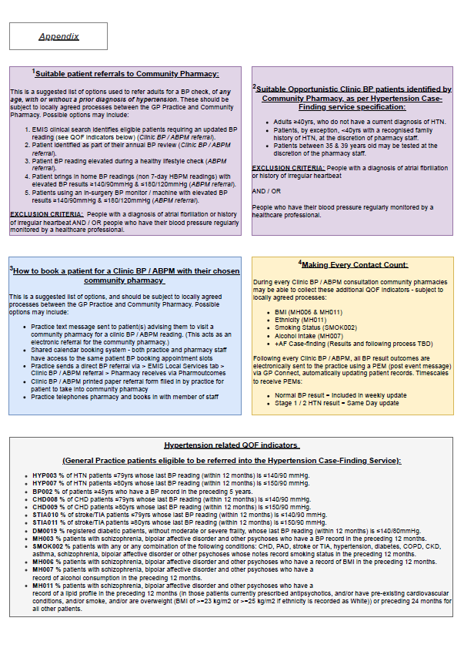

Benefits for practices

Referring patients through EMIS Web ‘Local Services’ offers several advantages:

Saves GP time on appointments:  
Referring patients to pharmacy services frees up GP team capacity, allowing practices to focus on more complex cases. This supports improving access to GP appointments for those who need them most.

Supports QOF hypertension indicators (2025–26):  
Pharmacy referrals increase opportunities for patients to have their blood pressure measured and managed, helping practices work towards HYP008 and HYP009 control targets.

Expands access for patients across the community:  
Pharmacies are embedded in local neighbourhoods and provide an additional access point for care. Patients benefit from more choice in where they are seen, often closer to home, in private consultation rooms with trained healthcare professionals.  
  
**Supports local priorities (STW MQCF):**  
Referrals align with the **STW Medicines Quality and Commissioning Framework (MQCF) 2025-26,** helping practices deliver on local quality improvement and commissioning priorities.

Further information:

* [NHS Community Blood Pressure Check Service Specification](https://www.england.nhs.uk/publication/advanced-service-specification-nhs-community-pharmacy-hypertension-case-finding-advanced-service/)
* [NHS Community Pharmacy Contraception Service Specification](https://www.england.nhs.uk/publication/nhs-pharmacy-contraception-service/)
* [NHS Community Pharmacy First Service Specification](https://www.england.nhs.uk/publication/community-pharmacy-advanced-service-specification-nhs-pharmacy-first-service/)
* For queries, contact: **stw.motqueries@nhs.net**