The Big Health and Wellbeing Conversation - Suggested Social Media Posts
Generic posts
Image | Twitter | Facebook / LinkedIn
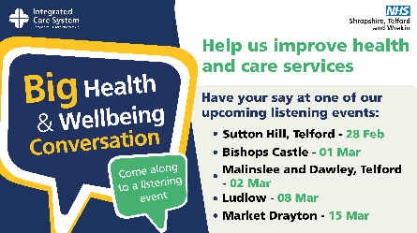 | @NHSSTW is holding community listening events to hear the views of residents to help improve local health & care services. They will discuss hospital services, GP access, care services & much more. 🗨️  Have your say at a FREE event ➡️: www.nhsbigconversation.org  #STWBigConvo | Between March and May 2023, @NHS STW will be holding a number of community listening events, to hear the views of residents.  Feedback from these events will help to improve local health and care services. They will be discussing hospital services, GP access, care services, public health services and much more. 🗨️  Have your say on how the local NHS works and attend one of the FREE events ➡️: www.nhsbigconversation.org  #STWBigConvo
 | Have your say! Join the Big Health and Wellbeing Conversation 🗨️  Your feedback will help the NHS to improve local services.  Find out more and register for a FREE listening event near you ➡️: www.nhsbigconversation.org  #STWBigConvo | Take part in the Big Health and Wellbeing Conversation and help the NHS improve health and care services in your local area! 🗨️  Come along and share your views at one of our listening events – they're open to everyone! Find out more and register for a FREE event near you ➡️: www.nhsbigconversation.org  #STWBigConvo
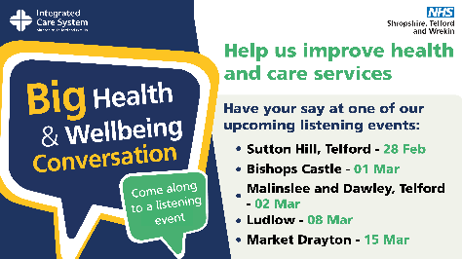 | Waiting times, community hospitals, GP access, travel to appointments and A&E are just some of the topics covered by the Big Health and Wellbeing Conversation 🗨️  Have your say on how the local NHS works by attending one of the FREE listening events ➡️: www.nhsbigconversation.org  #STWBigConvo | Waiting times, community hospitals, GP access, travel to appointments and A&E are just some of the topics covered by the Big Health and Wellbeing Conversation 🗨️  Have your say on how the local NHS works by attending one of the FREE listening events➡️: www.nhsbigconversation.org  #STWBigConvo
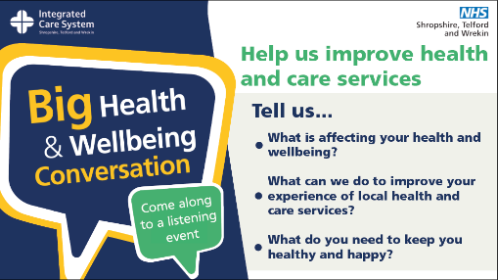 | Would you rather travel further for a specialist appt, but be seen quicker, or wait longer, but be seen locally?  This is one of the Qs @NHSSTW is asking at the Big Health and Wellbeing Conversation listening events.  Have your say and register for a FREE event:➡️: www.nhsbigconversation.org | Would you rather travel further for a specialist appt, but be seen quicker, or wait longer, but be seen locally?  This is one of the Qs @NHS STW will be asking at the Big Health and Wellbeing Conversation listening events.  Have your say and register for a FREE event:➡️: www.nhsbigconversation.org  #STWBigConvo
Video - tbc | The local NHS wants to hear your views on the future of NHS services. Watch this video to find out what it’s all about.  #STWBigConvo

Suggested hashtag:
#STWBigConvo
Sutton Hill – Tuesday 28 February
Image | Twitter | Facebook / LinkedIn
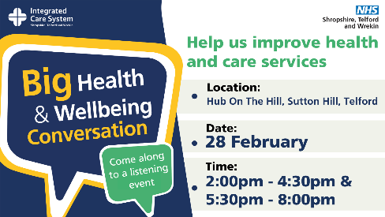 | Have your say! Join the Big Health and Wellbeing Conversation 🗨️  Your feedback will help the NHS to improve local services.  Find out more and register for a listening event in Sutton Hill, Telford: www.nhsbigconversation.org | Help us improve your local health and care services - Tell us what you think!  Have you or someone you care for used GP or hospital services recently? What was your experience?  Come along and share your views at a listening event at Hub On The Hill, Sutton Hill, Telford on Tuesday 28 February - it’s FREE and open to everyone!  These are your service so your voice matters.  Find out more and register: www.nhsbigconversation.org
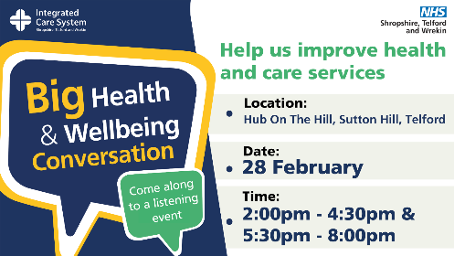 | Have your say! Less than 24 hours to go until our Big Conversation listening events in Sutton Hill.  This is your chance to share your views on health and care services and influence future plans.  To find out more and register for the events: www.nhsbigconversation.org

Bishops Castle – 1 March
Image | Twitter | Facebook / LinkedIn
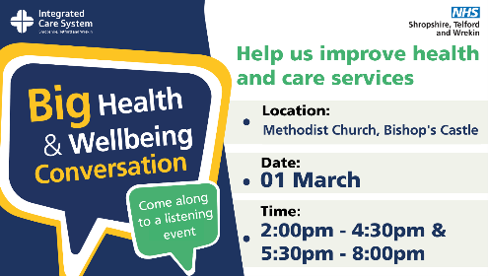 | Have your say! Join the Big Health and Wellbeing Conversation 🗨️  Your feedback will help the NHS to improve local services.  Find out more and register for a listening event in Bishops Castle: www.nhsbigconversation.org | Help us improve your local health and care services - Tell us what you think!  Have you or someone you care for used GP or hospital services recently? What was your experience?  Come along and share your views at a listening event at Methodist Church, Bishops Castle on Wednesday 01 March - it’s FREE and open to everyone!  These are your service so your voice matters.  Find out more and register: www.nhsbigconversation.org
Have your say! Less than 24 hours to go until our Big Conversation listening events in Bishops Castle.

This is your chance to share your views on health and care services and influence future plans.

To find out more and register: www.nhsbigconversation.org

Malinslee and Dawley – 2 March
Image | Twitter | Facebook / LinkedIn
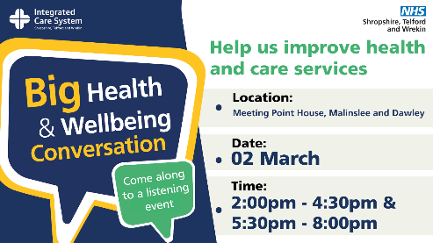 | Have your say! Join the Big Health and Wellbeing Conversation 🗨️  Your feedback will help the NHS to improve local services.  Find out more and register for listening events in Malinslee and Dawley: www.nhsbigconversation.org | Help us improve your local health and care services - Tell us what you think!  Have you or someone you care for used GP or hospital services recently? What was your experience?  Come along and share your views at a listening event at Meeting Point House, Telford on Thursday 02 March - it’s FREE and open to everyone!  These are your service so your voice matters.  Find out more and register: www.nhsbigconversation.org
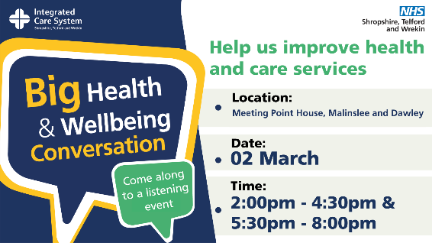 | Have your say! Less than 24 hours to go until our Big Conversation events in Malinslee and Dawley.  This is your chance to share your views on health and care services and influence future plans.  To find out more and register for a listening event: www.nhsbigconversation.org

Ludlow – Wednesday 8 March
Image | Twitter | Facebook / LinkedIn
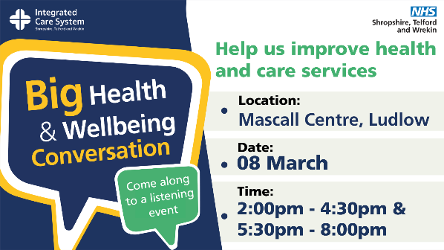 | Have your say! Join the Big Health and Wellbeing Conversation in Ludlow 🗨️  Your feedback will help the NHS to improve local services.  Find out more and register for a listening event in Ludlow: www.nhsbigconversation.org | Help us improve your local health and care services - Tell us what you think!  Have you or someone you care for used GP or hospital services recently? What was your experience?  Come along and share your views at a listening event at Mascall Centre, Ludlow on Wednesday 08 March - it’s FREE and open to everyone!  These are your service so your voice matters.  Find out more and register: www.nhsbigconversation.org
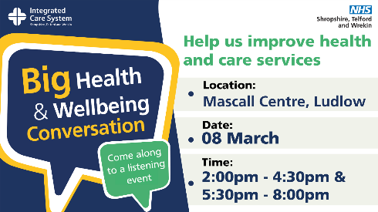 | Have your say! Less than 24 hours to go until our Big Conversation events in Ludlow.  This is your chance to share your views on health and care services and influence future plans.  To find out more and register for a listening event: www.nhsbigconversation.org

Market Drayton – Wednesday 15 March
Image | Twitter | Facebook / LinkedIn
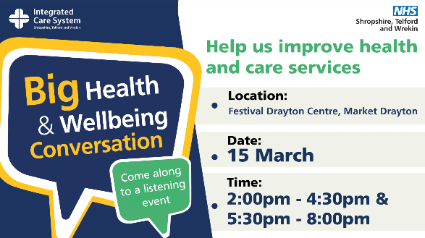 | Have your say! Join the Big Health and Wellbeing Conversation 🗨️  Your feedback will help the NHS to improve local services.  Find out more and register for a listening event in Market Drayton: www.nhsbigconversation.org | Help us improve your local health and care services - Tell us what you think!  Have you or someone you care for used GP or hospital services recently? What was your experience?  Come along and share your views at a listening event at Festival Drayton Centre, Market Drayton on Wednesday 15 March - it’s FREE and open to everyone!  These are your service so your voice matters.  Find out more and register: www.nhsbigconversation.org
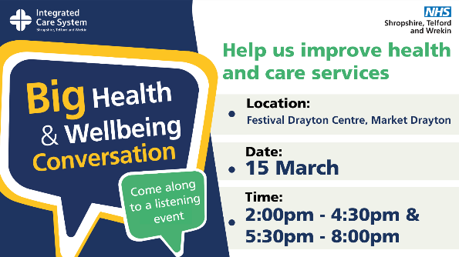 | Have your say! Less than 24 hours to go until our Big Conversation listening events in Market Drayton.  This is your chance to share your views on health and care services and influence future plans.  To find out more and register for an event: www.nhsbigconversation.org
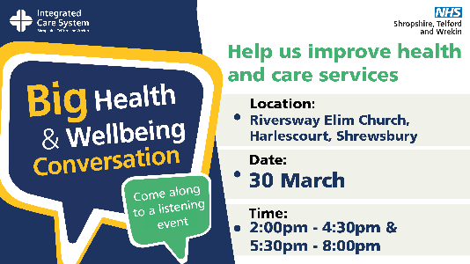 | Have your say! Join the Big Health and Wellbeing Conversation 🗨️  Your feedback will help the NHS to improve local services.  Find out more and register for a listening event in Shrewsbury: www.nhsbigconversation.org | Help us improve your local health and care services - Tell us what you think!  Have you or someone you care for used GP or hospital services recently? What was your experience?  Come along and share your views at a listening event at Riversway Elim Church, Shrewsbury on Thursday 30 March - it’s FREE and open to everyone!  These are your service so your voice matters.  Find out more and register: www.nhsbigconversation.org
Have your say! Less than 24 hours to go until our Big Conversation listening events in Shrewsbury

This is your chance to share your views on health and care services and influence future plans.

To find out more and register for an event: www.nhsbigconversation.org

