Mental Health Awareness Week 2026 – Orange Button Social Media Copy
Link to page: https://www.shropshiretelfordandwrekin.nhs.uk/your-health/where-to-get-advice-and-help/mental-health-services/orange-button-community-scheme/

Post 1: Launch post

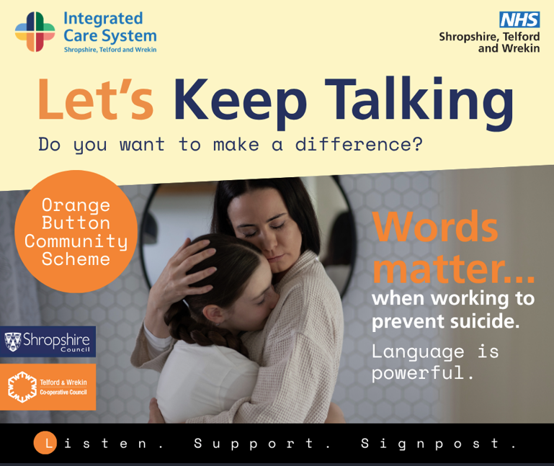

Facebook

This Mental Health Awareness Week (11–17 May), the theme is Action — because awareness is vital, but change happens when we do something.

One simple action we can all take is using supportive language and helping people find the next step when they’re struggling.

🧡 The Orange Button Community Scheme helps make support more visible in our communities, so people know they’re not alone.

Listen. Support. Signpost.
Let’s keep talking.

For more info➡️ https://www.shropshiretelfordandwrekin.nhs.uk/your-health/where-to-get-advice-and-help/mental-health-services/orange-button-community-scheme/

#MHAW2026 #TakeAction #MentalHealthAwarenessWeek #SuicidePrevention #OrangeButton #LetsKeepTalking #CommunitySupport

Instagram
This Mental Health Awareness Week (11–17 May), the theme is Action — because awareness is vital, but change happens when we do something.
One action we can all take is to use supportive language and help people find the next step.
🧡 The Orange Button Community Scheme helps make support more visible in our communities.
Listen. Support. Signpost.
Let’s keep talking.
#MHAW2026 #TakeAction #SuicidePrevention #KindWords #CommunityCare #OrangeButton

X (Twitter)

This Mental Health Awareness Week (11–17 May), the theme is Action.
Awareness matters — but change happens when we do something.

🧡 The Orange Button Community Scheme makes support more visible.
Listen. Support. Signpost.
Let’s keep talking.

For more info➡️ [insert link]

#MHAW2026 #TakeAction #MentalHealth #OrangeButton

You can also learn how to support others through Orange Button training:

LinkedIn
This Mental Health Awareness Week (11–17 May), the theme is Action — recognising that while awareness is vital, real change happens when we take practical steps.
One meaningful action is choosing our words carefully, listening with compassion, and helping people access the right support at the right time.
🧡 The Orange Button Community Scheme helps make support more visible within our communities.
Listen. Support. Signpost.
Let’s keep talking.
For more info -> [ICB link]
#MHAW2026 #ActionForMentalHealth #MentalHealthAwarenessWeek #SuicidePrevention #OrangeButton #CommunityWellbeing #LetsKeepTalking

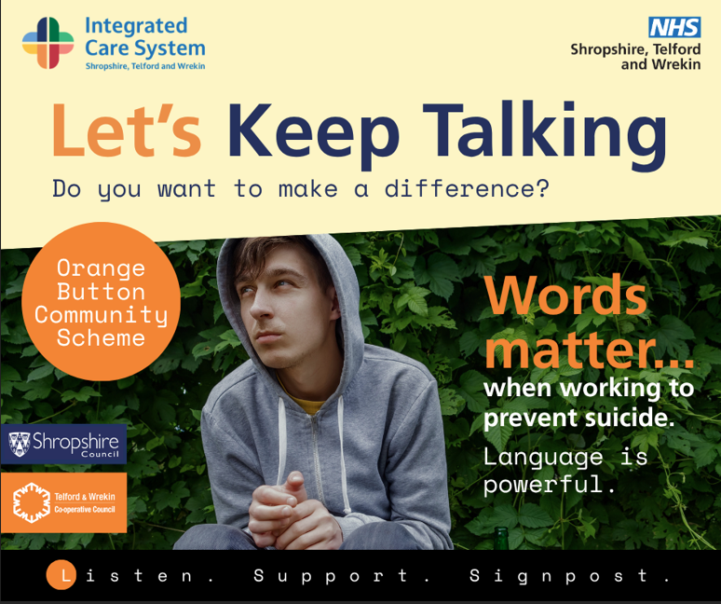
Post2: Let’s keep talking

Facebook
Let’s keep talking.
When it comes to preventing suicide, simple, supportive conversations can make a difference.
The Orange Button Community Scheme helps people feel more confident to listen, support and signpost if someone may be struggling.
During Mental Health Awareness Week (11–17 May 2026), local residents and organisations are encouraged to get involved:
For more info: [insert link to ICB website]
If you need support now, help is available.

Instagram
Let’s keep talking.
Words matter when working to prevent suicide - and talking is one action we can all take.
The Orange Button Community Scheme helps make support more visible in our communities.
Listen. Support. Signpost.
Find out more via the link in our bio.
#MHAW2026

X (Twitter)
Let’s keep talking.
Supportive conversations are an action we can all take to help prevent suicide.
The Orange Button Community Scheme helps people feel confident to listen, support and signpost.
Find out more: [link] #MHAW2026
LinkedIn
Let’s keep talking.
Suicide prevention relies on more than services alone - supportive conversations in communities and workplaces matter.
During Mental Health Awareness Week (11–17 May 2026), organisations and individuals are encouraged to take action.
The Orange Button Community Scheme helps people feel confident to listen, support and signpost when someone may need help.
Find out how to get involved locally: [link]

Post 3: Words matter

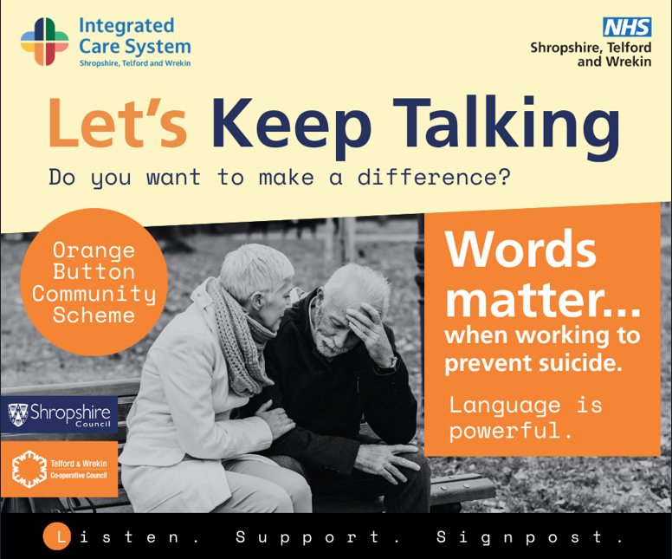

Facebook
Words matter when working to prevent suicide.
Language can help reduce stigma, encourage conversations and help people feel less alone.
During Mental Health Awareness Week (11–17 May), we’re encouraged to take action and one simple action we can all take is choosing words that are supportive, compassionate and safe.
The Orange Button Community Scheme provides training so people can respond safely and compassionately.
Find out more about training in your area: [link]

Instagram

Words matter.
Language is powerful — and choosing supportive words is an action we can all take.

Small, compassionate conversations can help people feel heard, supported and less alone.

🧡 Mental Health Awareness Week (11–17 May)
Let’s keep talking.

#MHAW2026 #WordsMatter #LetsKeepTalking

X (Twitter)

Words matter.
Language can open conversations, reduce stigma and support suicide prevention.

During Mental Health Awareness Week, taking action can be as simple as choosing compassionate words.

Find out how the Orange Button Community Scheme supports safer conversations: [link]
#MHAW2026

LinkedIn

Language plays an important role in suicide prevention.
The words we choose can help people feel seen, heard and supported — and that makes language a powerful form of action.

During Mental Health Awareness Week (11–17 May 2026), organisations and individuals are encouraged to take practical steps to support mental health.

🧡 The Orange Button Community Scheme provides training to support safe, compassionate conversations across Shropshire, Telford and Wrekin.

Learn more: [link]

Post 4: Listen. Support. Signpost.

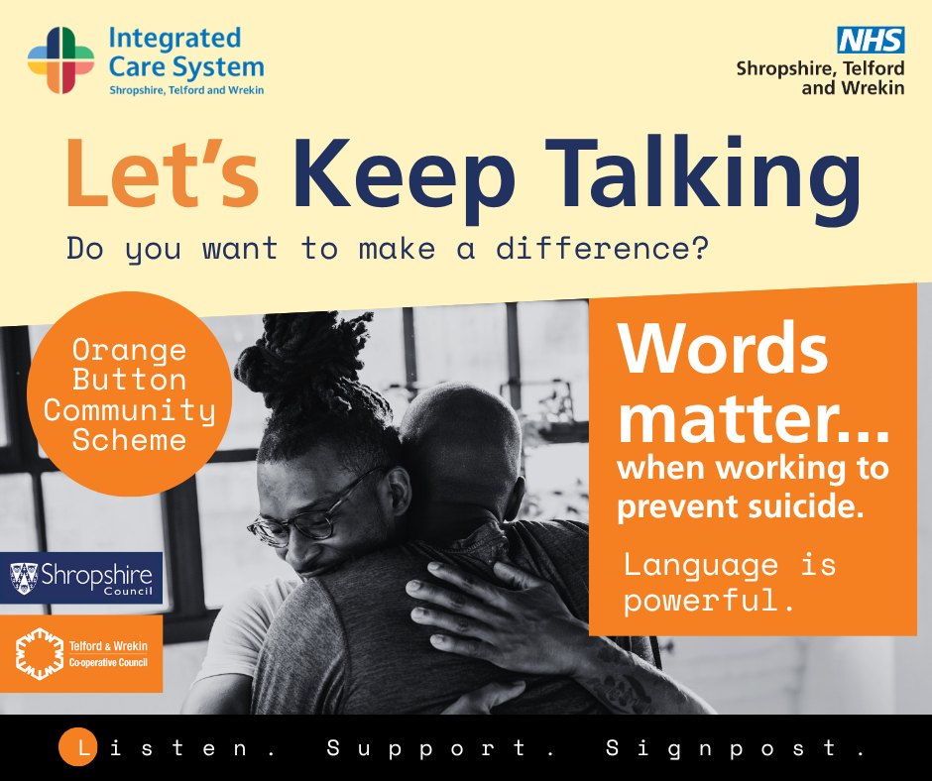

Facebook
Listen. Support. Signpost.

Three simple actions that can make a difference when someone is struggling.

During Mental Health Awareness Week (11–17 May), we’re encouraged to take action to support mental health in our communities.
One way to do that is being ready to listen and help someone find the right support.

🧡 The Orange Button Community Scheme helps people feel prepared to respond if someone shares concerns about their mental health or suicidal thoughts.
Orange Button holders are not counsellors — they are trained to listen, offer support and help people access appropriate services.

Find out more: [link]

Instagram
Listen.
Support.
Signpost.
Sometimes knowing you can talk – and be listened to - makes all the difference.
This Mental Health Awareness Week (11–17 May), taking action can start with these three simple steps.
🧡 Let’s keep talking.
#MHAW2026 #ListenSupportSignpost #MentalHealthAwarenessWeek

X (Twitter)
Listen. Support. Signpost.
These are simple actions that support suicide prevention in local communities.
During Mental Health Awareness Week, the Orange Button Community Scheme supports community-based suicide prevention across Shropshire, Telford and Wrekin.
Find out more: [link]
#MHAW2026

LinkedIn

The Orange Button Community Scheme focuses on three simple but powerful actions: listening, supporting and signposting.

During Mental Health Awareness Week (11–17 May 2026), organisations and individuals are encouraged to take practical action to support mental health alongside health and care services.

Orange Button training helps people feel confident to respond appropriately when someone may need support.

Find out more: [link]

Post 5: Community support matters

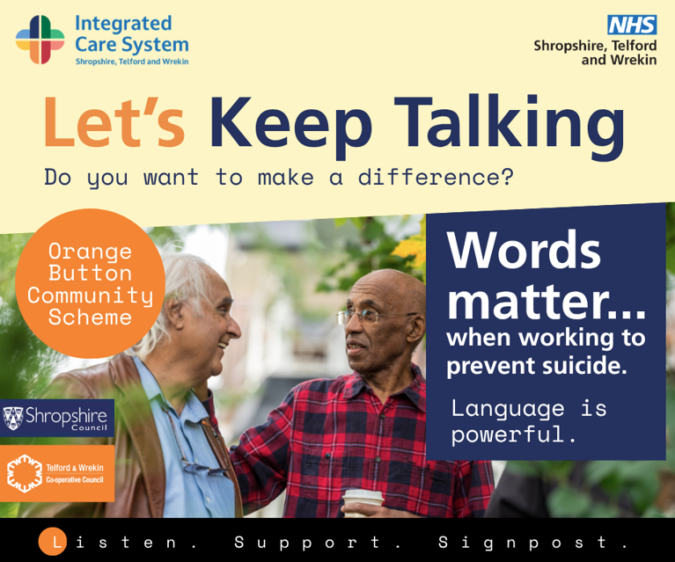

Facebook
Suicide prevention is not something services can do alone.
During Mental Health Awareness Week (11–17 May), we’re reminded that action in our communities matters.
The Orange Button Community Scheme helps build visible, community based support across Shropshire, Telford and Wrekin - supporting people to listen, respond and help others access the right support.
Together, small actions can make a difference.
Find out more: [link]

Instagram
Support can start anywhere.
In communities. In workplaces. In everyday conversations.
Find out more about the Orange Button Community Scheme.
This Mental Health Awareness Week, taking action can mean being ready to support one another.
🧡 Find out more about the Orange Button Community Scheme.
#MHAW2026 #CommunitySupport #TakeAction

X (Twitter)
Community support plays an important role in suicide prevention.
During Mental Health Awareness Week, taking action includes building visible, local support.
The Orange Button Community Scheme helps make community support more visible across Shropshire, Telford and Wrekin.
[link]
#MHAW2026

LinkedIn
Community based suicide prevention plays a vital role alongside clinical services.
During Mental Health Awareness Week (11–17 May 2026), organisations and individuals are encouraged to take action to support mental health in their communities and workplaces.
The Orange Button Community Scheme supports individuals and organisations to respond confidently when someone may be struggling.
Learn more: [link]

