Crisis mental health access via NHS 111
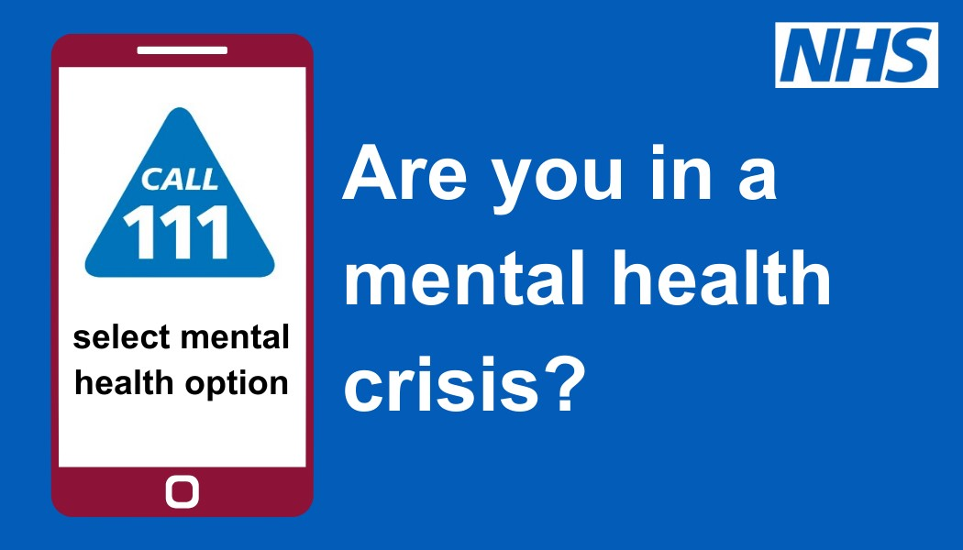
Examples of Tweets

Below are some examples of tweets you may wish to use on your channel. Fill in the blanks which your own area’s information. There are also banners included in the pack of visuals that accompanies this toolkit.

- If you’re in a #mentalhealth crisis in Shropshire, Telford and Wrekin you can now call 111 and select the mental health option to talk to a mental health professional and get help 24/7.

- It’s hard to know who to talk to if you’re in a mental health crisis. You can now call 111 and select the mental health option to get help 24/7 from a mental health professional in Shropshire, Telford and Wrekin.

- If you find yourself in a mental health crisis, it can be difficult to know what to do. Help is available – just call 111 and select the mental health option for urgent mental health support.

- Need urgent support for your mental health? Call 111 and select the mental health option to talk to a mental health professional in Shropshire, Telford and Wrekin.

- NHS Shropshire, Telford and Wrekin offers 24/7 mental health crisis support over the phone for all ages. Call 111 and select the mental health option to speak to a mental health professional.

