How to Update Your Outlook Signature with the New ‘Everyone Belong Here’ Banner
Step 1: Download the banner image and save it to your PC
- Right-click the banner image provided to you.
- Select "Save As" and save it to a location on your computer you can easily access (e.g. Desktop or Pictures Folder).

Step 2: Open Outlook Signature Settings
- Open Outlook.
- Click File (top left).
- Choose Options from the menu.
- In the Outlook Options window, select Mail.
- Click the Signatures… button on the right.

Step 3: Edit Your Signature
- In the Email Signature window, choose the signature you want to update – typically this will be the one under your own name, or create a new one by clicking New).
- Place your cursor where you want the banner to appear (for ICB staff this should be below the email address and social media icons, and above the ICS and ICB logos – shown below. For ICS colleagues, please follow the same format for your own organisations)

Step 4: Insert the Banner
- Click the Image icon (looks like a picture) in the signature editor toolbar.
- Browse to where you saved the banner image.
- Select the image and click Insert.

Step 5: Adjust and Finalise
- Make sure the banner is positioned correctly. We have provided an example of how this should look at the end of this document (NHS STW specific).
- Once done, click OK to save your changes.
- Click OK again to close the Options window.

Step 6: Test It
- Start a new email to check how your updated signature looks.
- Ensure the banner appears correctly and the rest of your signature is intact.

Example of how the banner should look on your email signature:

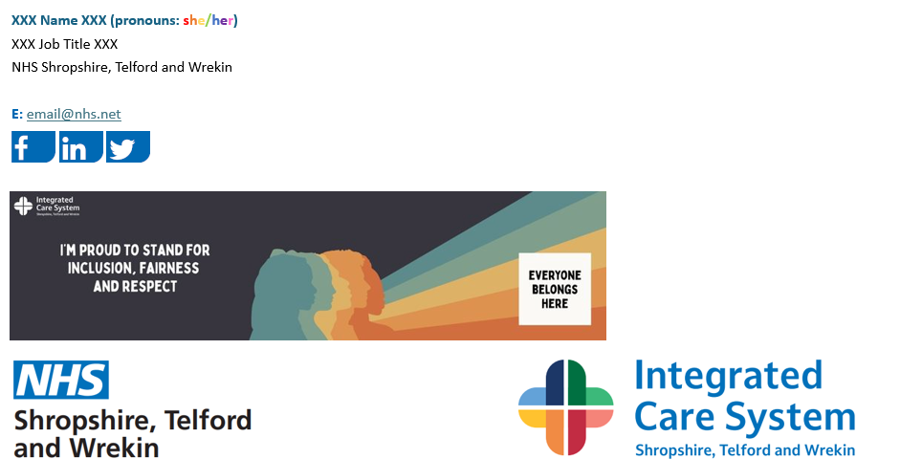

ENDS

