Image | Twitter | Facebook/LinkedIn
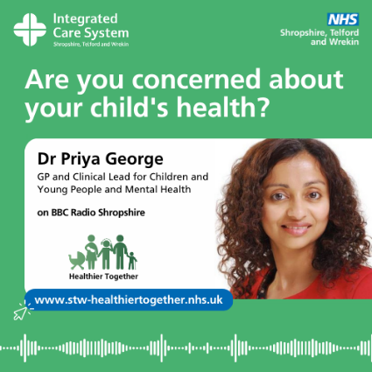 | Listen to Dr Priya George speak about the new NHS Shropshire, Telford and Wrekin Healthier Together website on BBC Shropshire 📢 Find out more ➡️ www.stw-healthiertogether.nhs.uk #NHS #STWHealthierTogether | Listen to Dr Priya George speak about the new NHS Shropshire, Telford and Wrekin Healthier Together website on BBC Shropshire 📢  💬 "The Shropshire, Telford and Wrekin Healthier Together website is an incredible local tool for healthcare colleagues, families and patients. It is a single resource for anyone concerned about childhood illnesses, and even has the functionality to send text messages to the patient, parent or carer - easily giving them the information they need"  Find out more ➡️ www.stw-healthiertogether.nhs.uk #NHS #STWHealthierTogether
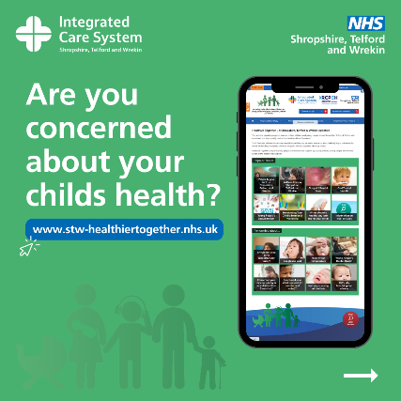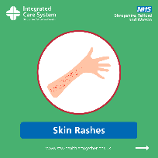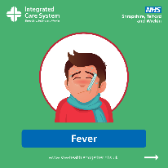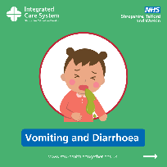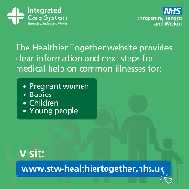  *Can use different images from the carousel library (Front graphic, Illness Graphic/s, End Graphic) | Are you concerned about your child’s health? 🤒 If you have an unwell child at home, Healthier Together can help you access local healthcare support and advice to make the best next decision 👍 ➡️ www.stw-healthiertogether.nhs.uk #NHS #STWHealthierTogether | Are you concerned about your child’s health? 🤒  If you have an unwell child at home, NHS Shropshire, Telford and Wrekin  Healthier Together can help you access the right local healthcare support and advice to make the best next decision 👍➡️ www.stw-healthiertogether.nhs.uk  #NHS #STWHealthierTogether
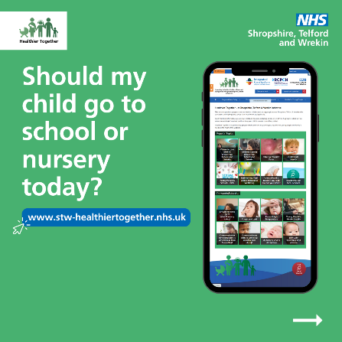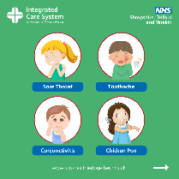*Can use different images from the carousel library (Front graphic, Illness Graphic/s, End Graphic) | Should my child go to school or nursery today? 🤕 If you have an unwell child at home, Healthier Together can help you access local healthcare support and advice to make the best decision 👍 ➡️ www.stw-healthiertogether.nhs.uk #NHS #STWHealthierTogether | Should my child go to school or nursery today? 🤕  If you have an unwell child at home and you're unsure if they should go to school or nursery, NHS Shropshire, Telford and Wrekin  Healthier Together can help you access the right local healthcare support and advice to make the best decision 👍 ➡️ www.stw-healthiertogether.nhs.uk  #NHS #STWHealthierTogether
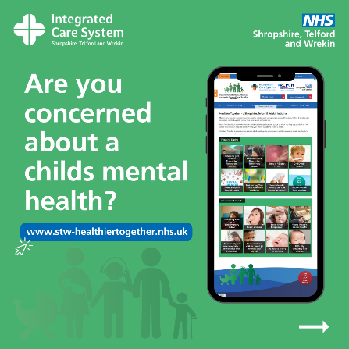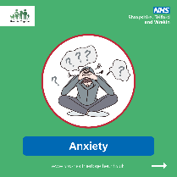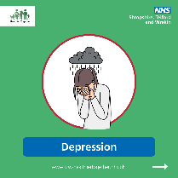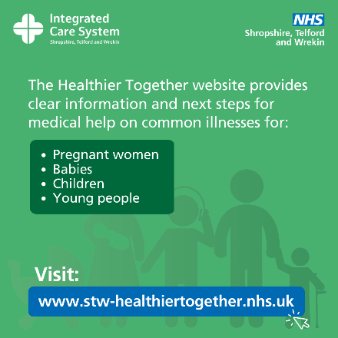*Can use different images from the carousel library (Front graphic, Illness Graphic/s, End Graphic) | Are you concerned about a child’s mental health? 🧠 Knowing when and where to access support for a child or young person can be tricky. We all worry about when to ask for help. Visit Healthier Together for localise support➡️ www.stw-healthiertogether.nhs.uk #NHS #STWHealthierTogether | Are you concerned about a child’s mental health? 🧠 Knowing when and where to access mental health support for a child or young person can be tricky. We all worry about when to ask for help. Visit Healthier Together for localise support and advice ➡️ www.stw-healthiertogether.nhs.uk #NHS #STWHealthierTogether
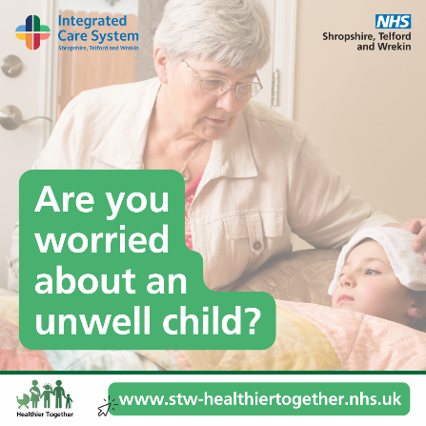 | To help stay in control of a child’s health, visit Shropshire, Telford & Wrekin Healthier Together 🤒 Developed by NHS professionals to provide peace of mind & access to the best healthcare support ➡️ www.stw-healthiertogether.nhs.uk #NHS #STWHealthierTogether | To help you stay in control of a child’s health, visit Shropshire Telford and Wrekin Healthier Together 🤒🤢🤕  Developed by NHS professionals to provide peace of mind and help you access the best Heathcare support ➡️ www.stw-healthiertogether.nhs.uk  #NHS #STWHealthierTogether
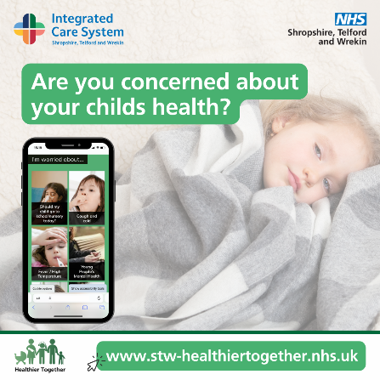 | Having an unwell child can often be stressful 🤕 Finding concise, reliable information on managing their illness is tricky at times. Visit Healthier Together today for NHS support to help manage your child’s health️ ➡️ www.stw-healthiertogether.nhs.uk  #NHS #STWHealthierTogether | Having an unwell child can often be stressful 🤕 Finding concise, reliable information on managing their illness is tricky at times.  The new NHS Shropshire, Telford and Wrekin  Healthier Together website is now available for NHS support to help you manage your child’s health right there, on your phone, when needed ➡️ www.stw-healthiertogether.nhs.uk  #NHS #STWHealthierTogether
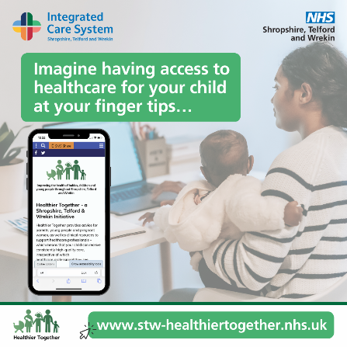 | Imagine having access to healthcare for your child at your fingertips…💻The new Healthier Together website gives you easy access to NHS traffic light symptom guidelines 🚦 so you know where to go for medical help if needed➡️ www.stw-healthiertogether.nhs.uk #NHS #STWHealthierTogether | Imagine having access to healthcare for your child at your fingertips…💻  The new NHS Shropshire, Telford and Wrekin  Healthier Together website gives you easy access to NHS traffic light symptom guidelines 🚦 so you know where to go for medical help if needed ➡️ www.stw-healthiertogether.nhs.uk  #NHS #STWHealthierTogether
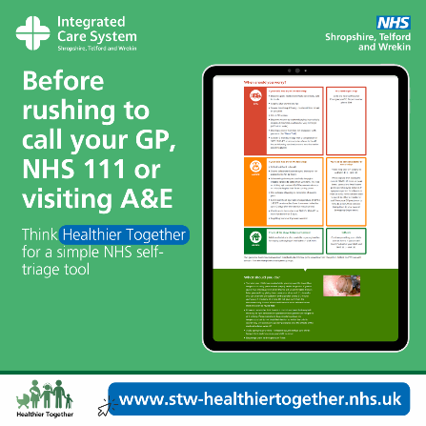 | Before visiting your GP, NHS 111 or A&E, take a moment and think Healthier Together - for a simple NHS self-triage tool that gives red, amber, and green advice on healthcare concerns for babies, children and young adults🚦➡️ www.stw-healthiertogether.nhs.uk #NHS #STWHealthierTogether | Before rushing to call your GP, NHS 111 or visiting A&E, take a moment and think Healthier Together - for a simple NHS self-triage tool 🏥  Healthier Together can give you red, amber, and green advice for healthcare concerns about a child in your care 🚦 meaning you can quickly get the right support from the right place at the right time ➡️ www.stw-healthiertogether.nhs.uk  #NHS #STWHealthierTogether
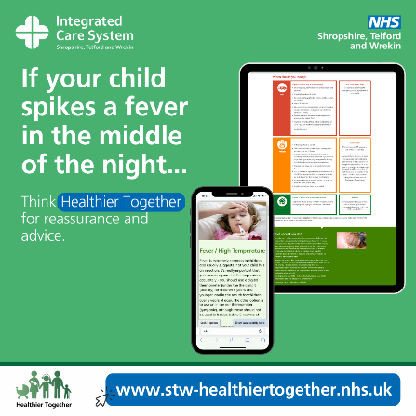 | It’s the middle of the night and your child spikes a fever 🤒 We’ve all been there and asked ourselves when we should be worried. The Healthier Together website provides advice on what to do, based on symptoms ➡️ www.stw-healthiertogether.nhs.uk  #NHS #STWHealthierTogether | It’s the middle of the night and your child spikes a fever 🤒 We’ve all been there and asked ourselves when we should be worried.  The new NHS Shropshire, Telford and Wrekin  Healthier Together website provides simple advice on what to do, based on the symptoms a child is experiencing. Visit the website for reassurance at your fingertips ➡️ www.stw-healthiertogether.nhs.uk  #NHS #STWHealthierTogether
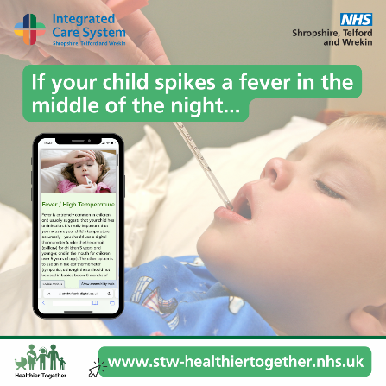 | It’s the middle of the night and your child spikes a fever 🤒 We’ve all been there and asked ourselves when we should be worried. The Healthier Together website provides advice on what to do, based on symptoms ➡️ www.stw-healthiertogether.nhs.uk  #NHS #STWHealthierTogether | It’s the middle of the night and your child spikes a fever 🤒 We’ve all been there and asked ourselves when we should be worried.  The new NHS Shropshire, Telford and Wrekin  Healthier Together website provides simple advice on what to do, based on the symptoms a child is experiencing. Visit the website for reassurance at your fingertips ➡️ www.stw-healthiertogether.nhs.uk  #NHS #STWHealthierTogether
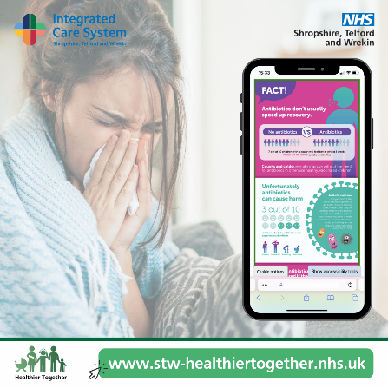 | Are you a young person looking for information and help on how to manage a common illness or mental health ❓ The NHS Healthier Together website can help you with many common physical and mental health illnesses ➡️ www.stw-healthiertogether.nhs.uk  #NHS #STWHealthierTogether | Are you a young person looking for information and help on how to manage a common illness or mental health ❓  The NHS Shropshire, Telford and Wrekin Healthier Together website can help you with many common physical and mental health illnesses ➡️ www.stw-healthiertogether.nhs.uk  #NHS #STWHealthierTogether

