Shropshire, Telford and Wrekin Healthier Together – a new website for families launches

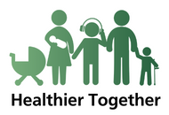
Shropshire, Telford and Wrekin Integrated Care System has launched a new website that provides a singular resource with consistent, accurate and trustworthy healthcare advice for parents, carers, young people and professionals to improve outcomes for children and their families.
Healthier Together is a new tool to help provide information about how to treat children who are unwell. It brings together all the local help available, and signposts where to seek further assistance from health and social care professionals. It also includes a text messaging functionality for people to receive immediate, and easy access to guidance or advice on a particular health concern.
Watch the video to find out more.
The website is available by visiting www.stw-healthiertogether.nhs.uk

