Think Which Service - February 2026
Thunderclap social media Alt text

Image | Alt text
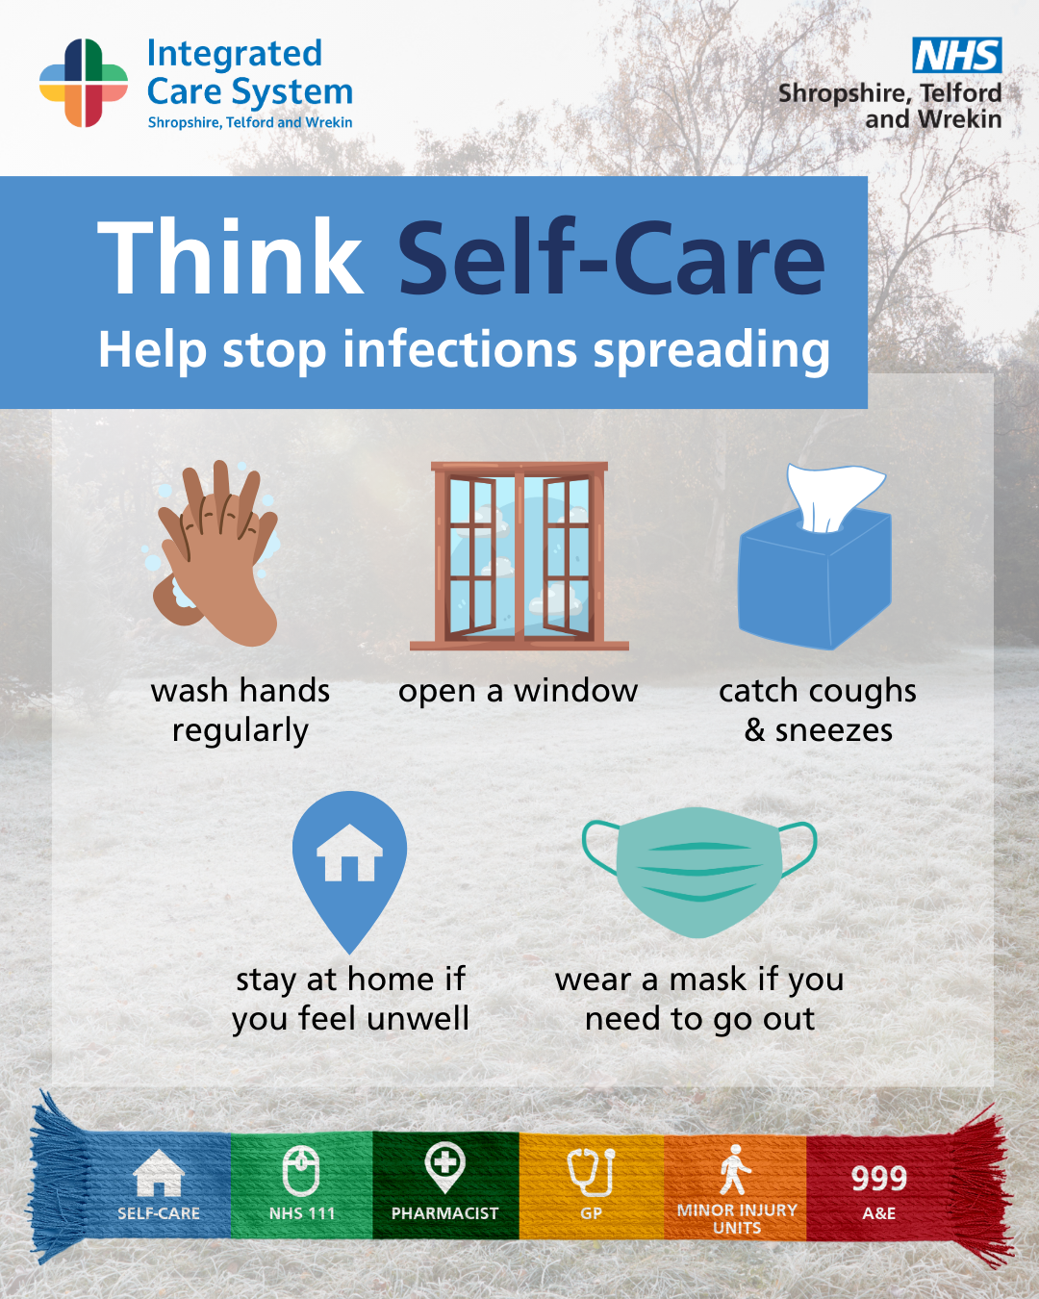 | Infographic with tips to prevent falls: keep hands free, wear shoes with good grip, and avoid going out early when frosty or late at night.
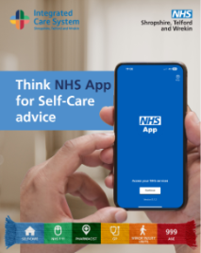 | A phone displaying the NHS App. Text reads: Think NHS App for Self-Care advice.
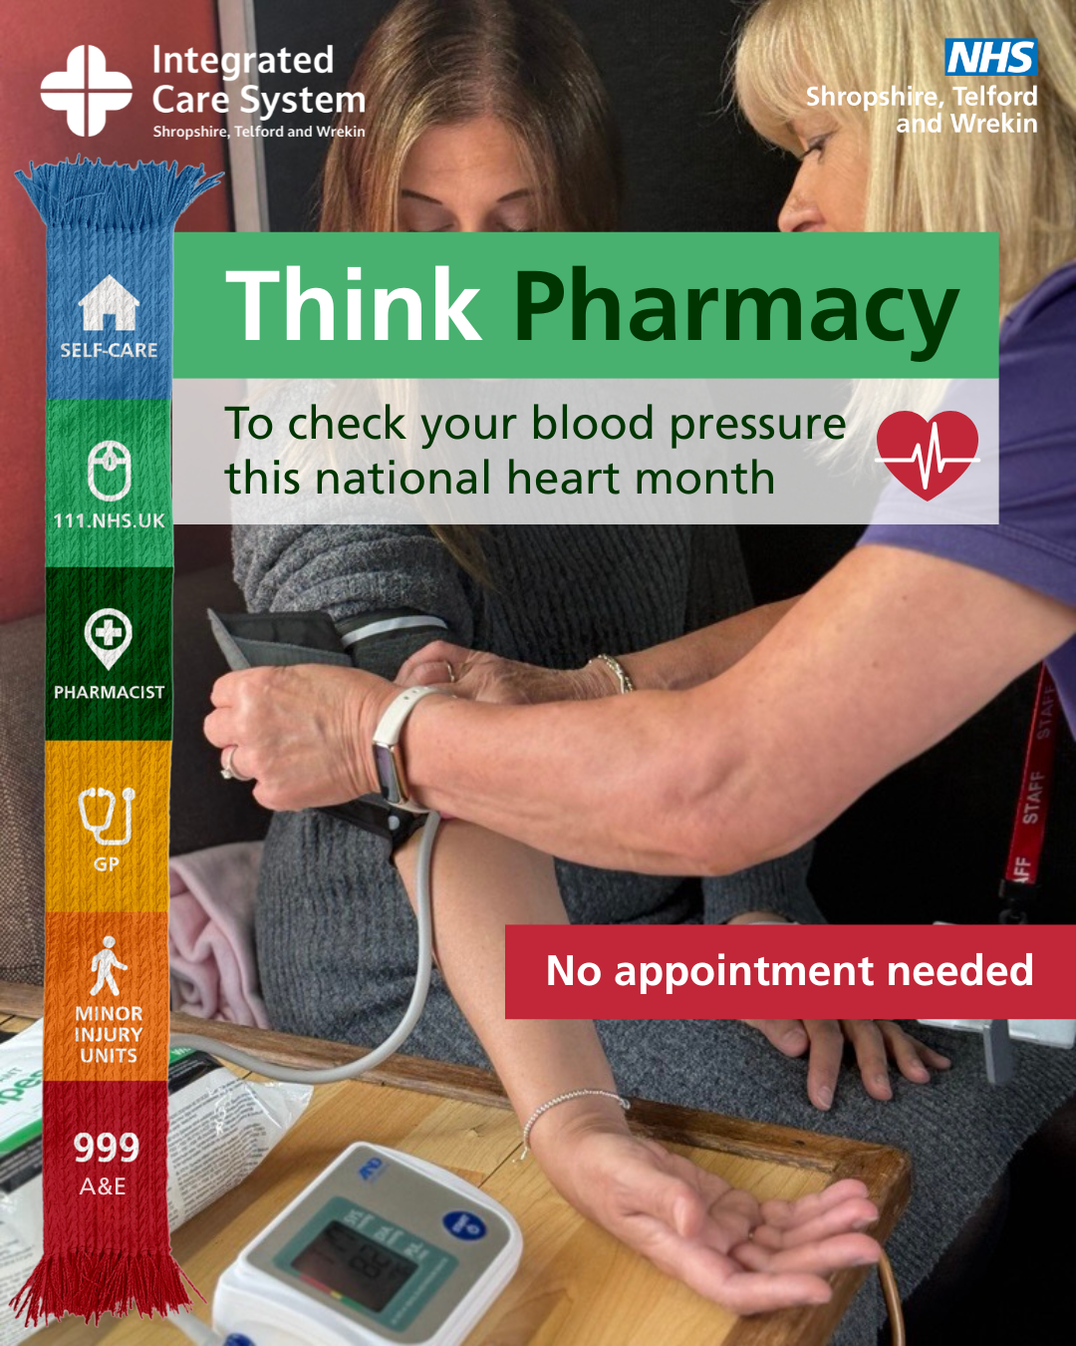 | A woman getting her blood pressure checked with a cuff around her arm. Text reads: Think Pharmacy to check your blood pressure this National Heart Month. No appointment needed.
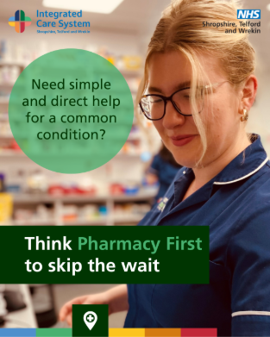 | A pharmacy technician. Text reads: Need simple and direct help for a common condition? Think Pharmacy First to skip the wait.
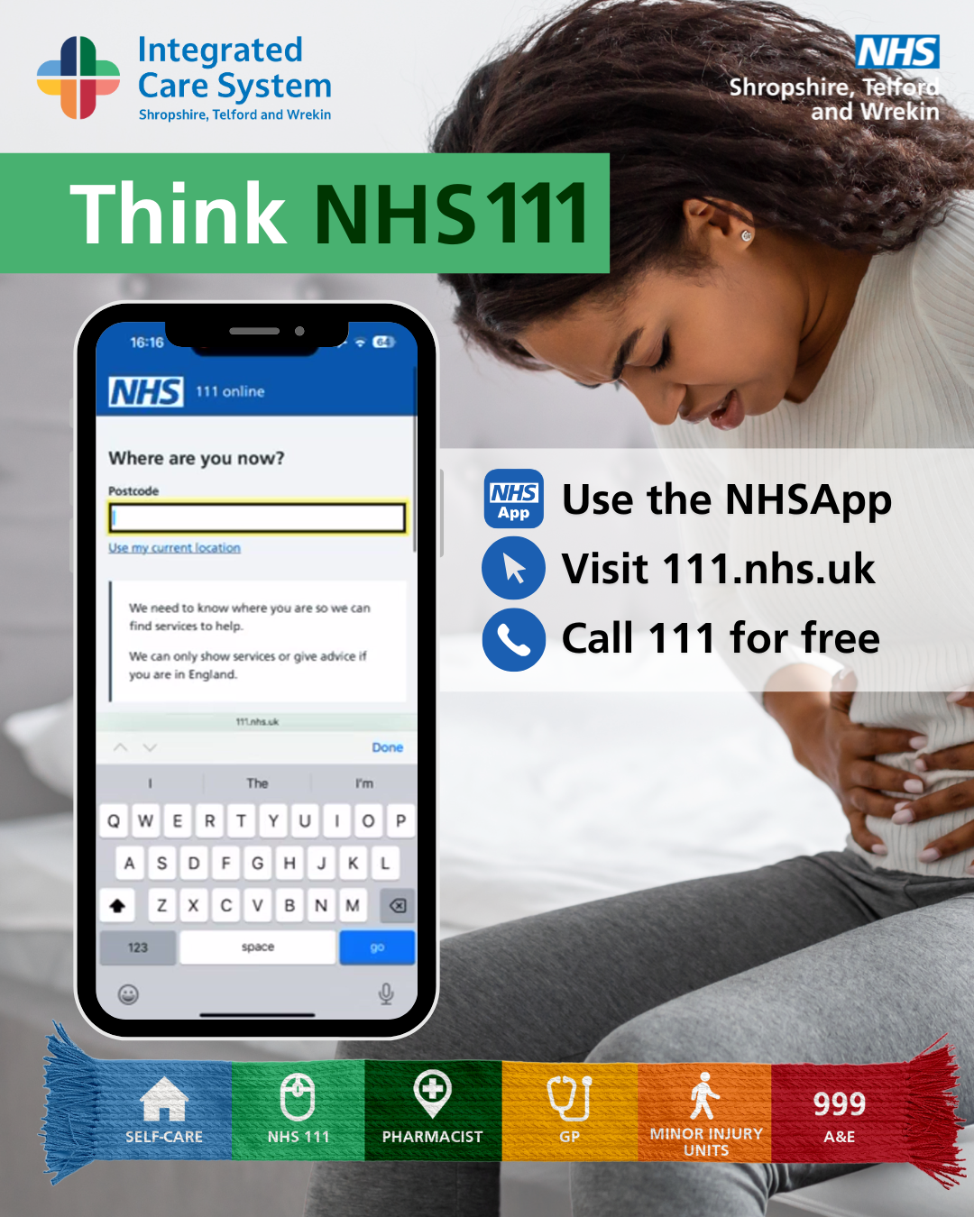 | A woman holding her stomach. A phone is overlayed displaying 111 in the NHS App. Text reads: Think NHS 111. Use the NHS App, visit 111 online, call 111 for free.
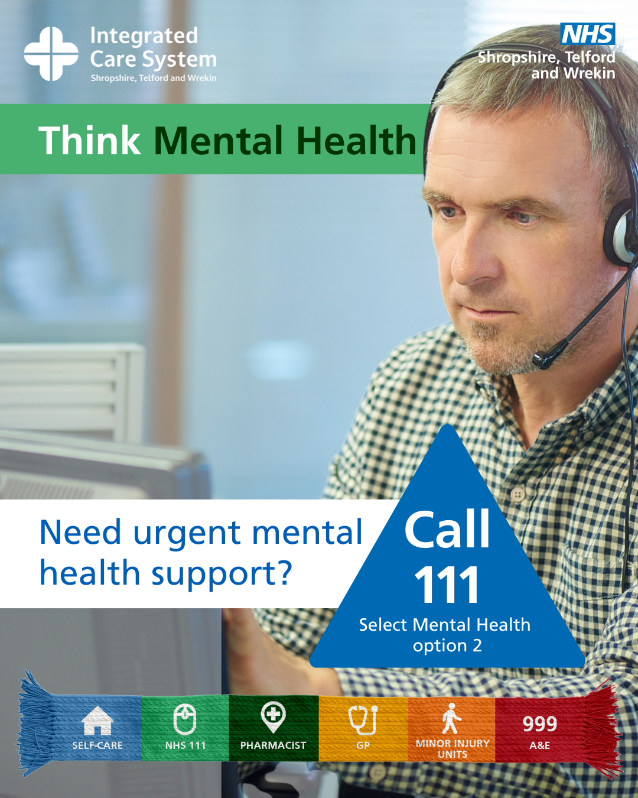 | A man working in a call centre wearing a headset. Text reads: Think Mental Health. Need urgent mental health support? Call 111and select option 2.
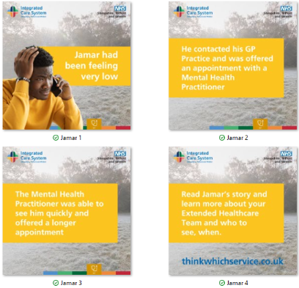 | Image 1: A wintery background and a young adult holding his head. Text reads: Jamar had been feeling very low.  Image 2: Text reads: He contacted his GP Practice and was offered an appointment with a Mental Health Practitioner.  Image 3: Text reads: The Mental Health Practitioner was able to see him quickly and offered a offered a longer appointment.  Image 4: Text reads: Read Jamar’s story and learn more about your Extended Healthcare Team and who to see, when.
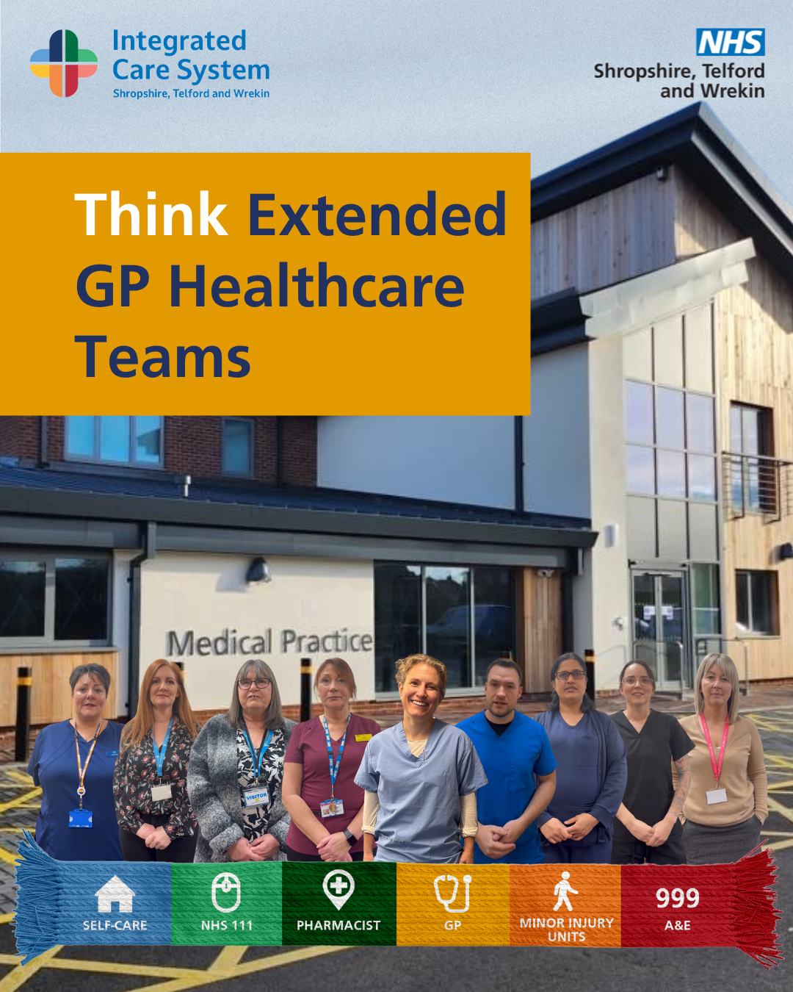 | A group of healthcare workers stood together in front of a building signposted as a medical practice. Text reads: Think Extended GP Healthcare Teams
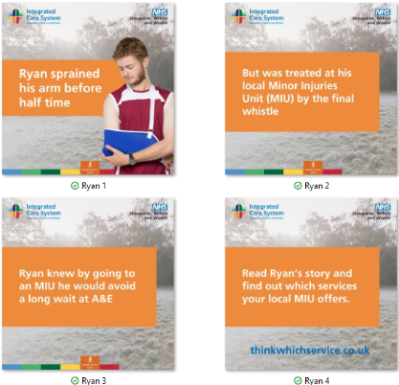 | Image 1: A wintery background and a young adult holding his arm in a sling. Text reads: Ryan sprained his arm before half time.  Image 2: Text reads: But was treated at his local Minor Injury Unit (MIU) by the final whistle  Image 3: Text reads: Ryan knew by going to an MIU he would avoid a long wait at A&E.  Image 4: Text reads: Read Ryan’s story and find out which services your local MIU offers.
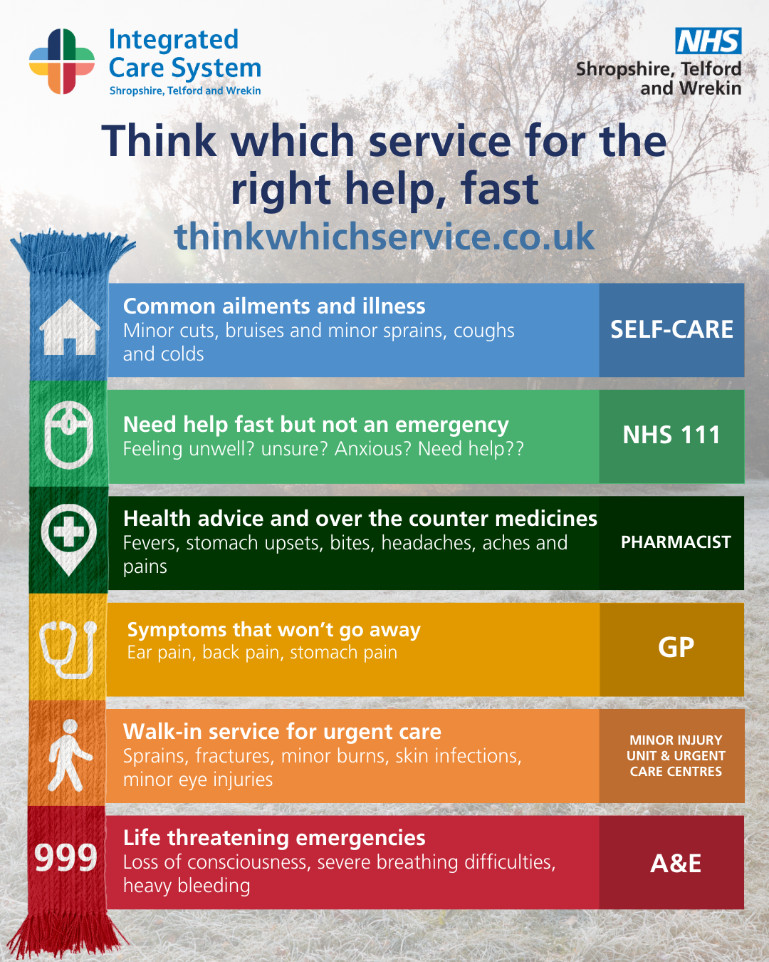 | An infographic titled ‘Think which service for the right help, fast,’ with the website thinkwhichservice.co.uk. It shows a vertical colour‑coded guide to help people choose the appropriate healthcare service.  - Self‑Care (blue): Common ailments and illness such as minor cuts, bruises, minor sprains, coughs and colds.  - NHS 111 (green): For help fast but not an emergency, including feeling unwell, unsure, anxious, or needing advice.  - Pharmacist (dark green): Health advice and over‑the‑counter medicines for fevers, stomach upsets, bites, headaches, aches and pains.  - GP (yellow): Symptoms that won’t go away, such as ear pain, back pain and stomach pain.  - Minor Injury Unit & Urgent Care Centres (orange): Walk‑in urgent care for sprains, fractures, minor burns, skin infections, and minor eye injuries.  - A&E / 999 (red): Life‑threatening emergencies including loss of consciousness, severe breathing difficulties and heavy bleeding.
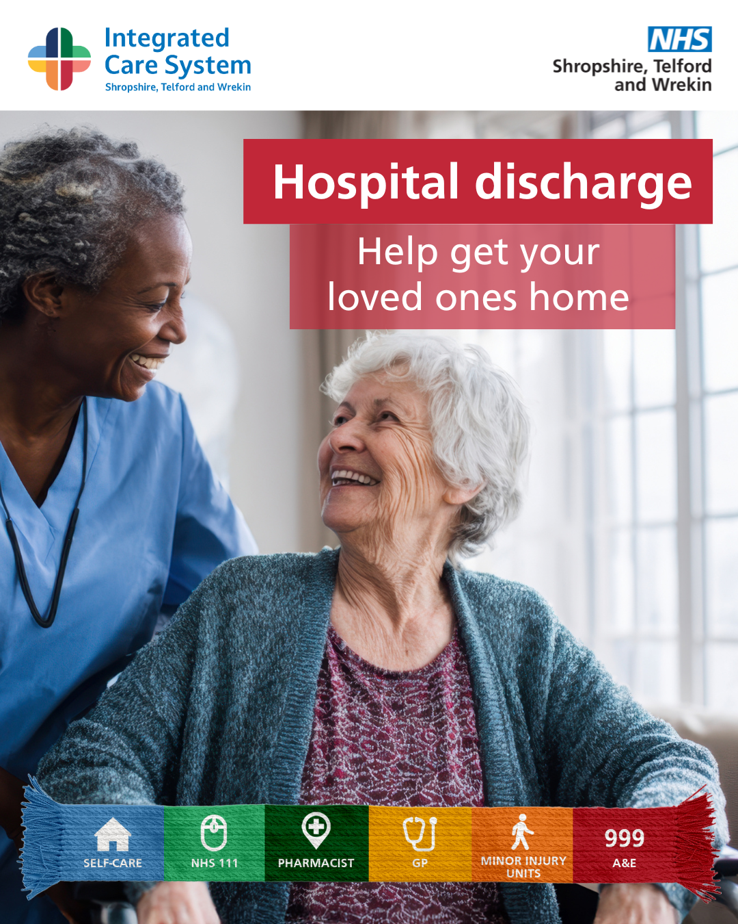 | A healthcare worker standing beside an older woman seated in a chair. Text reads: Hospital discharge. Help get your loved ones home.
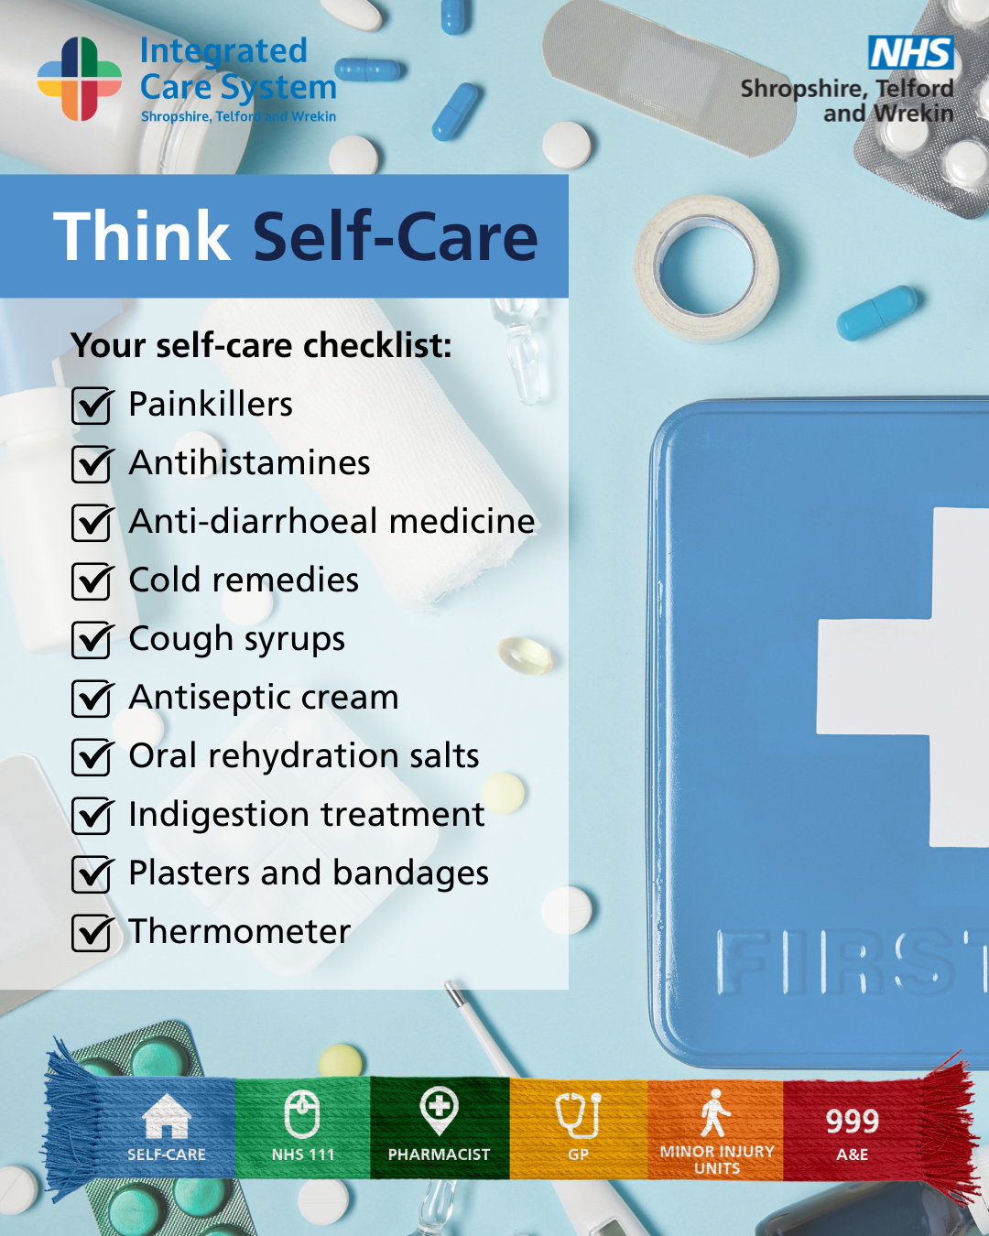 | Infographic titled ‘Think Self-Care’. The background shows various medical supplies such as tablets, capsules, bandages, plasters, and a blue first-aid box. A checklist reads:  - Painkillers  - Antihistamines  - Anti-diarrhoeal medicine  - Cold remedies  - Cough syrups  - Antiseptic cream  - Oral rehydration salts  - Indigestion treatment  - Plasters and bandages  - Thermometer
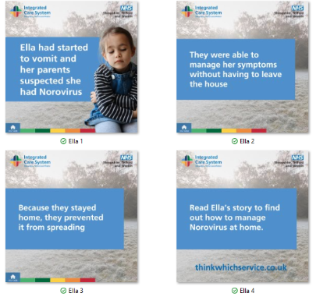 | Image 1: A wintery background and a young girl holding her tummy. Text reads: Ella had started to vomit and her parents suspected she had Norovirus.  Image 2: Text reads: They were able to manage her symptoms without having to leave the house.  Image 3: Text reads: Because they stayed home, they prevented it from spreading.  Image 4: Text reads: Read Ella’s story to find out how to manage Norovirus at home.

