Think Which Service
February 2026
Thunderclap social media proposal and post copy
The concept
What?
The idea behind the thunderclap is everyone posting the same thing at the same time.

Why?
To amplify the ‘Think Which Service’ campaign messages, increase reach and maximise impact across Shropshire, Telford and Wrekin.

When?
We're inviting all partners to take part between Wednesday 4 February and Tuesday 10 February.

How it will work
- A week prior to launch, we will share a ‘Think Which Service’ thunderclap social media toolkit. The toolkit will provide agreed social media content, including graphics, hashtags and, importantly, a schedule.

- We are proposing that during the launch week, two nominated time slots will be devoted to the ‘Think which service’ campaign messages each day. During this time, we are proposing that 2x social media messages will be issued at 9:05am and 3:05pm each day.

- For the thunderclap to work, it will be critical that all system comms colleagues schedule the posts on the day and time provided in the schedule. This will maximise the impact.

Day 1 Self-Care - February 2026
Time | Image | X (Twitter) copy | Facebook / LinkedIn copy | Instagram
9:05 AM | 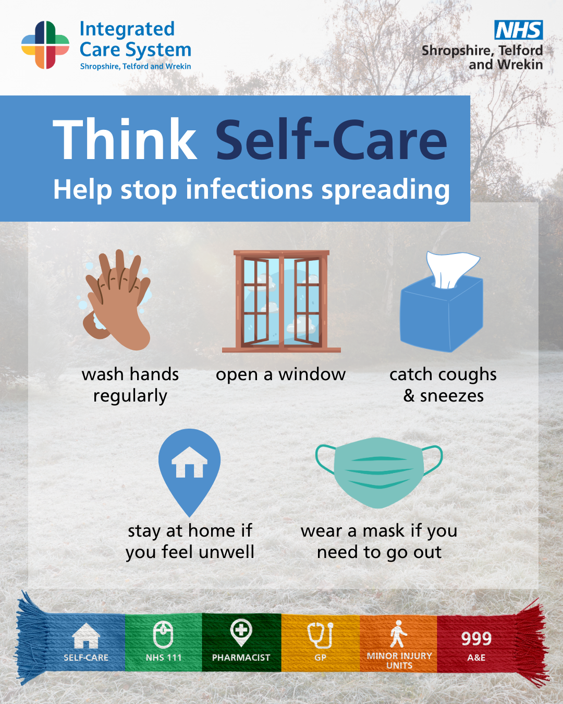 | Think Self-Care to help stop common winter infections from spreading with these simple steps for you and your household.  Find out more 👉 https://www.shropshiretelfordandwrekin.nhs.uk/your-health/our-campaigns/think-which-service/ellas-story/  #ThinkWhichService #NHSSTW | Noticed symptoms appearing?  Think Self-Care to help stop common winter infections from spreading with these simple steps for you and your household.  Find out more 👉 https://www.shropshiretelfordandwrekin.nhs.uk/your-health/our-campaigns/think-which-service/ellas-story/  #ThinkWhichService #NHSSTW | Noticed symptoms appearing?  Think Self-Care to help stop common winter infections from spreading with these simple steps for you and your household.  #ThinkWhichService #NHSSTW
3:05pm | 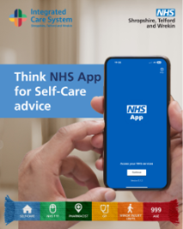 | Need quick, trusted health advice? The NHS App puts symptom checkers, self-care guidance and appointment tools in your pocket.📱  The NHS App makes managing your health easier.  Find out more and download the app ➡️ https://www.nhs.uk/nhs-app/  #NHSApp #SelfCare | Need quick, trusted health advice? The NHS App puts symptom checkers, self-care guidance and appointment tools in your pocket.📱  The NHS App makes managing your health easier.  Find out more and download the app ➡️ https://www.nhs.uk/nhs-app/  #NHSApp #SelfCare  Protect yourself and others. For more tips, visit 👉 https://www.nhs.uk/conditions/flu/  #NHS #FluPrevention #StayWell | Need quick, trusted health advice? The NHS App puts symptom checkers, self-care guidance and appointment tools in your pocket.📱  The NHS App makes managing your health easier.  Download the app today!  #NHSApp #SelfCare

Day 2: February 2026 – Pharmacist
Time | Image | X (Twitter) copy | Facebook / LinkedIn copy | Instagram
9:05 am | 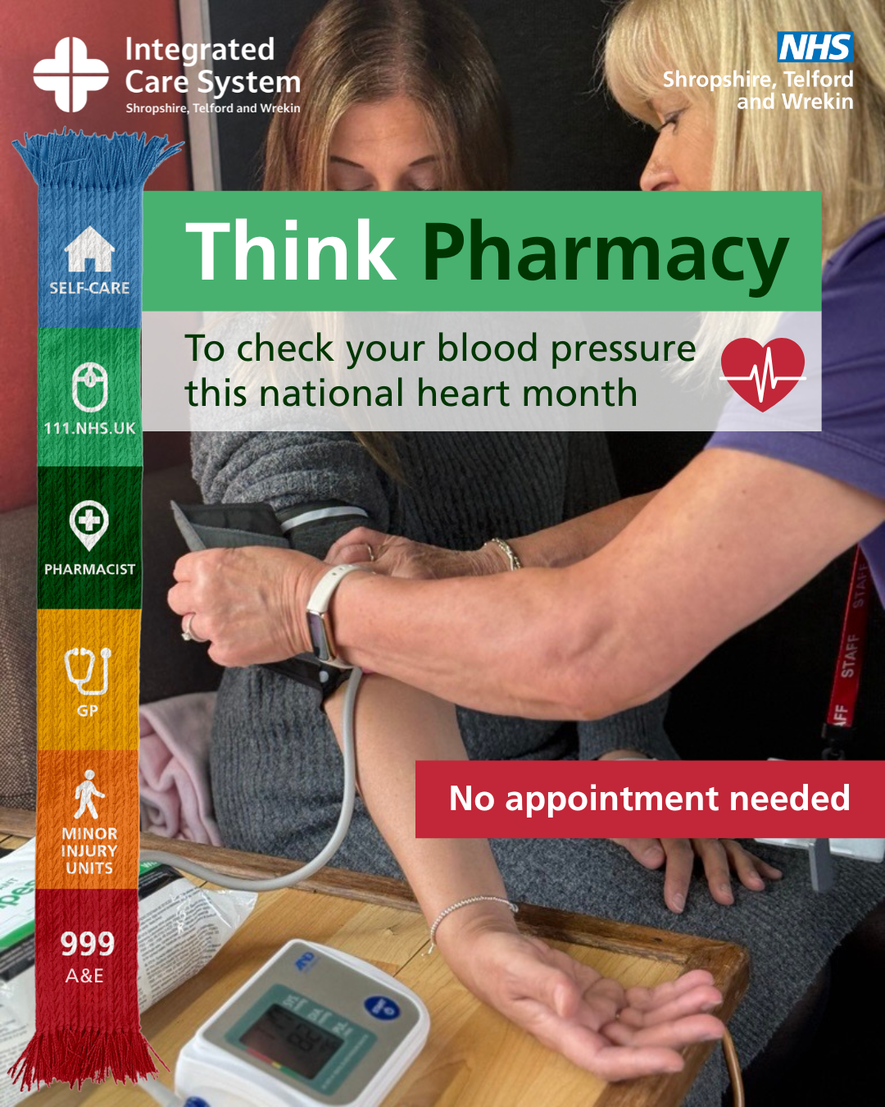 | Think Pharmacy this National Heart Month!  You can check your blood pressure at your local community pharmacy with no appointment needed.  Think Pharmacy to get the right care, faster ➡️ thinkwhichservice.co.uk  #ThinkWhichService #Pharmacy #NHS | Think Pharmacy this National Heart Month!  Did you know that high blood pressure often has no symptoms but can lead to serious health issues like heart disease or stroke?  You can check your blood pressure at your local community pharmacy with no appointment needed.  There’s also an online NHS tool you can use to help you understand your readings.  Think Pharmacy to get the right care, faster ➡️ thinkwhichservice.co.uk  #ThinkWhichService #Pharmacy #NHS | Think Pharmacy this National Heart Month!  Did you know that high blood pressure often has no symptoms but can lead to serious health issues like heart disease or stroke?  You can check your blood pressure at your local community pharmacy with no appointment needed.  There’s also an online NHS tool you can use to help you understand your readings.  Think Pharmacy to get the right care, faster!  #ThinkWhichService #Pharmacy #NHS
3:05 pm | 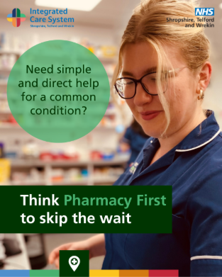 | Think Pharmacy and skip the wait this winter! 💊 With #PharmacyFirst, your local pharmacist can provide prescription medicines for a range of common conditions. Get advice and treatment for ear infections, sinusitis, urinary tract infections and more. ➡️ https://www.shropshiretelfordandwrekin.nhs.uk/think-pharmacy-first-new-advanced-pharmacy-service-now-available-across-shropshire-telford-and-wrekin/ | Think Pharmacy and skip the wait this winter! 💊  With Pharmacy First, your local pharmacist can provide prescription medicines for a range of common conditions:  - Sinusitis (12 +)  - Sore throat (5 +)  - Earache (1-17 years)  - Infected insect bites (1 +)  - Impetigo (1 +)  - Shingles (18 +)  - Uncomplicated urinary tract infections in women (16-64 years  If you don’t pay for prescriptions from your GP, you won't pay for prescriptions through Pharmacy First either.  Pop into your pharmacy for advice and treatment for ear infections, sinusitis, urinary tract infections and more.  Find out more ➡️ https://www.shropshiretelfordandwrekin.nhs.uk/think-pharmacy-first-new-advanced-pharmacy-service-now-available-across-shropshire-telford-and-wrekin/ | Think Pharmacy and skip the wait this winter! 💊  With Pharmacy First, your local pharmacist can provide prescription medicines for a range of common conditions:  - Sinusitis (12 +)  - Sore throat (5 +)  - Earache (1-17 years)  - Infected insect bites (1 +)  - Impetigo (1 +)  - Shingles (18 +)  - Uncomplicated urinary tract infections in women (16-64 years  If you don’t pay for prescriptions from your GP, you won't pay for prescriptions through Pharmacy First either.  Pop into your pharmacy for advice and treatment for ear infections, sinusitis, urinary tract infections and more.

Day 3: February 2026 – NHS 111
Time | Image | X (Twitter) copy | Facebook / LinkedIn copy | Instagram
9:05 AM | 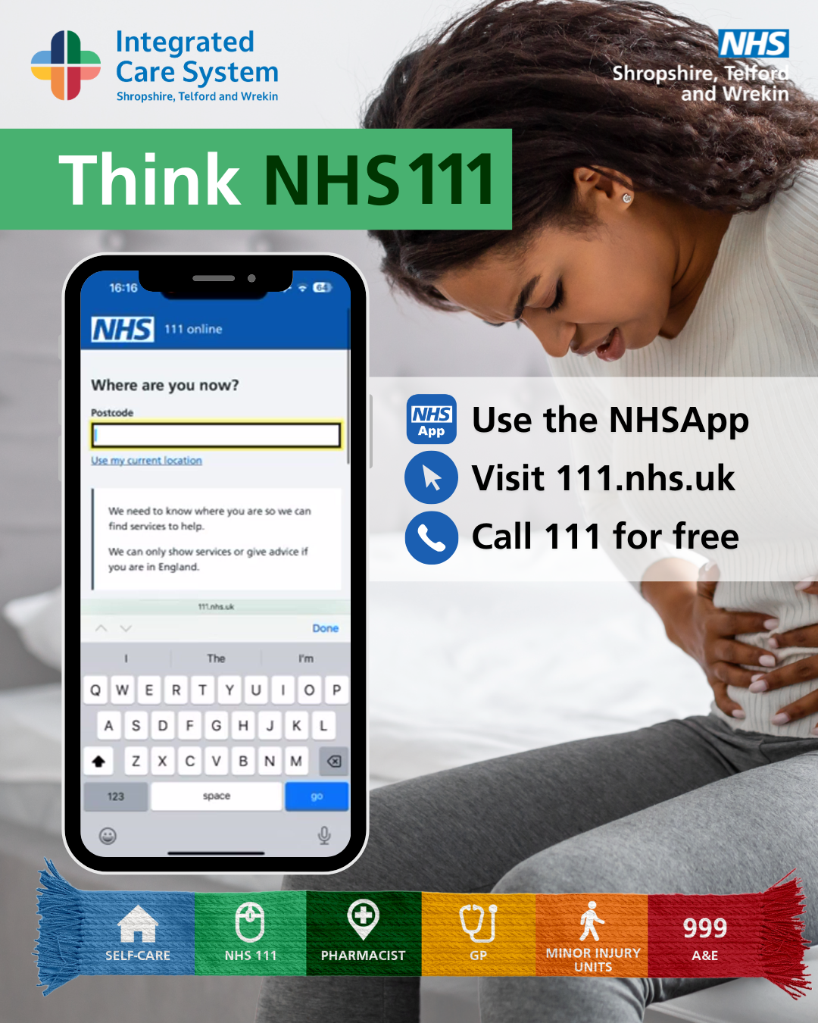 | Not sure where to go for help? 🤔  NHS 111 can tell you the best service for your symptoms – on the NHS App, online or by phone.  ➡️ thinkwhichservice.co.uk  #ThinkWhichService #NHS111 | Fallen over on the ice? Need help for an injury, cut or bruise? Or unsure where to get help for a rash or skin condition? NHS 111 is here to help.  You can:  - Use the NHS App  - Visit 111.nhs.uk  - Call 111 for free  They’ll assess your symptoms and guide you to the right care – whether that’s self-care, pharmacy, GP or urgent care.  Think NHS 111 to get the right help, first time ➡️ thinkwhichservice.co.uk  #ThinkWhichService #NHSSTW #NHS111 | Fallen over on the ice? Need help for an injury, cut or bruise? Or unsure where to get help for a rash or skin condition? NHS 111 is here to help.  You can:  - Use the NHS App  - Visit 111.nhs.uk  - Call 111 for free  They’ll assess your symptoms and guide you to the right care – whether that’s self-care, pharmacy, GP or urgent care.  Think NHS 111 to get the right help, first time.  #ThinkWhichService #NHSSTW #NHS11
3:05 pm | 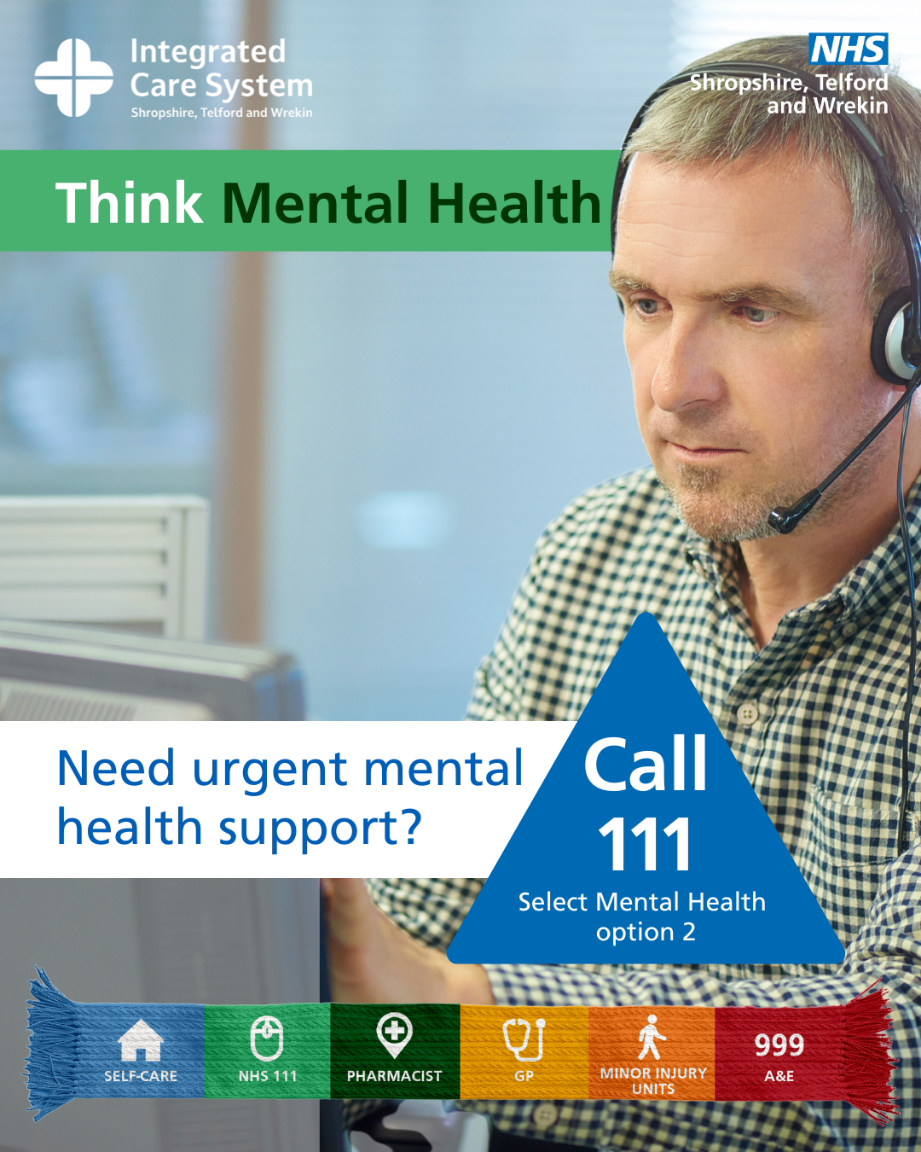 | You’re Not Alone 💙 Mental Health Support is just a Call or Text Away:  - 📞 Call NHS111 and select the mental health option 2  - Text ‘STW’ to 85258 for free  #YouAreNotAlone #NHSSTW #MentalHealth | You’re Not Alone 💙 Mental Health Support is just a Call or Text Away:  If you’re struggling or in emotional distress, support is available right now:  - Call: NHS 111 for urgent mental health support and select the mental health option 2  - Text: ‘STW’ to 85258 for free, confidential, 24/7 mental health support  - Talking therapies📞 call 0300 123 6020  Online Support  - Every Mind Matters: Visit www.nhs.uk/every-mind-matters for expert advice and practical tips to support your mental wellbeing.  Someone is always ready to listen 💙  #NHSSTW #ThinkWhichService | You’re Not Alone 💙 Mental Health Support is just a Call or Text Away:  If you’re struggling or in emotional distress, support is available right now:  - NHS 111: For urgent mental health support, select the mental health option 2  - Text: ‘STW’ to 85258 for free, confidential, 24/7 mental health support  - Talking therapies  Online Support  - Every Mind Matters: Visit www.nhs.uk/every-mind-matters for expert advice and practical tips to support your mental wellbeing.  Someone is always ready to listen 💙

Day 4: February 2026 - GP
Time | Image | X (Twitter) copy | Facebook / LinkedIn copy | Instagram
9:05 AM | 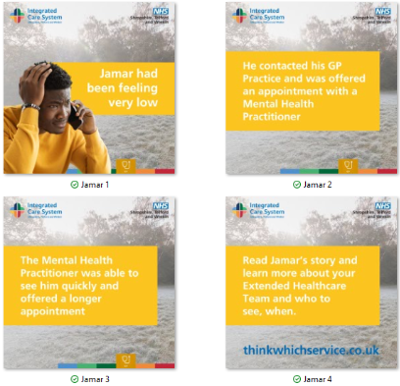 | Did you know GP practices across Shropshire, Telford and Wrekin are supported by extended healthcare teams? 💡 Read Jamar’s story to find out more about the teams working in GP Practices ➡️https://www.shropshiretelfordandwrekin.nhs.uk/your-health/our-campaigns/think-which-service/jamars-story/️  #ThinkWhichService #NHSSTW #NHS #GP | Did you know GP practices across Shropshire, Telford and Wrekin are supported by extended healthcare teams? 💡  From mental health practitioners and pharmacists to care coordinators and nurses, these experts work alongside your GP to ensure you get the right care, at the right time. 💙  Read Jamar’s story to find out more about the teams working in GP Practices ➡️https://www.shropshiretelfordandwrekin.nhs.uk/your-health/our-campaigns/think-which-service/jamars-story/️  #ThinkWhichService #NHSSTW #NHS #GP | Did you know GP practices across Shropshire, Telford and Wrekin are supported by extended healthcare teams? 💡  From mental health practitioners and pharmacists to care coordinators and nurses, these experts work alongside your GP to ensure you get the right care, at the right time. 💙  #ThinkWhichService #NHSSTW #NHS #GP
3:05 pm | 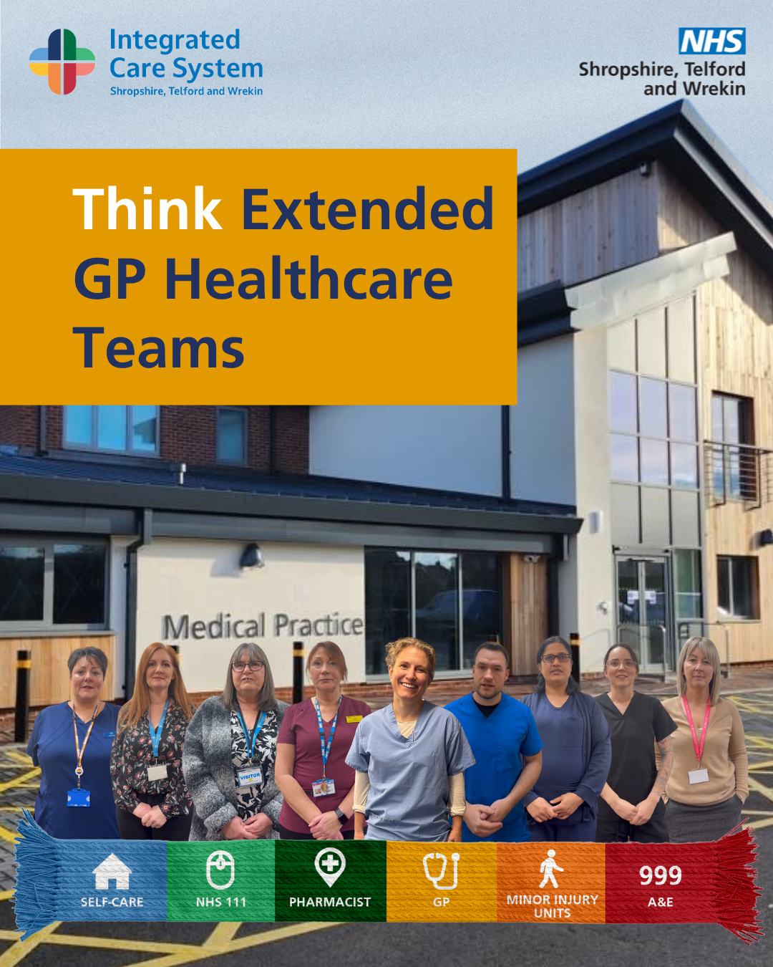 | “Our priority is making sure you’re seen by the most appropriate healthcare professional.”  Extended healthcare teams include people like nurse practitioners and pharmacists so you get seen by the right person for your needs.  Find out more 👉 thinkwhichservice.co.uk | “Our priority is making sure you’re seen by the most appropriate healthcare professional.” Jess Harvey, GP, NHS Shropshire, Telford and Wrekin  Extended healthcare teams include people like nurse practitioners, pharmacists and healthcare assistants, so you get seen by the right person for your needs.  Find out more 👉 thinkwhichservice.co.uk  #NHSSTW #ThinkGPHealthcareTeams #NHS | “Our priority is making sure you’re seen by the most appropriate healthcare professional.” Jess Harvey, GP, NHS Shropshire, Telford and Wrekin  Extended healthcare teams include people like nurse practitioners, pharmacists and healthcare assistants, so you get seen by the right person for your needs.  #NHSSTW #ThinkGPHealthcareTeams #NHS

Day 5 February 2026 – Minor Injury Unit
Time | Image | X (Twitter) copy | Facebook / LinkedIn copy | Instagram
9:05 AM | 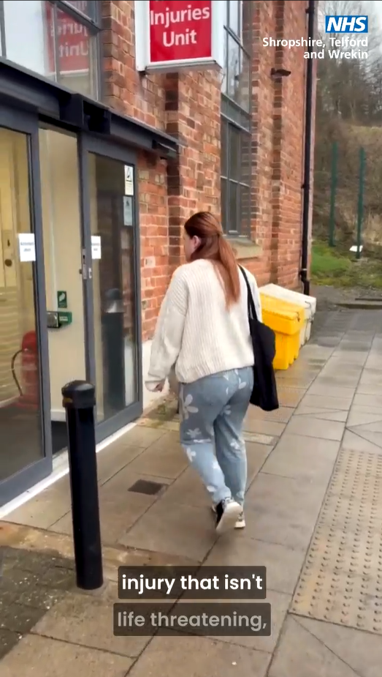 | If you've suffered a minor injury, our Minor Injury Units (MIUs) are here to help!  With locations in Bridgnorth, Oswestry, Ludlow and Whitchurch, MIUs offer professional care for a range of injuries.  For more information visit ➡️️ thinkwhichservice.co.uk | Need quick treatment for a minor injury?  If you've suffered a minor injury, our Minor Injury Units (MIUs) are here to help!  With locations in Bridgnorth, Oswestry, Ludlow, and Whitchurch, MIUs offer professional care for a range of injuries, including sprains, cuts, and minor burns.  Find your nearest MIU and get the help you need ➡️️ thinkwhichservice.co.uk  #Shropshire #MinorInjuries #NHS #NHSSTW | Need quick treatment for a minor injury?  If you've suffered a minor injury, our Minor Injury Units (MIUs) are here to help!  With locations in Bridgnorth, Oswestry, Ludlow, and Whitchurch, MIUs offer professional care for a range of injuries, including sprains, cuts, and minor burns.  #Shropshire #MinorInjuries #NHS #NHSSTW
3:05 pm | 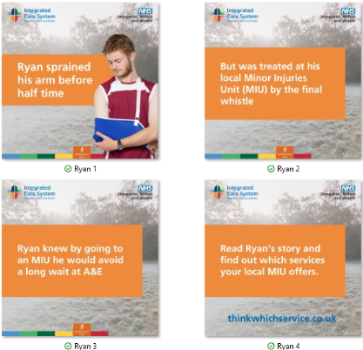 | Your local #MinorInjuryUnit (MIU) can help you get the care you need quickly, avoiding long waits in A&E. ⏰ Read Ryan’s story to find out more about Minor Injury Units ➡️https://www.shropshiretelfordandwrekin.nhs.uk/your-health/our-campaigns/think-which-service/ryans-story/ | Your local Minor Injury Unit (MIU) can help you get the care you need quickly, avoiding long waits in A&E. ⏰  MIUs treat a range of non-life-threatening injuries, including:  - Burns and scalds  - Sprains and strains  - Minor fractures  - Wounds needing stitches  - Minor head injuries  Get the right care, in the right place, this winter. 💙  Read Ryan’s story to find out more about Minor Injury Units ➡️https://www.shropshiretelfordandwrekin.nhs.uk/your-health/our-campaigns/think-which-service/ryans-story/ | Your local #MinorInjuryUnit (MIU) can help you get the care you need quickly, avoiding long waits in A&E. ⏰  MIUs treat a range of non-life-threatening injuries, including:  - Burns and scalds  - Sprains and strains  - Minor fractures  - Wounds needing stitches  - Minor head injuries  Get the right care, in the right place, this winter. 💙  #ThinkWhichService #NHSSTW #NHS #MIU

Day 6 February 2026 – A&E
Time | Image | X (Twitter) copy | Facebook / LinkedIn copy | Instagram
9:05 AM | 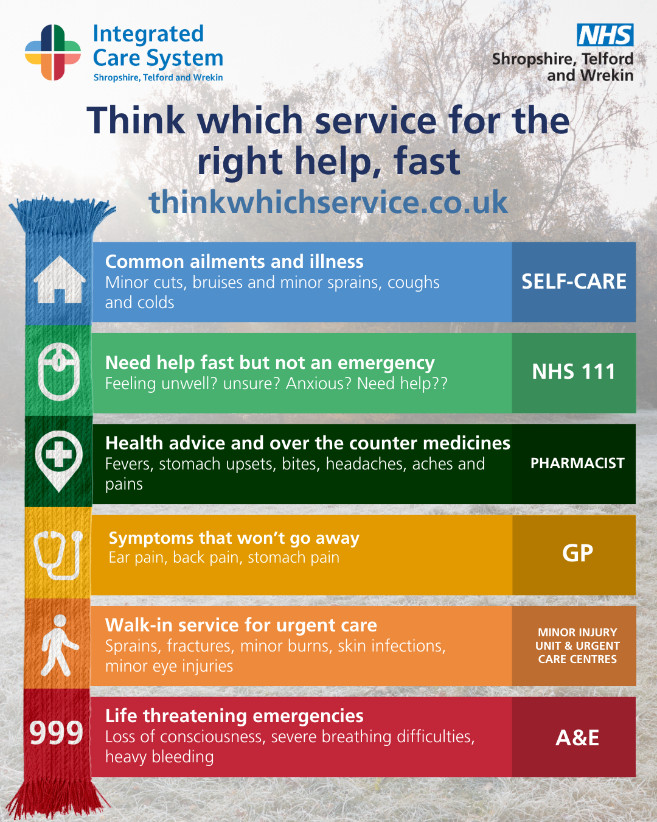 | 🚑 A&E is for life-threatening emergencies.  For everything else, there is a service to help you in the faster time possible ➡️ thinkwhichservice.co.uk  #ThinkWhichService #A&E #NHS | 🚑 A&E is for life-threatening emergencies.  For everything else, think before you act:  - Think NHS 111 for urgent advice  - Think Pharmacy First for minor illnesses  - Think Minor Injury Unit for non-life-threatening injuries  Get the right care, in the right place.  Find out more ➡️ www.thinkwhichservice.co.uk  #ThinkWhichService #NHSSTW | 🚑 A&E is for life-threatening emergencies.  For everything else, think before you act:  - Think NHS 111 for urgent advice  - Think Pharmacy First for minor illnesses  - Think Minor Injury Unit for non-life-threatening injuries  Get the right care, in the right place.  #ThinkWhichService #NHSSTW #NHS #999
3.05pm | 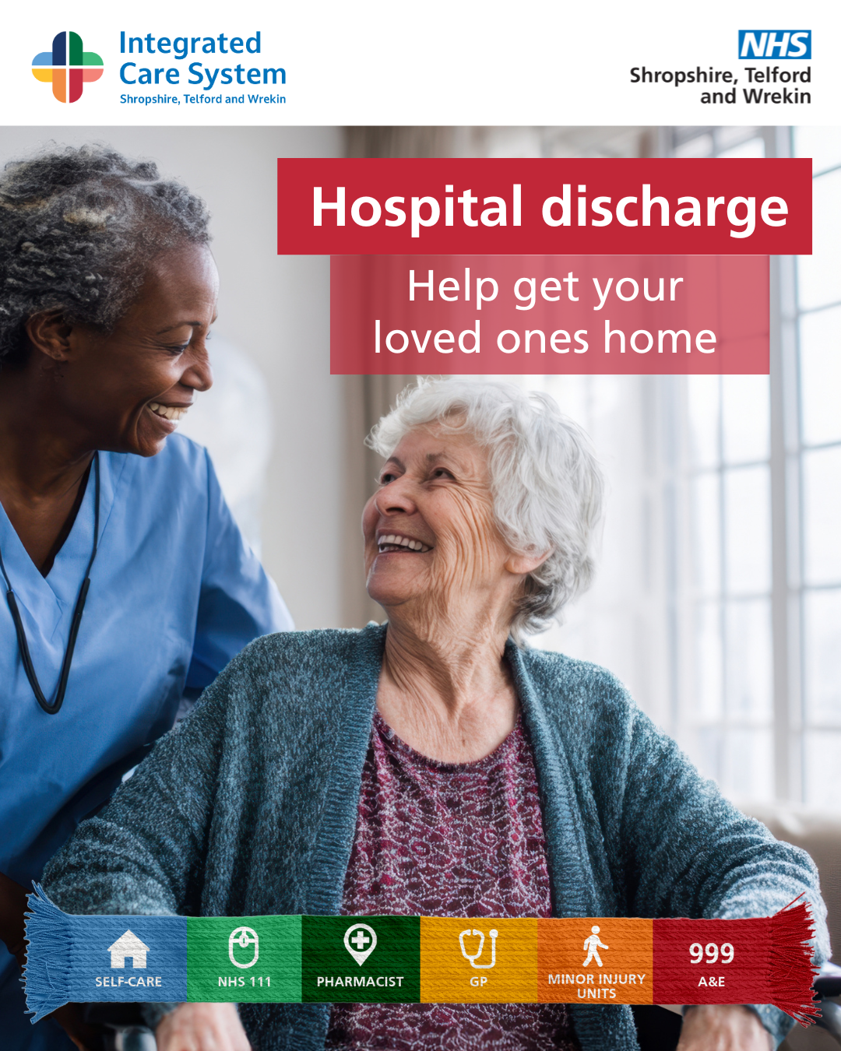 | By helping your loved ones get home as soon as they’re ready, you’re not only supporting their recovery but also helping the NHS by freeing up a bed for someone in need of care 💙  For more information 👉 https://www.shropshiretelfordandwrekin.nhs.uk/hospital-discharge/  #NHSSTW #ThinkWhichService #NHS | By helping your loved ones get home as soon as they’re ready, you’re not only supporting their recovery but also helping the NHS by freeing up a bed for someone in need of care 💙  You can help by:  -Offering a lift home from hospital  -Collecting prescriptions  -Ensuring their home is heated  -Stocking their cupboard with staple food items  For more information 👉 https://www.shropshiretelfordandwrekin.nhs.uk/hospital-discharge/  #NHSSTW #ThinkWhichService #NHS | By helping your loved ones get home as soon as they’re ready, you’re not only supporting their recovery but also helping the NHS by freeing up a bed for someone in need of care 💙  You can help by:  -Offering a lift home from hospital  -Collecting prescriptions  -Ensuring their home is heated  -Stocking their cupboard with staple food items  #NHSSTW #ThinkWhichService #NHS

Day 7 February 2026 – Self-Care
Time | Image | X (Twitter) copy | Facebook / LinkedIn copy | Instagram
9:05am | 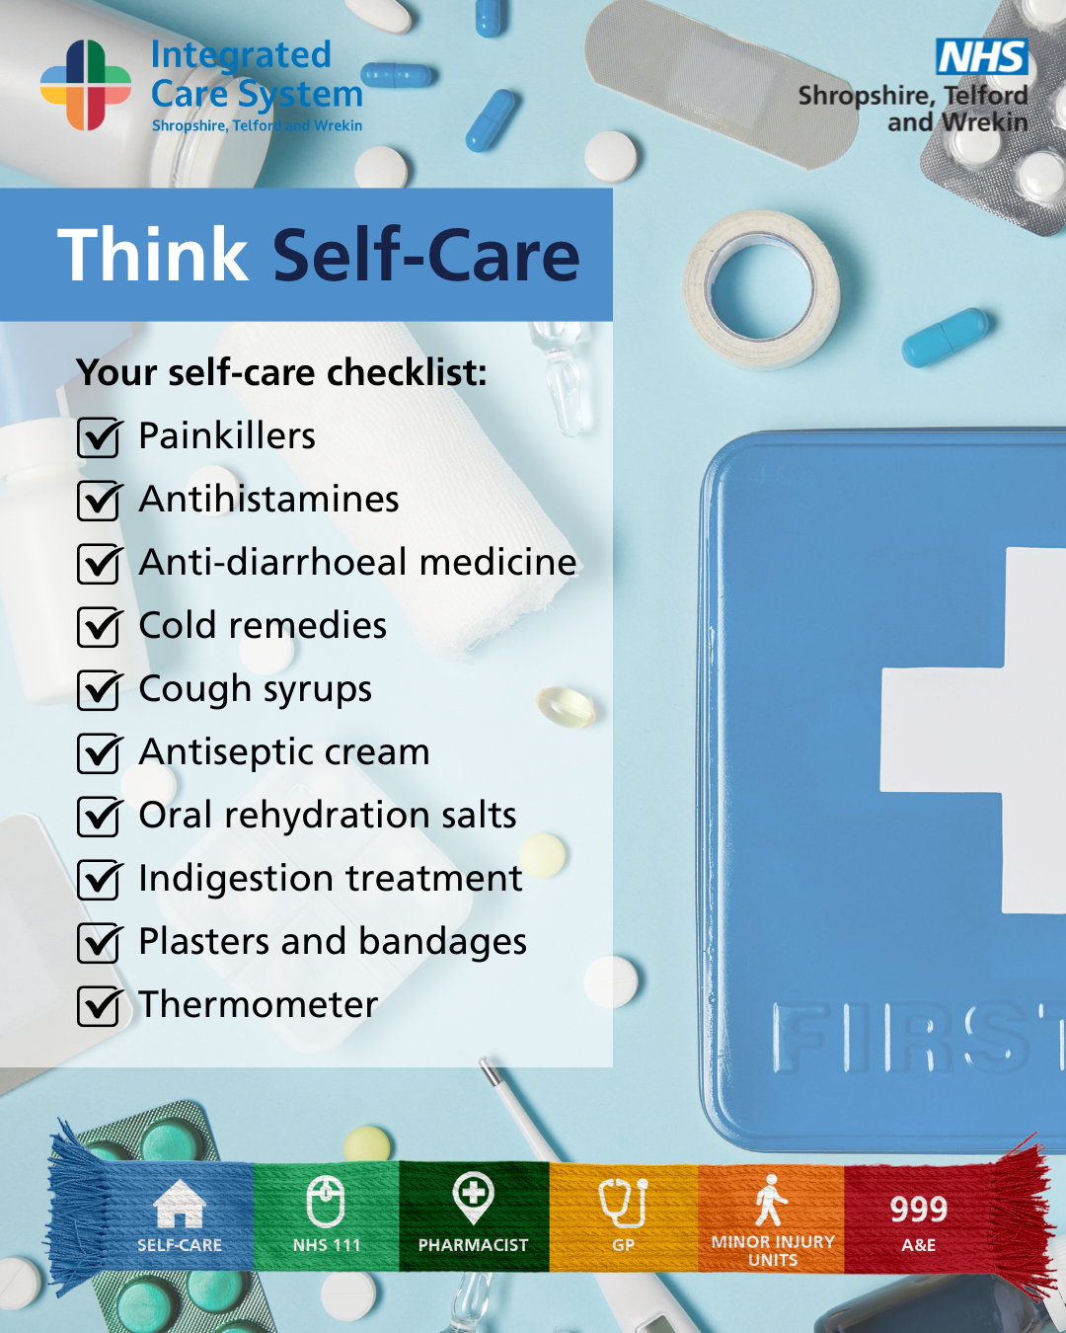 | A prepared medicine cabinet can make all the difference when minor illness strikes 💊Self-care is often best first step for minor illnesses.  Find out more 👉 thinkwhichservice.co.uk  #ThinkWhichService #NHSSTW | A prepared medicine cabinet can make all the difference when minor illness strikes💊  Your self-care checklist:  • Painkillers  • Antihistamines  • Anti-diarrhoeal medicine  • Cold remedies  • Cough syrups  • Antiseptic cream (for bites and stings)  • Oral rehydration salts  • Indigestion treatment  • Plasters and bandages  • Thermometer  Self-care is often the best first step for minor illnesses.  Find out more 👉 thinkwhichservice.co.uk  #ThinkWhichService #NHSSTW | A prepared medicine cabinet can make all the difference when minor illness strikes 💊  Your self-care checklist:  • Painkillers  • Antihistamines  • Anti-diarrhoeal medicine  • Cold remedies  • Cough syrups  • Antiseptic cream (for bites and stings)  • Oral rehydration salts  • Indigestion treatment  • Plasters and bandages  • Thermometer  Self-care is often the best first step for minor illnesses.  Find out more 👉 thinkwhichservice.co.uk  #ThinkWhichService #NHSSTW
3.05pm | 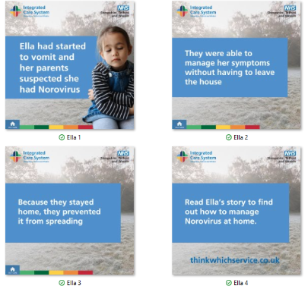 | Norovirus spreads easily & can cause unpleasant symptoms.  - Wash hands with soap & water  - Stay home until 48 hrs after symptoms stop  - Keep surfaces clean & wash laundry thoroughly  Keep yourself and others healthy this winter ➡️https://www.shropshiretelfordandwrekin.nhs.uk/your-health/our-campaigns/think-which-service/ellas-story/ | Norovirus spreads easily and can cause unpleasant symptoms such as:  - Vomiting  - Diarrhoea  - Stomach cramps  How to stop the spread:  - Wash your hands regularly with soap and water  - Stay at home until 48 hours after your symptoms have stopped  - Keep surfaces clean and wash laundry thoroughly  Keep yourself and others healthy this winter 💙  Read Ella’s story to find out more about self-care ➡️https://www.shropshiretelfordandwrekin.nhs.uk/your-health/our-campaigns/think-which-service/ellas-story/ | Norovirus spreads easily and can cause unpleasant symptoms such as:  - Vomiting  - Diarrhoea  - Stomach cramps  How to stop the spread:  - Wash your hands regularly with soap and water  - Stay at home until 48 hours after your symptoms have stopped  - Keep surfaces clean and wash laundry thoroughly  Keep yourself and others healthy this winter 💙  #ThinkWhichService #NHSSTW #NHS #Norovirus

