Carer’s Library Card
If you are a carer, you can ask for a concessionary library card which means that you can borrow up to 10 books and 6 other items. This includes audiobook loans free of charge. You can also make free reservations and are exempt from charges if you are late returning your loans.

Libraries Online Anytime
The Shropshire Libraries website gives access to the full library catalogue, library news, and events. You can also search, request or renew items online.
You may also find the e-Library useful, offering e-books, e-magazines, e-newspapers and online reference resources.
The Shropshire Community Directory gives details about local clubs, societies, health and care organisations.
All libraries offer free use of computers for internet, email, word processing and spreadsheets. Most libraries also have free Wi-Fi.
Further information
Shropshire Libraries, The Annexe, Shirehall, Abbey Foregate, Shrewsbury, SY2 6ND
01743 255024
libraries@shropshire.gov.uk
www.shropshire.gov.uk/libraries

If you can read this but know someone who cannot, please contact us on 0345 6789034 so we can provide this information in a more suitable format.

Leaflet D069 May 2021
Library Services for People Living with Memory Loss

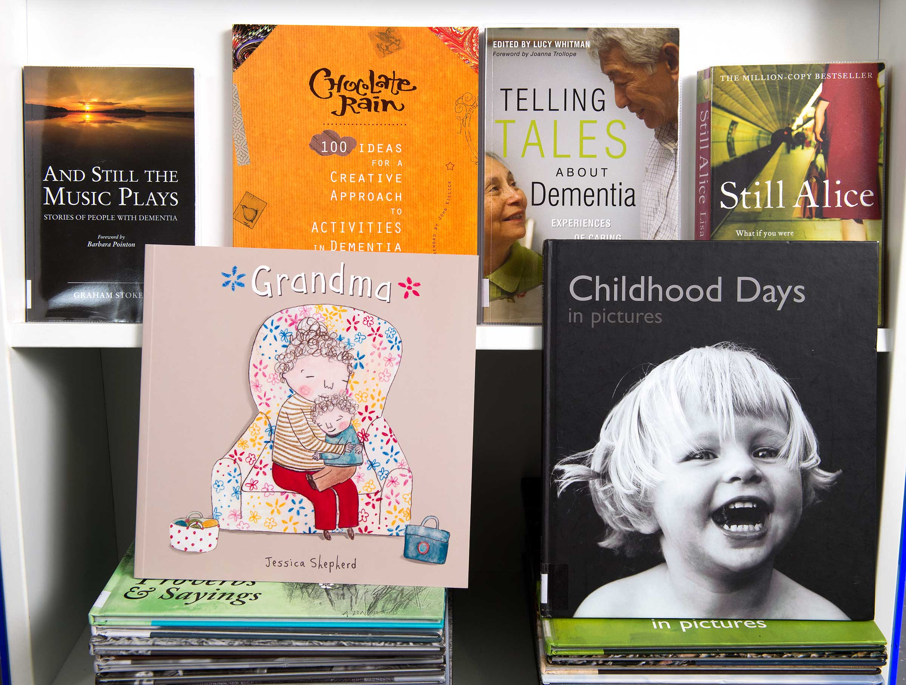

Are you a person living with memory loss? Do you support a relative or friend with a condition affecting their memory? Do you work in a care setting?
Shropshire Libraries provide a wide range of services to those living with memory loss, and the people that look after them – and most of them are free.
Here is a guide to help you find out more.


Shared Memory Bags
An object, a photograph, some music, a word - sometimes it takes a trigger to bring memories flooding back…
Shared Memory Bags are just that – an easily portable collection of items, books and activities to share at home or in a group to prompt conversation.

You can borrow a Shared Memory bag from Shropshire Libraries free of charge for three weeks using your library card. There are many bags available with themes including Music, Family Life, Travelling, Sporting Life, Seaside, Childhood Days and Countryside. There is also a dual language English/Welsh bag.

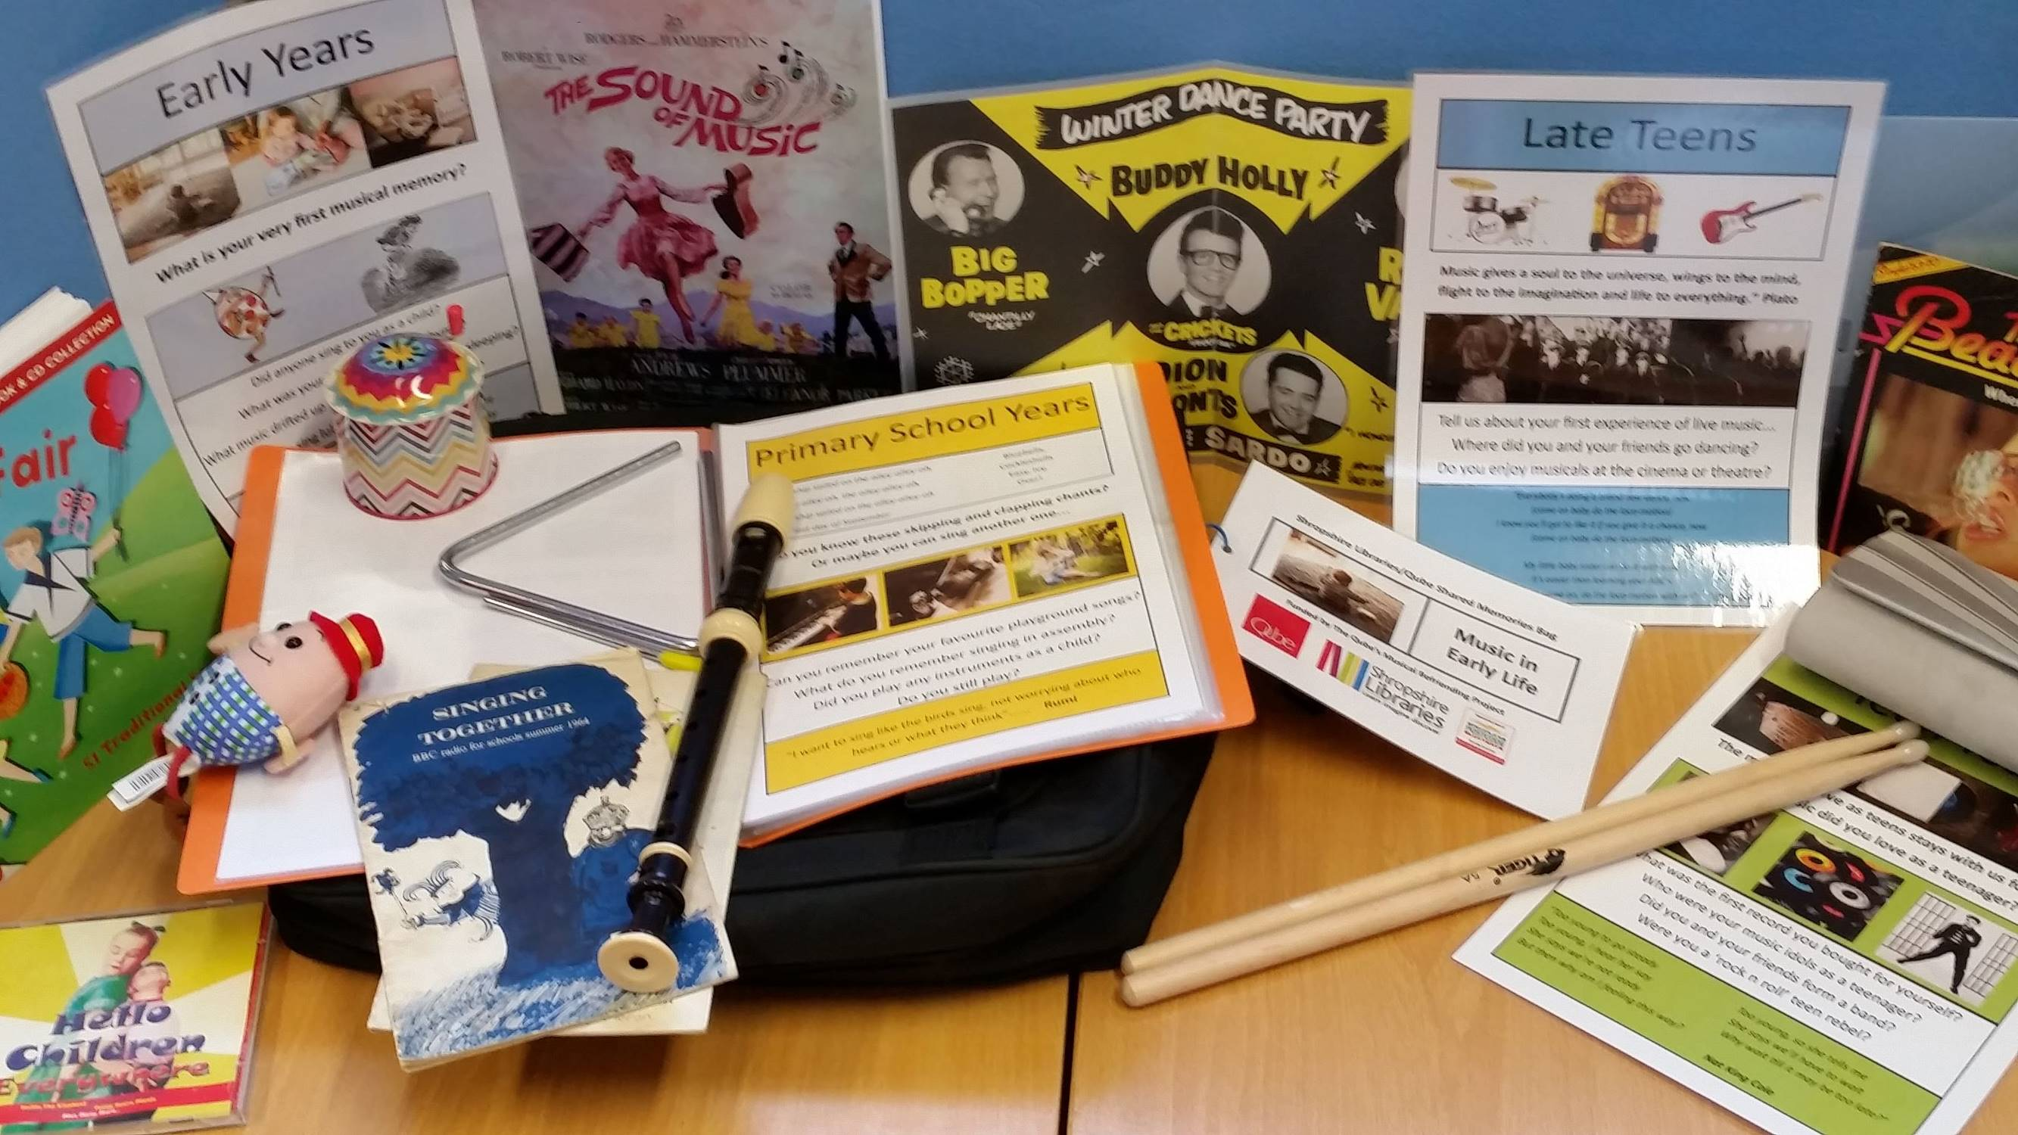
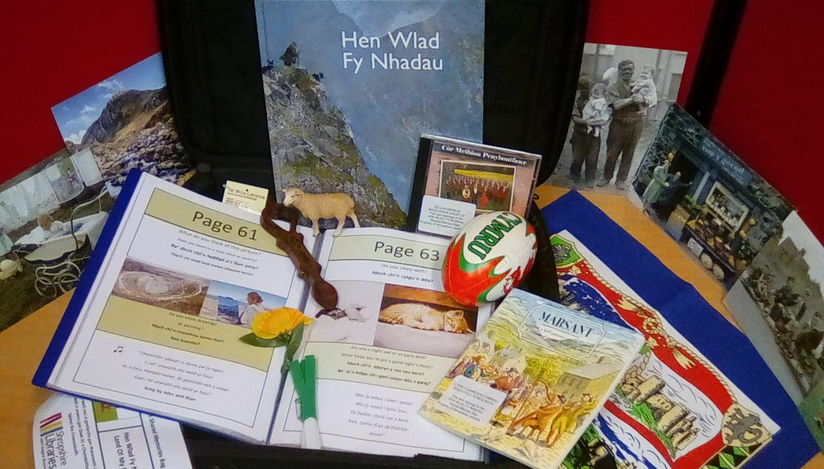

These bags have been developed with the help and support of a range of different organisations across Shropshire.

Books on Prescription

Reading Well book collections - endorsed by health experts - help you to understand and manage your family’s wellbeing using self-help reading on a wide range of topics such as mental health for adults and young people, dementia and long-term conditions

Home Library Service
If you find it difficult to get to a library, you can receive a visit at home. Trained staff and volunteers regularly call to bring a selection of titles direct to your door.
Oswestry Memory Loss Collection
A wide range of loanable items including large-piece jigsaws, games, fidget widgets, therapeutic sounds CDs, conversation starters, song books and a range of other helpful books. An additional eight shared memory bags are available on the themes of leisure, work, childhood, music and Christmas in the 1950s and 1960s.

Kindly sponsored by Oswestry Town Council, all items are free to borrow or reserve by anyone with a Shropshire Libraries card and can be delivered to a nearby branch for collection.

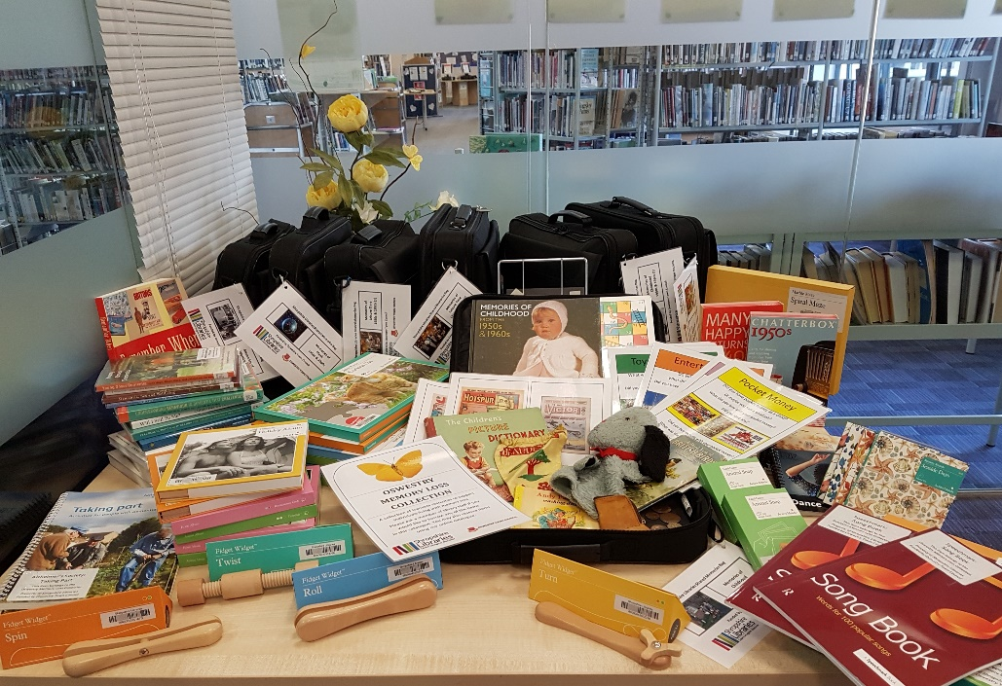
Visit https://shropshire.gov.uk/media/18666/omlc-catalogue.pdf to explore the collection and place reservations.

Events
Check in your branch and on the library website for regular updates on friendly and stimulating events. All library staff are Dementia Friends.

