Think Which Service Campaign Case Studies
IMAGE | FACEBOOK | INSTAGRAM | ALT TEXT
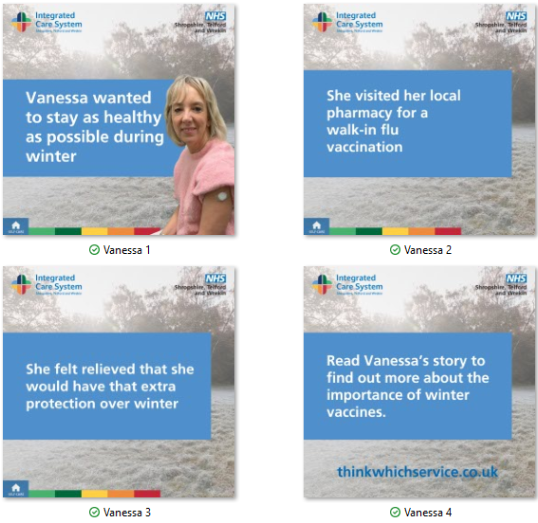 | Think vaccination to help protect yourself this winter.  During the winter #Flu and #COVID19 cases are likely to increase.  Protect you and your loved ones from becoming seriously unwell by getting your vaccinations if you’re eligible.  Read Vanessa’s story to find out more about the importance of winter vaccines ➡️https://www.shropshiretelfordandwrekin.nhs.uk/your-health/our-campaigns/think-which-service/vanessas-story/  #ThinkWhichService #Vaccinations #WinterVaccinations #NHSSTW | Think vaccination to help protect yourself this winter.  During the winter #Flu and #COVID19 cases are likely to increase.  Protect you and your loved ones from becoming seriously unwell by getting your vaccinations if you’re eligible  #ThinkWhichService #Vaccinations #WinterVaccinations #NHSSTW | Image 1: A wintery background and woman with a plaster on her arm. Text reads: Vanessa wanted to stay as healthy as possible during winter.  Image 2: Text reads: She visited her local pharmacy for a walk-in flu vaccination.  Image 3: Text reads: She felt relieved that she would have extra protection over winter.  Image 4: Text reads: Read Vanessa’s story to find out more about the importance of winter vaccines.
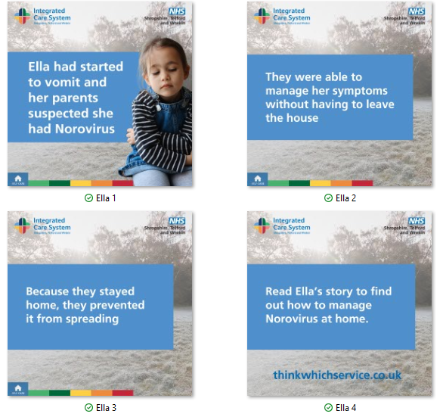 | Norovirus spreads easily and can cause unpleasant symptoms such as:  - Vomiting  - Diarrhoea  - Stomach cramps  How to stop the spread:  - Wash your hands regularly with soap and water  - Stay at home until 48 hours after your symptoms have stopped  - Keep surfaces clean and wash laundry thoroughly  Keep yourself and others healthy this winter 💙  Read Ella’s story to find out more about self-care ➡️https://www.shropshiretelfordandwrekin.nhs.uk/your-health/our-campaigns/think-which-service/ellas-story/  #ThinkWhichService #NHSSTW #NHS #Norovirus | Norovirus spreads easily and can cause unpleasant symptoms such as:  - Vomiting  - Diarrhoea  - Stomach cramps  How to stop the spread:  - Wash your hands regularly with soap and water  - Stay at home until 48 hours after your symptoms have stopped  - Keep surfaces clean and wash laundry thoroughly  Keep yourself and others healthy this winter 💙  #ThinkWhichService #NHSSTW #NHS #Norovirus | Image 1: A wintery background and a young girl holding her tummy. Text reads: Ella had started to vomit and her parents suspected she had Norovirus.  Image 2: Text reads: They were able to manage her symptoms without having to leave the house.  Image 3: Text reads: Because they stayed home, they prevented it from spreading.  Image 4: Text reads: Read Ella’s story to find out how to manage Norovirus at home.
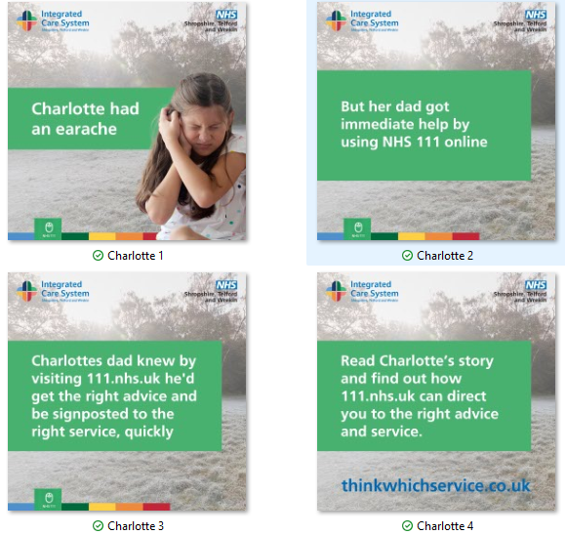 | It’s never easy when your little one isn’t feeling well 💙  If you’re unsure what to do, NHS 111 is here to help and can give you expert advice and guide you to the right care, all from the comfort of your own home 🏠  Quick, simple, and available 24/7.  Read Charlotte’s story to find out more about how NHS 111 can help➡️ https://www.shropshiretelfordandwrekin.nhs.uk/your-health/our-campaigns/think-which-service/charlottes-story/ ️  #ThinkWhichService #NHSSTW #NHS | It’s never easy when your little one isn’t feeling well 💙  If you’re unsure what to do, NHS 111 is here to help and can give you expert advice and guide you to the right care, all from the comfort of your own home 🏠  Quick, simple, and available 24/7.  #ThinkWhichService #NHSSTW #NHS | Image 1: A wintery background and a young girl holding her ear. Text reads: Charlotte had an earache.  Image 2: Text reads: But her dad got immediate help by using NHS 111 online.  Image 3: Text reads: Charlotte’s dad knew by visiting 111.nhs.uk he’d get the right advice and be signposted to the right service, quickly.  Image 4: Text reads: Read Charlotte’s story and find out how 111.NHS.uk can direct you to the right advice and service.
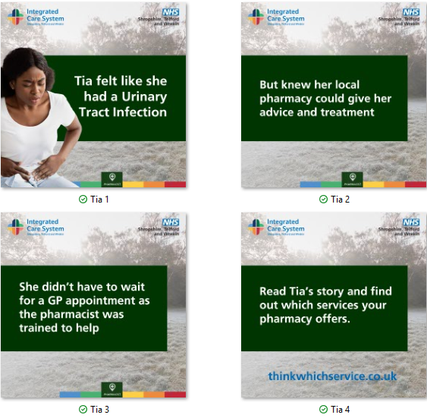 | Before booking a GP appointment, think #PharmacyFirst 💙  Your local pharmacist is highly trained to assess your symptoms and provide expert advice or treatment, often without an appointment.  From coughs and colds to sore throats and skin rashes, pharmacies can help you feel better faster this winter.  Read Tia’s story to find out more about Pharmacy First ➡️https://www.shropshiretelfordandwrekin.nhs.uk/your-health/our-campaigns/think-which-service/tias-story/️  #ThinkWhichService #NHSSTW #NHS #Pharmacy | Before booking a GP appointment, think #PharmacyFirst 💙  Your local pharmacist is highly trained to assess your symptoms and provide expert advice or treatment, often without an appointment.  From coughs and colds to sore throats and skin rashes, pharmacies can help you feel better faster this winter.  #ThinkWhichService #NHSSTW #NHS #Pharmacy | Image 1: A wintery background and a young adult holding her stomach. Text reads: Tia felt like she had a Urinary Tract Infection  Image 2: Text reads: But knew her local pharmacy could give her advice and treatment.  Image 3: Text reads: She didn’t have to wait for a GP appointment as the pharmacist was trained to help.  Image 4: Text reads: Read Tia’s story and find out which services your pharmacy offers.
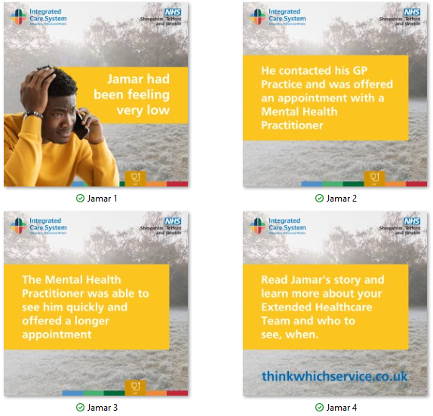 | Did you know GP practices across Shropshire, Telford and Wrekin are now supported by extended healthcare teams? 💡  From mental health practitioners and pharmacists to care coordinators and nurses, these experts work alongside your GP to ensure you get the right care, at the right time. 💙  Read Jamar’s story to find out more about the teams working in GP Practices ➡️https://www.shropshiretelfordandwrekin.nhs.uk/your-health/our-campaigns/think-which-service/jamars-story/️  #ThinkWhichService #NHSSTW #NHS #GP | Did you know GP practices across Shropshire, Telford and Wrekin are now supported by extended healthcare teams? 💡  From mental health practitioners and pharmacists to care coordinators and nurses, these experts work alongside your GP to ensure you get the right care, at the right time. 💙  #ThinkWhichService #NHSSTW #NHS #GP | Image 1: A wintery background and a young adult holding his head. Text reads: Jamar had been feeling very low.  Image 2: Text reads: He contacted his GP Practice and was offered an appointment with a Mental Health Practitioner.  Image 3: Text reads: The Mental Health Practitioner was able to see him quickly and offered a offered a longer appointment.  Image 4: Text reads: Read Jamar’s story and learn more about your Extended Healthcare Team and who to see, when.
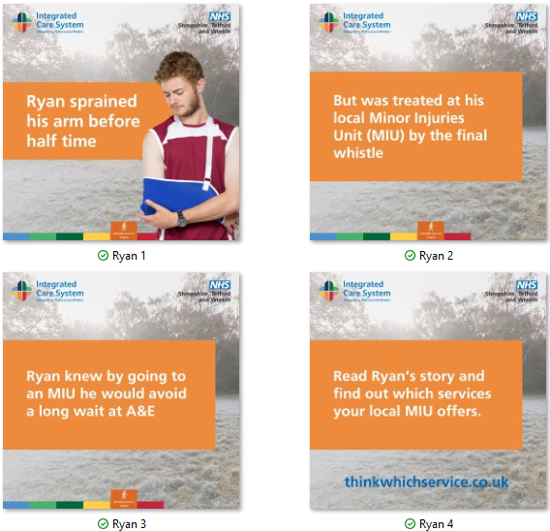 | Your local #MinorInjuryUnit (MIU) can help you get the care you need quickly, avoiding long waits in A&E. ⏰  MIUs treat a range of non-life-threatening injuries, including:  - Burns and scalds  - Sprains and strains  - Minor fractures  - Wounds needing stitches  - Minor head injuries  Get the right care, in the right place, this winter. 💙  Read Ryan’s story to find out more about Minor Injury Units ➡️https://www.shropshiretelfordandwrekin.nhs.uk/your-health/our-campaigns/think-which-service/ryans-story/  #ThinkWhichService #NHSSTW #NHS #MIU | Your local #MinorInjuryUnit (MIU) can help you get the care you need quickly, avoiding long waits in A&E. ⏰  MIUs treat a range of non-life-threatening injuries, including:  - Burns and scalds  - Sprains and strains  - Minor fractures  - Wounds needing stitches  - Minor head injuries  Get the right care, in the right place, this winter. 💙  #ThinkWhichService #NHSSTW #NHS #MIU | Image 1: A wintery background and a young adult holding his arm in a sling. Text reads: Ryan sprained his arm before half time.  Image 2: Text reads: But was treated at his local Minor Injury Unit (MIU) by the final whistle  Image 3: Text reads: Ryan knew by going to an MIU he would avoid a long wait at A&E.  Image 4: Text reads: Read Ryan’s story and find out which services your local MIU offers.

