
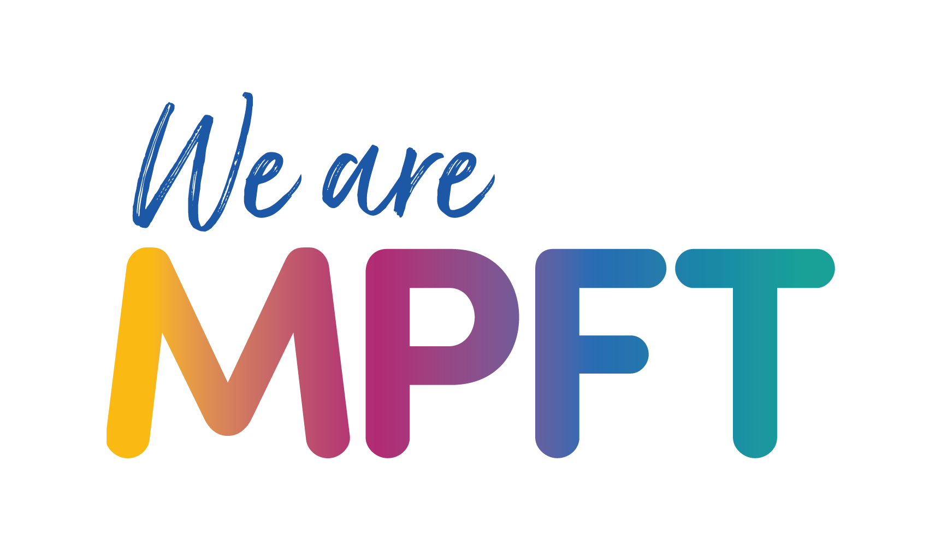


Child and Adolescent Mental Health Service Shropshire, Telford and Wrekin (CAMHS STW) – toolkit

Social media post

Facebook/ LinkedIn

A new NHS-led service for children and young people in Shropshire, Telford and Wrekin with mental health, emotional wellbeing and neurodevelopmental needs has launched.  The Child and Adolescent Mental Health Service Shropshire, Telford and Wrekin (CAMHS STW) is provided by @mpftnhs and replaces BeeU.  There will be a three-year journey of change, with easier access, earlier support and more joined-up care prioritised to ensure the right help is available at the right time.  The new service is also seeking to reduce inequalities in access, outcomes and experience, especially for vulnerable groups, including children in care and those with special education needs and disabilities (SEND).  For more information about the service, including what is changing visit www.mpft.nhs.uk/camhs-stw | 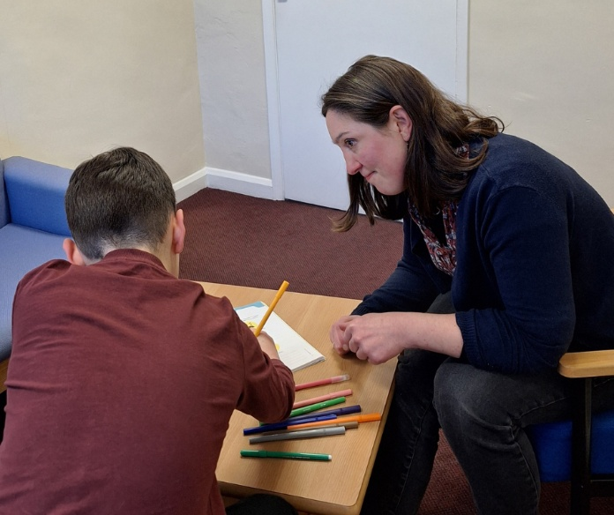  Alternative image  

Instagram

A new NHS-led service for children and young people in Shropshire, Telford and Wrekin with mental health, emotional wellbeing and neurodevelopmental needs has launched.  The Child and Adolescent Mental Health Service Shropshire, Telford and Wrekin (CAMHS STW) is provided by @mpftnhs and replaces BeeU.  There will be a three-year journey of change, with easier access, earlier support and more joined-up care prioritised to ensure the right help is available at the right time.  The new service is also seeking to reduce inequalities in access, outcomes and experience, especially for vulnerable groups, including children in care and those with special education needs and disabilities (SEND).  For more information about the service, including what is changing visit www.mpft.nhs.uk/camhs-stw | 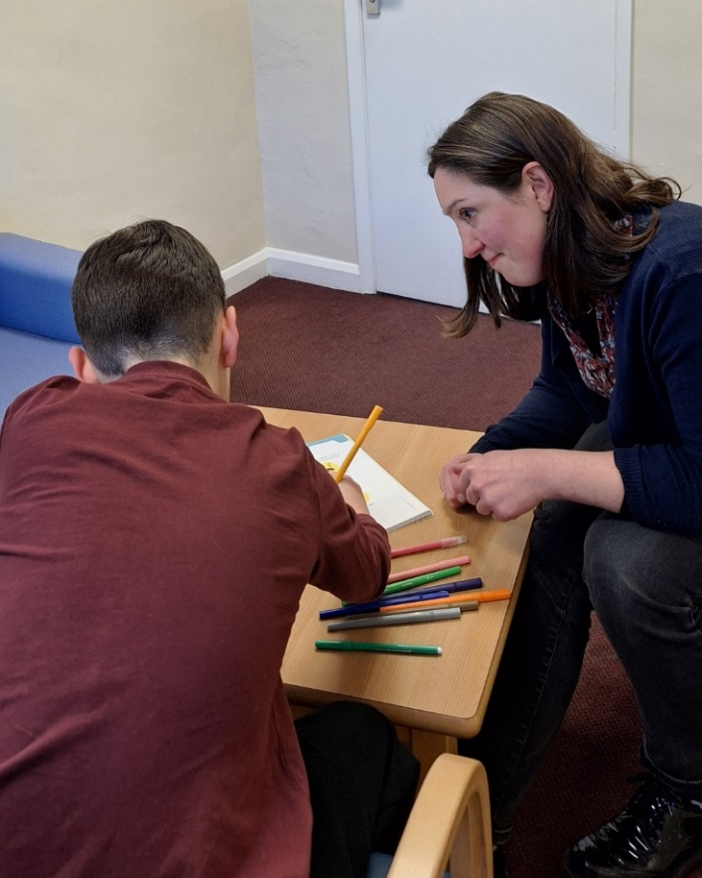  Alternative image  

