Child and Adolescent Mental Health Services (CAMHS)
Frequently Asked Questions (FAQs)
FAQs – July 2025
- Why is the CAMHS procurement exercise taking place, and why now?
NHS Shropshire, Telford and Wrekin (NHS STW) is re-procuring the Child and Adolescent Mental Health Services (CAMHS) to comply with statutory and legal duties. This is part of our regular business cycle as a commissioning organisation.
The Provider Selection Regime (PSR), effective from 1 January 2024, mandates specific rules for procuring healthcare services in England. The PSR was introduced by regulations made under the Health and Care Act 2022 which you can read more about at: NHS England » The Provider Selection Regime: statutory guidance.
As a result of this, we have had to undertake an exercise to look at all contracts due to end in 2024-25 and to assess which procurement process can be used for each individual service using the legislative framework. CAMHS was a service that needed to undergo a re-procurement process and so the opportunity was taken to review and redesign the service prior to recommissioning and is aligned with the current BeeU contract due to end on 31/3/26.
- Why has the ICB decided to go down a competitive procurement route rather than awarding the contract on a ‘most suitable provider’ basis?
Due to changes in national regulations, NHS STW agreed to review and update the current service specification for CAMHS, to ensure that it is up to date, effective, efficient, meets all of the latest national and local improvement recommendations and best practice, and better meets the evolving needs of our local population.
The Health Care Services (Provider Selection Regime) Regulations 2023 (PSR) applies to this service, NHS STW must act in accordance with the following regulatory principles, that must all be done with a focus on integrated service delivery:
- securing the needs of the people who use the services
- improving the quality of the services
- improving efficiency in the provision of the services.
Relevant authorities (NHS STW) must also act transparently, fairly, and proportionately when procuring health care services.
There is further emphasis in PSR on the requirement for Commissioners to understand the markets they operate in. This understanding supports Commissioners in identifying the correct PSR supplier selection route. To enable decision making and ensure understanding of this market, a Prior Information Notice (PIN) was issued via Find a Tender Service (FTS) on 13th September 2024 and the Commissioner proceeded to

undertake market engagement with all the providers who Expressed an Interest in attending. In total, 15 potential provider organisations attended the market engagement event, which included 13 private sector/charitable sector organisations, and two NHS Mental Health Trusts. The level of attendance clearly identified a market for provision of this service.
Approval was given to proceed with a competitive open procurement i.e., tender process, enabling offers and bids to be robustly evaluated, providing assurance to NHS STW that the best provider has been selected to fulfil the contract considering assurance on delivery of the model as set out in the specification, quality & safety, outcomes and cost.
This approach helps us continue providing a high-quality mental health service that meets local needs.
- Is this a money-saving exercise? Will the ICB prioritise local knowledge, experience, and relationships above cost?
There is no financial saving because the same amount of investment will be spent, but on an improved version of the service that delivers greater access, experience and outcomes with a key focus on early identification, early help, support and prevention. It is about ensuring the best version possible of the service, with a service that is more effective, efficient and value for money but at the same cost.
Our priority is to minimise impact on children and young people and their families & carers while providing the best service possible with improved timeliness or service and outcomes. The decision to go out to procurement was driven by legislation, not financial considerations. The procurement aims to ensure value for money alongside high-quality service provision.
You can view the service specification for CAMHS here.
- How can you ensure this is in the best interest of patients, and how have people been involved in this process?
Providers bidding for the new contract must demonstrate how they will meet specific requirements and criteria including delivering improved access, experience and outcomes through a more integrated and improved delivery model that are better for our local residents. This will be evaluated by a range of individuals from both within and outside of NHS STW including four public representatives, based on providers’ answers to these questions.
As part of the process to review and redesign the service before recommissioning, involving and engaging the public was at the very centre of everything we did. We collected extensive feedback from children, young people, parents, and carers throughout the whole project to understand views on CAMHS, what is working well, the

challenges and what needs to be improved. This feedback helped shape the new service to better meet the changing needs of our local children and young people, and their carers and families, as well as professionals who work in these service areas. Four patient representatives are on the tender evaluation and bidder interview panel. Once the contract is in place, performance monitoring against a range of outcomes and criteria will also ensure requirements are met.
- When can we expect an outcome from the procurement exercise?
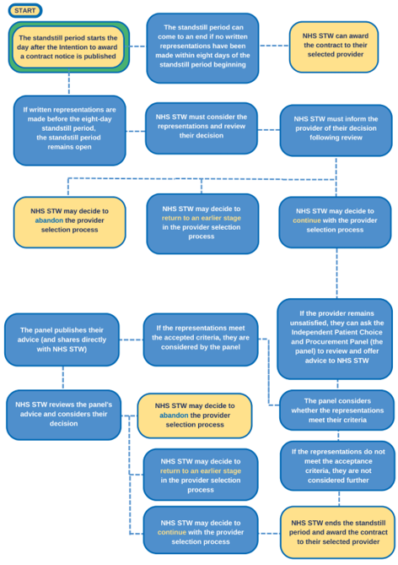
After the evaluation process in August 2025, outcomes will go through NHS STW governance in September 2025. Approval to award the contract the successful provider will be made in a closed Board due to the requirement of confidentiality, followed by a ‘standstill period’ as part of the PSR process. Until the process concludes, NHS STW cannot share the outcome due to legal constraints.

- Will a new provider change the current service?
The new provider will deliver services according to an updated specification designed to better meet the needs of our current and future population. This specification was developed through extensive engagement with the public and professionals. While the goal is to ensure minimal impact on service users, the changes aim to improve the service to better meet the demands of the population.
Key priorities include earlier assessment, identification, early help, intervention, prevention, and improving outcomes. Additional resources from the Mental Health Investment Standard (MHIS) and Service Development Funding (SDF) will expand CAMHS capacity, reduce waiting times, and ensure timely support. Revised Key Performance Indicators (KPIs) will target critical areas such as routine mental health assessments, crisis response, and neurodevelopmental assessments, ensuring a sustainable and effective mental health service for children and adolescents.

-Ends-

