
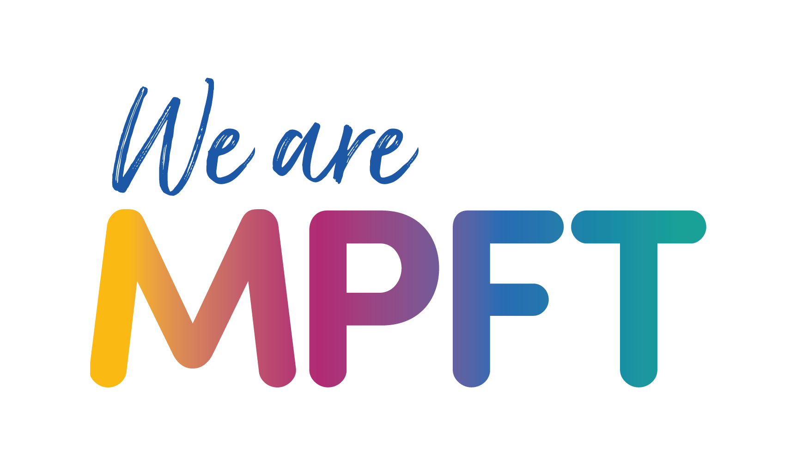


Child and Adolescent Mental Health Service Shropshire, Telford and Wrekin (CAMHS STW) – toolkit

Copy for websites

Child and Adolescent Mental Health Service Shropshire, Telford and Wrekin (CAMHS STW) provides NHS emotional wellbeing and mental health services for children and young people aged 0 to 25 in Shropshire, Telford and Wrekin, and also supports families and carers. The service helps with:

- Emotional wellbeing and mental health support for children and young people (0-25)
- Questions about autism for children and young people aged 5-18
- Questions about Attention Deficit Hyperactivity Disorder (ADHD) for children and young people aged 6–18
- Eating problems for children and young people aged up to 18 years

How to access help and support
CAMHS STW’s website provides information on the different ways to access support – these include:

- Services children, young people and families can directly access – including online emotional wellbeing support for children and young people aged 11-25 without the need for a referral.
- How professionals can refer children, young people and families for assessment and treatment when more help is needed
- Support available if there is an immediate concern

Urgent help
If you are experiencing something that makes you feel unsafe, distressed, or worried about your mental health, or if you are worried a child or young person’s mental health call NHS 111 and select the mental health option (option 2).

You can also:

- Call 0808 196 4501 for 24/7 to speak to the urgent NHS Mental Health Helpline
- Text STW to 85258 to receive support for your mental health at any time of the day or night
- Email access.shropshire@mpft.nhs.uk

In an emergency call 999
If you are worried about your own, or someone else's immediate safety, have thoughts about hurting yourself or other people, or do not feel you can keep yourself or someone else safe, you should call 999 immediately.

www.mpft.nhs.uk/camhs-stw

