
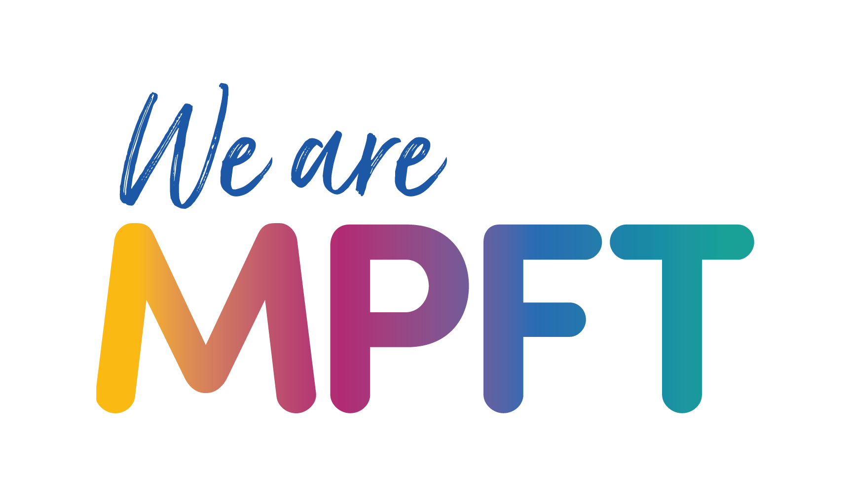


Child and Adolescent Mental Health Service Shropshire, Telford and Wrekin (CAMHS STW) – toolkit

Copy for newsletters (shorter copy)

Launch of the Child and Adolescent Mental Health Service Shropshire, Telford and Wrekin (CAMHS STW)
A new model for emotional wellbeing and mental health services for children, young people and their families and carers launched on 1 April in Shropshire, Telford and Wrekin, marking the start of a three-year journey of transformation.

Child and Adolescent Mental Health Service Shropshire, Telford and Wrekin (CAMHS STW) replaces and expands on the previous BeeU service and will be provided by Midlands Partnership University NHS Foundation Trust (MPFT) – the same NHS trust that delivered BeeU.

Care will continue for any child or young person currently receiving support. They do not need to opt in or be re-referred.

CAMHS STW helps with:

- Emotional wellbeing and mental health support for children and young people (0-25)
- Questions about autism for children and young people aged 5-18
- Questions about Attention Deficit Hyperactivity Disorder (ADHD) for children and young people aged 6–18
- Eating problems for children and young people aged up to 18 years

It will be prioritising easier access, earlier support and more joined-up care over the next three years to ensure the right help is available at the right time. It is also seeking to reduce inequalities in access, outcomes and experience, especially for vulnerable groups, including children in care and those with special education needs and disabilities (SEND).

For more information about the service, including what is changing over the next three years visit www.mpft.nhs.uk/camhs-stw

