
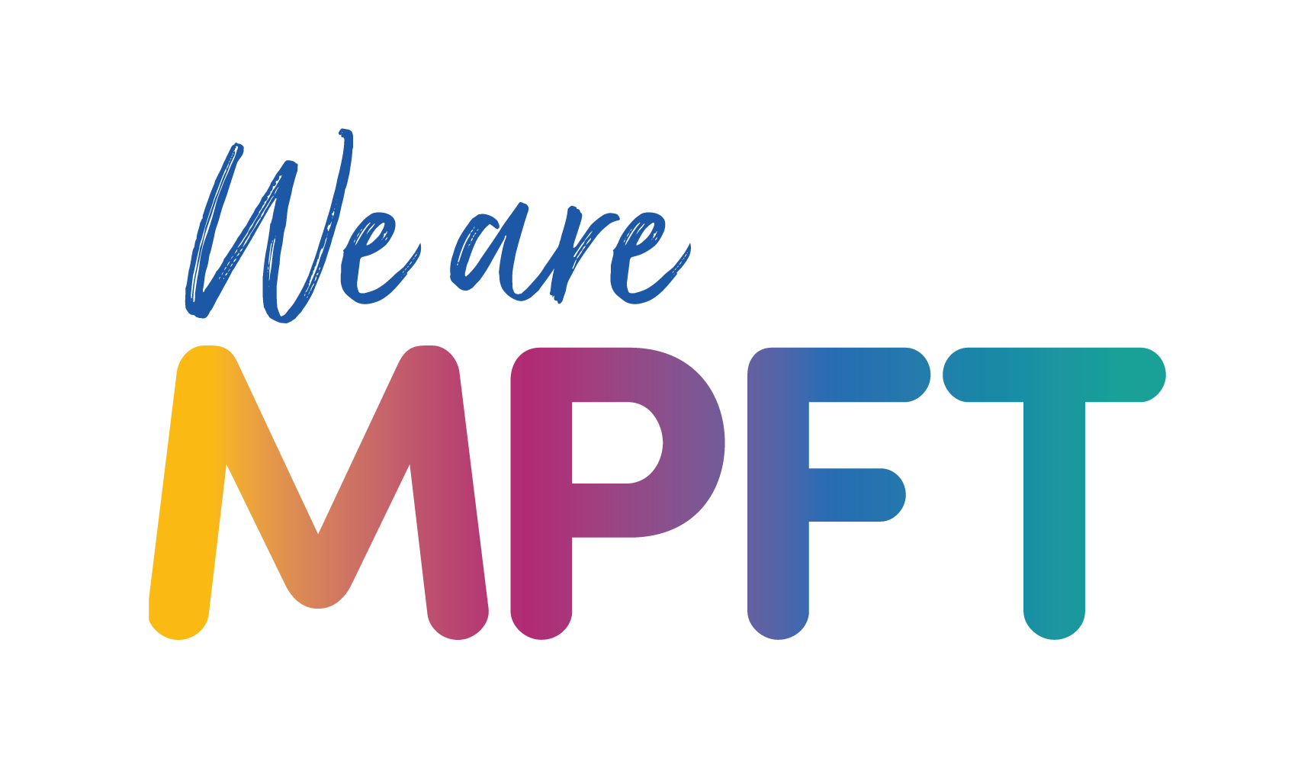


Child and Adolescent Mental Health Service Shropshire, Telford and Wrekin (CAMHS STW) – toolkit

Copy for newsletters (longer copy)

Launch of the Child and Adolescent Mental Health Service Shropshire, Telford and Wrekin (CAMHS STW)
A new model for emotional wellbeing and mental health services for children, young people and their families and carers launched on 1 April in Shropshire, Telford and Wrekin, marking the start of a three-year journey of transformation.

Child and Adolescent Mental Health Service Shropshire, Telford and Wrekin (CAMHS STW) replaces and expands on the previous BeeU service and will be provided by Midlands Partnership University NHS Foundation Trust (MPFT) – the same NHS trust that delivered BeeU.

It is important to note that care will continue for any child or young person currently receiving support. They do not need to opt in or be re-referred.

CAMHS STW helps with:

- Emotional wellbeing and mental health support for children and young people (0-25)
- Questions about autism for children and young people aged 5-18
- Questions about Attention Deficit Hyperactivity Disorder (ADHD) for children and young people aged 6–18
- Eating problems for children and young people aged up to 18 years

The new service model will be prioritising easier access, earlier support and more joined-up care over the next three years to ensure the right help is available at the right time.

It is also seeking to reduce inequalities in access, outcomes and experience, especially for vulnerable groups, including children in care and those with special education needs and disabilities (SEND).

What will be changing
- One front door for information and referrals, guiding people to the right support
- Earlier help and support while waiting
- Joined-up care so families don’t repeat their story
- Support from 0–25, with planned moves into adult services where required
- Fair access and targeted support for vulnerable groups, including the development, in partnership with local authorities, of an enhanced pathway for children with specific needs in this area
- An improved digital offer providing greater choice to children, young people and families in how to access the support they need
- An enhanced pathway to more effectively meet the needs of vulnerable children will be developed later this year in partnership with local authorities as part of the ongoing transformation of the service

The new service will offer help for everyday worries and provide short-term support when needs are rising, alongside specialist care for more complex difficulties, and round-the-clock urgent support.

It will strengthen its autism and attention deficit hyperactivity disorder (ADHD) support, with clear steps, family and school advice, and safe medication reviews where appropriate, while for eating difficulties and disorders there will be greater community-based support in place, alongside early help and medical monitoring.

Support in schools will continue to expand through the Mental Health Support Teams, with the ambition to reach all schools by 2030.

The transition to adult services will also be improved, with young people being supported where needed, and those leaving the service will receive a care and support plan, with a quick route back if things change.

The service will continue to develop over the next three years, and children, young people, families and professionals will be able to get involved in helping to shape this. MPFT will also work closely with NHS Shropshire, Telford and Wrekin, local authorities, schools and VCSE partners to ensure the new service continues to reflect local priorities and lived experiences of families in Shropshire, Telford & Wrekin.

How to access help and support
CAMHS STW’s website (link below) provides information on the different ways to access support, including:

- Services children, young people and families can directly access – including online emotional wellbeing support for children and young people aged 11-25 without the need for a referral.
- How professionals can refer children, young people and families for assessment and treatment when more help is needed
- Support available if there is an immediate concern

For more information visit www.mpft.nhs.uk/camhs-stw

