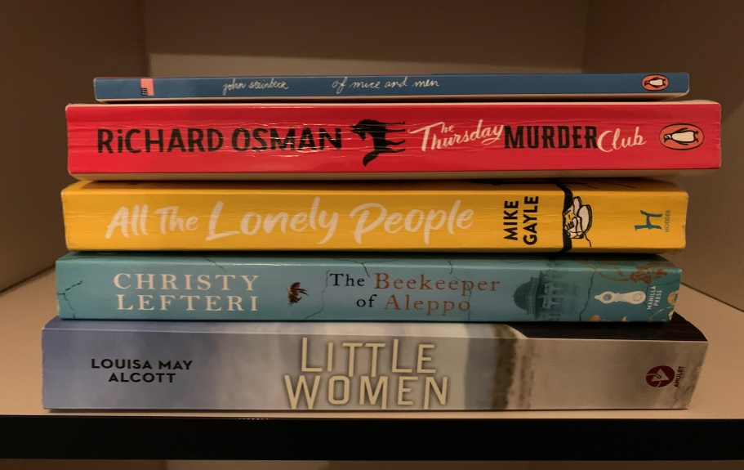
Here’s a selection of the books we’ve read so far.
Interested in setting up a book club?
After some suggestions about staff interests and improving wellbeing, a group of staff across the CCG came together and did just that! During the second lockdown in October 2020 a small but perfect book loving group was formed.
Aptly named Little Women & Meredith, the members are Meredith Vivian, Alison Massey, Lynn Nicholls, Rachel Rogers & Charlotte Dunn.
We meet over MS Teams roughly every 6 weeks, and commit to reading the chosen book within that time. It’s an enjoyable way to spend some downtime, we can keep in contact with colleagues that we wouldn’t otherwise connect with, and it exposes us to books that we may not have chosen ourselves. So a win win all round!
We are now amazingly on our 11th book, and we offer some “top tips” if you want to set up a book club of your own…
• You don’t always have to buy the book full price – you can pre-order via Shropshire Libraries online for just 75p per book. It’s also a good way to support your local library.
• Make use of technology with audio versions – especially great for listening to if you are often in the car.
• If you’re really not enjoying the book, don’t put yourself under too much pressure to finish it. You can still add something to the debate even by reading 2 chapters. Reading should be enjoyable after all!
• We score each book that we read, and keep a log of the scores to look back on.
• Don’t take it too seriously…have a laugh!
For more information, or if you want to join in then feel free to contact one of the members.
Article by Rachel Rogers

