Image | Twitter | Facebook / LinkedIn
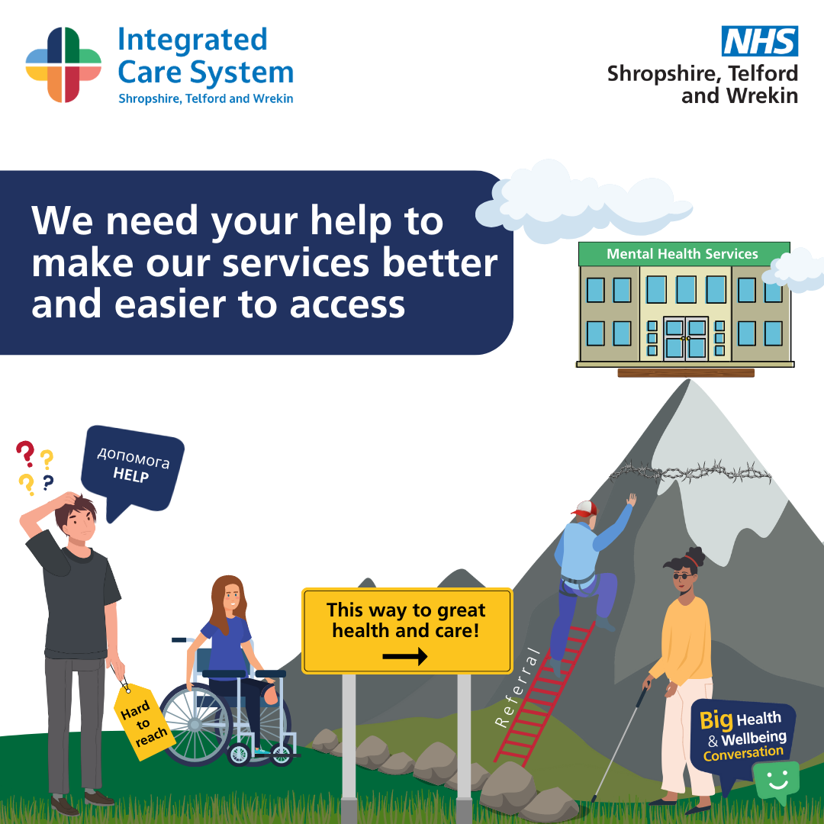 | The #NHS Big Health and Wellbeing Conversation Survey is now live 🗨️ Your feedback will help the NHS to improve local services. To complete the #survey and for a chance to #WIN a £100 voucher ➡️: www.nhsbigconversation.org The survey closes Thursday 22 June 2023. | The Big Conversation survey is now live 🗨️ Anyone who lives, works or accesses health and care services in Shropshire, Telford and Wrekin can take part. Your feedback will help the NHS to improve local services.  To complete the #survey and for a chance to #WIN a £100 voucher, please visit ➡️: www.nhsbigconversation.org  The survey closes Thursday 22 June 2023.
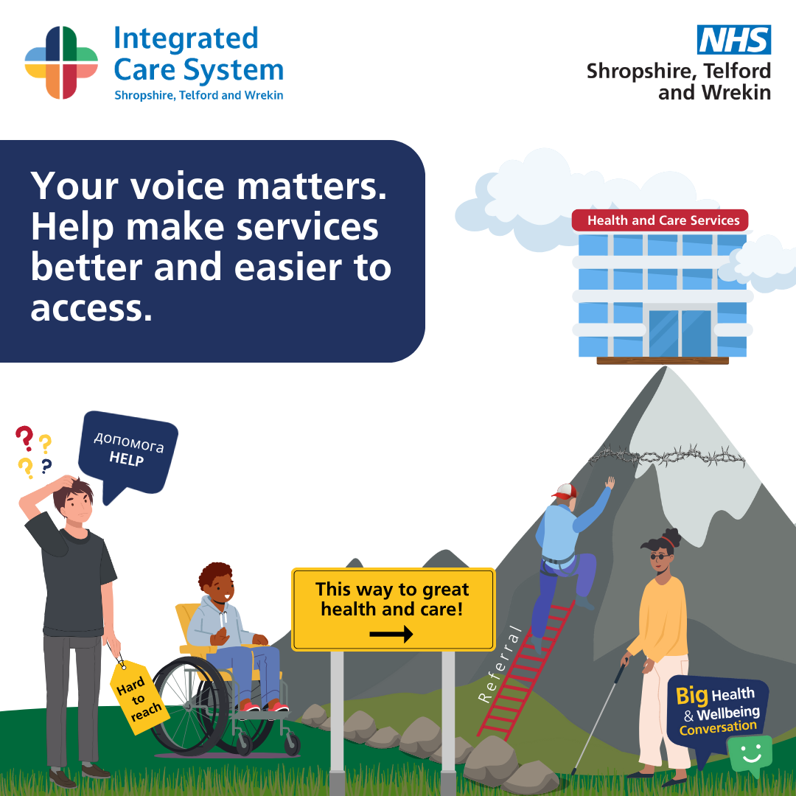 | Your voice matters! 📣 Help #NHS Shropshire, Telford and Wrekin understand what is affecting your #health and #wellbeing by completing this short #survey, and for a chance to #WIN a £100 voucher ➡️: www.nhsbigconversation.org  The survey closes Thursday, 22 June 2023. | Your voice matters! 📣  Help #NHS Shropshire, Telford and Wrekin understand what is affecting your #health and #wellbeing by completing this short survey, and for a chance to #WIN a £100 voucher, please visit ➡️: www.nhsbigconversation.org  The survey closes Thursday 22 June 2023.
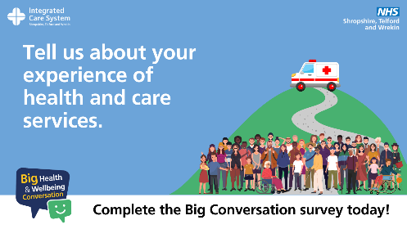 | Have your say! The #NHS Big Health and Wellbeing Conversation Survey is now live 🗨️  Your feedback will help the NHS to improve local services. To complete the #survey and for a chance to #WIN a £100 voucher ➡️: www.nhsbigconversation.org  The survey closes Thursday 22 June 2023. | Have your say! The #NHS Big Health and Wellbeing Conversation Survey is now live 🗨️  People from every corner of Shropshire are being invited to join a conversation about the future of health and care services. To complete the #survey and for a chance to #WIN a £100 voucher, please visit ➡️: www.nhsbigconversation.org  The survey closes Thursday 22 June 2023.
