Green

Amber

Red

Green

Amber

Red

This guidance is written in the following context

This assessment tool was arrived at after careful consideration of the evidence available including but not and NHS evidence. Healthcare the circumstances of the individual patient, in consultation with the patient and/or

Fever

Green – low risk

Fever advice for children and young people in Shropshire
Do not worry about food if your child does not
feel like eating but encourage them to drink more fluids.

Look for signs of dehydration such as a dry mouth, lack of tears, sunken eyes, sunken fontanelle – the soft spot on your baby’s head, passing less amounts of urine.

Children with a fever should not be over or underdressed. If your child is shivering or sweating a lot, change the amount of clothes they are wearing.

Physical methods of cooling your child such as fanning them, cold bathing and tepid sponging can cause discomfort and are not advised.

It is not necessary to use medicines to treat your child’s fever but if your child is distressed, you can help them feel better by giving them medicines like paracetamol or Ibuprofen. These medicines should not be given together. Always follow the instructions on the bottle to avoid overdosing your child. These medicines can
make your child feel more comfortable but they do not treat the cause of the temperature.

Check on your child regularly, including during the night, especially if your child is less than 6 months old as they are at higher risk of serious infection.

Keep your child away from nursery or school whilst they have a fever.
A fever is an increase in body temperature. This
in itself is not dangerous. Your child’s body temperature is normally between 36˚C and 37˚C, variations between 0.5 and 1 degree are common.

Fevers in children are not uncommon. This leaflet provides advice on when to seek help and on what you can do to help your child feel better. Often the fever lasts for a short duration and many children can be cared for at home if the child continues to drink, remains alert and does not develop any worrying symptoms.

However, if you are worried or your child is getting worse with warning symptoms as listed in this leaflet, then you should seek the advice of a healthcare professional.
Working out the cause of the fever
If you are talking to a healthcare professional on the telephone, they will ask you questions about your child’s health and symptoms. This will help them to decide if your child is best cared for at home or needs to see a healthcare professional face to face.

Sometimes your healthcare professional will not find a reason for your child’s fever, even after a full examination. If your child is otherwise looking well, then treatment may not be necessary.

Most children can be safely cared for at home if otherwise well. Your healthcare professional may decide that your child needs a follow-up appointment. They will give you information on how to look for symptoms that may suggest more serious illnesses and how to get further help if they occur.
The tumbler test
If a rash appears, do the tumbler test?
Press a glass tumbler firmly against the rash. If you can see spots through the glass and they do not fade, this is called a ‘non blanching rash’. If this rash is present, seek medical advice immediately to rule out serious infection.
The rash is harder to see on dark skin so check paler areas such as the palms of hands and soles of feet.
Looking after your feverish child
Give your child plenty of drinks e.g. water or squash. If you are breastfeeding then continue as breast milk is best.

Give babies smaller but more frequent feeds to help keep them hydrated.

Big 6 – Fever/Sepsis

What is a fever?

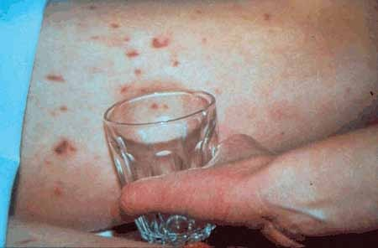
This guide will help you to select the right service to contact. You need to regularly check your child and follow the advice below:
999 or go straight to the nearest

If you have concerns about looking after your child at home

You need to see a nurse or doctor today. Please ring your surgery/health visitor/ community nurse/Shropshire Walk-in Centre or contact NHS111 by dialing 111 for access to the Out of Hours GP service.

 If your child’s health gets worse or if you are worried
 If your child has signs of dehydration including dry mouth, no tears, sunken eyes, sunken fontanelle (soft spot on the baby’s head), drowsiness and seems generally unwell
 The temperature lasts more than 5 days and your child has not seen a health care professional
 If your child is less than 6 months old

You need urgent help please phone

Accident and Emergency Dept.

 If your child becomes unresponsive

 If your child becomes blue

 If your child is finding it hard to breathe

 If your child has a fit

 If your child develops a rash that does not disappear with pressure (see the tumbler test)

Big 6 – Fever/Sepsis

Useful Information

GP Surgery

Shropshire Public Health Nursing Service
General Contact Number: 0333 358 3654

Telford and Wrekin
Public Health Nursing Service,
General Contact Number: 0333 358 3328

Shropshire Walk-in Centre Located next to
A&E at Royal Shrewsbury Hospital.
Open from 8am to 8pm,
7 days a week including bank holidays

NHS 111:
Dial 111 24 hour telephone service
Or visit NHS 111 Online https://111.nhs.uk/

(

All advice sheets can be found on Shropshire, Telford and Wrekin CCG Website: https://www.shropshiretelfordandwrekinccg.nhs.uk/your-health/childrens-health/

Sepsis advice sheet
What is Sepsis?

Big 6 – Fever/Sepsis

Sepsis is a rare but serious medical condition that results from the body’s overwhelming response to an infection.
Sepsis can occur in anyone at any time and from any type of infection affecting any part of the body.
Without quick and timely treatment, sepsis can lead to septic shock, multi-organ failure and death.
Causes of Sepsis
Sepsis is most often caused by bacterial, viral or fungal infections; sometimes the cause of sepsis is never identified.
Children with pneumonia, urinary tract infections, meningitis and severe skin infections can rapidly deteriorate and develop sepsis.
It is important to recognise and act quickly on the symptoms of sepsis in order to reduce morbidity and mortality.
Look out for the signs of Sepsis
A raised temperature (fever) in children is common, but can be worrying. Almost all children will recover quickly and without problems. However, a very small proportion may have a serious infection with sepsis (bloodstream infection) that requires urgent treatment in hospital.

This information is designed to help you monitor your child’s condition if they have a raised temperature, so you know when to ask for help and can describe the symptoms.

Just tick off any of those symptoms that you observe with a note of the date and time, and follow the advice at the top of the page.
For ease of use, the symptoms are split into:
Amber, where medical advice should be asked for

Red, which means you should get the child to hospital quickly – dial ‘999’ if necessary and ask for an ambulance.

Again, we must stress that the great majority of children do not have sepsis. But if you do have concerns and your child seems to be getting worse, even if their temperature falls, act swiftly just in case.

Find out more
Detailed information can be found on the NICE website: www.nice.org.uk/Guidance/CG160
The UK Sepsis Trust also has a lot of helpful material at: www.sepsistrust.org
Email: info@sepsistrust.org Phone: 0800 389 6255

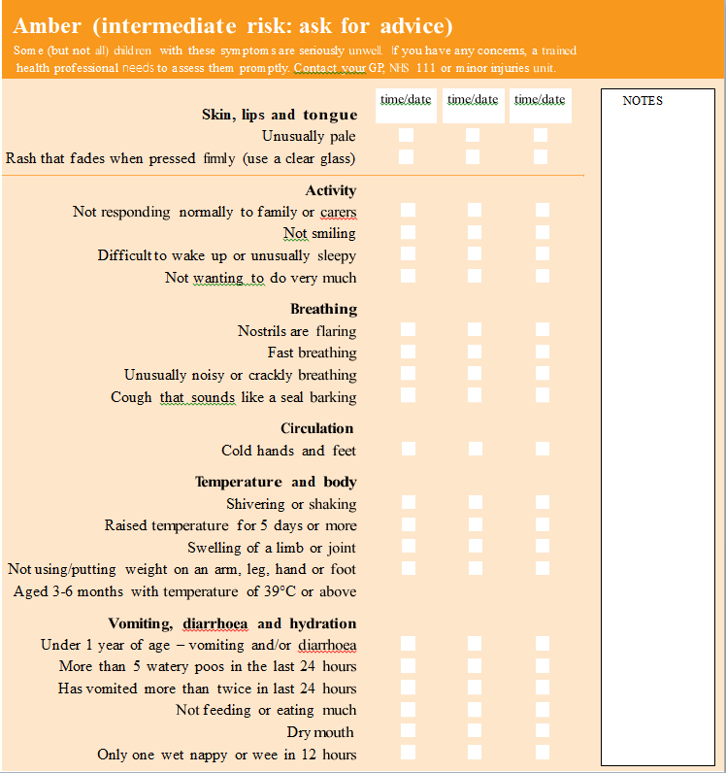
Big 6 – Fever/Sepsis

Big 6 – Fever/Sepsis

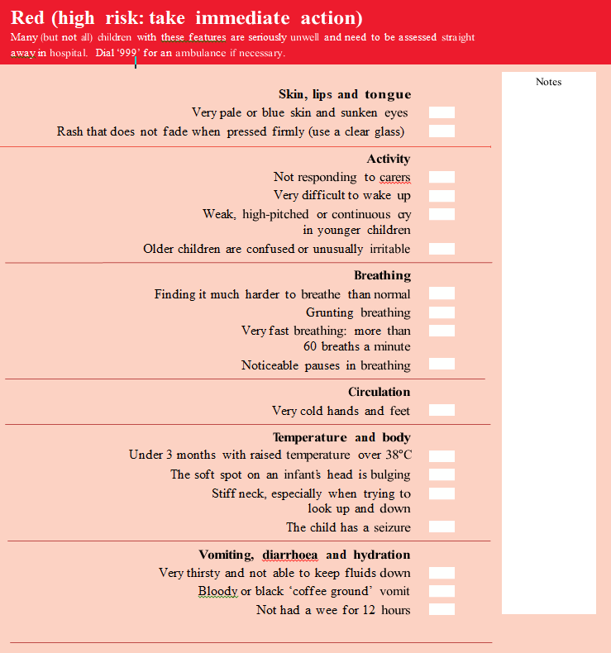

This guidance is written in the following context

This assessment tool was arrived at after careful consideration of the evidence available including but not guideline, EBM data and NHS evidence. Healthcare professionals are expected to take it fully into account when clinical judgement. The guidance does not, however, override the individual responsibility of healthcare professionals to make decisions appropriate to the circumstances of the individual patient, in consultation with the patient

Gastroenteritis

Most children

Green

Amber

Red

Head Injury

Green

Amber

Red

Head Injury

Green

Amber

Red

Abdominal Pain

.

)

Green

Amber

Abdominal Pain

