Image | Alt text
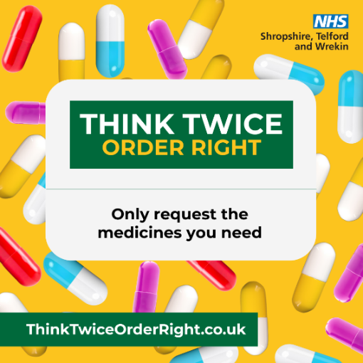 | Yellow background with tablet capsules. Text reads: Think Twice Order Right. Only request the medicines you need.
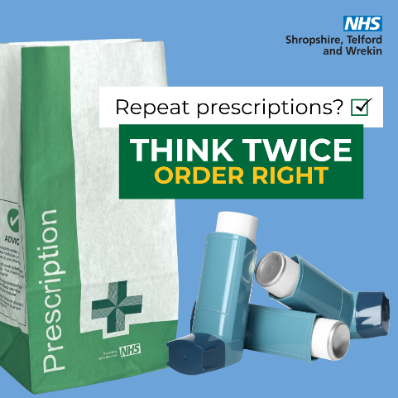 | Blue background. A pharmacy bag and inhalers. Text reads: Repeat prescriptions? Think Twice Order Right.
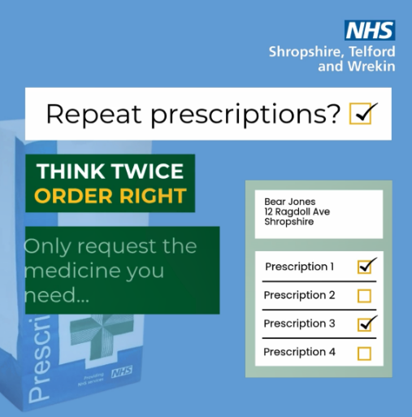 | Blue background. A pharmacy bag and check box list with two out of four options checked. Text reads: Repeat prescriptions? Think Twice Order Right. Only request the medicine you need… Bear Jones, 12 Ragdoll Ave, Shropshire. Prescription 1, Prescription 2, Prescription 3, Prescription 4.
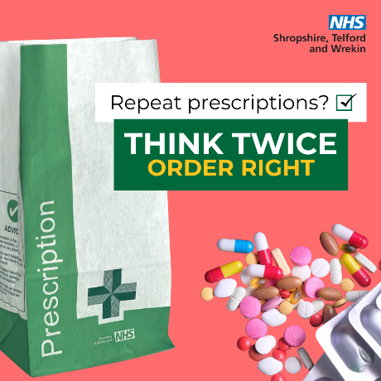 | Pink background. A pharmacy bag and a pile of tablets. Text reads: Repeat prescriptions? Think Twice Order Right.
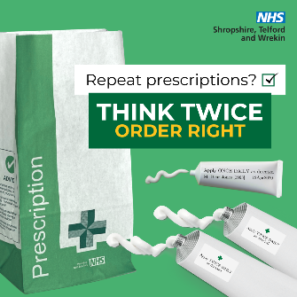 | Green background. A pharmacy bag and three tubes of ointment. Text reads: Repeat prescriptions? Think Twice Order Right.
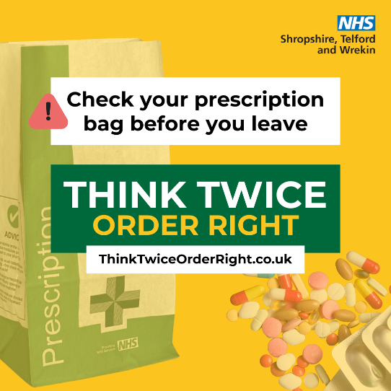 | Yellow background. A pharmacy bag and a pile of tablets. Text reads: Check your prescription bag before you leave. Think Twice Order Right.
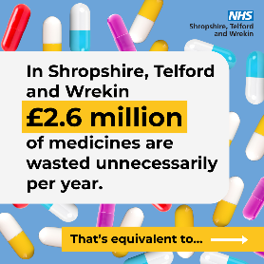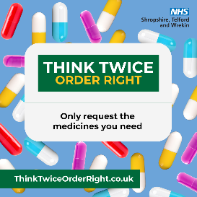 | Image 1: Blue background with tablet capsules. Text reads: In Shropshire, Telford and Wrekin £2.6 million of medicines are wasted unnecessarily per year. That’s equivalent to…  Image 2: A blue background. A photo of a doctor talking to a patient. Text reads: 61,900 GP appointments.  Image 3: Blue background with tablet capsules. Text reads: Think Twice Order Right. Only request the medicines you need.
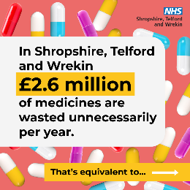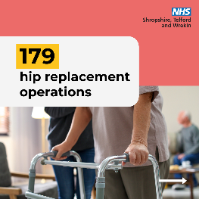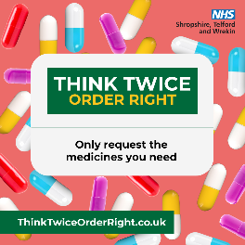 | Image 1: Pink background with tablet capsules. Text reads: In Shropshire, Telford and Wrekin £2.6 million of medicines are wasted unnecessarily per year. That’s equivalent to…  Image 2: A pink background. A photo of someone walking with a walking frame. Text reads: 179 hip replacement operations.  Image 3: Pink background with tablet capsules. Text reads: Think Twice Order Right. Only request the medicines you need.
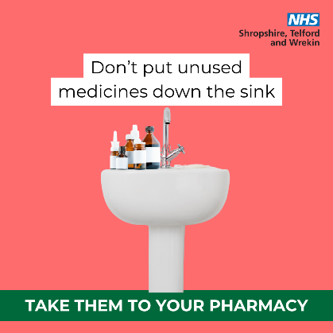 | Pink background with a photo of a sink. Text reads: Don’t put unused medicines down the sink. Take them to your pharmacy.
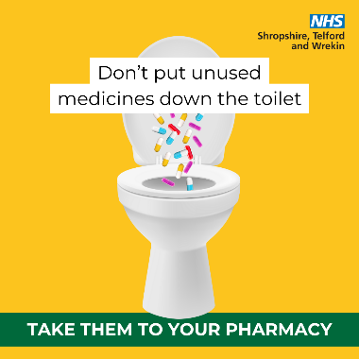 | Yellow background with a photo of a toilet. Text reads: Don’t put unused medicines down the toilet. Take them to your pharmacy.
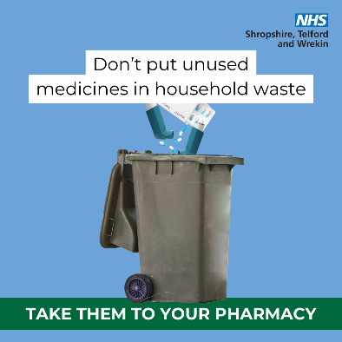 | Blue background with a photo of a bin. Text reads: Don’t put unused medicines in household waste. Take them to your pharmacy.
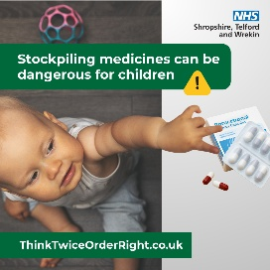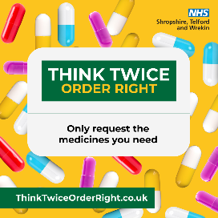 | Image 1: A baby reaching for packets of tablets. Text reads: Stockpiling medicines can be dangerous for children.  Image 2: A Yellow background with tablet capsules. Text reads: Think Twice Order Right. Only request the medicines you need.

