Think Which Service 2025/2026 - Festive period social media alt text
Image | Alt Text
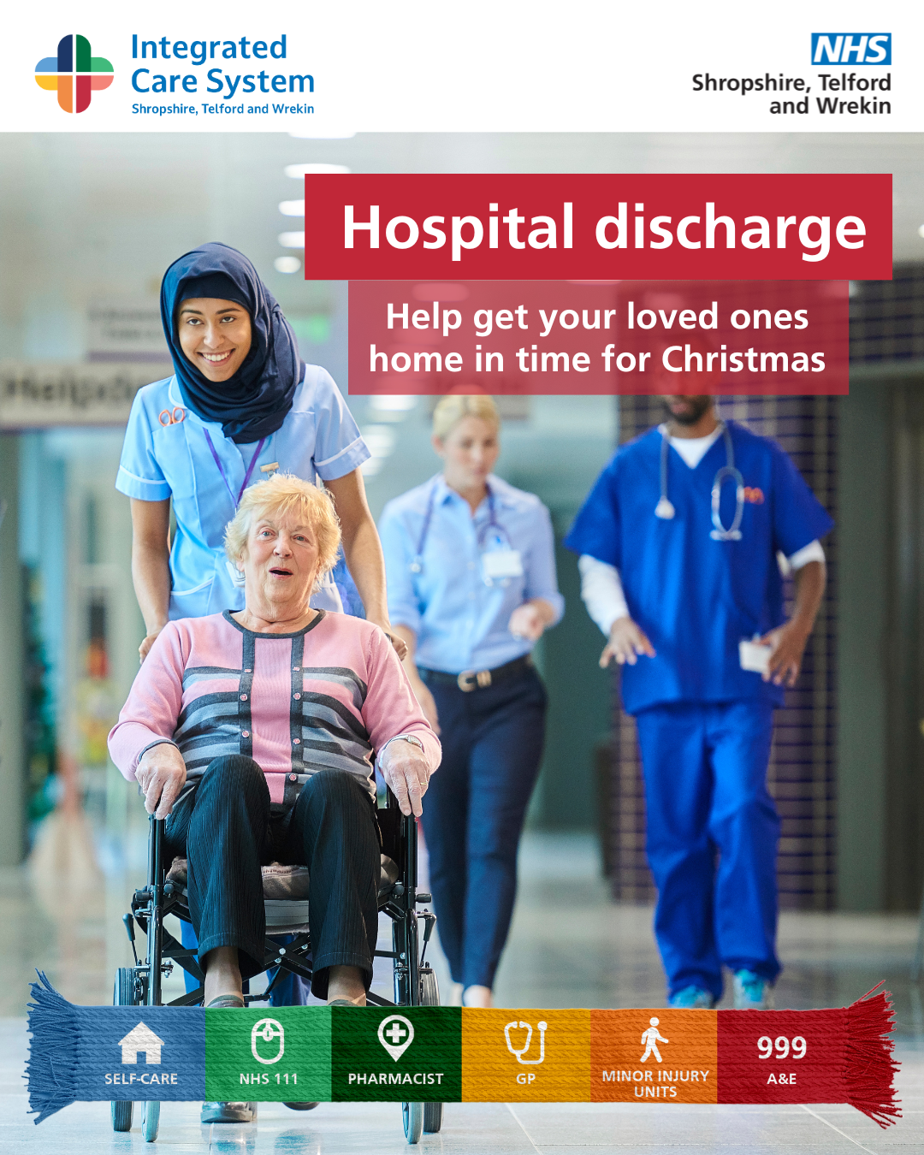 | A woman being pushed in a wheelchair by a healthcare worker. Text reads: Hospital discharge. Help your loved ones home in time for Christmas
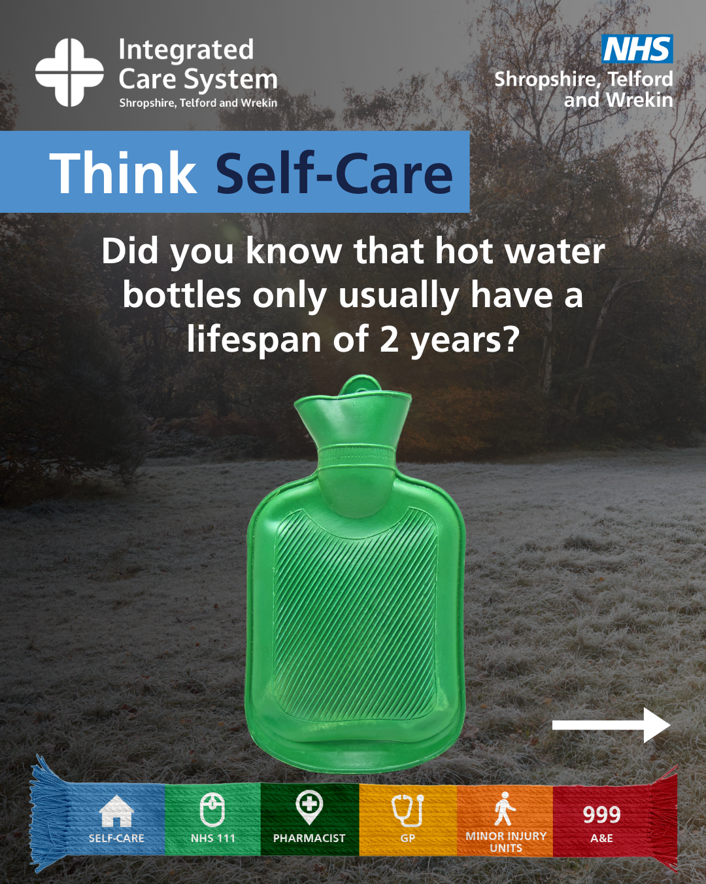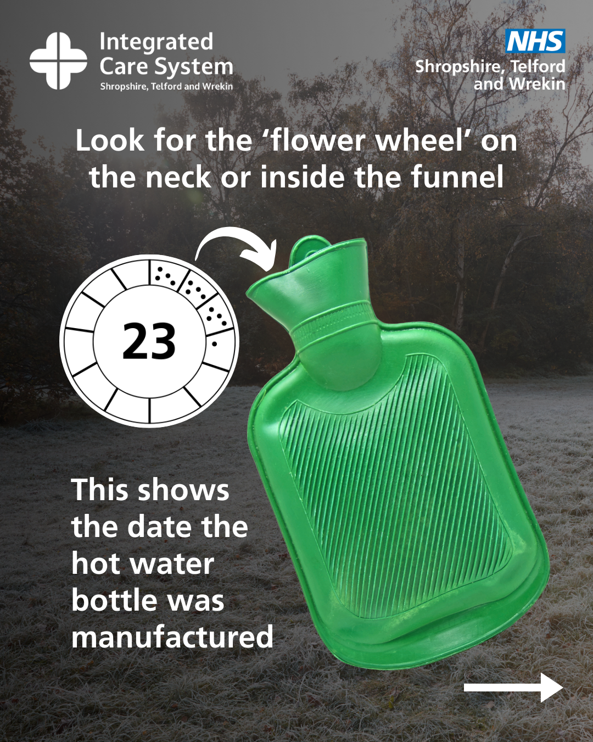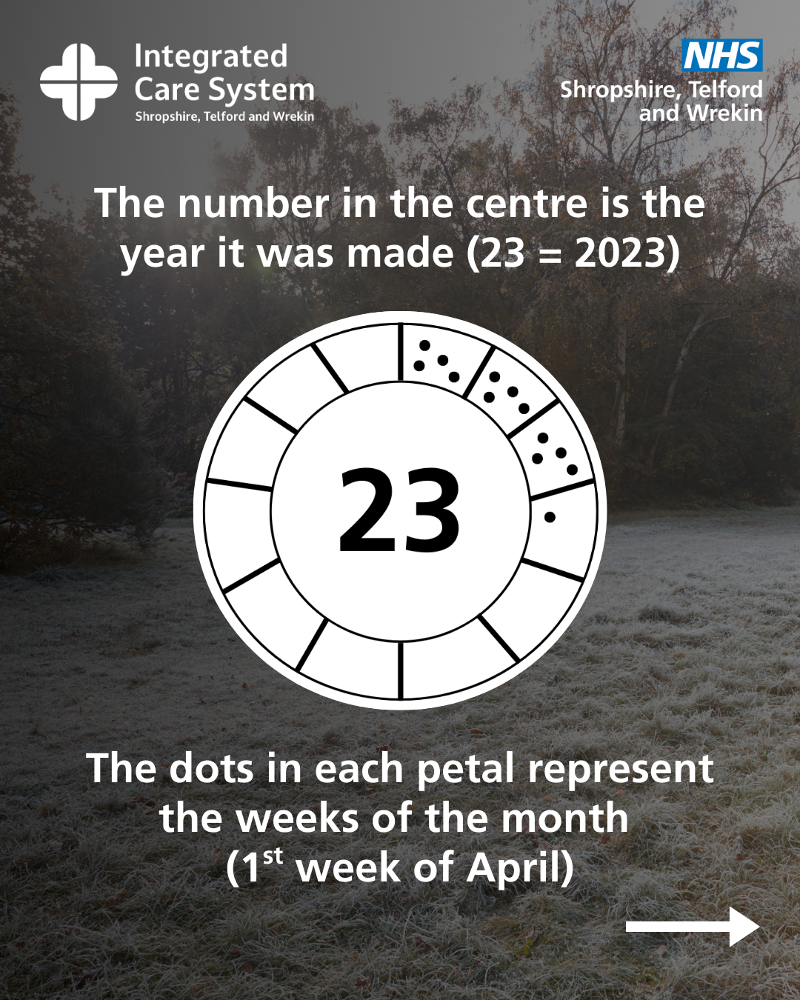  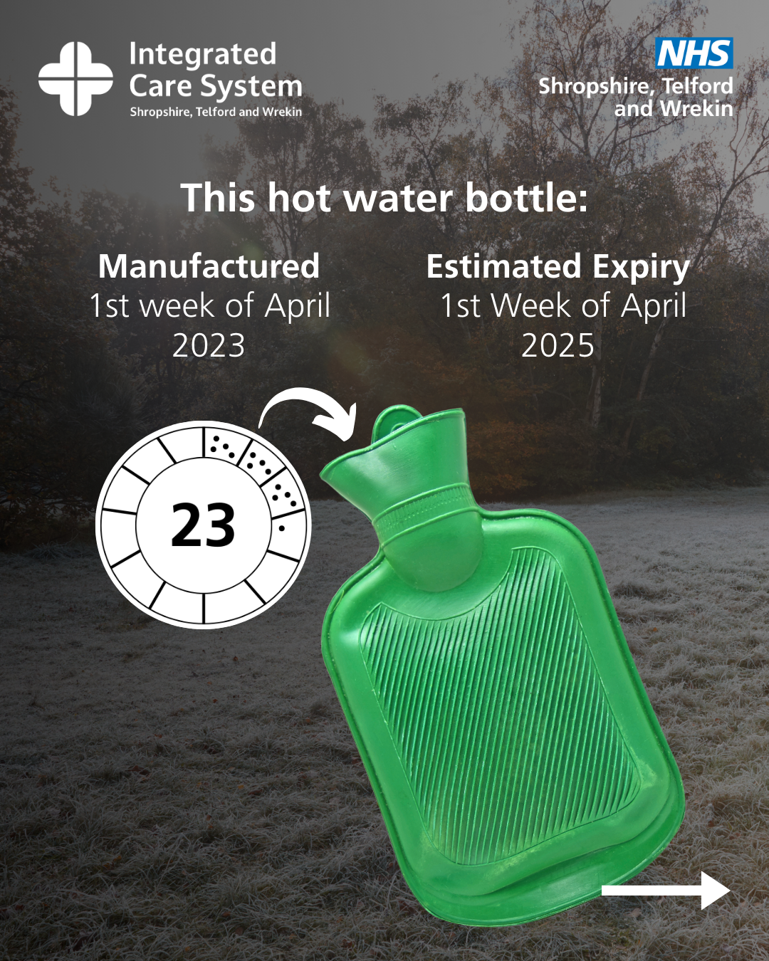 | Image 1: A green hot water bottle. Text reads: Think self care. Did you know that hot water bottles only usually have a lifespan of 2 years?  Image 2: A green hot water bottle. A circle icon with 23 in the middle. 12 sections surround this. Dots are in 4 of these sections. Text reads: Look for the flower wheel on the neck or inside the funnel. This shows the date the hot water bottle was manufactured.  Image 3: A green hot water bottle. A circle icon with 23 in the middle. 12 sections surround this. Dots are in 4 of these sections. In the fourth section there is only one dot. Text reads: The number in the centre is the year it was made (23 = 2023). The dots in each petal represent the weeks of the month (1st week of April).  Image 4: A green hot water bottle. A circle icon with 23 in the middle. 12 sections surround this. Dots are in 4 of these sections. Text reads: This hot water bottle: manufactured 1st week of April 2023. Estimated expiry 1st week of April 2025.
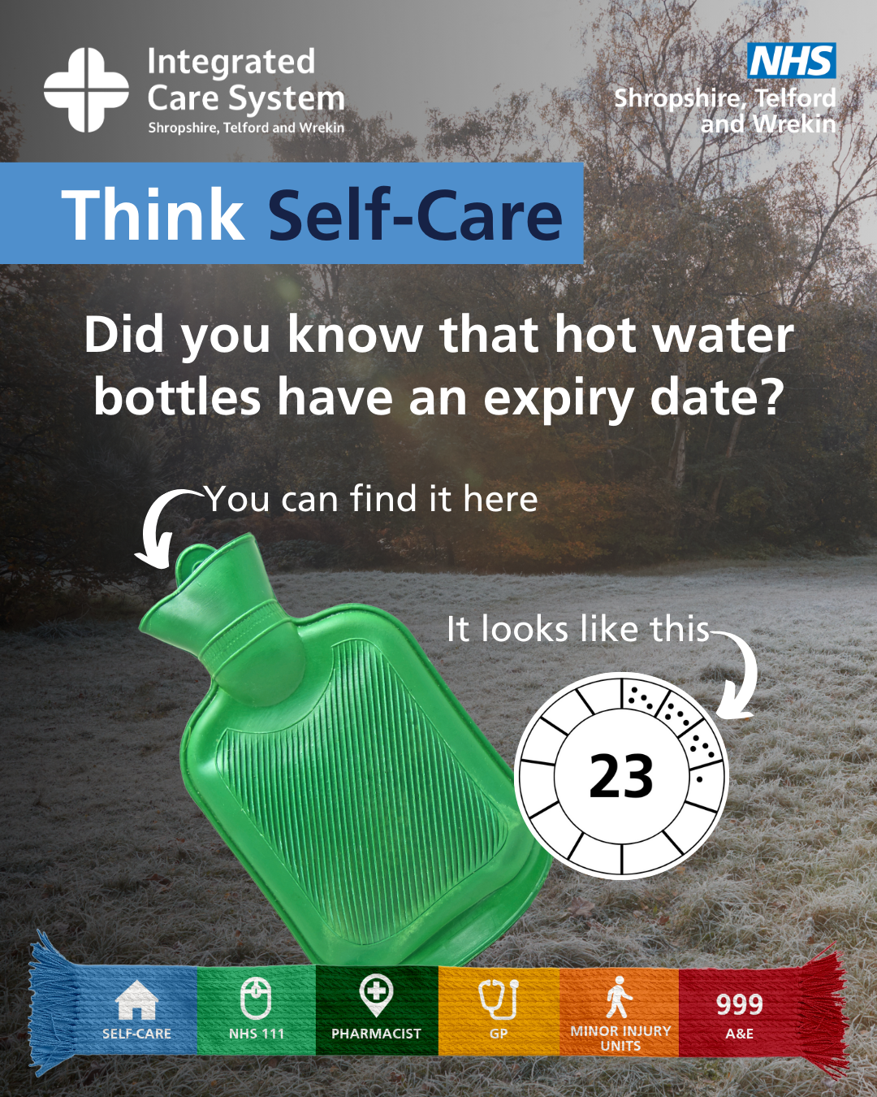 | Image 2: A green hot water bottle. A circle icon with 23 in the middle. 12 sections surround this. Dots are in 4 of these sections. Text reads: Think self care. Did you know that hot water bottles have an expiry date? You can find it here – an arrow points to the neck of the hot water bottle.  Text reads: It looks like this – an arrow points to the circle icon.
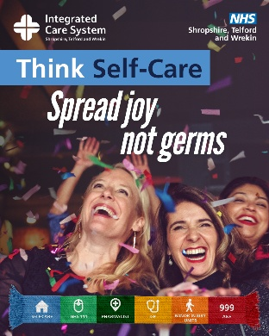 | Women partying. Text reads: Think self care. Spread joy, not germs.
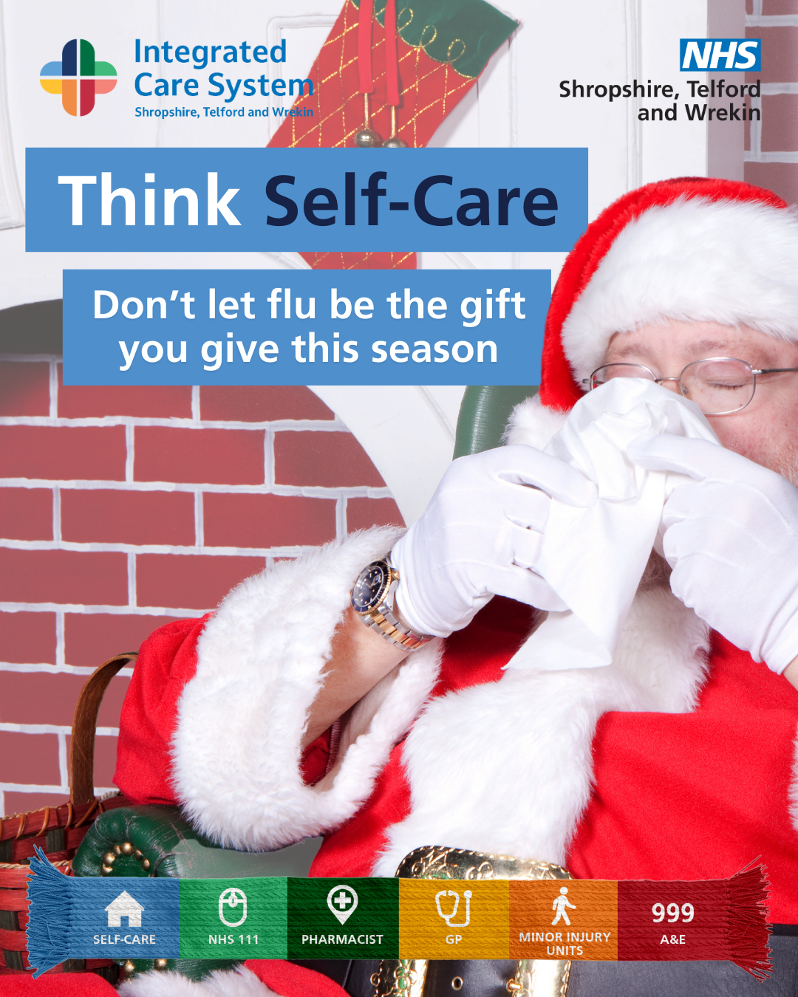 | Santa blows his nose in a tissue. Tex reads: Think self care. Don’t let flu be the gift you give this season.
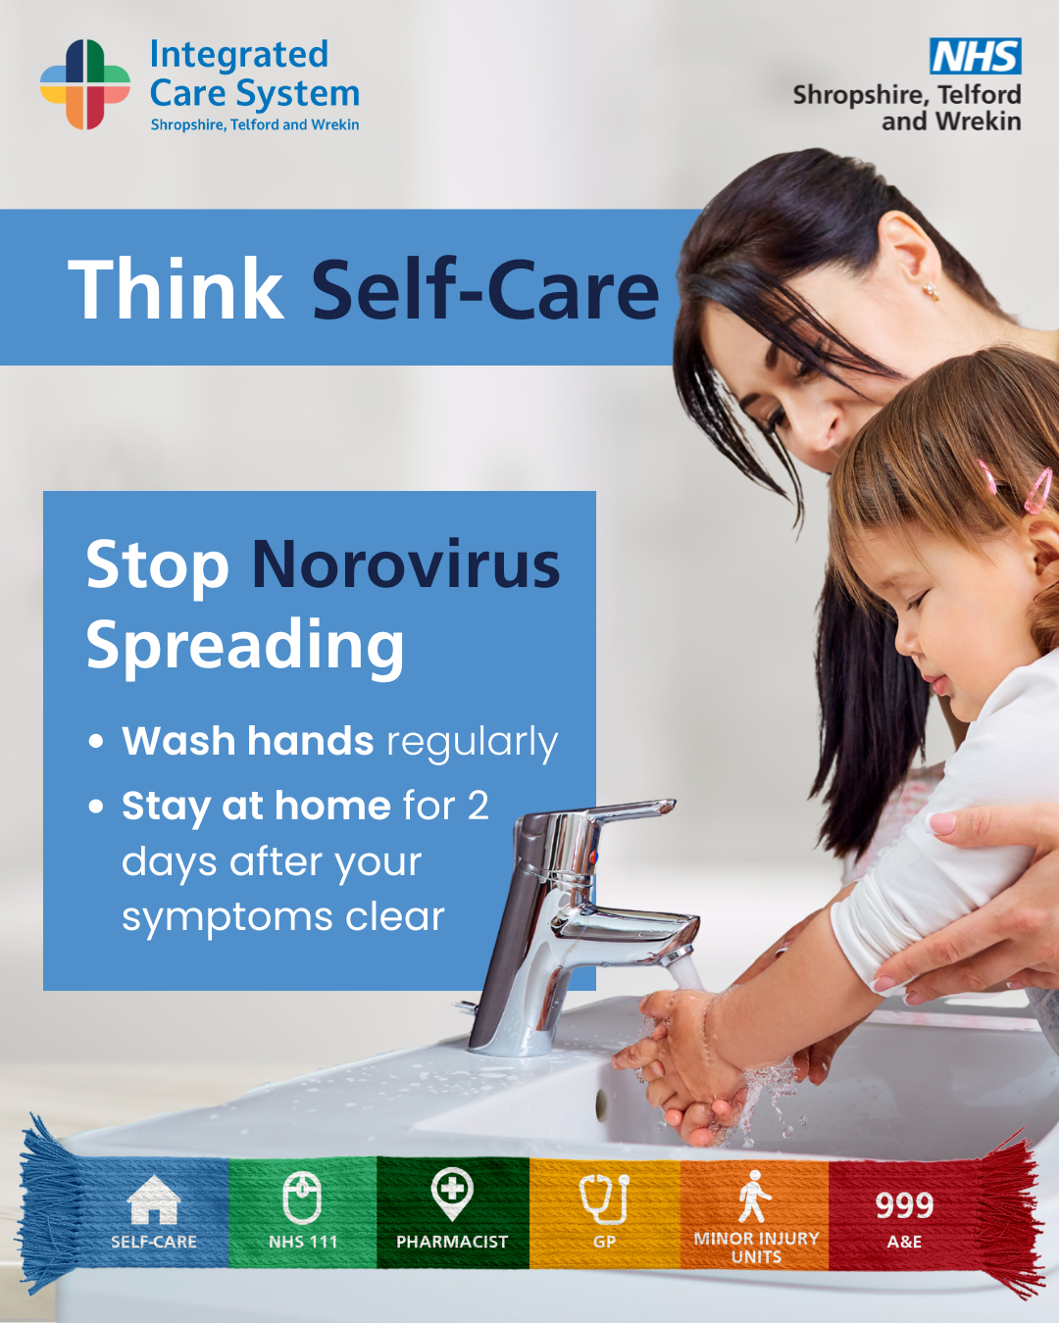 | A woman helping a child wash their hands. Text reads: Think self care. Stop norovirus spreading. Wash hands regularly. Stay at home for 2 days after your symptoms clear.
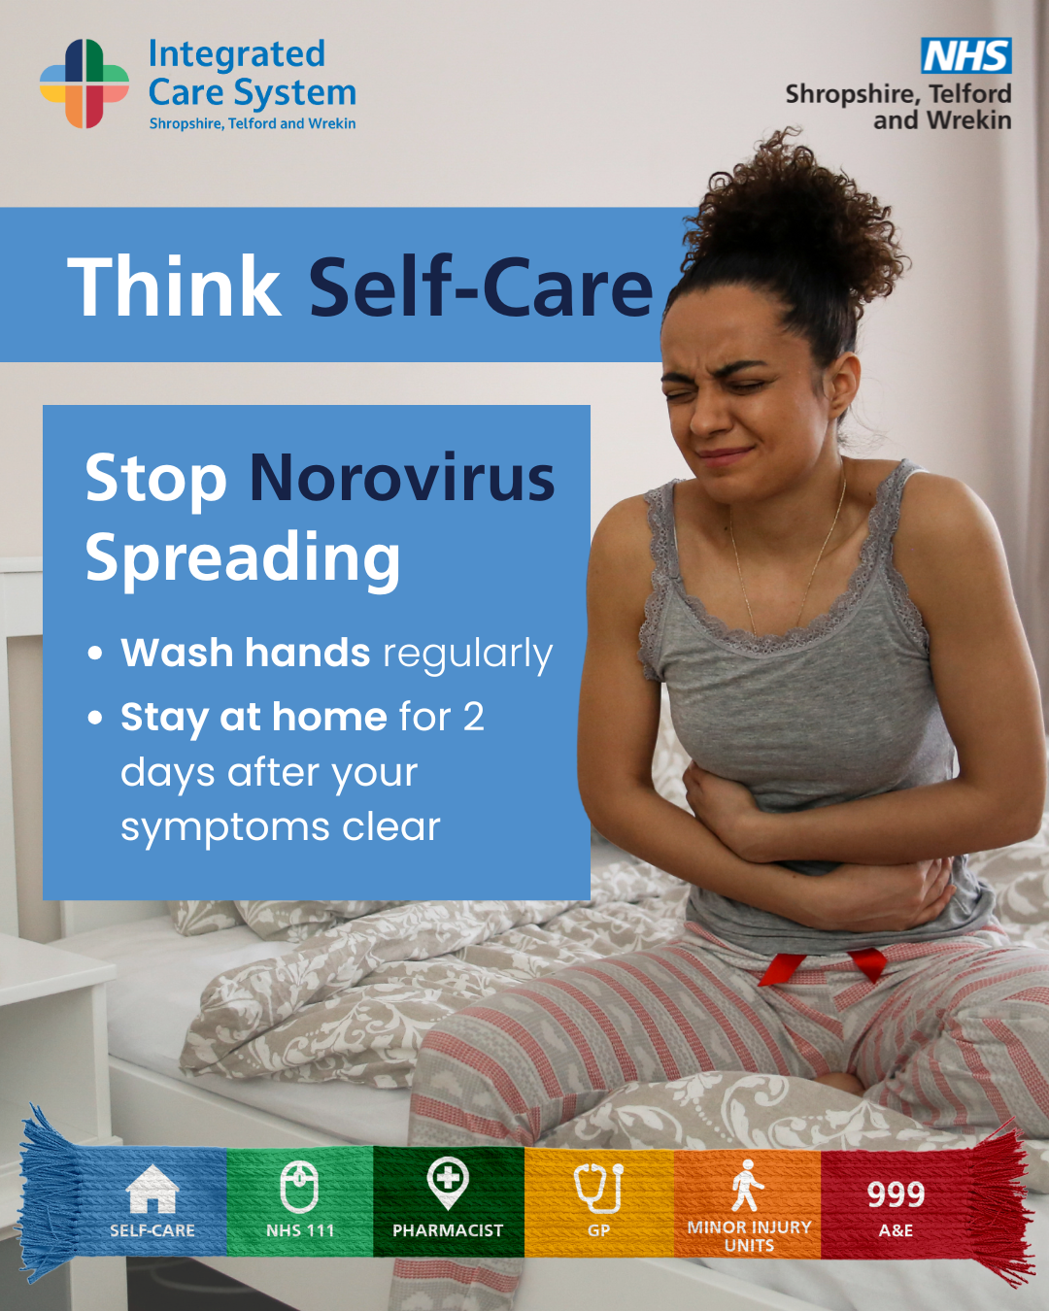 | A woman holding her stomach. Text reads: Think self care. Stop norovirus spreading. Wash hands regularly. Stay at home for 2 days after your symptoms clear.
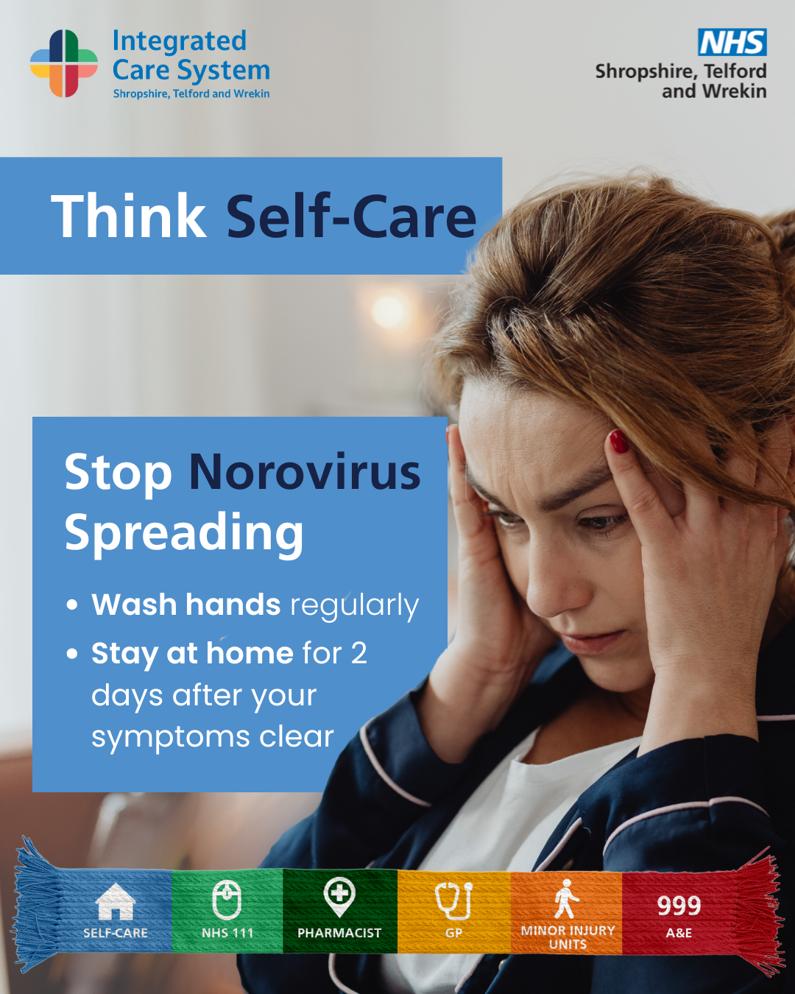 | A woman holding her head in her hands. Text reads: Think self care. Stop norovirus spreading. Wash hands regularly. Stay at home for 2 days after your symptoms clear.
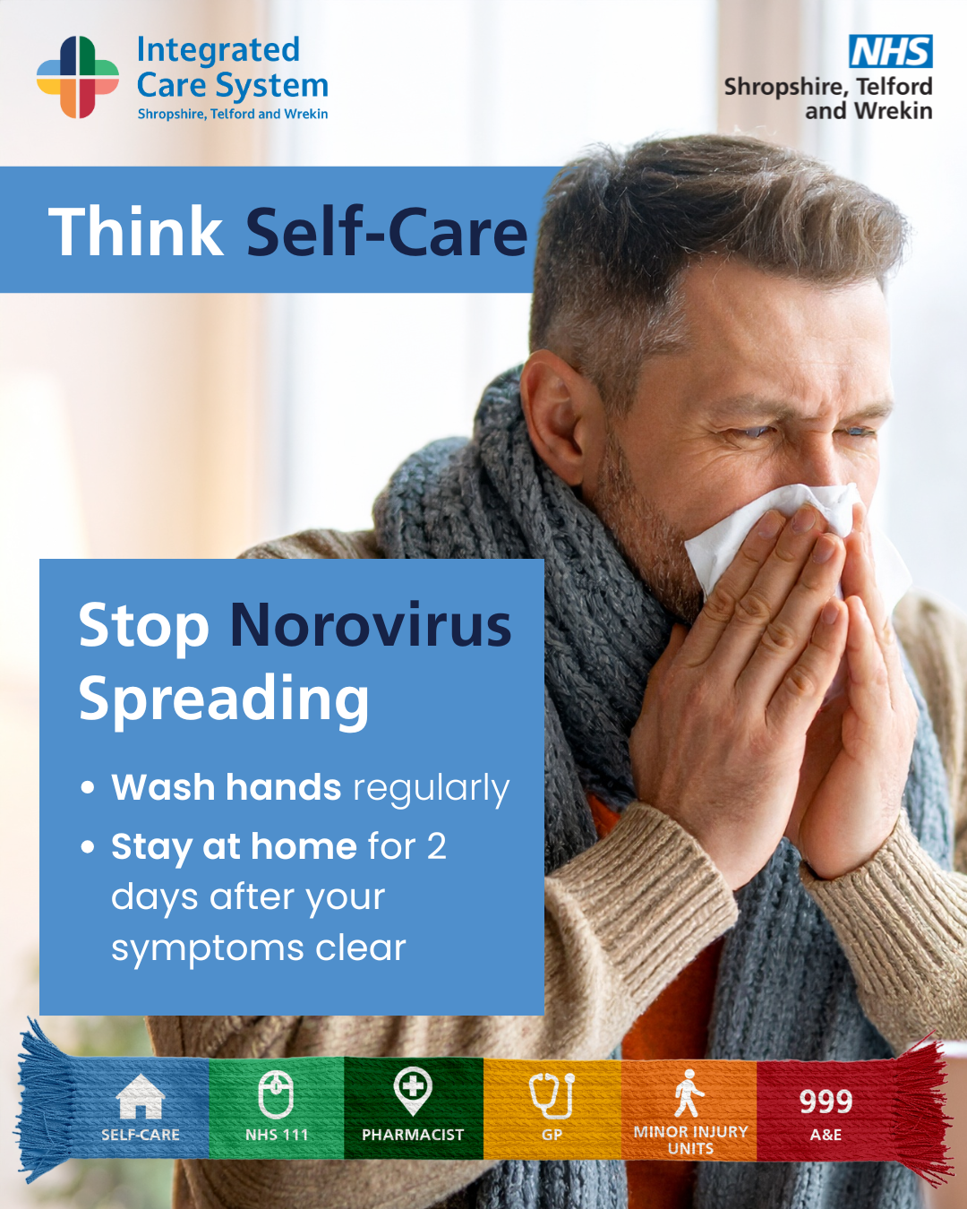 | A man blowing his nose in a tissue. Text reads: Think self care. Stop norovirus spreading. Wash hands regularly. Stay at home for 2 days after your symptoms clear.
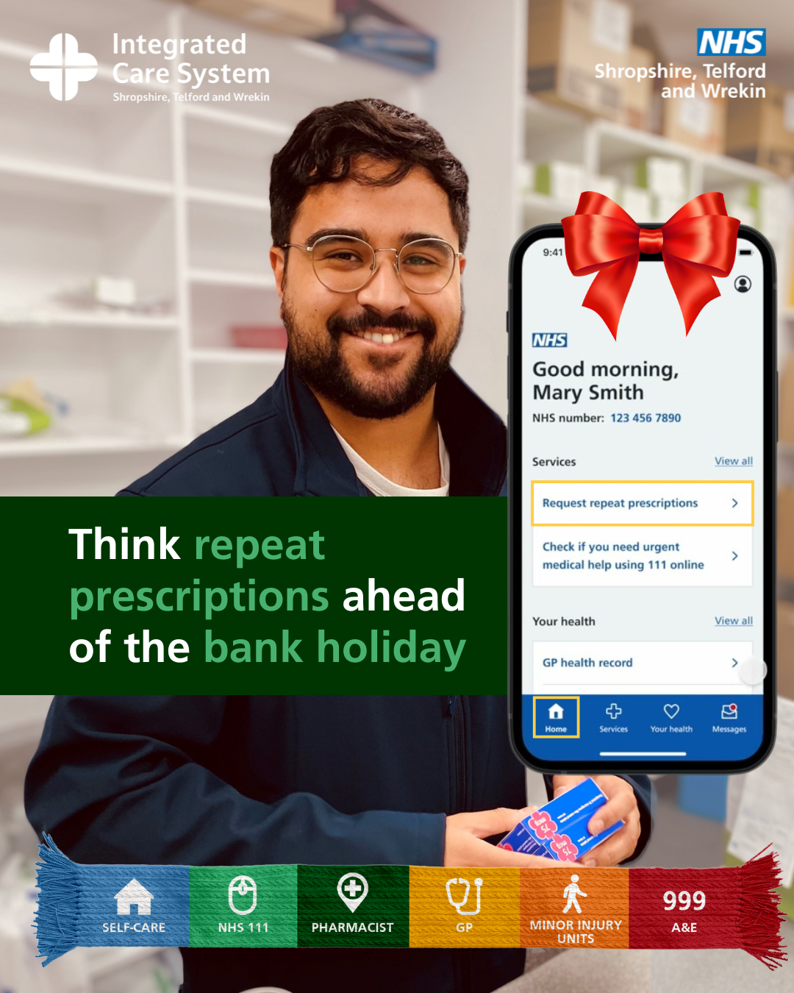 | A pharmacist smiling. A graphic of a phone showing the NHS app is displayed next to him. Text reads: Think repeat prescriptions ahead of the bank holiday.
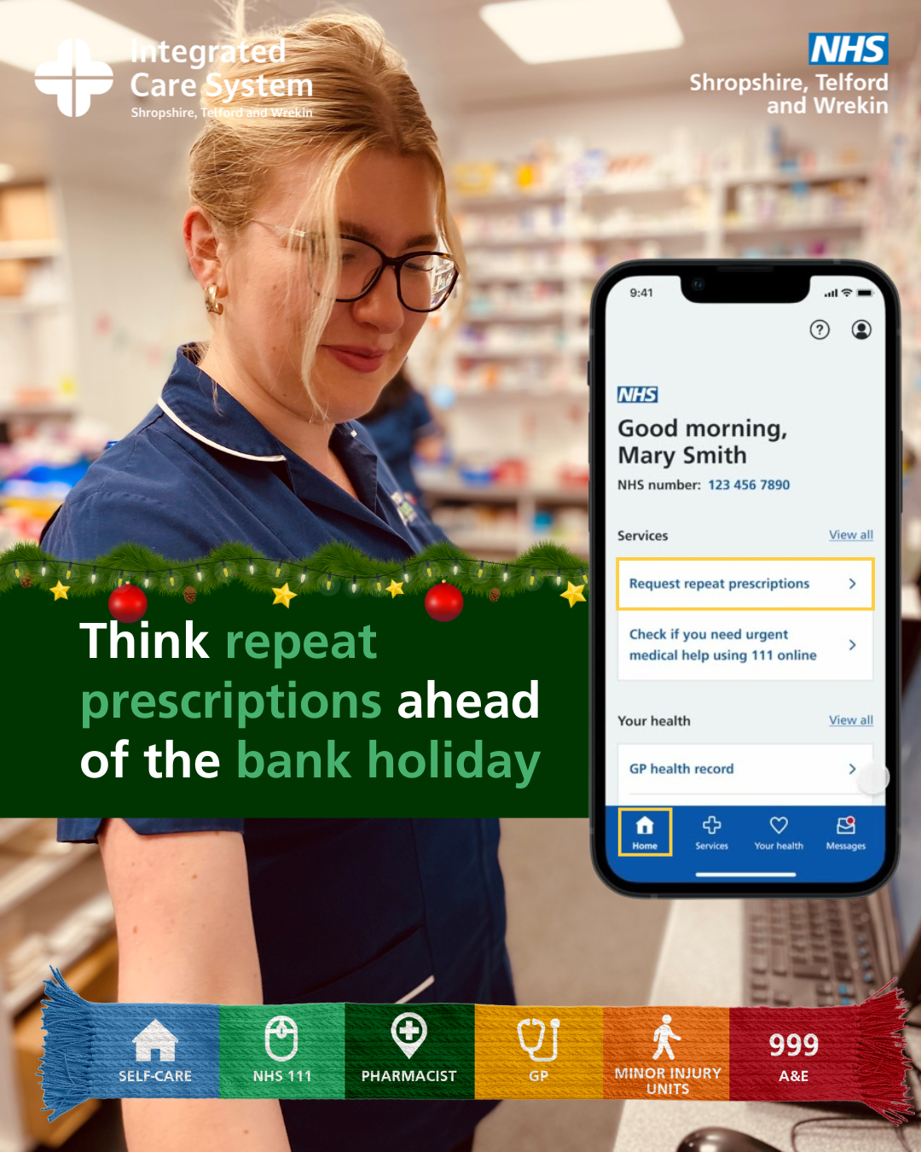 | A pharmacist smiling. A graphic of a phone showing the NHS app is displayed next to her. Text reads: Think repeat prescriptions ahead of the bank holiday.
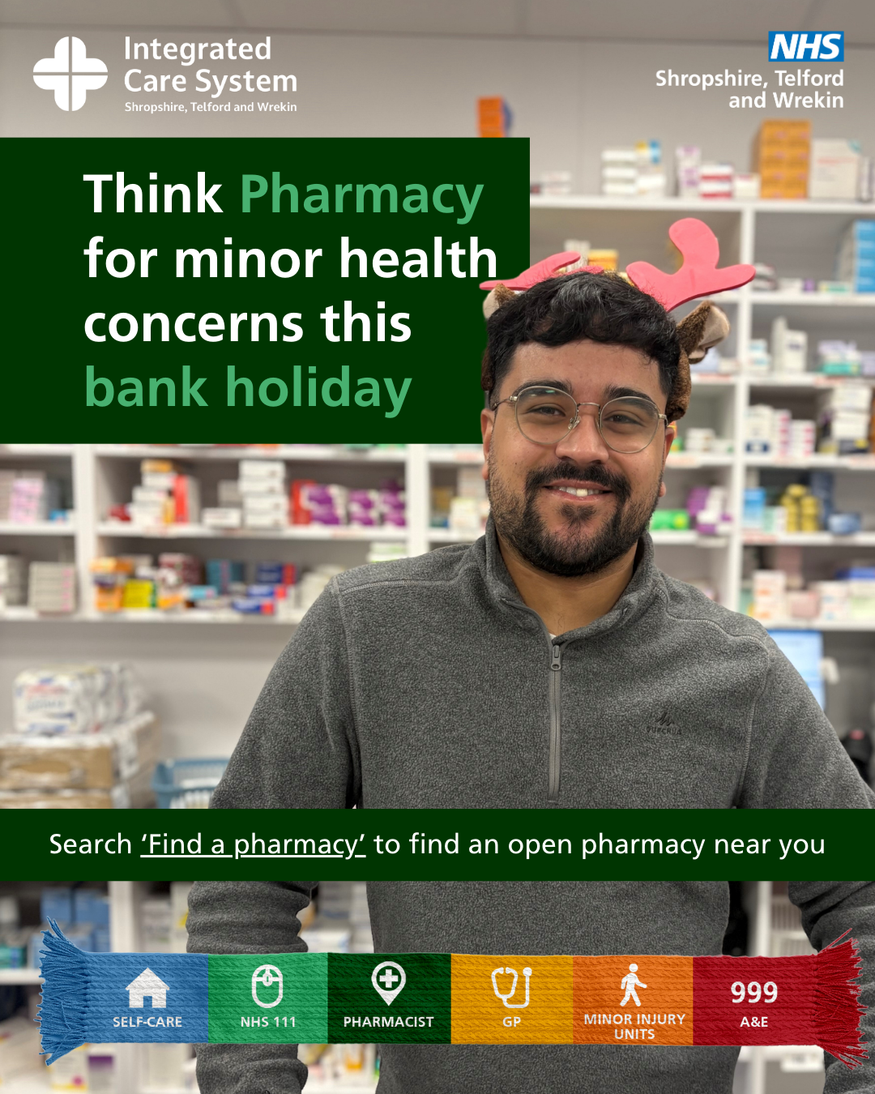 | A pharmacist smiling and wearing festive antlers on his head. Text reads: Think pharmacy for minor health concerns this bank holiday.
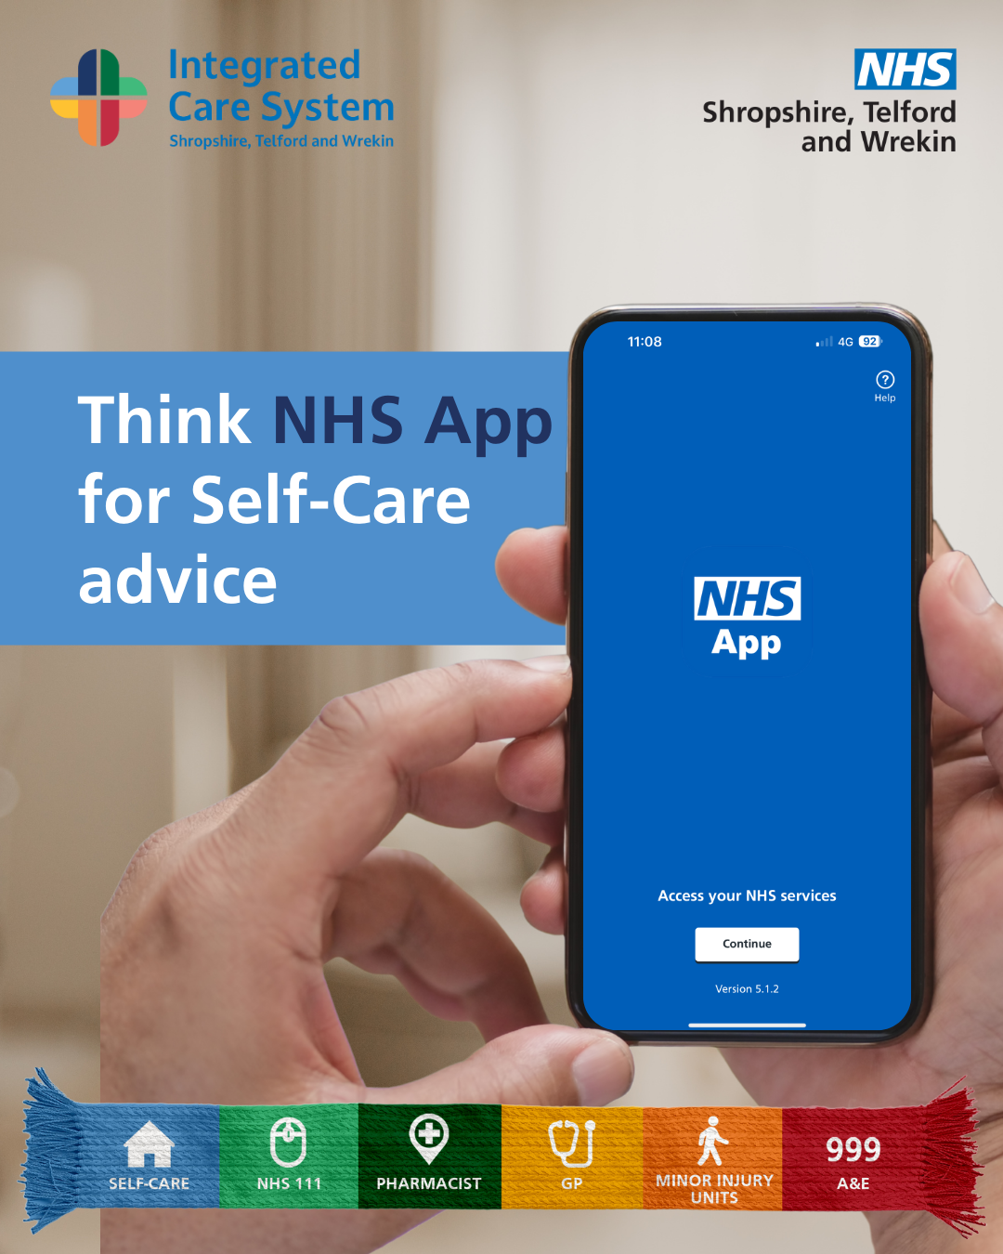 | Someone holding a phone displaying the NHS App. Text reads: Think NHS App for self care advice
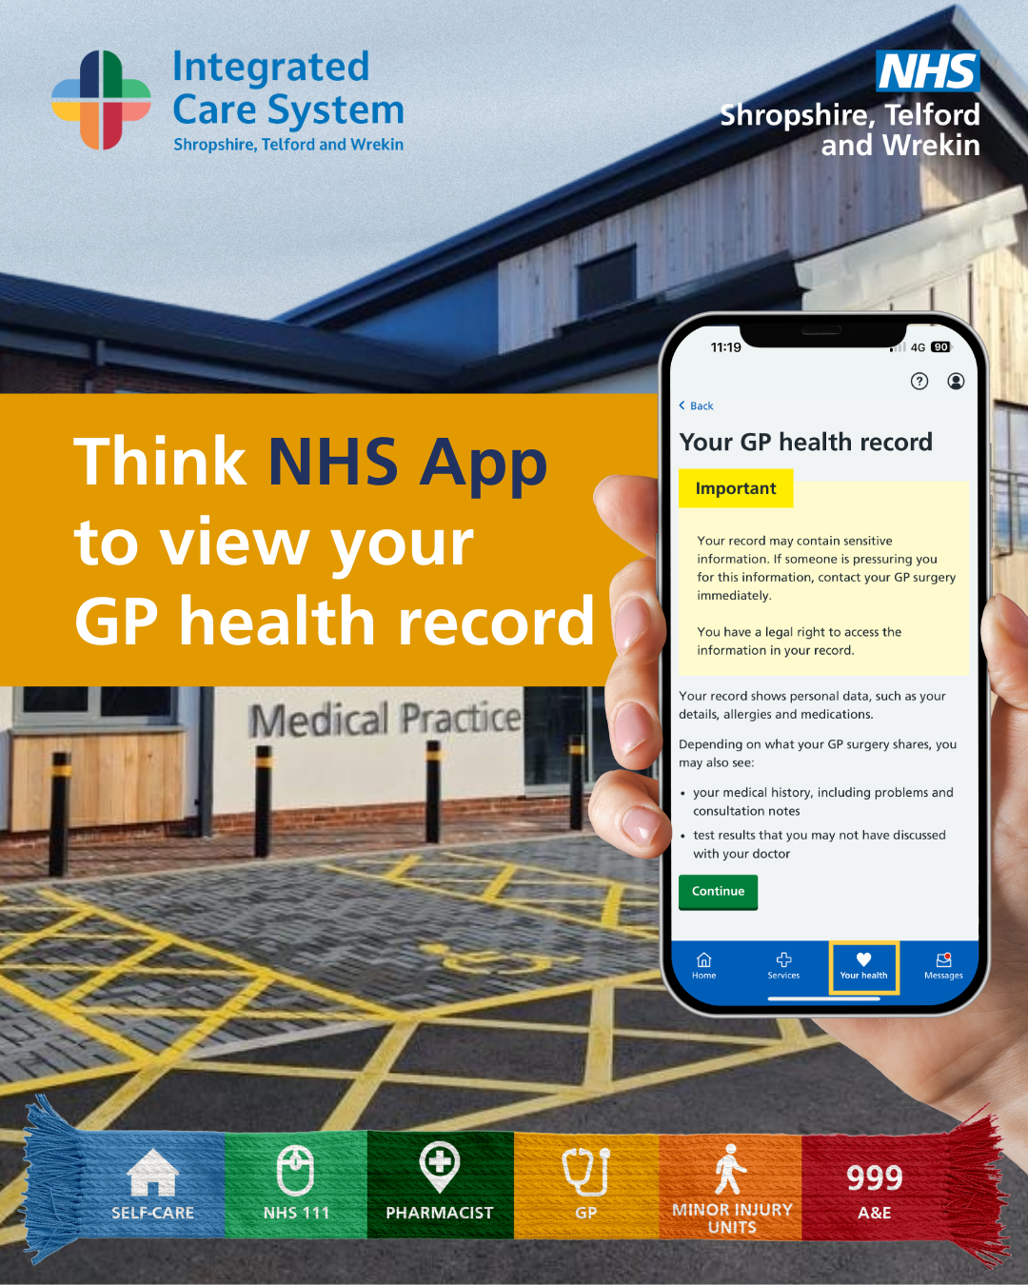 | Someone holding a phone displaying the NHS App. Text reads: Think NHS App to view your GP health record.
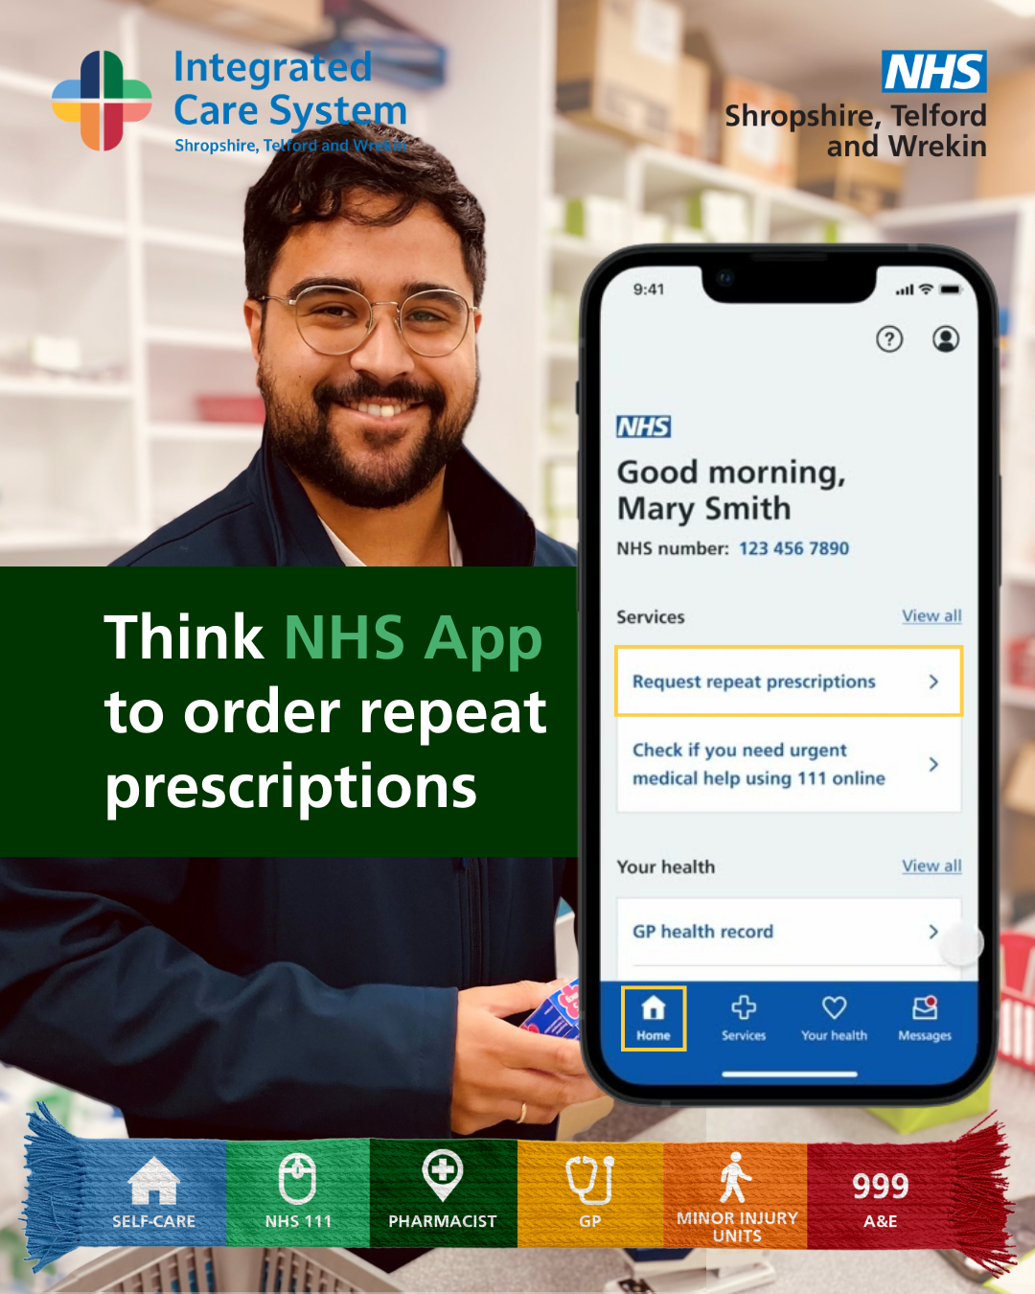 | A pharmacist smiling. A graphic of a phone showing the NHS app is displayed next to him. Text reads: Think NHS App to order repeat prescriptions
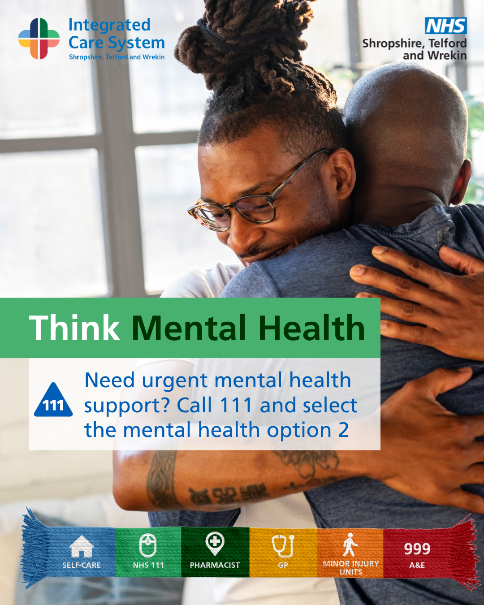 | Two men hugging. Text reads: Think Mental Health. Need urgent mental health support? Call 111 and select the mental health option 2.
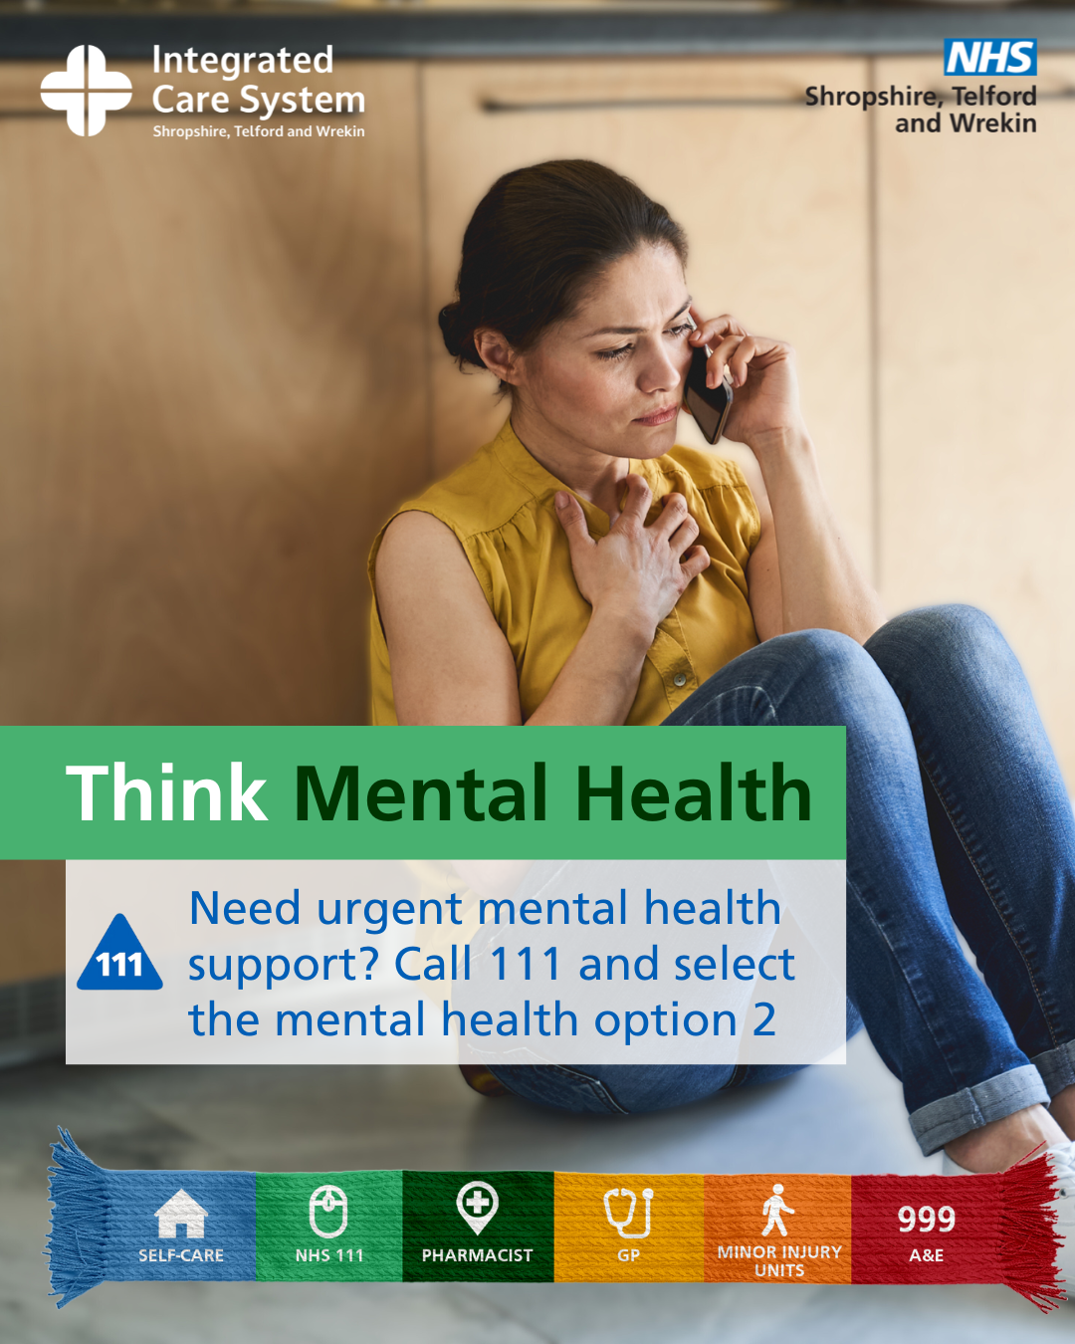 | A woman sat on the floor taking a phone call. Text reads: Think Mental Health. Need urgent mental health support? Call 111 and select the mental health option 2.
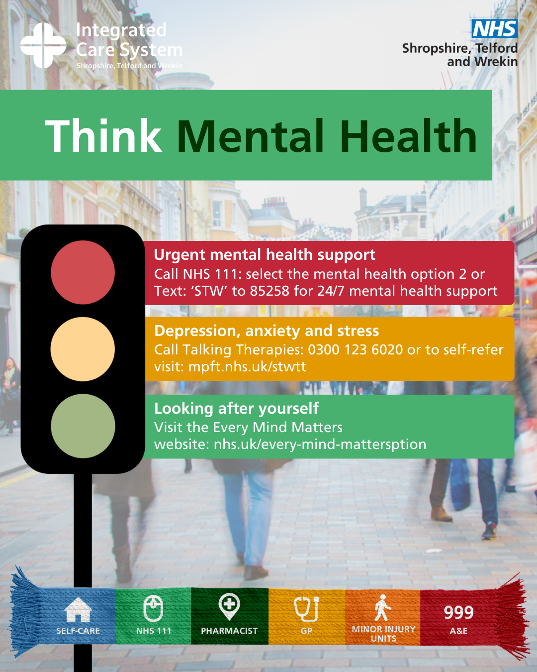 | A graphic of a traffic light. Text reads: Think Mental Health. Urgent help – call NHS 111 option 2 or text STW to 85258.
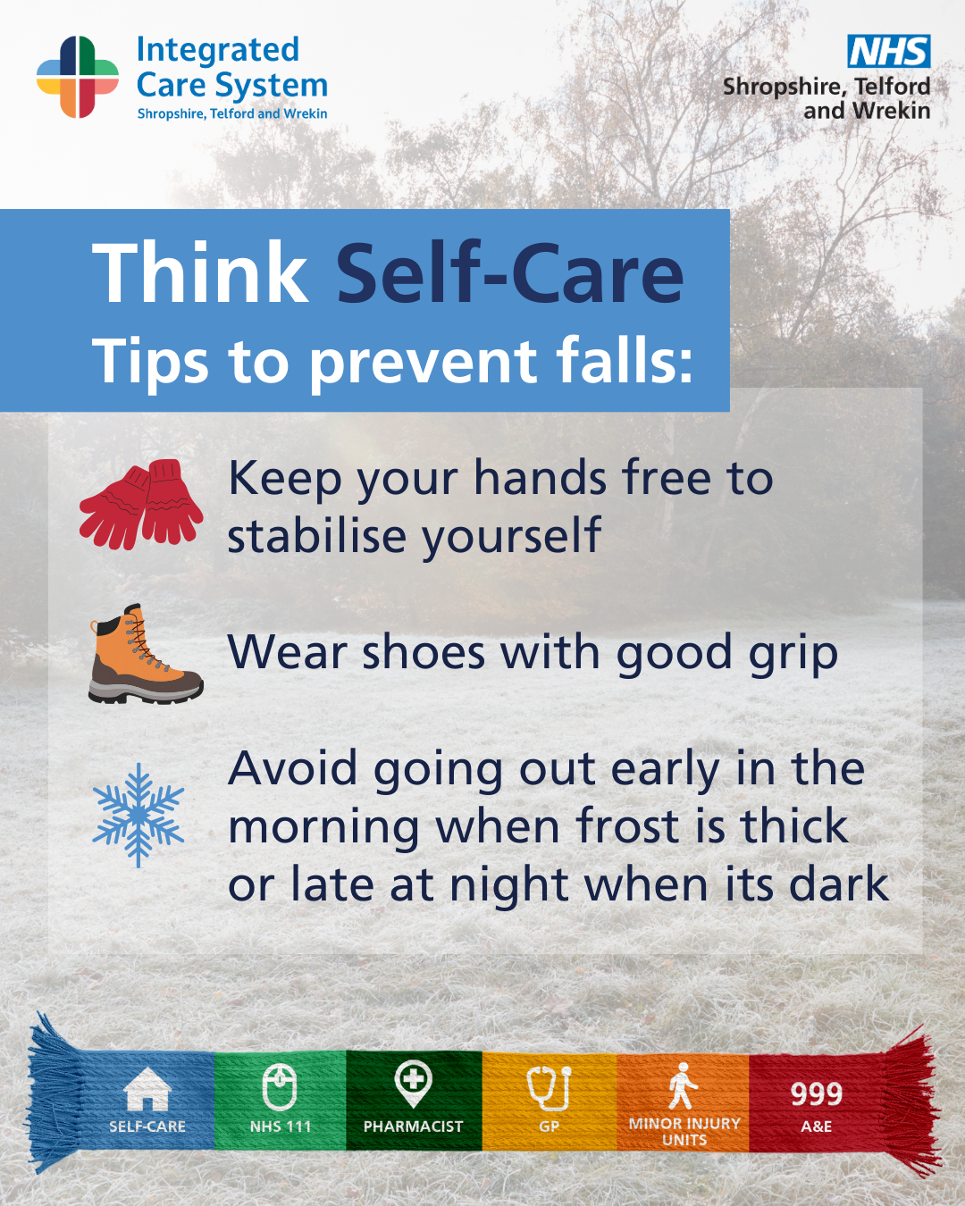 | A graphic titled “Think Self-Care – Tips to prevent falls.”  Three illustrated tips are shown:  - Red gloves icon with text: “Keep your hands free to stabilise yourself.”  - Brown boot icon with text: “Wear shoes with good grip.”  - Blue snowflake icon with text: “Avoid going out early in the morning when frost is thick or late at night when it’s dark.”
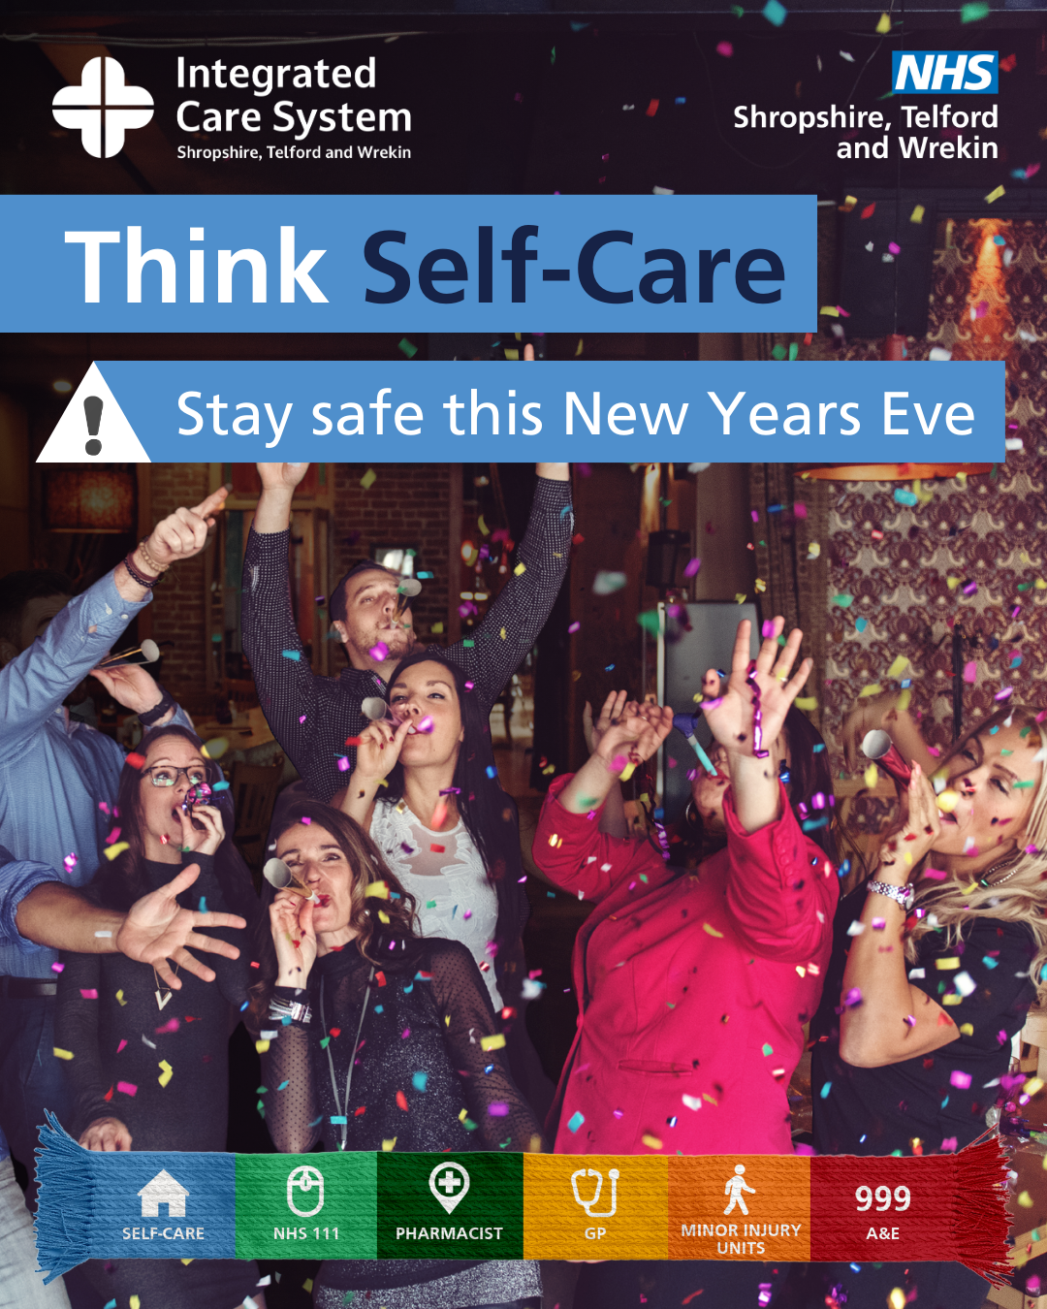 | Women partying. Text reads: Think self care. Stay safe this New Years Eve.
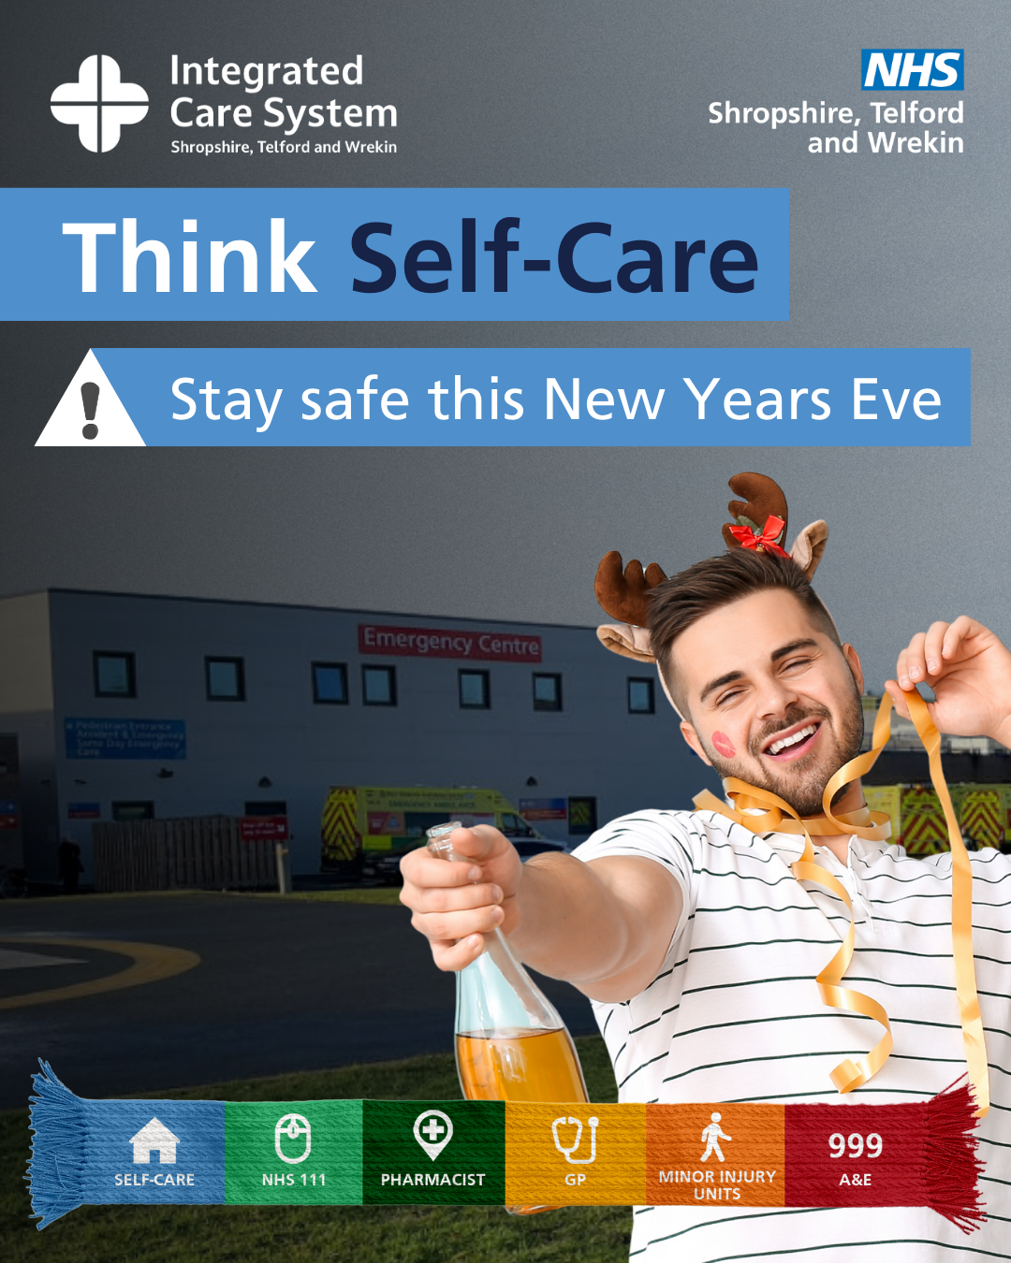 | A man holding a bottle of champagne. Text reads: Think self care. Stay safe this New Years Eve
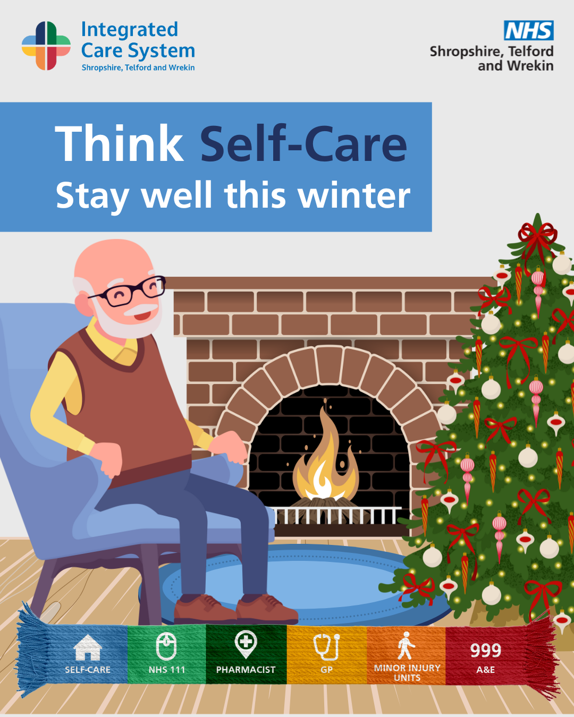 | A graphic of an older man sat in front of a fireplace. Text reads: Think self care. Stay well this winter.
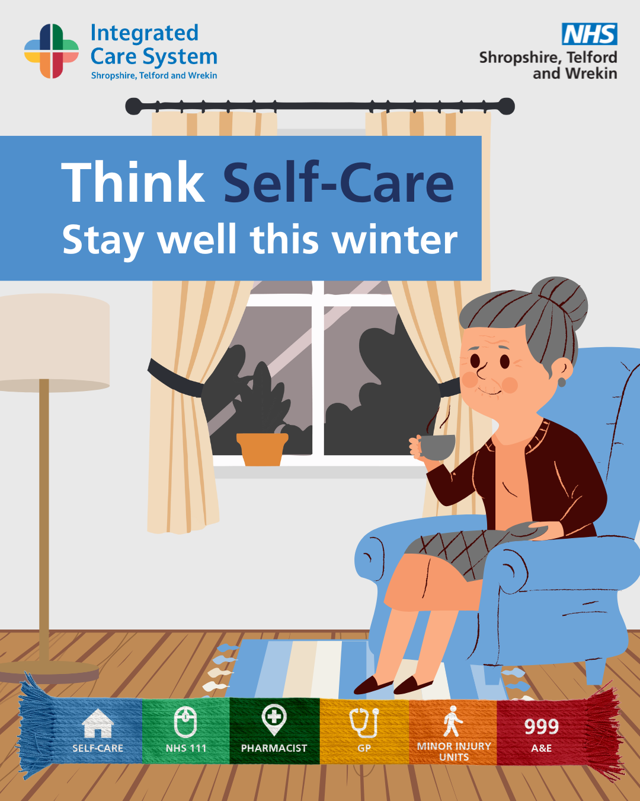 | A graphic of an older woman sat in an arm chair. Text reads: Think self care. Stay well this winter.
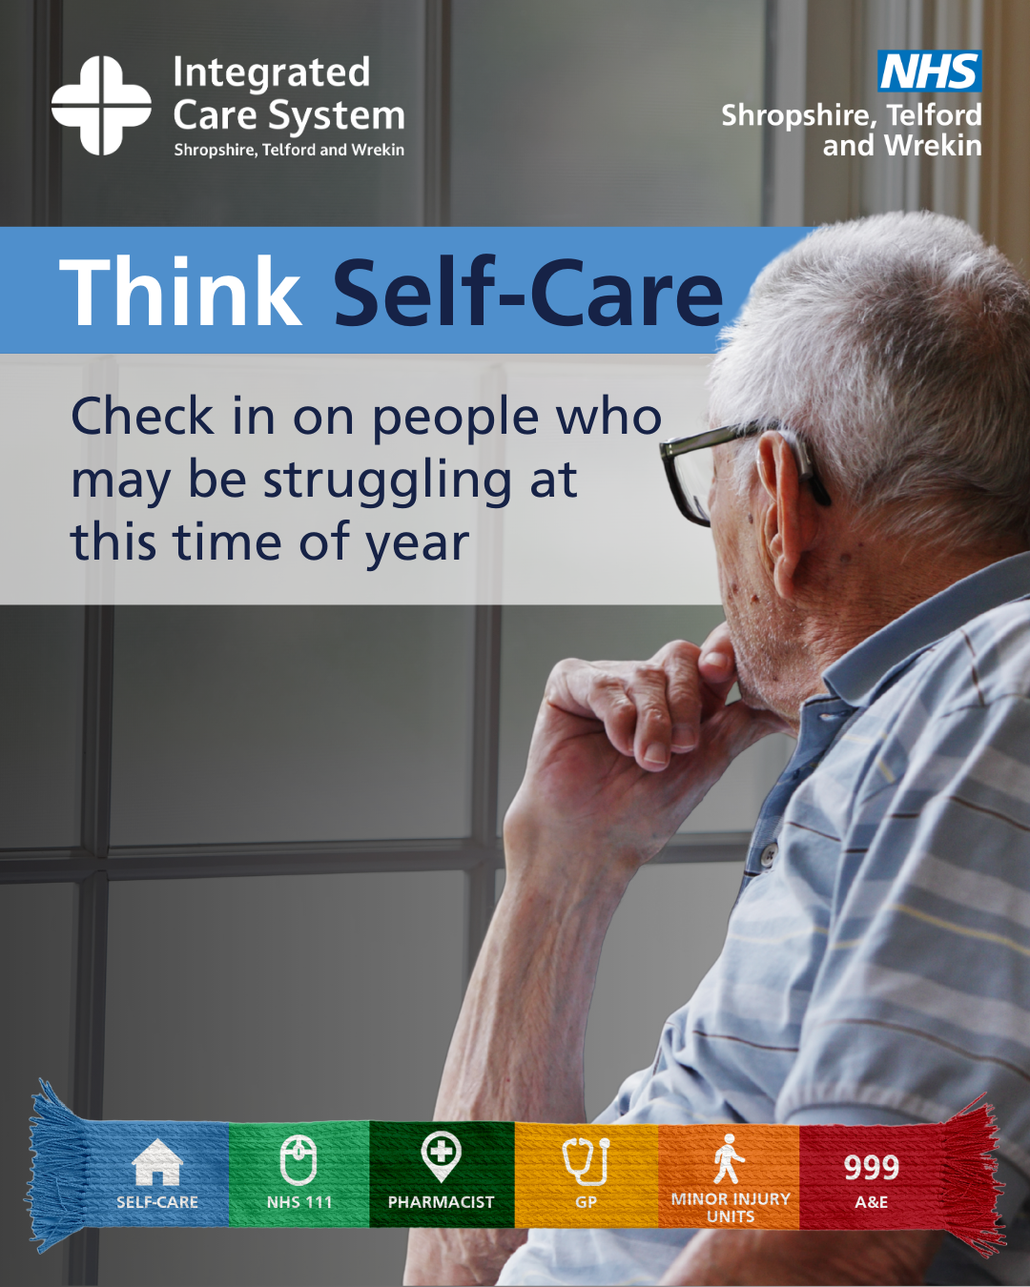 | An older man looking out of the window. Tex reads: Think self care. Check in on people who may be struggling at this time of year.
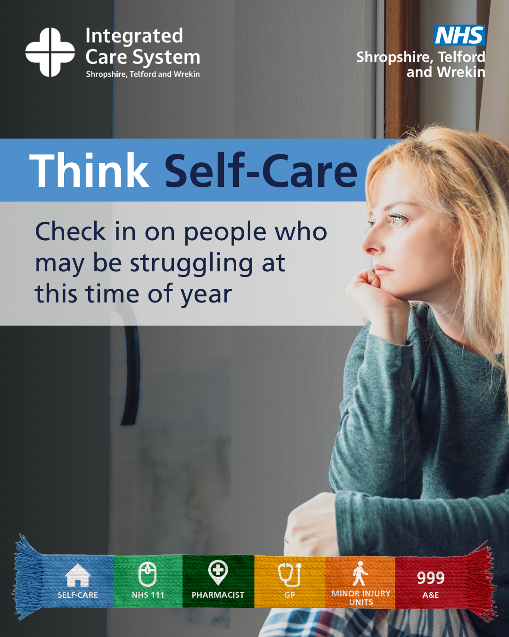 | A woman looking down. Check in on people who may be struggling at this time of year.

