Think Which Service 2025/2026
Festive period social media

Image | X (Twitter) copy | Facebook / LinkedIn copy | Instagram
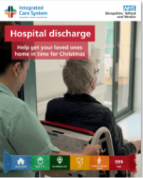  Hospital Discharge 2 | By helping your loved ones get home as soon as they’re ready, you’re not only supporting their recovery but also helping the NHS by freeing up a bed for someone in need of care 💙  For more information 👉 https://www.shropshiretelfordandwrekin.nhs.uk/hospital-discharge/  #NHSSTW #ThinkWhichService #NHS | By helping your loved ones get home as soon as they’re ready, you’re not only supporting their recovery but also helping the NHS by freeing up a bed for someone in need of care 💙  You can help by:  -Offering a lift home from hospital  -Collecting prescriptions  -Ensuring their home is heated  -Stocking their cupboard with staple food items  For more information 👉 https://www.shropshiretelfordandwrekin.nhs.uk/hospital-discharge/  #NHSSTW #ThinkWhichService #NHS | By helping your loved ones get home as soon as they’re ready, you’re not only supporting their recovery but also helping the NHS by freeing up a bed for someone in need of care 💙  You can help by:  -Offering a lift home from hospital  -Collecting prescriptions  -Ensuring their home is heated  -Stocking their cupboard with staple food items  #NHSSTW #ThinkWhichService #NHS
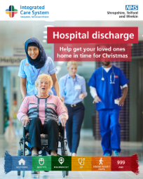  Hospital Discharge 1 | If your loved one is being discharged from the hospital, please help get them home. Delays often happen when transport isn’t arranged, or their home isn’t ready.  For more information 👉 https://www.shropshiretelfordandwrekin.nhs.uk/hospital-discharge/  #NHSSTW #ThinkWhichService #NHS | If your loved one is being discharged from the hospital, please help get them home. Delays often happen when transport isn’t arranged, or their home isn’t ready.  You can help by:  -Offering a lift home from hospital  -Collecting prescriptions  -Ensuring their home is heated  -Stocking their cupboard with staple food items  For more information 👉 https://www.shropshiretelfordandwrekin.nhs.uk/hospital-discharge/  #NHSSTW #ThinkWhichService #NHS | If your loved one is being discharged from the hospital, please help get them home. Delays often happen when transport isn’t arranged, or their home isn’t ready.  You can help by:  -Offering a lift home from hospital  -Collecting prescriptions  -Ensuring their home is heated  -Stocking their cupboard with staple food items  #NHSSTW #ThinkWhichService #NHS
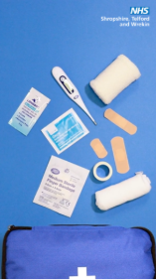  Self Care Medicine Bag Video 2025 | Winter can bring a variety of health challenges, from colds and flu to minor injuries.  Having a well-stocked medicine cabinet can help you manage these issues effectively💊  For more information➡️️ thinkwhichservice.co.uk  #ThinkWhichService #NHSSTW | Is your first-aid kit #WinterReady?  Help keep yourself well this winter and stock your first-aid kits 🩹💊  - Painkillers  - Antihistamines  - Anti-diarrhoeal medicine  - Antiseptic cream (for bites and stings)  - Oral rehydration salts  - Indigestion treatment  - Plasters and bandages  - Thermometer  Find out more 👉 thinkwhichservice.co.uk  #NHS ##ThinkWhichService #FirstAid #FirstAidKit #NHSSTW #SelfCare #NHS | Is your first-aid kit #WinterReady?  Help keep yourself well this winter and stock your first aid-kits 🩹💊  - Painkillers  - Antihistamines  - Anti-diarrhoeal medicine  - Antiseptic cream (for bites and stings)  - Oral rehydration salts  - Indigestion treatment  - Plasters and bandages  - Thermometer  #NHS ##ThinkWhichService #FirstAid #FirstAidKit #NHSSTW #SelfCare #NHS
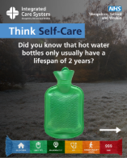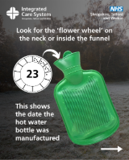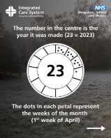  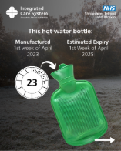  Hot Water Safety 2025 1, 2, 3, 4 | Did you know that hot water bottles only usually have a lifespan of 2 years? 🤔  If your hot water bottle is more than two years old, it is at risk of bursting or leaking, so for your safety it’s time to replace it. #HotWaterBottle #KeepWarm #Winter #TopTips #ThinkWhichService | Did you know that hot water bottles only usually have a lifespan of 2 years? 🤔  While they are a low-cost way to keep warm, they only usually have a lifespan of two years!  If your hot water bottle is more than two years old, it is at risk of bursting or leaking, so for your safety and to prevent burns, it’s time to replace it.  It’s easy to find the expiry date - just follow the instructions:  - Look for the ‘flower wheel’ on the neck or inside the funnel  - The number in the centre is the year it was made (so 21 = 2021)  - The twelve petals equal the months of the year  - The dots in each petal represent the weeks of the month  #NHSSTW #NHS #HotWaterBottle #KeepWarm #Winter #TopTips #ThinkWhichService | Did you know that hot water bottles only usually have a lifespan of 2 years? 🤔  While they are a low-cost way to keep warm, they only usually have a lifespan of two years!  If your hot water bottle is more than two years old, it is at risk of bursting or leaking, so for your safety and to prevent burns, it’s time to replace it.  It’s easy to find the expiry date - just follow the instructions:  - Look for the ‘flower wheel’ on the neck or inside the funnel  - The number in the centre is the year it was made (so 21 = 2021)  - The twelve petals equal the months of the year  - The dots in each petal represent the weeks of the month  #NHSSTW #NHS #HotWaterBottle #KeepWarm #Winter #TopTips #ThinkWhichService
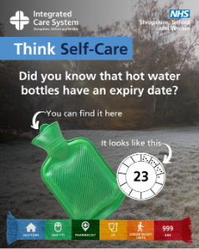  Hot Water Safety 2025 | Did you know that hot water bottles only usually have a lifespan of 2 years? 🤔  If your hot water bottle is more than two years old, it is at risk of bursting or leaking, so for your safety it’s time to replace it. #HotWaterBottle #KeepWarm #Winter #TopTips #ThinkWhichService | Did you know hot water bottles expire? 🤔  While they are a low-cost way to keep warm, they only usually have a lifespan of two years!  It’s easy to find the expiry date - just follow the instructions below:  - Look for the ‘flower wheel’ on the neck or inside the funnel  - The number in the centre is the year it was made (so 21 = 2021)  - The twelve petals equal the months of the year  - The dots in each petal represent the weeks of the month  So, in our photo, the hot water bottle was made in the first week of April 2023.  If your hot water bottle is more than two years old, it is at risk of bursting or leaking, so for your safety and to prevent burns, it’s time to replace it.  #NHSSTW #NHS #HotWaterBottle #KeepWarm #Winter #TopTips #ThinkWhichService | Did you know hot water bottles expire? 🤔  While they are a low-cost way to keep warm, they only usually have a lifespan of two years!  It’s easy to find the expiry date - just follow the instructions below:  - Look for the ‘flower wheel’ on the neck or inside the funnel  - The number in the centre is the year it was made (so 21 = 2021)  - The twelve petals equal the months of the year  - The dots in each petal represent the weeks of the month  So, in our photo, the hot water bottle was made in the first week of April 2023.  If your hot water bottle is more than two years old, it is at risk of bursting or leaking, so for your safety and to prevent burns, it’s time to replace it.  NHS #HotWaterBottle #KeepWarm #Winter #TopTips #ThinkWhichService
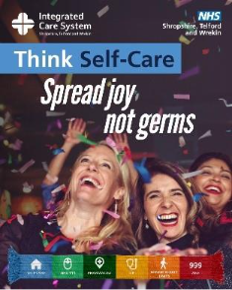  Spread Joy | Nobody wants the #flu crashing the party! 🥳  Stop flu from spreading:  - Wash your hands often  - Cover your mouth and nose when sneezing  - Bin used tissues  Spread joy, not germs. More info: www.nhs.uk/conditions/flu/  #NHS | Nobody wants the #flu crashing the party! 🥳🤧  Flu spreads easily, especially to our loved ones but there are also ways you can stop it in its tracks…  - Wash your hands often  - Cover your mouth and nose when coughing or sneezing  -️ Bin used tissues  Let’s make this season about sharing joy, not germs! For more tips, visit https://www.nhs.uk/conditions/flu/ #NHS | Nobody wants the #flu crashing the party! 🥳🤧  Flu spreads easily, especially to our loved ones but there are also ways you can stop it in its tracks…  - Wash your hands often  - Cover your mouth and nose when coughing or sneezing  -️ Bin used tissues  Let’s make this season about sharing joy, not germs! For more tips, visit https://www.nhs.uk/conditions/flu/ #NHS
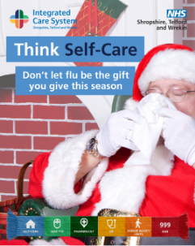  Santa Self-Care | #Flu spreads easily, especially to our loved ones but there are also ways you can stop it in its tracks  - Wash your hands often  - Cover your mouth and nose when coughing or sneezing  -️ Bin used tissues  For more tips, visit https://www.nhs.uk/conditions/flu/ #NHS | Don’t let #flu be the gift you give this season.  Flu spreads easily, especially to our loved ones but there are also ways you can stop it in its tracks…  - Wash your hands often  - Cover your mouth and nose when coughing or sneezing  -️ Bin used tissues  Let’s make this season about sharing joy, not germs! For more tips, visit https://www.nhs.uk/conditions/flu/  #NHS | Don’t let #flu be the gift you give this season.  Flu spreads easily, especially to our loved ones but there are also ways you can stop it in its tracks…  - Wash your hands often  - Cover your mouth and nose when coughing or sneezing  -️ Bin used tissues  Let’s make this season about sharing joy, not germs! For more tips, visit https://www.nhs.uk/conditions/flu/
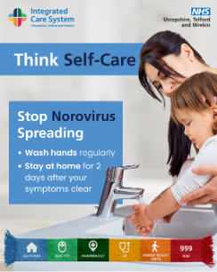  Norovirus 1  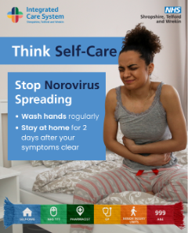Norovirus 4 | Norovirus is highly contagious, and we have seen a rise in cases recently 🤧  Symptoms include:  - Vomiting  - Diarrhoea  - Stomach cramps  - High temperature  - Headache  - Tummy pain  - body aches and pains  Stay healthy and protect others! 💙  www.nhs.uk/conditions/norovirus/  #Norovirus #NHS | Norovirus is highly contagious, and we have seen a rise in cases recently 🤧  Symptoms include:  - Vomiting  - Diarrhoea  - Stomach cramps  Stop Norovirus spreading:  - Wash your hands regularly  - Catch coughs and sneezes in tissues  - Open a window when meeting inside  Stay healthy and protect others! 💙  Find out more.  www.nhs.uk/conditions/norovirus/  #Norovirus #NHS | Norovirus is highly contagious, and we have seen a rise in cases recently 🤧  Symptoms include:  - Vomiting  - Diarrhoea  - Stomach cramps  Stop Norovirus spreading:  - Wash your hands regularly  - Catch coughs and sneezes in tissues  - Open a window when meeting inside  Stay healthy and protect others! 💙  #Norovirus #NHS
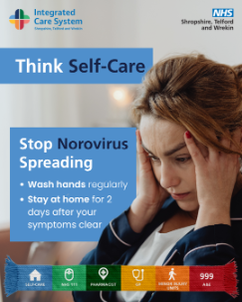  Norovirus 2  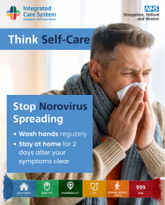  Norovirus 3 | Norovirus is a stomach bug that causes diarrhoea and vomiting. It can be very unpleasant but usually goes away in about 2 days.  If you catch it – stay home to stop the spread, rest up and have plenty of fluids. Find out more.  www.nhs.uk/conditions/norovirus/ | Norovirus is a stomach bug that causes diarrhoea and vomiting. It can be very unpleasant but usually goes away in about 2 days.  If you catch it – stay home to stop the spread, rest up and have plenty of fluids. Find out more.  www.nhs.uk/conditions/norovirus/ | Norovirus is a stomach bug that causes diarrhoea and vomiting. It can be very unpleasant, but usually goes away in about 2 days.  If you catch it – stay home to stop the spread, rest up and have plenty of fluids.
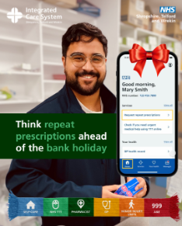  Repeat Prescription 1 | Don’t get caught short over the Christmas bank holiday!🎄  💊Think ahead - order your repeat prescriptions by 12 Dec.  You can easily request repeats using the NHS App or through your GP practice.  #RepeatPrescriptions #NHSApp #Christmas #BankHoliday | Plan ahead this Christmas and don’t get caught short!🎄  Make sure you have enough medication to see you through the bank holidays.  💊 Order your repeat prescriptions by 12 Dec via the NHS App or your GP practice.  Avoid the last-minute rush and enjoy a stress-free Christmas knowing you’re covered.  Download the NHS App here 👉 www.nhs.uk/nhs-app  #RepeatPrescriptions #NHSApp #Christmas #BankHoliday | Plan ahead this Christmas and don’t get caught short!🎄  Make sure you have enough medication to see you through the bank holidays.  💊 Order your repeat prescriptions by 12 Dec via the NHS App or your GP practice.  Avoid the last-minute rush and enjoy a stress-free Christmas knowing you’re covered.  #RepeatPrescriptions #NHSApp #Christmas #BankHoliday
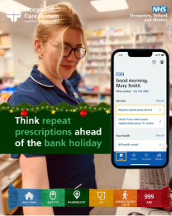  Repeat Prescription 2 | Think ahead this Christmas bank holiday. Don't forget to collect your repeat Prescription ⭐💊  #RepeatPrescriptions #NHSApp #BankHoliday #Christmas | Think ahead this Christmas bank holiday. Don't forget to collect your repeat Prescription ⭐💊  Avoid the last-minute rush and enjoy a stress-free Christmas knowing you’re covered.  Download the NHS App here 👉 www.nhs.uk/nhs-app  #RepeatPrescriptions #NHSApp #BankHoliday #Christmas | Think ahead this Christmas bank holiday. Don't forget to collect your repeat Prescription ⭐💊  Avoid the last-minute rush and enjoy a stress-free Christmas knowing you’re covered.  #RepeatPrescriptions #NHSApp #BankHoliday #Christmas
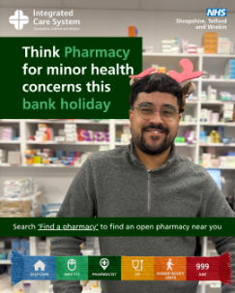  Bank holiday pharmacy opening hours | Think Pharmacy for minor health concerns over the festive bank holiday 🎄  To check the bank holiday opening times of your local pharmacy over the festive period ➡️Pharmacy-Bank-Holiday-Opening-Times-Christmas-Bank-Holidays-2025.pdf  #Pharmacy #BankHoliday #Christmas | Think Pharmacy for minor health concerns over the festive bank holiday 🎄  Pharmacists are expert health professionals who can provide advice without an appointment and recommend over-the-counter treatments.  To check the bank holiday opening times of your local pharmacy over the festive period ➡ Pharmacy-Bank-Holiday-Opening-Times-Christmas-Bank-Holidays-2025.pdf  #Pharmacy #BankHoliday #Christmas | Think Pharmacy for minor health concerns over the festive bank holiday 🎄Pharmacists are expert health professionals who can provide advice without an appointment and recommend over-the-counter treatments.  To check the bank holiday opening times of your local pharmacy over the festive period ➡️Pharmacy-Bank-Holiday-Opening-Times-Christmas-Bank-Holidays-2025.pdf  #Pharmacy #BankHoliday #Christmas
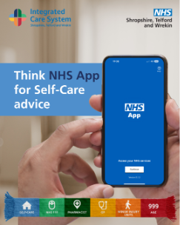Think NHS App | Need quick, trusted health advice? The NHS App puts symptom checkers, self-care guidance and appointment tools in your pocket.📱  The NHS App makes managing your health easier.  Find out more and download the app ➡️ https://www.nhs.uk/nhs-app/  #NHSApp #SelfCare | Need quick, trusted health advice? The NHS App puts symptom checkers, self-care guidance and appointment tools in your pocket.📱  The NHS App makes managing your health easier.  Find out more and download the app ➡️ https://www.nhs.uk/nhs-app/  #NHSApp #SelfCare | Need quick, trusted health advice? The NHS App puts symptom checkers, self-care guidance and appointment tools in your pocket.📱  The NHS App makes managing your health easier.  Download the app today!  #NHSApp #SelfCare
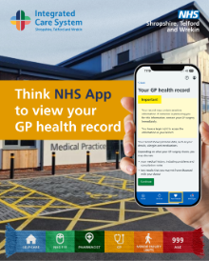  Think NHS App | You can use the NHS App or log in through the NHS website to access your GP health record, order repeat prescriptions, self-care guidance and book appointments 💊  The NHS App makes managing your health easier.  Find out more and download the app ➡️ https://www.nhs.uk/nhs-app/ | You can use the NHS App or log in through the NHS website to access your GP health record, order repeat prescriptions, self-care guidance and book appointments 💊  Your GP health record is a record of your personal health information. It may include details about your health conditions and treatments you've had.  The NHS App makes managing your health easier.  Find out more and download the app ➡️ https://www.nhs.uk/nhs-app/  #NHSApp | You can use the NHS App or log in through the NHS website to access your GP health record, order repeat prescriptions, self-care guidance and book appointments 💊  Your GP health record is a record of your personal health information. It may include details about your health conditions and treatments you've had.  The NHS App makes managing your health easier.  Download the app today!  #NHSApp
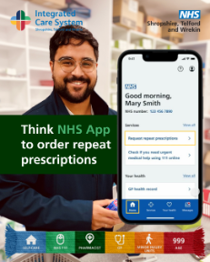  Think NHS App | You can order a repeat prescription using the NHS App or by logging into your account on the NHS website. 💊  The NHS App makes managing your health easier.  Find out more and download the app ➡️ https://www.nhs.uk/nhs-app/  #NHSApp #repeat prescription | You can order a repeat prescription using the NHS App or by logging into your account on the NHS website. 💊  You'll be able to collect your medicine in person when it's ready. Some high street pharmacies also deliver.  The NHS App makes managing your health easier.  Find out more and download the app ➡️ https://www.nhs.uk/nhs-app/  #NHSApp #repeat prescription | You can order a repeat prescription using the NHS App or by logging into your account on the NHS website. 💊  You'll be able to collect your medicine in person when it's ready. Some high street pharmacies also deliver.  The NHS App makes managing your health easier.  Download the app today!  #NHSApp #repeat prescription
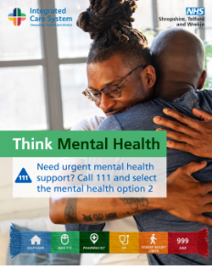  Think Mental Health 1  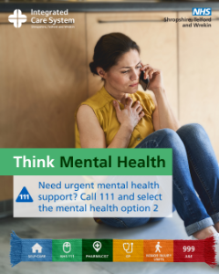  Think Mental Health 2 | If you’re struggling with your mental health, NHS 111 can help you. Visit 111.nhs.uk or call 111 and select mental health option 2 for advice on your symptoms and the best care for you💙 | If you’re struggling with your mental health, NHS 111 can help you.  Visit 111.nhs.uk or call 111 and select the mental health option 2 for advice on your symptoms and the best care for you 💻  Getting the right help, in the right place, can help us keep our NHS running smoothly this winter 💙  #ThinkWhichService #NHSSTW | If you’re struggling with your mental health, NHS 111 can help you.  Visit 111.nhs.uk or call 111 and select the mental health option 2 for advice on your symptoms and the best care for you 💻  Getting the right help, in the right place, can help us keep our NHS running smoothly this winter 💙  #ThinkWhichService #NHSSTW #NHS111 #WinterCare #HelpUsHelpYou
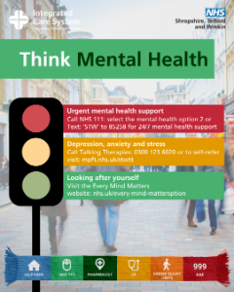  Think Mental Health 3 | Think Mental Health💚  🔴 Urgent support: Call NHS 111 & select mental health or Text: ‘STW’ to 85258 for 24/7 mental health support  🟡 Anxiety, stress, or low mood? Call 0300 123 6020 or visit mpft.nhs.uk/stwtt  🟢 Self-care tips: nhs.uk/every-mind-matters  #MentalHealthMatters | Think Mental Health 💚  Your mental health is just as important as your physical health.  If you’re struggling, help is here:  🔴 Urgent support: Call NHS 111 & select mental health or Text: ‘STW’ to 85258 for free, confidential, 24/7 mental health support  🟡 Feeling anxious, stressed or low? Contact Talking Therapies on 0300 123 6020 or self-refer online: mpft.nhs.uk/stwtt  🟢 Looking after yourself: Visit Every Mind Matters for advice and support: nhs.uk/every-mind-matters  Remember - it’s okay to ask for help.  #ThinkMentalHealth #NHS111 #MentalHealthSupport #EveryMindMatters #ShropshireTelfordWrekin | Think Mental Health 💚  Your mental health is just as important as your physical health.  If you’re struggling, help is here:  🔴 Urgent support: Call NHS 111 & select mental health or Text: ‘STW’ to 85258 for free, confidential, 24/7 mental health support  🟡 Feeling anxious, stressed or low? Contact Talking Therapies on 0300 123 6020 or self-refer online: mpft.nhs.uk/stwtt  🟢 Looking after yourself: Visit Every Mind Matters for advice and support: nhs.uk/every-mind-matters  Remember - it’s okay to ask for help.  #ThinkMentalHealth #NHS111 #MentalHealthSupport #EveryMindMatters #ShropshireTelfordWrekin
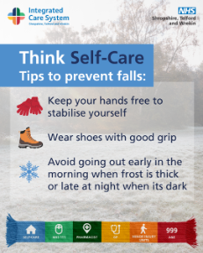Falls Prevention | You’re more at risk of slips, trips and falls during icy conditions.  🧤Keeps your hands free to stabilise yourself  👟Wear shoes with good grip  ❄️Avoid going out early in the morning when frost is thick or late at night when it is dark  Find out more ➡ https://www.shropshiretelfordandwrekin.nhs.uk/your-health/our-campaigns/think-which-service/ | You’re more at risk of slips, trips and falls during icy conditions.  Plan ahead to #StayWellThisWinter  🧤Keeps your hands free to stabilise yourself  👟Wear shoes with good grip  ❄️Avoid going out early in the morning when frost is thick or late at night when it is dark  Find out more ➡ https://www.shropshiretelfordandwrekin.nhs.uk/your-health/our-campaigns/think-which-service/ | You’re more at risk of slips, trips and falls during icy conditions.  Plan ahead to #StayWellThisWinter  🧤Keeps your hands free to stabilise yourself  👟Wear shoes with good grip  ❄️Avoid going out early in the morning when frost is thick or late at night when it is dark
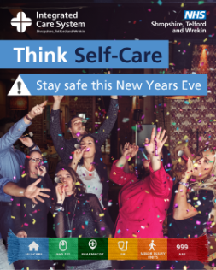  NYE1  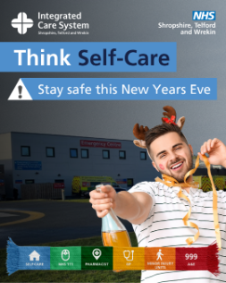  NYE 2 | Think Self-Care this festive season. Nobody wants #NewYearsEve celebrations ruined by a trip to A&E 🚑  Make sure you stay safe:  - Drink alcohol responsibility  - Eat before you start drinking alcohol  - Plan your journey home ahead of time  - Look out for family &friends  ➡ https://www.shropshiretelfordandwrekin.nhs.uk/your-health/our-campaigns/think-which-service/ | Think Self-Care this festive season.  Nobody wants #NewYearsEve celebrations ruined by a trip to A&E 🚑  Make sure you stay safe:  - Drink alcohol responsibility  - Eat before you start drinking alcohol  - Plan your journey home ahead of time  - Look out for family and friends  Find out more ➡ https://www.shropshiretelfordandwrekin.nhs.uk/your-health/our-campaigns/think-which-service/ | Think Self-Care this festive season.  Nobody wants #NewYearsEve celebrations ruined by a trip to A&E 🚑  Make sure you stay safe:  - Drink alcohol responsibility  - Eat before you start drinking alcohol  - Plan your journey home ahead of time  - Look out for family and friends
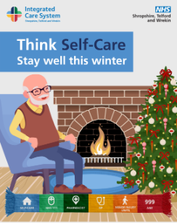  Stay well this winter 2  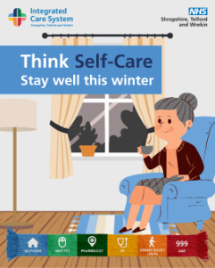  Stay well this winter 1 | Temperatures are dropping across the country this week.  Cold weather can have a serious impact on health, particularly in older people and those with pre-existing health conditions.  Find out how you can stay well this winter http://nhs.uk/staywell | Temperatures are dropping across the country this week.  Cold weather can have a serious impact on health, particularly in older people and those with pre-existing health conditions.  Find out how you can stay well this winter  http://nhs.uk/staywell | Temperatures are dropping across the country this week.  Cold weather can have a serious impact on health, particularly in older people and those with pre-existing health conditions.  Find out how you can stay well this winter  http://nhs.uk/staywell
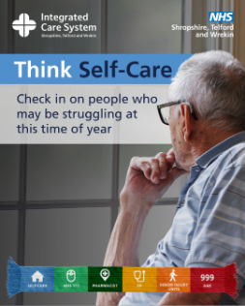  Loneliness 1 | Sometimes admitting you’re feeling lonely is hard. 💙  This time of year can be tough, so check in on someone who might be struggling. A small conversation can make a big difference.  Find out more ➡ https://www.shropshiretelfordandwrekin.nhs.uk/your-health/our-campaigns/think-which-service/ | Sometimes admitting you’re feeling lonely is hard. 💙  This time of year, can be tough, so check in on someone who might be struggling. A small conversation can make a big difference.  Find out more ➡ https://www.shropshiretelfordandwrekin.nhs.uk/your-health/our-campaigns/think-which-service/ | Sometimes admitting you’re feeling lonely is hard. 💙  This time of year, can be tough, so check in on someone who might be struggling. A small conversation can make a big difference.
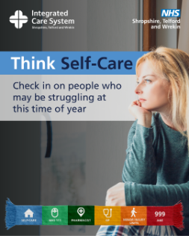  Loneliness 2 | Loneliness isn’t always easy to talk about. 💙  A quick check-in could mean the world to someone today.  Learn more https://www.shropshiretelfordandwrekin.nhs.uk/your-health/our-campaigns/think-which-service/ | Loneliness isn’t always easy to talk about. 💙  A quick check-in could mean the world to someone today.  Learn more https://www.shropshiretelfordandwrekin.nhs.uk/your-health/our-campaigns/think-which-service/ | Loneliness isn’t always easy to talk about. 💙  A quick check-in could mean the world to someone today.  Learn more https://www.shropshiretelfordandwrekin.nhs.uk/your-health/our-campaigns/think-which-service/

Image | X (Twitter) copy | Facebook / LinkedIn copy | Instagram
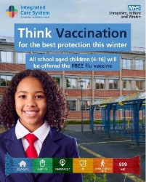  Think Vaccination Winter 2  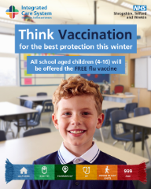  Think Vaccination Winter 3 | Think Vaccination!  Flu season is coming! Give your child and family the best defence this winter  Sign the consent form today for your child to receive their free flu vaccination at school.  Painless nasal spray – no needles!  Visit: nhs.uk/vaccinations | Think Vaccination!  Flu season is coming! Give your child and family the best defence this winter  Sign the consent form today for your child to receive their free flu vaccination at school.  Painless nasal spray – no needles!  📅 To find out more about booking your child's vaccination, go to the NHS website and search “child flu vaccine”.  #ThinkVaccination | Think Vaccination!  Flu season is coming! Give your child and family the best defence this winter  Sign the consent form today for your child to receive their free flu vaccination at school.  Painless nasal spray – no needles!  Visit: nhs.uk/vaccinations
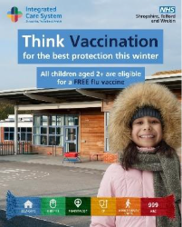  Think Vaccination Winter 1 | The flu nasal spray vaccine for children is quick, simple and effective – if your child is school-aged, look out for a consent letter.  If your child is aged 2 to 3 years, speak to your GP practice or book an appointment at a local pharmacy.  Book your appointment today nhs.uk/vaccinations | Think Vaccination!  Did you know that winter vaccines can reduce the risk of your child getting very ill?  The flu nasal spray vaccine for children is quick, simple and effective – if your child is school-aged, look out for a consent letter.  If your child is aged 2 to 3 years, speak to your GP practice or book an appointment at a local pharmacy.  📅 To find out more about booking your child's vaccination, go to the NHS website and search “child flu vaccine”.  #Thinkvaccination | Think Vaccination!  Did you know that winter vaccines can reduce the risk of your child getting very ill? 🤒 The flu nasal spray vaccine for children is quick, simple and effective – if your child is school-aged, look out for a consent letter.  ➡️ nhs.uk/vaccinations  #Thinkvaccination
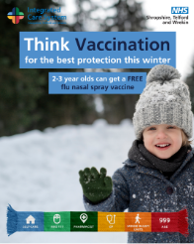  Think Vaccination Winter 4 | Think Vaccination! For the first time, parents can now get their 2 and 3 year olds vaccinated at local pharmacies.  It’s quick, safe and effective. Protect your child this winter.  Book now or find a local pharmacy offering walk-in appointments: nhs.uk/vaccinations | Think Vaccination!  For the first time, parents can now get their 2 and 3 year olds vaccinated at local pharmacies.  It’s quick, safe and effective. Protect your child this winter.  📅 To find out more about booking your child's vaccination, g tot he NHS website and search “child flu vaccine”. | For the first time, parents can now get their 2 and 3 year olds vaccinated at local pharmacies.  It’s quick, safe and effective. Protect your child this winter.  Book now or find a local pharmacy offering walk-in appointments: nhs.uk/vaccinations  #Thinkvaccination
  COVID-19 and flu vaccines 4 | Think Vaccination! If you’re pregnant, get your flu vaccine. Vaccination against common illnesses like flu helps to protect you & your baby.  Speak to your midwife or GP Practice for more information & to receive your vaccination.  ➡️https://www.shropshiretelfordandwrekin.nhs.uk/your-health/where-to-get-advice-and-help/vaccinations/  #ThinkVaccination | Think Vaccination!  If you’re pregnant, get your flu vaccine. Vaccination against common illnesses like flu helps to protect you and your baby.  Speak to your midwife or GP Practice for more information and to receive your vaccination.  📅 Book your appointment today on the NHS website. Search “Book Vaccination”.  #ThinkVaccination | If you’re pregnant, get your flu vaccine. Vaccination against common illnesses like flu helps to protect you and your baby.  Speak to your midwife or GP Practice for more information and to receive your vaccination.  ➡️ https://www.shropshiretelfordandwrekin.nhs.uk/your-health/where-to-get-advice-and-help/vaccinations/  #ThinkVaccination

For further posts see: Think Vaccination Campaign Toolkits - NHS Shropshire, Telford and Wrekin

