Shropshire, Telford & Wrekin

Joint Forward Plan

2025-2030

Date: 28th March 2025
Owner: Emma Pyrah

Version Editor Status of document Date
1.0 E Pyrah First review and amends for refresh 17.1.25
2.0 E Pyrah/C Parker Revised format and amends following joint
Review 25.1.25
3.0 E Pyrah Narrative updated by lead officers and
Amendments to improve digital accessibility 6.3.25 Submission to Strategic Commissioning Cttee
4.0 E Pyrah Amendment following feedback from SLT 17.3.25
5.0 E Pyrah Final version following approval by Board 28.3.25
Executive summary 5
Chapter 1: Our Integrated Care System (ICS) 7
1.1 Background 8
1.2 Our population……………………………………………………………………………………………….……….………………………………………….……9
1.3 What we want to achieve 9
1.4 How we will deliver these priorities 10
1.5 Our operating model 10
1.6 Our approach to working together 11
1.7 Our approach to commissioning 13
1.8 Our approach to taking specialist and clinical advice 16
1.9 Our approach to quality 17
1.10 Our approach to engaging with our communities ………………………………………………………………………………………….……19
1.11 Our approach to Climate and Green Planning 81
1.12 Our approach to measuring what we have achieved 17
Chapter 2: Delivering Person-centred Care 26
2.1 How we will implement a person-centred care approach 27
2.2 What we mean by person centered care 27
2.3 Our approach to tackling inequalities and duty to reduce health inequalities 28
2.4 Our approach to Population Health Management 29
2.5 Our approach to Prevention 29
2.6 Our approach to Proactive Care 73
Chapter 3: Place, Neighbourhoods and Collaboration 32
3.1 Place and Neighbourhood Health 33
3.2 Our Places 33
3.3 Our Neighbourhoods and Integrated Neighbourhood Teams 37
3.4 Our approach to Women's Health Hubs…………………………………………………………………………………………..……42
3.5 Our approach to Provider Collaboratives and Collaboration 44
3.6 Supporting social and economic developments 45
3.5 Voluntary, Community and Social Enterprise (VCSE) 47
Chapter 4: Improving Access to Services 49
4.1 Primary Care Networks and General Practice 50
4.2 Community Pharmacy, Optometry and Dentistry 50
4.3 Elective Care Recovery 52
4.4 Urgent and Emergency Care 54
4.5 Cancer 55
Chapter 5: Our Key Clinical Transformation Programmes and other Clinical Priorities 57
5.1 Hospital Transformation Programme 58
5.2 Local Care Programme 60
5.3 Cardiovascular Disease (CVD) 62
5.4 Diabetes 63
5.5 Musculoskeletal (MSK) 64
5.6 Mental Health 65
5.7 Maternity 66
5.8 Children and Young People 66
5.9 Healthy Ageing and Frailty 67
5.10 End of Life 69
5.11 Medicines 70
5.12 Our duty to address the needs of survivors of abuse 73
Chapter 6: Enablers 75
6.1 People 76
6.2 System procurement 77
6.3 Digital 79
6.4 Data and Information 81
6.5 Estates – System Physical Infrastructure, Estates Strategy and Planned Delivery 83
6.6 Financial sustainability 84
6.7 Productivity 86
6.8 Our commitment to research and innovation 87
Appendix A: Schematic of Delivery Governance and Assurance Governance 91
Appendix B: Duty to offer choice 92
Appendix C: Our Neighbourhoods 94
Appendix D: List of acronyms 95
Appendix E: How we engaged with our stakeholders 97

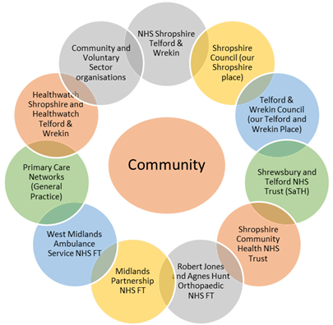
Executive summary
The Shropshire, Telford and Wrekin (STW) Integrated Care System (ICS) has developed this Joint Forward Plan to outline how our health and care system will work together to deliver the priorities we have jointly agreed over the next five years.

This plan has been developed through a collaborative approach with all system partners and wider stakeholders in this diagram (right) and is based on engagement with our local communities. It is not set in stone, and we will continue to engage with our communities beyond the publication of the plan.

Since March 2020, when the COVID-19 pandemic was declared, our health and care system has been through some of the most challenging few years in its history. The pandemic changed the way we worked, lived and how our health and care was delivered. As a system, as partners and as individuals, we learned a lot about working together and the importance of community and wellbeing. However, the pandemic has also exacerbated our challenges and the demand for services.

For example, we are seeing unprecedented demand for mental health and wellbeing services, particularly for our children and young people (CYP). The backlog of planned operations and medical interventions has grown, and we have experienced challenges in delivering several constitutional standards. Our whole system also faces significant challenges in recruitment and workforce shortages, particularly in relation to restoring elective inpatient and cancer activity.

In July 2021, our system was formally placed in the national Recovery Support Programme (RSP) due to serious, complex, and critical quality and finance concerns that required intensive support.

Our system is currently spending more than its allocated finances and, therefore, our plan is set in the context of a financial recovery trajectory. Rather than spending more, we need to allocate resources based on creating health value – implementing innovative financial flows and payment mechanisms and considering allocation of resources to provider collaboratives and ‘Places’. We need to think and work differently to meet these challenges, including working more closely together.

The three key elements of our plan are:
- Taking a person-centred approach (including proactive prevention, self-help, and population health to tackle health inequalities and wider inequalities).
We are committed to working with service users, carers, and partners to support our citizens to live healthy, happy, and fulfilled lives. This will mean supporting people to proactively look after their own health, putting a greater emphasis on preventing illness and staying well, but also providing the right care when and where they need it. Chapter 2 talks about person-centred care, what it is and how we will deliver it.
- Improving place-based delivery, having integrated multi-professional teams providing a joined-up approach in neighbourhoods, supporting our citizens and providing care closer to home, where possible.
The STW Local Care Transformation Programme (LCTP) brings together a collection of transformation initiatives that will deliver more joined-up and proactive care closer to home, supporting improved health and wellbeing for our population. This is encompassed by the local care vision of “adding years to life and life to years”. Details of the LCTP are set out in Chapter 3 of this plan.
- Providing additional and specialist hospital services through our Hospital Transformation Programme (HTP).
The HTP is putting in place the core components of the acute service reconfiguration, agreed as part of the Future Fit consultation. It is helping us to address our most pressing clinical challenges and establish solid and sustainable foundations upon which to make further improvements. Details of the HTP are set out in Chapter 4 of this plan.

In conclusion, this plan highlights the work that we are undertaking across the ICS to improve the care we provide for the citizens of Shropshire, Telford and Wrekin. We understand that this is an ambitious plan which faces significant challenges. But while there is much work to be done, we believe that it is achievable. We must deliver our plan to improve the health and care services for our population through the strong commitment of our partner organisations and by talking to and working with our communities.

Chapter 1:

Our Integrated Care System (ICS)

1.1 Background
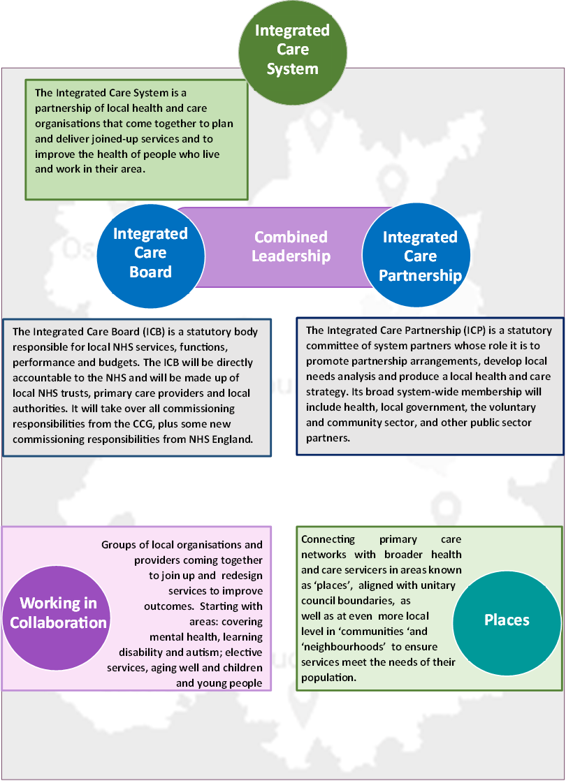
Our Joint Forward Plan has been developed through a collaborative approach with all system partners and wider stakeholders, including our Health and Wellbeing Boards. We will be held to account for its delivery by our population, patients and their carers or representatives and, in particular, through the Integrated Care Partnership (ICP), Healthwatch and the local authorities’ Joint Health Overview and Scrutiny Committees.

As an ICS we understand the importance of developing our health and care services based on the views of our local population, alongside the evidence on population health. We have been working with our two Healthwatch organisations to hear what our residents are telling us.

Residents have asked for “a person-centred approach to our care”. People must be at the heart of everything we do and by delivering joined-up services in both acute and community settings, we can give everyone the best start in life, create healthier communities and help people age well.

1.2 Our population
Our approach to population health management and business intelligence, and our understanding of our population and their needs, will ensure that as a system, we are working on the right priorities. Furthermore, it will then provide the in-depth analysis to support commissioners in facilitating work with providers, community assets and our population to find solutions to our ‘wicked’ issues.

Our councils provide the Joint Strategic Needs Assessments (JSNAs) for our populations and communities. These inform the Health and Wellbeing Strategies for each of our Places and, subsequently, our interim Integrated Care Strategy, was approved in March 2023 by the Integrated Care Partnership with the final version approved in October 2024.

1.3 What we want to achieve
Within the context described above, our ICS vision, pledges and strategic priorities are summarised in the diagram below:

1.4 How we will deliver these priorities
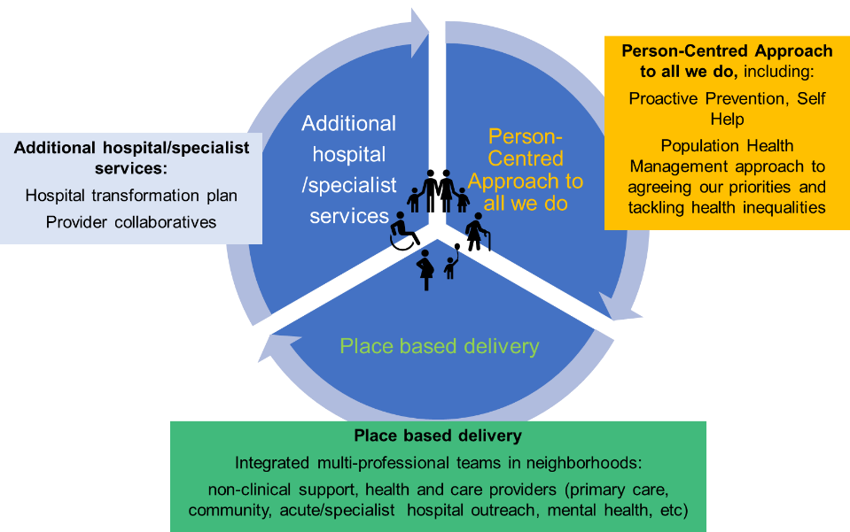
There are three key components of our plan which will help us achieve our priorities and our model of care. These are shown in the diagram on the right.

Our two Places will play a major role in delivery of our priorities. The table below shows how the ICS priorities align with our Place priorities.

1.5 Our operating model
Although we are a challenged system, we are an ambitious one. Our operating model outlines how we plan to deliver our statutory duties and our ambitious plans. The operating model has our purpose at its foundation:

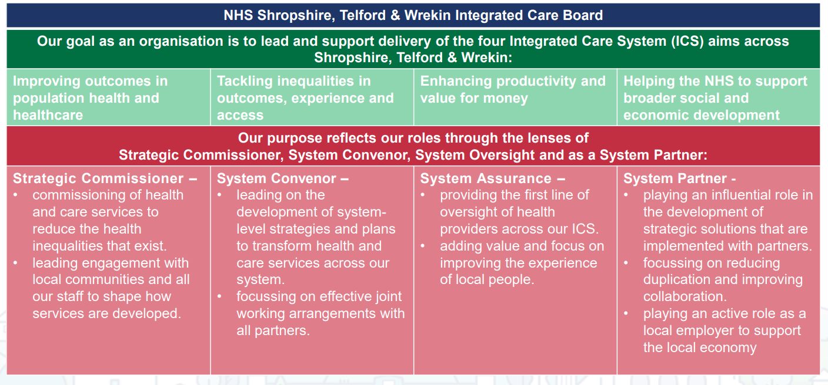

In combination with our purpose and goals – our values, behaviours and leadership approach shape the design principles for our ICB teams and functions, our relationships within and beyond our organisation and how we design our processes. This includes how we commission and how we support our providers of care to collaborate.

We undertake our unique role in the Shropshire, Telford and Wrekin health and care system with compassion, respect, drive and integrity. This means that we value diverse contributions, drawing on the expertise and experience of local people, staff and partners, alongside high-quality intelligence to make choices which best serve the people of Shropshire, Telford and Wrekin. You can expect to see and experience:
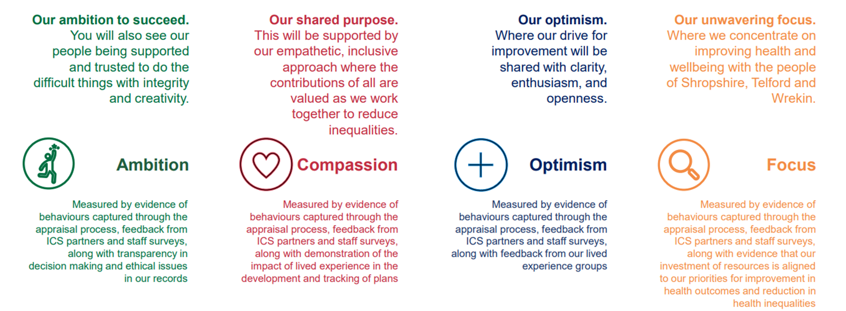
These values form one of the pillars of our recruitment and retention processes and shape our behaviours.

We have worked with our staff to develop design principles which underpin how we design our functions to deliver our purpose:
- Outcome focussed – design for our 4 purposes and unique role in the ICS
- Positive future mindset – Design for how we want to work in the future
- Affordable – Clear roles and functions, aligned to the commissioning cycle to ensure clear relationships and contributions within and beyond the ICB
- Collaborative – Do once what can be done once for all (ICB or ICS, or prepare for that in the future) Support colleagues to be intelligent consumers of specialism and design to service our colleagues and partners
- Challenge assumptions – Find new ways of working, support others to hold their responsibilities
- Compliant – Fulfil our statutory obligations
- Enabling – Design for: expertise and freedom to act; efficiency; the ability to flex and change, developing talent; and transition through pain points supported by governance which supports us and keeps us safe
These design principles, along with our values, behaviours and leadership models, form the principles of how we design our operating processes:
- Strategy will be grounded in population health management approaches, with equitable targeting to reduce inequalities, and measurable outcomes, clearly laid out contributions to its implementation, draw on experience and insight from across the ICS and align resources to clinical priorities
- Our relationships within the ICS will be grounded in mutual support and our shared success will make Shropshire, Telford and Wrekin a great place to work
- We will place our people in roles that they have the skills and experience for, create clear career pathways and ensure that every member of the team understands how they can make decisions and contribute to the delivery of our purpose
- We will set out clear accountability and ensure collective responses to any challenges we face
- Our record keeping will ensure transparency in our decision-making process and how we prioritise.

1.6 Our approach to working together
In 2024, working with the Good Governance Institute, the ICB developed a governance improvement programme. The aim of the programme was to develop a simplified corporate divisional structure for the ICB with fewer, more efficient meetings that strengthen assurance, management of processes and board oversight.

A core principle of these proposals is to recognise the distinctive role of the board and management. In particular:
- The ICB board sets the strategy and receives assurance
- ICB committees provide and receive assurance on risks to the ICB strategy and support continuous improvement
- ICB executives develop and implement plans and actions.

ICB Board
The board of our ICB is a unitary board at the centre of the ICB governance framework. It is accountable for the performance and assurance of the NHS and the wider Integrated Care System (ICS) within Shropshire, Telford and Wrekin in both operational delivery and to ensure progress towards its four aims. To discharge this, the board also sets the strategy for the NHS within the ICS and supports the delivery of the Integrated Care Partnership (ICP) Strategy.

The board provides leadership for the transformation of the NHS in Shropshire, Telford and Wrekin, and oversees the activities carried out by the ICB, in Place and in the ICP, ensuring good corporate, financial, clinical and quality governance throughout the ICS. The board convenes committees within the ICB or across the ICS to assure these activities.

All members of the board are jointly and equally responsible for the decisions and actions of the board and, whilst drawing on their experience in undertaking their ICB role, do not represent the particular interest of any organisation, community or group.

Our non-executive directors provide leadership of the key assurance functions of the board including chairing the committees of the ICB. Our partner members lead ICS delivery portfolios.

Our Places
Telford and Wrekin Integrated Place Partnership (TWIPP) and Shropshire Integrated Place Partnership (ShIPP) are our system’s two Place-based partnership boards. They are based on the well-established relationships across the NHS and with our local authority and community and voluntary sector partners. Our Joint Forward Plan describes the actions and ambitions to deliver the Place-based strategies over the coming five years.

Both Places have strategies that are based on delivery of their respective Health and Wellbeing Board strategies and the Integrated Care Strategy (a joint strategy originally developed in March 2023 and subsequently refreshed in and signed off by the ICP in October 2024).

Our Place delivery model recognises that neighbourhoods are key to having thriving communities that support people to keep well, prevent ill health, and manage long-term conditions closer to their homes, schools, or primary care.

Our Provider Collaborative
Collaboration between providers forms a cornerstone of the ICS’s approach to delivering better outcomes for our population. The ICB will continue to support the development of formal collaboratives between provider organisations with which it can commission a range of joined up services.
As the Provider Collaborative landscape develops a key step will be the inclusion of a wider set of partners in formal collaborative arrangements to ensure we are embracing collaboration and the opportunities this presents, in its widest sense.

1.9 Our approach to Commissioning

Delivering the NHS Commissioning Cycle
The ICB works to deliver its four purposes through the three phases of the commissioning cycle:
- Strategic planning – co-assessment of ICS needs, planning of services, engagement with stakeholders
- Procuring services – service specification development, provider selection, engagement with stakeholders, contract development
- Monitoring and evaluation – contract compliance, oversight of delivery, feedback from stakeholders.

In combination, this enables our ICS to respond and transform delivery. The ICB will not undertake every part of each phase of the commissioning cycle, but it will hold the responsibility for ensuring that all activities happen. The fundamentals of commissioning (in its fullest sense) remain crucial in structuring health services. However, how we commission is being transformed. The introduction of the provider selection regime requires a new function within the ICB that can collaborate with partners in a different way. We will use the commissioning cycle to align the efforts and contributions of each function in the ICB to achieve our commissioning objectives.

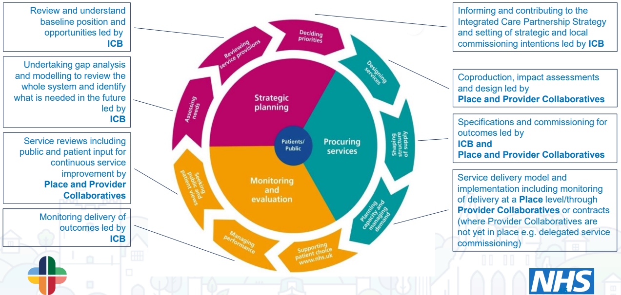
Figure 1: How we will work together to deliver outcomes

Our approach to Commissioning Intentions
Commissioning intentions describe how the organisation intends to shape local services to meet the needs of the population.
As well as ensuring we continue to meet our historic mandatory requirements for commissioning intentions and contract negotiations, the ICB has begun considering how it will evolve to focus upon outcomes.

As the ICB’s attention and focus is shifting to the role of becoming the Strategic Commissioner within the ICS, with the ambition of starting to delegate tactical commissioning and transformation to Place and Provider Collaboratives as our key delivery vehicles over a period of time, a new approach to the development of Commissioning Intentions is required.

The approach will form a key element of the Planning process and our Commissioning Intentions will be co-produced working with all health and care partners across the system focusing on a number of high level priorities already agreed through the Joint Forward Plan and Clinical Strategy underpinned by the Joint Strategic Needs Assessments across Shropshire, Telford and Wrekin turning actions into deliverable outcomes that can be quantified from an activity and finance perspective and also deliver demonstrable patient/pathway improvements. These intentions may also span a number of financial years.

In addition, the Commissioning Intentions will also provide the framework to facilitate the ICB to lead, develop and embed an outcome-based commissioning approach which is a data driven and evidence based reflecting the needs of the population and providing strategic direction without specifying ways of delivering services.

This approach will also support the development of a robust, integrated commissioning framework delivering the ICB’s statutory duty with a focus on the alignment of commissioning priorities, strategic market development, delivery of outcomes and maximisation of financial resources including the joint commissioning of services through pooled or aligned budget arrangements.

The golden threads that run throughout the development of the Commissioning Intentions are as follows:
- System Strategies – the Commissioning Intentions take the relevant strategies and aim to develop a high-level set of deliverables and measurable outcomes against each of the areas
- The system overarching Integrated Strategy (IS) - The four aims of the IS run through the Intentions with clear links to how the successful delivery will contribute to one or more of the following:
  - Financial Improvement and the Medium Term Financial Plan
  - Operational Planning Rounds submissions
  - Darzi review and high level ambitions of the upcoming 10 year plan’s 3 shifts i.e. hospital to community, illness to prevention, analogue to digital.

Our Commissioning Intention principles
- Wherever possible we will do things only once but with flexibility
- Reducing inequalities by tackling the wider determinants of health and inequity in access, experience and outcomes, including poverty and rural exclusion
- Drive efficiency and productivity, delivering best value, effective use of resources
- Committed to working with people with lived experience and coproduction
- Decision making will be devolved to the most appropriate place
- Risk with be shared – clinical, financial and operation
- Be ambitious in our approach, recognising the challenges we have alongside the breadth of opportunities
- Fully embed evidence based shared decision making and contracting for outcomes
- Commissioning for outcomes; giving freedom for design and coproduction across sectors

Our approach to integration and joint commissioning
Joint commissioning refers to arrangements in which public bodies look to undertake the planning and implementation of services collaboratively. This could be for a whole population or in relation to people with particular needs (such as those with a complex disability). We believe that commissioning collaboratively as a system enables benefits for everyone, including improved outcomes and experiences for people, reduced duplication, best use of resources and improved access to services.
We will use joint commissioning to deliver integrated services.
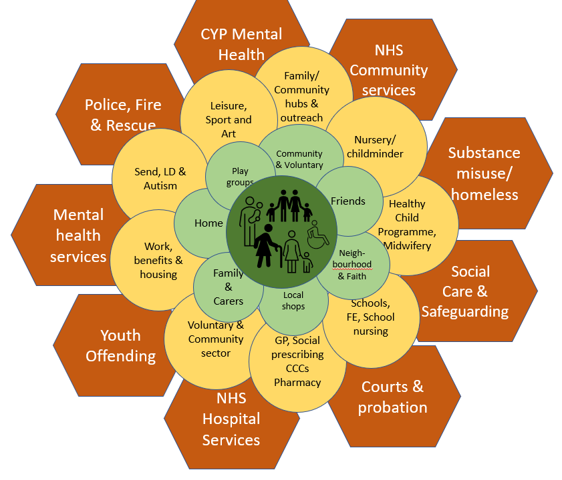
Integration focuses on the strengths of people and communities as a cornerstone of how we will work. As described in our model of care – people, communities and public services work together to support people to build the foundations for a healthy and fulfilling life.
The diagram on the right demonstrates this people and community-centred approach that is echoed throughout this plan and the ICS’s work.
Specifically, we will work together to design and invest in pathways which are person-centred and hold organisations jointly accountable for the overall experience of individuals and families. We will also engage people with lived experience, communities, and professionals in setting the overall priorities for an area and designing pathways that reflect local needs and opportunities. We will develop performance management frameworks which consider not only quality of individual services, but also the extent to which people experience integrated, high-quality care. We will use the financial and workforce resources available across our organisations to support local populations in the most effective means possible. The Better Care Fund (BCF) enables this joint working and focuses on local priorities at place-based level.

1.10 Our approach to taking specialist and clinical advice
We strongly believe that our Clinical and Care Professional leaders should be at the centre of our system planning and decision-making. We start from a strong foundation, with dedicated ICB Clinical Leads for each of our system portfolios who are responsible for convening and chairing multi-disciplinary and multi-organisational Clinical Advisory Groups (CAGs) which provide clinical/specialist advice into each programme of work. Individuals from within these groups lead work on clinical pathways and transformation, using the CAG to engage, inform, check and challenge.

The CAGs feed into four specialist delivery groups that support the ICS. These are:
- Mental Health and Learning Disabilities and Autism Delivery Group
- Children and Young People, SEND and Families Delivery Group
- Urgent and Emergency Care Delivery Group
- Planned Care Delivery Group.

We also have a well established Local Maternity and Neonatal System which is clinically-led and involves a range of multi-disciplinary clinicians from a variety of organisations, and focuses on transformation, quality, governance and assurance.

Our Clinical Cabinet brings together our Clinical and Care Professional leaders for strategic discussion, and our Health and Care Senate, acts as a wider forum for clinicians to share learning, information, and challenges across our system.

We have also developed a collaborative peer learning network for Maternity and Neonatal Care with Staffordshire & Stoke-on-Trent ICB and system partners, in order for us to maximise our ability to take clinical and specialist advice from outside our own system. We plan to utilise a similar model of cross system collaborative learning across other clinical priorities.

We will continue to build on this solid foundation to ensure that clinical and/or specialist advice is embedded throughout all levels of the ICS, through visible multi-professional leadership and strong professional networks, supported by clear governance structures.

Specialist advice is also supported by NHS England through the clinical and specialist networks.

1.11 Our approach to quality
As a system, we commit to using all available resources, including Right Care Opportunities, to deliver improved quality by removing unwarranted variation and improving outcomes at a population health level.

It is our ambition to create outstanding quality by:
- Committing to patient-centred, personalised care where patients have ownership of their own care, but also routinely inform development and delivery of future services based on the learning of their lived experiences
- Strengthening integrated multi-disciplinary working across our organisations to ensure our population receives care in the right place at the right time
- Streamlining care with robust pathways to ensure sufficient capacity for planned care, designed to improve patient experience and outcomes
- Making sure people can navigate a simplified urgent care system to meet both physical and mental health needs
- Supporting our health and care providers to achieve improved CQC ratings where appropriate.

Key areas where we need to improve quality of services:
- Children and young people’s (CYP) services
  - We want to strengthen the multi-agency approach to the prevention of poor mental health and improve access when services are needed
  - We want to ensure children’s acute services are safe and effective, and waiting lists are tackled in line with adult services
- Urgent and emergency care (UEC)
  - We want to improve timely access to urgent and emergency care
- Diabetes care
  - We want to focus on prevention of diabetes and ensuring healthy lives for people with diabetes
- Maternity care
  - We want to continuously improve our maternity services and sustain improvements made in response to the Ockenden reports.

As a system, we will fully prepare for the CQC framework to monitor the quality of services for integrated care systems.

Our plans to continuously improve the quality of our services are outlined below:

How will we monitor quality?
- Listening to those with experience of care
- System quality risk register
- System risk escalation
- System quality metrics at Place
- System Quality Group with clear terms of reference and feed to Regional Quality Group
- The Quality and Performance Committee seeking assurance against the risks with the partnership of key agencies across the ICS, in line with national guidance
- Learning from deaths, child death overview panel (CDOP), infant mortality and people with a learning disability and autistic people (LeDeR)
- The co-ordinated introduction of a Patient Safety Incident Response Framework (PSIRF) and learning from incidents as a system and beyond, driven by patient safety specialists and patient safety partners
- Receiving and discussing quality exception reports monthly at ICB Board

How will we measure and sustain quality?
- Executive champions of quality health and social care coming together at System Quality Group to drive quality services forward across the ICS and beyond
- Contracts and local quality requirements
- Clearly defined system quality metrics
- Themed quality visits
- Partnering with Healthwatch and the voluntary sector
- Co-production with those who experience care
- Feedback from our residents
- Quality accounts

How will we improve quality?
- Integration of quality improvement expertise into system priority programmes
- Research and innovation
- Rapid learning from incidents and themes across partners
- Finding out what works through quality improvement projects with partners across the ICS
- Focus on personalised palliative and end-of-life care
- Aging well though the support of care homes and domiciliary care to deliver the highest possible care they can
- A focus on early years
- Ensuring quality care is accessible to all though strategic integration of quality and Core20PLUS5.

1.12 Our approach to engagement with communities
In line with our values, we have built our Joint Forward Plan through a process of genuine engagement with our local communities, stakeholders, and our staff.

Comprehensive and meaningful engagement will ensure our services are more responsive to people’s physical, emotional, social and cultural needs. We will take active steps to strengthen public, patient and carers’ voices at Place and system levels. We have engaged with groups who are seldom heard and those who have the greatest health inequalities, in relation to access to services and health outcomes, to ensure they are not excluded from the dialogue.

We have developed a set of principles for involvement which have been shaped with input from people across our health and care system and communities. They have been informed by the knowledge and experience of a diverse range of people, including those with lived experience of using our services and those for whom involvement is already embedded into their working practices.

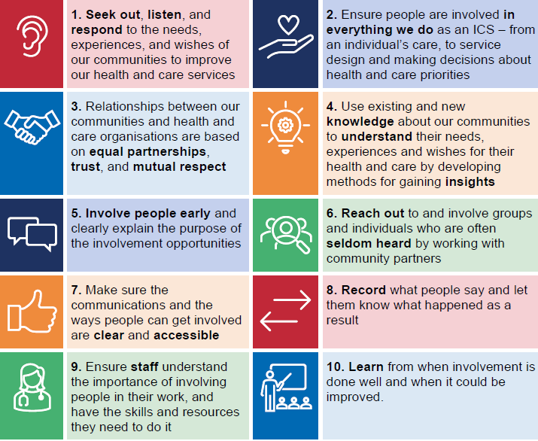

Read our full Involving People and Communities Strategy.

To support staff to plan and undertake the appropriate level of involvement of people and communities, we have established an Equality and Involvement Committee into our governance arrangements. The role of the Committee is to provide assurance to the Board that our strategies, plans, service designs and developments have adequately and appropriately:

- considered and addressed the health and care needs and aspirations of residents in Shropshire, Telford and Wrekin who do, or may, experience inequalities in access to health services and health outcomes,
- involved people who do, or may, use the services under consideration.
Read more about the role of the Committee and its membership.

In 2023, we launched the Big Health and Wellbeing Conversation asking people who live, work or access health and care services in Shropshire, Telford and Wrekin how the care they receive could be improved. The Big Health and Wellbeing Conversation aimed to understand local views on what is affecting their health and wellbeing and what could make the biggest difference to improve experiences of local health and care services. The feedback gathered is helping NHS Shropshire, Telford and Wrekin to develop future plans. We also continue to engage and listen to the views of people and communities through individual programmes of work to support the delivery of our Joint Forward Plan, for example the Children and Adolescent Mental Health Service, GP Out of Hours Service, and more broadly the Think Which Service Campaign and Change NHS.

The key recommendations from the Big Health and Wellbeing Conversation included the following:
- Improve communication with patients and between services.
- Improve access to appointments including increasing virtual appointments.
- Raise awareness of services to help people to live well.
- Support patients to minimise digital exclusion.
- Sharing learning from patient experience of poor-quality services.

1.13 Our approach to Climate and Green planning
Climate change presents an immediate and growing threat to health. The UK is already experiencing more frequent and severe floods and heatwaves, as well as worsening air pollution. Up to 38,000 deaths a year are associated with air pollution alone, disproportionately affecting the most deprived and further exacerbating health inequalities.
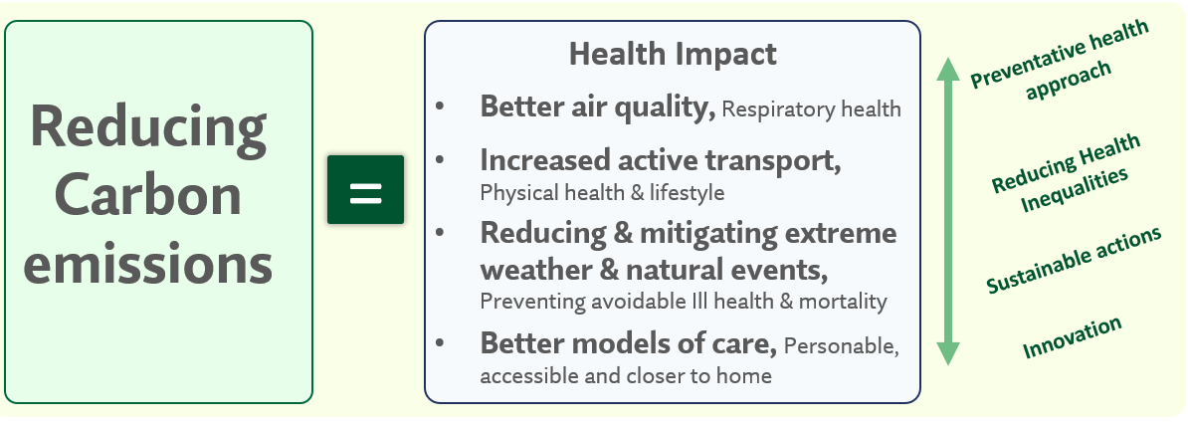
In October 2020, the NHS became the world’s first health service to commit to reaching carbon net zero, in response to the profound and growing threat to health posed by climate change.
The “Delivering a Net Zero Health Service” report sets out a clear ambition and two evidence-based targets.
- For the emissions we control directly (the NHS Carbon Footprint), we will reach net zero by 2040, with an ambition to reach an 80% reduction by 2028 to 2032; These are the areas shown in scope 1 below.
- For the emissions we can influence (our NHS Carbon Footprint Plus), we will reach net zero by 2045, with an ambition to reach an 80% reduction by 2036 to 2039. These are shown in the indirect scope 2 and 3 of the diagram.
Each Provider has a carbon reduction plan that looks to reduce carbon emissions in direct and indirect carbon emissions. This is achieved through implementing the delivery across key areas of focus detailed below
The system works collectively on achieving the net zero objectives across providers through a climate change group co-chaired by Shrewsbury and Telford Hospital (SaTH) and Robert Jones and Agnes Hunt (RJAH).
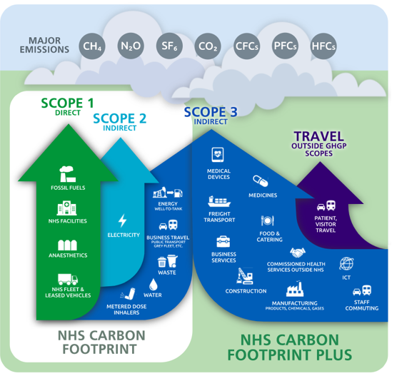
Examples of work to date has included
- Heat Decarbonisation Projects: Successful applications for funding and in the process of implementation at SaTH
- Installation of electric ambulance charging points at SaTH, and increased staff charging points installed in RJAH carpark
- Use of solar power and renewable energy sources/tariffs
- RJAH recognised as Exemplar status for catering – particularly for work around reduction of single use plastic in catering, recently winning Gold Award for Excellence in Waste Management (NHSE) for reusable food container projects
- Reduction emissions from nitrous oxide and mixed nitrous oxide waste through capped use and not including use in new estate builds at SaTH and RJAH
- Staff active travel schemes with Aviva and increase of use of Park and Ride
- Introduction of system wide fleet policy in 2024 re low emission and zero emission vehicles
- Greener Trainer hub at Midlands Partnership Foundation Trust
- Biodiversity schemes across a range of providers
- LED lighting at RJAH with plans for funding submitted across providers to national funding pots.
- Providers across system adopting and following the Total Roadmap for Greener Procurement
- Improvements made in reducing carbon emissions from inhalers, a significant contributor to the NHS carbon footprint. Key initiatives have included awareness campaigns among clinicians and patients to promote lower-emission alternatives, including dry powder inhalers (DPIs), where clinically appropriate.
- Collaborations with GP practices and pharmacy teams have focused on optimising prescriptions, with an emphasis on reducing unnecessary short-acting beta-agonist (SABA) inhaler use.
The Health and Care Act 2022 placed new duties on NHS organisations to consider statutory emissions targets in their decisions, making the NHS the first health system in the world to embed net zero in legislation. STW delivers these duties through considering the impact of climate change as part of the summary documentation in reports to key committees and Boards and in ensuring compliance with adherence to procurement regulations when awarding contracts for new services.
A Greener NHS Refresh Plan was published in February 2025 which re-emphasised the NHS’s commitment to achieving NET zero in line with the Darzi Independent Review of the NHS:
“Given the global health imperatives, the NHS must stick to its net zero ambitions. There is no trade-off between climate responsibilities and reducing waiting lists. Indeed, often health and climate are mutually reinforcing goals: cleaner air is good for the environment and good for respiratory health.”
Independent investigation of the NHS in England, Lord Darzi, September 2024
The Greener NHS Refreshed Guidance (2025) retains the focus on delivery of Net Zero in the NHS through:
- supporting high-quality, preventative and low-carbon care, in line with the NHS’s goal to boost out-of-hospital and digitally enabled care, improve prevention of ill health and reduce health inequalities
- reducing air pollution by decarbonising the NHS fleet, which is set to save the NHS over £59 million every year and deliver a range of health benefits valued at over £270 million.
- modernising and decarbonising the NHS estate, which is expected to reduce energy costs while creating a better environment for patient care
- minimising waste through circularity – where reusable, remanufactured or recycled solutions are used – which is often cost-saving and helps protect against external supply disruptions
In response, Shropshire, Telford and Wrekin ICB will produce a refreshed system Green Plan covering the next 3 years (2025-2028) for Board approval in July 2025. This system plan will reflect the contents of individual provider plans as well as new duties on the ICB to cover as a minimum the ICB’s role in:
- providing system leadership on emissions reduction and engaging with wider system partners – for example, by working with local authorities on travel and transport initiatives
- supporting partner trusts to deliver their green plan objectives and overseeing progress, including through contract monitoring (NHS Standard Contract service conditions, section 18)
- supporting primary care providers to contribute to system-wide emissions reductions – for example, by working with and through overarching structures such as primary care networks and primary care committees
- sharing best practice across partner organisations, supporting collaboration and facilitating engagement with relevant research and innovation activities, such as through health innovation networks
- maximising opportunities to reduce emissions and improve population health when planning and commissioning NHS services
- ensuring that green plan priorities are aligned with and reflected in the ICB Joint forward plan, Integrated care system (ICS) infrastructure strategy and capital plans, and other relevant system-wide plans in line with the 4 core purposes of the ICS
- delivering a limited set of priority actions at system-level, as set out in areas of focus

1.14 Our approach to measuring what we have achieved
Shropshire Telford and Wrekin ICS has developed a system Accountability and Performance Framework (SAPF) during the later part of 24/25 which is to be implemented from April 25 and provides a governance structure across the system to ensure successful delivery of operational plans, national standards and effective reporting of improvement where recovery is required. It will be an integrated model that takes account of individual organisational accountability and performance governance but ensures delivery across the whole system. This framework is a key deliverable (4.2) for the System Integrated Improvement Plan agreed at the Integrated Care Board in November 24 and signed off by NHSE in December 24.

The SAPF sets out the systems and processes through which the system will support organisations/ teams and manage the delivery of our strategic and operational goals, as well as ensuring that the regulatory and statutory requirements that apply to the system and its Trusts are met (including those outlined in the NHS Constitution).

The SAPF drives the implementation of best practice performance assurance processes throughout the system, aligned to organisational and IC Board committees, ensuring that:

- Accountability arrangements are in place across the system and individual Trusts to drive the delivery of all agreed objectives, targets, and standards. Performance is seen as a continuous process which is embedded in all aspects of organisational activity.
- Agreed performance objectives and targets are Specific, Measurable, Agreed, Realistic and Time bound (SMART) and transparent measurements are set to monitor performance.
- Timely information is available to enable appropriate understanding, monitoring, and assessing of the System and individual Trust’s quality and performance, prompting appropriate action to be taken if performance is forecast to fall below set objectives and targets at both organisation and system level as required.
- All system partners and their respective Committees understand their roles and responsibilities and are supported and motivated to deliver, with a clear line of sight between their contributions and the overall success of the Trust and wider system.
- Action plans are developed as soon as risks to the achievement of required targets or standards and/or barriers to effective performance are identified within individual trusts and then, if necessary, aggregated by the ICB where system performance is affected.

To deliver the SAPF a stepped approach to performance management is required which clearly specifies roles, accountabilities, and responsibilities. It is essential that key targets, programmes, projects, and actions are disaggregated throughout the System and within Trusts and hierarchy to ensure delivery of targets at every level and across the system/organisation as a whole; to understand what is expected of them and the part they play in the overall success of the system and Trust.

Chapter 2:

Delivering person-centred care

2.1 How we will implement a person-centred care approach
The diagram below summarises how we will implement our person-centred approach.

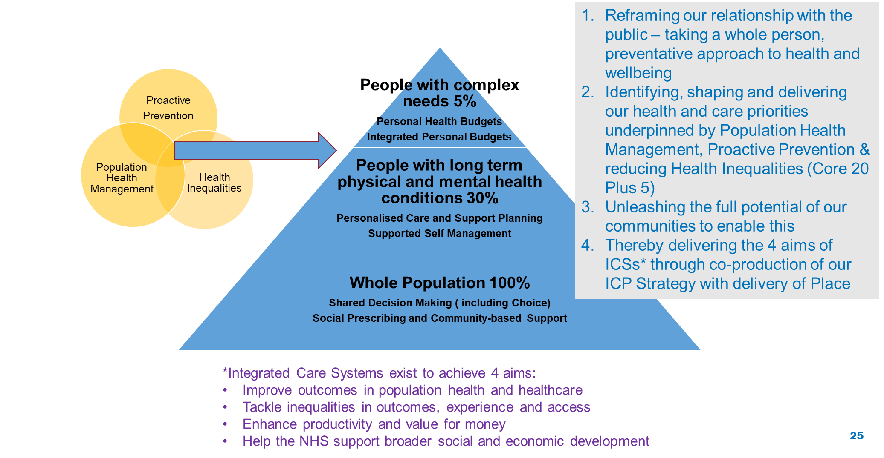

2.2 What we mean by a ‘person-centred approach’
Person-centred care moves away from professionals deciding what is best for patients or service users, and places the person at the centre, as an expert in their own experience and lives. The person, and their family where appropriate, become an equal partner in the planning of their care and support, ensuring it meets their needs, goals, and outcomes.

With an emphasis on ‘doing with’ rather than ‘doing to’, person-centred care runs through both individual and group settings, allowing users of services to be active not only in their own care but also in the design and delivery of services. This approach can improve both the experience and quality of care.

Person-centred care relies on several aspects, including:

- People’s values and putting people at the centre of their care, considering people’s preferences and chosen needs
- Ensuring people are physically comfortable and safe
- Emotional support involving family and friends
- Making sure people have access to appropriate care that they need, when and where they need it
- Ensuring people get all the information they need, in a way that is accessible for them, to make decisions for their care and support.

Person-centred care also recognises the strong and evidenced link between non-clinical, community support, and improvement in health and wellbeing.

We will facilitate a strengths-based approach in our communities to utilise non-clinical resources, recognising that the wider determinants of health affect 90% of our health and wellbeing, with health and care services impacting only 10%.

2.3 Our approach to tackling inequalities/duty to reduce health inequalities
Health inequalities are unfair and avoidable differences in health across the population, and between different groups within society. Healthcare inequalities can arise from differences in access, experience and outcomes achieved from health care services. At a fundamental level this will result in a reduction in life expectancy and healthy life expectancy for those who experience health care inequalities.

Whilst the ICB recognises its duty to address access to, experiences of and outcomes related to directly provided health services, we also wish to recognise and work with partners to tackle the causes of the wider determinants of health inequalities, including preventable causes of ill health. These wider determinants can include discrimination of the basis of protected characteristics, socio economic factors as well as wider geographical impacts.

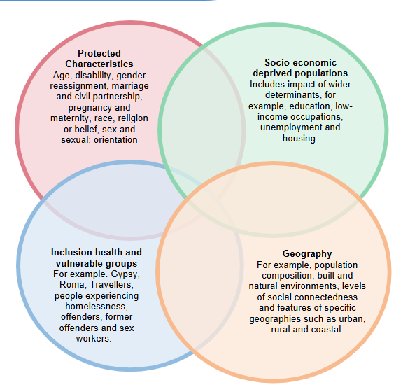
NHSE National Healthcare Inequalities Improvement Programme provides guidance to the ICB in relation to the evidence-based areas of targeted interventions that will make the most impact on reducing healthcare inequalities.

This approach is referred as the Core20PLUS5 approach, where Core 20 refers the population living in the m20% most deprived areas , PLUS refers to inclusion health groups and 5 to the clinical areas where evidence indicates worse health outcomes that can be addressed through system actions

To enable co-ordinated delivery across our system, a Prevention and Health Inequalities Group has been established which will monitor progress against our system high level implementation plan which addresses these mandated areas. To recognise partner working this Group is chaired by the Director for Public Health from Telford and Wrekin Local Authority with membership consisting of the ICB lead for health inequalities and SRO leads for health inequalities from across main provider organisations.

As part of the refresh of this JFP in February 2025, a review of the newly launched NHSE guidance documents that inform our healthcare inequalities focus as a system has been undertaken to assess areas for continued focus over the upcoming period.

2.4 Our approach to Population Health Management (PHM)
Population health management (PHM) is a person-centred, data-driven approach that seeks to improve the physical and mental health of people over their lifetime. PHM allows our system to use all the digitally-collated data, intelligence and insight from our area to make collective decisions and prioritise key issues and specific populations of people, depending on need and equity. It requires clinicians, professionals, and frontline workers to expand their focus from treatment and/or assessment to considering the whole person and their health risk.

System leaders, in conjunction with local stakeholders and the public, have set our ambitions and priorities for PHM over the next five years. We expect our priorities to evolve and respond to conversations with the public over the next five years. Our six population health priorities are:

- Give every child the best start in life (including healthy pregnancy)
- Encourage healthier lifestyles with a priority focus on unhealthy weight and smoking
- Prevention, screening, early detection of preventable illness e.g. cancer and heart disease
- Improving peoples’ mental wellbeing and mental health
- Dementia
- Reduce the impact of drugs, alcohol, domestic abuse on our communities

2.5 Our approach to Prevention
The Shropshire, Telford and Wrekin Integrated Care Partnership Strategy have confirmed its ambition and vision that a greater emphasis on prevention is crucial, to improve the quality of people’s lives and the time they spend in good health. STW ICS recognised that not everyone has an equal chance of a happy, healthy long life and therefore we need to do more to improve health and wellbeing and tackle all inequalities.

In January 2024, the Shropshire Health and Wellbeing Board (HWBB) approved its prevention framework and action plan and in the October 2024, at its Integrated Care Partnership meeting, STW ICS agreed our ambition to focus on prevention, specifically to consider how the pathway reflects the prevention shift outlined in the national and local direction and strategy.

An agreement was reached to develop and clarify the STW system prevention priorities aligned to the “three shifts” which will underpin the NHS 10 Year Plan. During 2025 this work will be further developed into a systemwide framework, priorities, action plans for each Place and metrics to monitor delivery aligned to the ICP Strategy to demonstrate our ambition to shift from treatment to prevention. A draft framework is in development based on the ICP Strategy, HWBB frameworks and best practice.

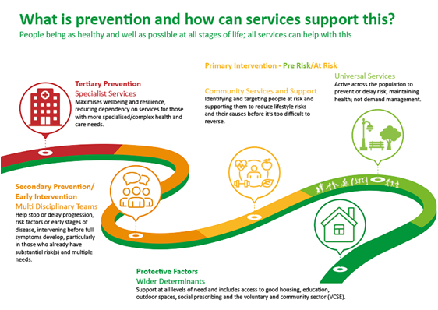

2.6 Proactive preventative care
Proactive care is personalised and co-ordinated multi-professional support and interventions for people living with complex needs.

The specific aims of proactive care are to improve health outcomes and patient experience by:
- delaying the onset of health deterioration where possible
- maintaining independent living
- reducing avoidable exacerbations of ill health, thereby reducing use of unplanned care.

Proactive care is not a new service or pathway, the focus is on using existing resources to support the defined group within local priorities. It is a model of care, delivered in the community, to a targeted cohort of patients with multiple long-term conditions who would benefit from integrated care to support management of their conditions. A successful model will result in reductions in the use of unplanned care, reductions in morbidity, addressing health inequalities, improved patient experience and supporting people to stay well for longer.

A pilot begun in 2024, in line with national guidance, in 2 Primary Care Networks. The learning from these pilots and other multi disciplinary team developments will be captured to inform an approach working in partnership with system providers, the voluntary and community sector, the public and patients, to embed a system-wide model that is flexible enough to meet the needs of the population for delivery at a local level.

Chapter 3:

Place, neighbourhood health and collaboration

3.1 Our approach to Place and Neighbourhood health
Neighbourhood working is not new, it is something that has existed for many years both locally, regionally and nationally. ​There is no single or accepted blueprint for a Neighbourhood, but some definitions/descriptions include: ​
​
- An approach that strengthens and re-designs community services to meet local needs, to include better coordination and communication locally. ​

- An approach that supports teams and services to work in a more integrated way across health, local authorities, VCSE and the community. ​
​
- Level of locality or neighbourhood that tends to be between 30,000 - 50,000 people

In January 2025, NHSE published Neighbourhood Health Services guidance as part of its NHS Planning Guidance for 2025. This guidance recognises there is an urgent need to transform the health and care system and to move to a neighbourhood health service that will deliver more care at home or closer to home, improve people’s access, experience and outcomes, and ensure the sustainability of health and social care delivery. More people are living with multiple and more complex problems and the absolute and relative proportion of our lives spent in ill-health has increased.

All parts of the health and care system – primary care, social care, community health, mental health, acute, and wider system partners – will need to work closely together to support people’s needs more systematically, building on existing cross-team working, such as primary care networks, provider collaboratives and collaboration with the voluntary, community, faith and social enterprise (VCFSE) sector.

Neighbourhood health aims to create healthier communities, helping people of all ages live healthy, active and independent lives for as long as possible while improving their experience of health and social care, and increasing their agency in managing their own care.

As described below, STW has already made progress in developing an integrated local approach to NHS and social care delivery in advance of the full vision for the health system which will be set out in the 10 Year Health Plan to be published in Spring 2025.

3.2 Our Places
In STW there are two Place areas (coterminous with the local authority administrative boundaries of Shropshire and Telford & Wrekin), with neighbourhoods aligned currently to our 9 Primary Care Networks.
Both of our Places have strong Place-based integration boards – Telford and Wrekin Integrated Place Partnership (TWIPP) and Shropshire Integrated Place Partnership (ShIPP). Both ShIPP and TWIPP are committees of the Shropshire, Telford & Wrekin Integrated Care Board.
The role of Place, delivered through the two place boards, is to agree and drive the delivery of proactive, preventative, high quality, community centred health and care integration at place to improve their residents' outcomes. They have a key focus upon reducing health inequalities, improving place-based proactive prevention and delivering seamless, accessible, safe, high quality community centred health and care services for all residents.
In addition, Place:
- Champions the needs and voices of local people
- Ensures that local voices, (people, elected members, local services, primary care), are part of developments and decision making
- Ensures that the voluntary and community sector (VCSE) play a central role in the health and wellbeing of local populations and integration work
- Assesses need and develops ongoing needs assessments (JSNAs and regular feedback loops)
- Understands how effectively the improvements in quality and safety are being driven forward.
- Works with partners to align strategic priorities with need through strategic plans and actions
- Works with the ICB on developing governance and delegation of decision a and finances to place and neighbourhood
- Understands, influences and develops local implementation of strategy and transformation programmes, that take into account need and local voices.
Both ShIPP and TWIPP membership comprise of senior officers from Telford and Wrekin Council, NHS Shropshire, Telford and Wrekin, Primary Care Networks (PCNs), Midlands Partnership University NHS Foundation Trust, Shropshire Community Health NHS Trust, Shrewsbury and Telford Hospital NHS Trust, Healthwatch, Shropshire Partners in Care and the Voluntary, Community and Social Enterprise Sector (VCSE).
ShIPP and TWIPP reflect the identity of each of the Places and benefit from the assets and strengths of the communities within that Place. However, the Places ensure that standards of access and quality do not vary. They connect across STW to ensure that the evidence of the most effective prevention, population health and care models are applied in every neighbourhood.
Our Integrated Strategy is overseen by the Integrated Care Partnership and is informed by the Health and Wellbeing Board strategies of our two Places. This plan sets out how we deliver the strategy across the system, ensuring that organisational strategies understand how they will contribute and impact on this delivery. The HWBB strategies for both Places will be reviewed in 2027/28 and will inform the integrated strategy and delivery, and set out the further ambition of the system in 2029.

Telford and Wrekin Health and Wellbeing Strategy
Telford and Wrekin Health and Wellbeing Board refreshed its priorities during 2022 and its updated strategy in June 2023. The priorities are defined through engagement and insight with local residents and intelligence from the Joint Strategic Needs Assessment (JSNA) on local the wider determinants of health, health and wellbeing outcomes and inequalities gaps. Delivery of these health and wellbeing strategy priorities is steered and overseen by various partnerships including TWIPP, Domestic Abuse Local Partnership Board, the Alcohol & Drugs Partnership Board the Community Safety Partnership. The Council’s Cabinet approved the Telford & Wrekin Children & Young People’s Strategy in February 2025, this overarching strategy includes the following aims: start well, stay well, keep safe and enjoy and achieve.
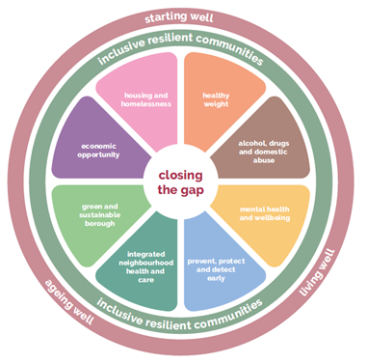
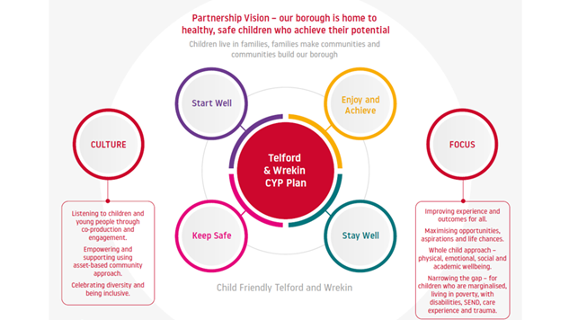

TWIPP Priorities for 2024-2026
In addition to the Health and Wellbeing Strategies TWIPP has identified 3 key priorities that it will focus on up to March 2026. These are:
- Supporting General Practice by working together to reduce and manage demand for GP services/appointments​
- Improving all-age mental health provision (prevention, early intervention and specialist services)
- Preventing, reducing and delaying frailty (with a focus on healthy ageing)
The outcomes TWIPP will achieve will be defined by each priority area within their Programme Initiation Documents.
In addition to its priority areas, TWIPP will:
- Work with the system to devolve decision making and resources to place and neighbourhood where appropriate;
- Act in an oversight capacity for the Better Care Fund Board, the Ageing Well Partnership, the Mental Health Partnership, Learning Disability Partnership, Autism Partnership. This will include at least annual updates to TWIPP along with providing where needed an escalation route.

Shropshire Health and Wellbeing Strategy 2022-2027
The Shropshire Health and Wellbeing Board acts to ensure that key leaders from the health and care system work together to improve the health and wellbeing of Shropshire residents. Board members collaborate to understand their local community’s needs, agree priorities and work together to plan how best to deliver services. Shropshire’s Health and Wellbeing Board has produced its Joint Health and Wellbeing Strategy based on the needs of local people, setting out the long-term vision for Shropshire and identifying the immediate priority areas for action and how the Board intends to address these.
The priorities of the Joint Health and Wellbeing Strategy are developed in response to the Shropshire Joint Strategic Needs Assessment (JSNA). The JSNA fulfils a statutory duty to identify areas of health and wellbeing need through the examination of national and highly localised data. In Shropshire, the JSNA is considered a dynamic assessment that is regularly updated as new understanding and data come to light. In addition to thematic assessments, we have developed Locality Needs Assessments, which demonstrate the need in our very local communities (based on 18 Place plan areas). To support delivery of the strategy, the Shropshire HWBB has developed a Prevention Framework, which supports the system to prioritise prevention activity, working through our local communities and with our statutory partners and voluntary and community sector colleagues.
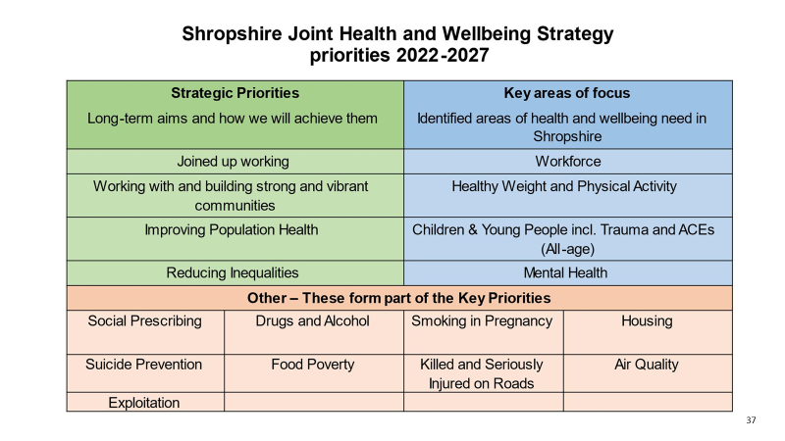

3.3 Our approach to Neighbourhoods and Integrated Neighbourhood Teams (INT)
Our neighbourhood approach is about joining up local services in the community and fostering community connections so that everyone in a neighbourhood can thrive. Providing more services closer to home and taking a neighbourhood approach to prevention is at the heart of our wider vision to improving wellbeing and preventing illness and poor health and reduce inequalities.
In Shropshire, Telford and Wrekin we are taking a proactive, preventative, person-centred neighbourhood approach to care as we have listened to and understand that people require joined up care and support as close to home as possible. We know that local areas have different needs and our neighbourhoods will develop in a tailored way to reflect this, e.g. what’s needed in Lawley in Telford, may not be the same as the priorities for Ludlow in South Shropshire.
By adopting an intelligence-led approach and being focused on understanding local health needs, neighbourhood approaches will contribute to reducing inequalities.

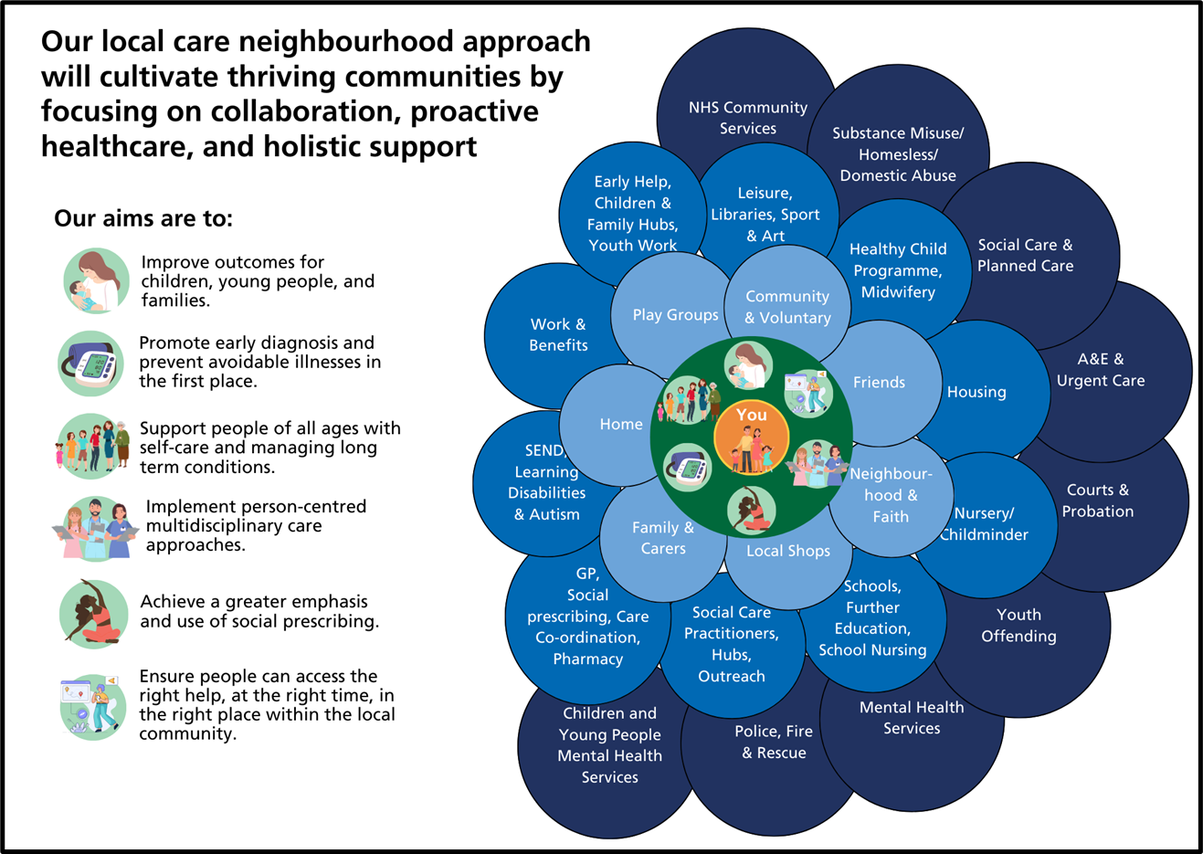

Local Principles for Neighbourhood Working
In neighbourhoods, we are committed to strengthening and evolving existing networks, while forging new connections and fostering collaboration. By bringing together teams and services across health, care, the voluntary and community sector, businesses, schools and education settings and other key partners -including police, housing, and education - we will adopt the following principles:-

Proactive Population Health Management
Working in a proactive, preventative, assets based, population health way that maximises health, wellbeing, independence and self care in or as close to people’s homes as possible, in order to reduce their need for health and care services.

Person Centred Approach
Ensuring that we take a person centred approach, putting people at the centre of what we do.

Learning and Evidence
Building on what already works and using learning and evidence to develop a more comprehensive community based prevention offer which includes universal, early help, targeted and specialist system services.

Integration
Working across service areas, integrating where possible, embracing partnership and collaborative working, creating a culture of working jointly across professions, organisations and teams for the benefit of our communities.

Time
Adopting a test and learn approach allowing projects time to evolve and deliver outcomes, embedding evaluation in all development programmes from the start.

Leadership
Collaborative local leadership with a shared vision, culture and values to support transformation.
The configuration of our Neighbourhoods can be found at Appendix C.

‘Team of Teams’ working in Neighbourhoods
‘Teams of teams’ work in neighbourhoods, they are not restricted by geographical boundaries and link together providing personalised care, centred around individual needs.
Various teams, sometimes referred to as 'a team of teams,’ will operate within neighbourhoods with a range of different remits, for example multi-disciplinary teams (MDTs) supporting people with specific needs, one example is an MDT approach for people with frailty and multiple long-term conditions, as well as specialist teams focused on tackling local issues such as widening the range of activities available for local children.
Through resource pooling and information sharing, these teams can streamline access to services and provide more proactive, preventative and personalised approaches.
‘Teams of teams’ is not only about professionals working better together, it is about empowering residents to come together to create thriving communities.

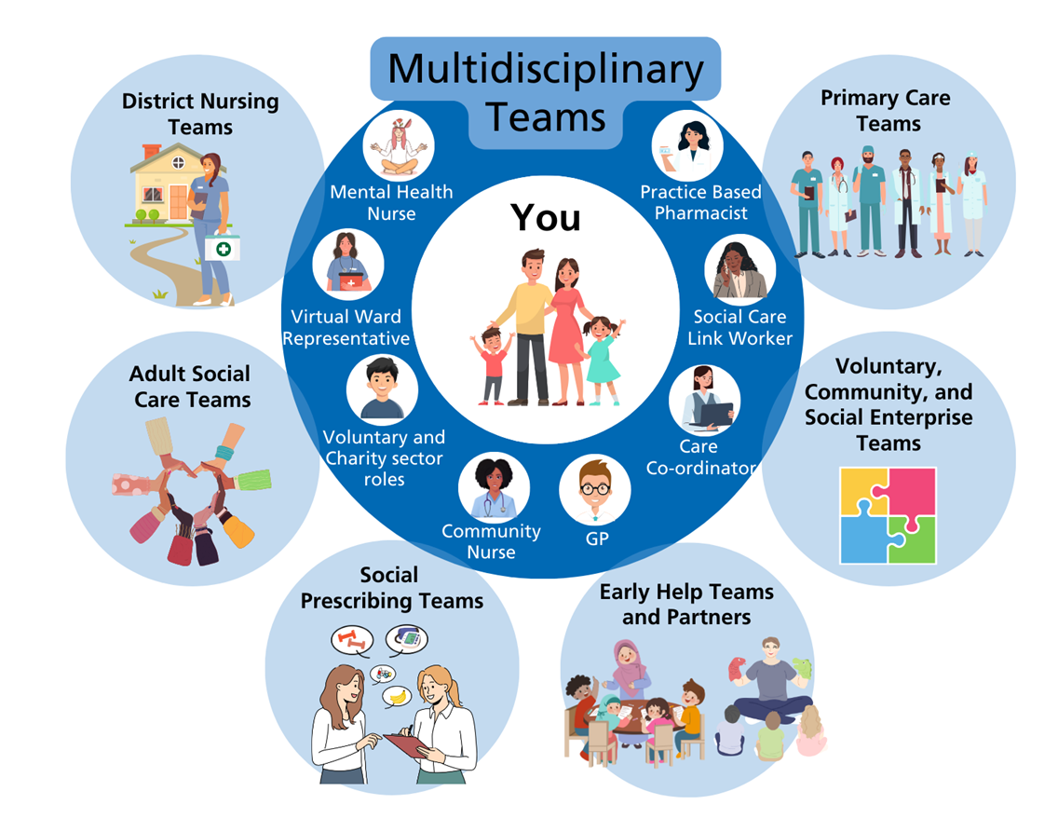

Next steps for Neighbourhood health services
The diagram below shows the national aims for all neighbourhoods over the next 5 to 10 years. For 2025/26, systems are primarily to focus on the innermost circle to prevent people spending unnecessary time in hospital and care homes.

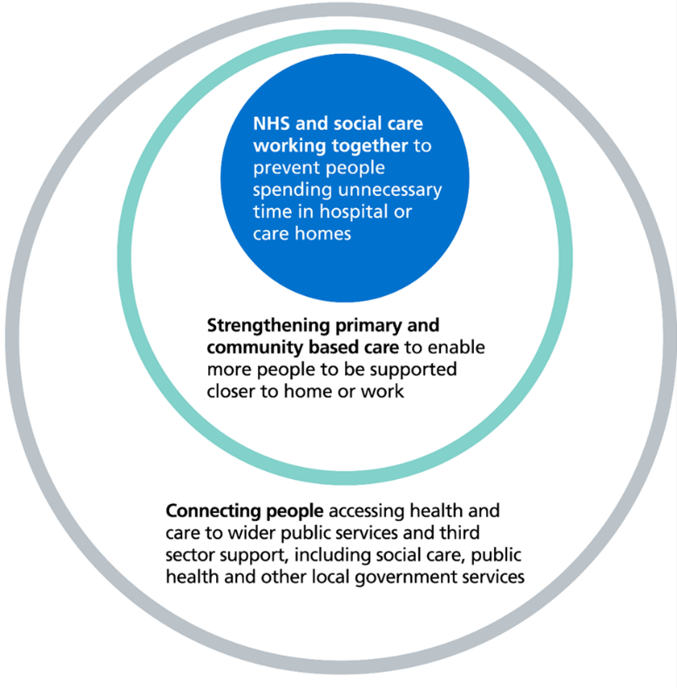
Whilst we await the 10 Year Plan and to strengthen the existing foundations for scaling and expanding the neighbourhood approach over the coming years, STW will continue to build on current momentum for a neighbourhood health approach by making further progress to:-

- standardise the 6 core components of existing practice to achieve greater consistency of approach:-
  - Population Health Management
  - Modern General Practice
  - Standardising community health services
  - Neighbourhood multi-disciplinary teams (MDT’s)
  - Neighbourhood intermediate care with a ‘Home First’ approach#
  - Urgent neighbourhood services
- bringing together the different components into an integrated service offer to improve coordination and quality of care, with a focus on people with the most complex needs
- scaling up to enable more widespread adoption
- rigorously evaluating the impact of these actions, ways of working and enablers both in terms of outcomes for local people and effective use of public money

We will work with our NHSE regional team, and local government and our other Place partners, informed by the evidence generated from our existing work, to agree locally what specific impacts are to be achieved during 2025/26. We expect these to include, as a minimum, improving timely access to general practice and urgent and emergency care, preventing long and costly admissions to hospital and preventing avoidable long-term admissions to residential or nursing care homes. The primary focus will be on:-

- supporting adults, children and young people with complex health and social care needs who require support from multiple services and organisations.
- Integrated neighbourhood teams for children and young people

The Neighbourhood Health Guidelines for 2025/26 include several prevention programmes aimed at improving health outcomes and reducing inequalities. Key prevention initiatives include:
- Health Literacy and Education: Programs to enhance public understanding of health issues, encouraging healthier lifestyles and informed decision-making.
- Early Intervention: Initiatives to identify and address health issues at an early stage, preventing them from becoming more serious.
- Chronic Disease Management: Support for managing long-term conditions such as diabetes, hypertension, and respiratory diseases to prevent complications.
- Mental Health Support: Programs to promote mental well-being, including early detection and intervention for mental health issues.
- Vaccination Campaigns: Efforts to increase vaccination rates and prevent the spread of infectious diseases.
- Healthy Living Initiatives: Encouraging physical activity, healthy eating, and smoking cessation through community-based programs.

These prevention programmes are designed to create healthier communities by addressing the root causes of health issues and promoting overall well-being.

The Neighbourhood Health Guidelines for 2025/26 outline several strategies to tackle health inequalities:
- Integrated Care: Encouraging collaboration between the NHS, local government, social care, and other partners to provide seamless and coordinated care.
- Community-Based Care: Shifting care from hospitals to community settings, making it more accessible and closer to home.
- Prevention Over Treatment: Focusing on health literacy, early intervention, and preventive measures to reduce the incidence of health issues.
- Digital Solutions: Utilizing digital tools to improve care delivery, accessibility, and patient empowerment.
- Targeted Interventions: Implementing specific programs to address the needs of the most deprived and vulnerable populations, such as the CORE20PLUS5 approach.

  - Our approach to Women’s Health Hubs

The Women’s Health Strategy for England sets 10-year ambitions for boosting the health and wellbeing of women and girls, and for improving how the health and care system listens to women. The strategy encourages the expansion of women’s health hubs across the country to improve access to services and health outcomes.

Women’s health hubs bring together healthcare professionals and existing services to provide integrated women’s health services in the community, centred on meeting women’s needs across the life course. Hub models aim to improve access to and experiences of care, improve health outcomes for women, and reduce health inequalities. Women’s health hubs are models of care working across a population footprint and are not necessarily a single physical place.
We introduced our Women’s Health Hub model in 2024. The approach encompasses specific needs of women and young women, with a focus on inequalities and rural inequalities including sustainable, community-based Women’s Health Hubs, ensuring equitable access to clinical and non-clinical support by building on family & community hubs within PCN areas and other clinical offers informed by the JSNAs, population health and clinical data.
Following expressions of interest from Primary Care Networks and one practice, we have 10 hub offers with a specific focus on the NHSE core specification and additionally all 9 PCNs chose to develop specific projects focusing on health inequalities. The key objectives of the model are: -
- Increasing uptake of cervical screening especially with women who haven’t or don’t often attend.
- Increasing access to menopause advise and treatment.
- Increasing access to Long-Acting Reversible Contraception (LARC) consultations and fittings
- Women’s Clinics during extended hours offering both clinical and non-clinical advice & guidance for a range of Women’s health services including contraception, menstruation, pessary fitting & removal, menopause & breast pain.
- Developing awareness & understanding

Health inequality initiatives include: -
- Transgender and Non-Binary Opt-In for Cervical Screening Call/Recall
- Targeted approach to working with girls and younger women within communities.
- Working with women and girls with learning difficulties to understand and access cancer screening, especially breast and cervical screening.
- Increase awareness of Women's health related services, cervical cancer screening, breast cancer screening and safeguarding support for Afghan women and girls registered with PCN practices, part of Operation Lazurite.
- Work with the community teams and the Job centres to host information events and promote women’s health in the community.
- Developing a “smear buddy” system linking women who are due to have their cervical smear. e.g. A patient that only speaks Japanese could be paired with a patient that speaks both Japanese and English. They could be booked back-to-back appointments, offering each other support and translating for each other.

In 2025, the Government will publish an update following its rapid review of the Women’s Health Strategy focusing on identifying keys priorities and areas of focus. Our plans for Women’s Health Hubs over the coming years will be approached through the development of integrated neighbourhood teams at place, building on embedding a digital approach and supported by the increased knowledge and skills of the workforce. Importantly the interdependencies with system work and collaboration with existing commissioned and noncommissioned providers will enable a system wide approach with a focus on meeting need and improving experiences for women and young women in STW.

Key Deliverables for Integrated Neighbourhood Team Development
- Year 1 - Phase 1 – Foundations and integrated practice – functioning integrated teams in place.
- Year 2 - Phase 2 – Population Health Management with supporting infrastructure – PHM fully established, digital interoperability and estates solutions confirmed.
- Year 3 - Phase 3 – Integrated and intelligence led practice – INTs plan their workforce to meet needs.
- Year 4 - Phase 4 – Full delegation for STW Neighbourhood delivery – INTs delivering demonstrable system benefits and outcomes.

3.5 Our approach to Provider Collaboratives and Collaboration
Provider collaboratives are partnerships that bring together two or more NHS trusts (public providers of NHS services including hospitals and mental health services) to work together at scale to benefit their populations. While providers have worked together for many years, the move to formalise this way of working is part of a fundamental shift in the way our health and care system is organised, continuing to move from an emphasis on organisational autonomy and competition to collaboration and partnership working. The rationale for providers working together in this way comes down to improving efficiency, sustainability and quality of care.
Collaborative arrangements see providers coming together to consolidate services for greater efficiency, increase sustainability by making better use of a limited workforce and improving quality of care by standardising clinical practice to tackle variations in care across different sites. It also supports joint accountability for service delivery in the areas where formal collaboratives have been established as the delivery vehicle with which the ICB will commission services.
In STW, provider collaboratives are still developing and have been referred to in various sections of this plan. The main focus is how a provider collaborative will drive improved patient outcomes and quality while supporting the following areas:
• Addressing unwanted variation across service delivery
• Improving resilience on delivery
• Improving productivity
• Developing the right Governance and accountability
• Leadership development.

STW is committed to the development of its collaborative arrangements and has commenced a programme of work to develop this approach further to ensure it forms a cornerstone of our delivery approach going forwards.

Each of STW’s provider trusts (Shrewsbury and Telford Hospital NHS Trust, Shropshire Community Health NHS Trust, Robert Jones and Agnes Hunt Orthopaedic Hospital NHS Foundation Trust and Midlands Partnership University NHS Foundation Trust) have agreed to develop the provider collaborative approach.

This will encompass both the development of a provider collaborative infrastructure to support the approach across STW, as well as the oversight of a number of collaborative programmes of work and will broaden to include a wider set of partners as it develops

Collaboration will occur at three levels:
- Collaboration between STW providers (as a whole group or in combinations of providers depending on the field of delivery and outcomes to be achieved)
- Collaboration between STW providers and commissioners (where there are tangible benefits of including the ICB in a collaborative partnership)
- Collaboration with partners outside of STW ICS boundaries where it delivers increased efficiency, productivity and/or improved patient outcomes

We have a number of established and formalised collaboratives already, for example, Shrewsbury and Telford Hospital NHS Trust and University Hospital of North Midlands NHS Trust collaborating in the provision of a range of speciality services, a number of collaboratives are still in stages of development towards formalisation and there is opportunity to build on this further

Currently, STW providers have collectively identified 5 key workstream areas of focus:
- Urgent and Emergency Care
- Musculoskeletal Services
- Workforce
- Mental Health, Learning Disabilities and Autism
- Shared Services Efficiencies

The identified areas are those where there is potential for providers to deliver better outcomes for patients through more formalised collaborative approaches and work will continue to evolve to define the collaborative outcomes to be achieved for each workstream

In addition to these priority programmes, mapping work continues to establish pipeline areas for collaboration.

Future plans
We will continue the development of both our local provider collaborative infrastructure and collaborative programmes focusing on developing effective partnerships and working collaboratively to provide seamless, well integrated services whilst bringing the design and provision of care closer together for the benefit of our communities. The provider collaborative will focus on the delivery of outcomes in relation to specific programmes set by the ICB acting as the strategic commissioner for the STW population.

Over the period covered by this plan, we will seek to ensure that the provider collaborative works across statutory and non-statutory organisations and use co-production with the wider communities involved with service delivery.

Local provider collaboratives (LPC) under integrated models would see delegation of functions to the provider collaborative from the ICB, pooled budgets for areas agreed by the collaborative as being within the scope and a focus on adding value, increasing efficiency, and improving quality of care.

3.6 Support social and economic development
Telford and Wrekin’s Health and Wellbeing Strategy refresh proposals have been developed based on Joint Strategic Needs Assessment (JSNA) intelligence and informed by engagement with residents as part of the development of the ‘Vision 2023 – Building an Inclusive Borough’.

Shropshire’s Health and Wellbeing Strategy is being developed at a community level by engaging with the residents and local town councils using the data from the JSNA.

The ICP brought together the available intelligence from the HWBB strategies to inform the priorities for the Integrated Care Strategy and Joint Forward Plan. The refresh of the Joint Forward Plan continues to use the HWBB strategies and Integrated Care Strategy as its anchor points and reflects wider determinants and health inequalities.

The JSNAs, population health intelligence and the Integrated Care Strategy informs system partners about areas of health and social need and inequalities gaps within our communities. In Shropshire, the Social Task Force meets bimonthly to address wider socio-economic development and the wider determinants that impact health, care and wellbeing and reports into the HWBB. In Telford and Wrekin, the HWBB covers health and care including socio-economic factors and priority areas are reported back through the board. Areas of delivery for the partnership are reported through the Place partnerships to deliver and give assurance on. This process is evolving.

Healthy life expectancy for males and females is unfortunately getting worse, and health inequalities are widening, so our partnerships focus on the root causes of health inequalities, the wider determinants of health, and addressing inequity of access to services for those most in need. We need to understand the multiple barriers people can face in accessing our services more fully, and we are taking a person-centred approach to do this. We are using this approach to deliver our Women’s Health Hubs across STW.

We are tackling the wider determinants of health, such as homelessness, healthy homes, poverty and the cost of living, through positive work and employment of the social task force and HWBB. This includes warm spaces, access to leisure, road and transport reports, and warm housing being made available through VCSE organisations. We also aim to give every child the best start in life which will influence a range of outcomes throughout people’s lives.

We are improving equity of access to healthcare for those living in our most deprived areas, including rurally excluded locations, as well as other forms of exclusion. This includes Core20PLUS5 and a focus on preventable health conditions. For adults, this includes hypertension, early cancer diagnosis, health checks for severe mental illness (SMI) and LDA, vaccinations, continuity of carer in maternity. For children, this includes epilepsy, diabetes and asthma.

As the partnership develops our five-year plan, we are considering broader system working. Programmes of work need to demonstrate how they will deliver against the Integrated Care Strategy.

This includes:
- Local planning and regeneration including transport
- Housing and employment
- Education
- VCSE and community partners, police and fire service
- HTP
- Local Care Integration Programme including Integrated Neighbourhood teams.

3.7 Voluntary, Community and Social Enterprise
Our system has a wealth of experience as well as knowledge, professional expertise and skills in our voluntary, community sector (VCSE). During the COVID-19 pandemic, the VCSE delivered an unprecedented level of services to our communities.

The VCSE across STW is committed to supporting the delivery of the priorities within our plan and to joint working that has, and will continue to, shape and improve services in STW from a grassroots perspective. As a system, we need to support the VCSE ambition to deliver well-resourced services to our places, neighbourhoods and communities. With the knowledge of the communities and populations they serve, sustainable community services will underpin the person-centred approach to delivery of prevention, self-care and keeping well throughout a person’s health and care journey.

Our strong VCSE sector underpins healthy communities, supports wellbeing and specialist services. Our VCSE already contributes to our neighbourhood working in communities and at place.

We recognise that, to reduce inequalities, we will need to draw on the knowledge of the local authorities, voluntary, community and social enterprises (VCSEs) and other partners with experience and expertise in this regard.

The VCSE sector is an important partner in our system and plays a key role in improving health, wellbeing, and care outcomes due to their reach and connection with communities. Our partnership working has previously been formalised within two Memorandum of Understandings (MOUs) with the VCSE and Healthwatch. These MOUs set out why the ICS values the role of the VCSE and Healthwatch in improving health, social care and wellbeing in this area.

As a system we are further developing our working with the VCSE to develop a joint framework with some key principles underpinning our work together across the system. These principles include:
- Leadership and Governance
- Financial sustainability
- Contractual arrangements
- Market development
- Data analysis
- Operational understanding and delivery

The VCSE is impacted by changes to government legislation in relation to minimum wage increase and National Insurance increases that are impacting on, particularly, smaller charitable and voluntary organisations. Our system commitment is to continue to work closely in collaboration with the VCSE, our local authorities, who have developed their own partnerships with the VCSE such as the Shropshire Accord and align the framework to a way of working to deliver prevention, support, early help and other services such as supporting care closer to home and early discharge from hospital.

ICB Commissioning Ambition
- Preventative Proactive Person Centred care delivered through multi-disciplinary Integrated Neighbourhood Teams
- To commission a sustainable community bed model that is cost effective, meets need and focuses on rehabilitation and reablement to deliver optimum outcomes for the residents of STW.

Key Commissiong Intention Deliverables

Year 1
- Using a Population Health Management approach model designed for a targeted and sustainable model to proactively support adults, children and young people with complex health and social care needs who require support from multiple services and organisations.
- Integrated Neighbourhood Team for Children and Young People.
- Model designed for the community nursing service delivering preventative proactive care through integrated neighbourhood teams wrapped around General Practice with a
- Implement a VCSE framework to ensure impact, delivery, assurance and sustainability
- Scheme of delegation from the ICB in relation to Place based decision making and budgets and a timeline for implementation
- Model redesigned for the whole wound care pathway utilising a provider collaborative approach
- Completion of the review of the Community Bed Model including sub acute following any required public engagement, staff engagement and due process via NHS including sub acute following any required public engagement, staff engagement and due process via NHSE

Years 1-2
- Implement at scale the Proactive Care model designed in Year 1
- Implement the revised community nursing service model
- Continue to develop the integrated neighbourhood teams delivery model, aligning existing LA, NHS and community assets/meeting places informed by the needs of local populations
- Expanded range of services delivered through provider collaboratives/collaboration delivering shared efficiencies
- Implement the revised wound care pathway

Chapter 4:

Improving Access to Services

4.1 Primary Care Networks (PCNs) and General Practice
The current model of contracting for and providing general medical services has not changed in decades, despite changes to the way modern healthcare is accessed and delivered. Despite the huge amount of demand and work delivered in general practice, there have been increasing levels of dissatisfaction in primary care access and care for both patients and staff, and these challenges are now threatening the sustainability of our primary care services. General practice is suffering the same challenges in workforce and resources as the rest of our system. In particular, there are challenges related to the development of GP estates, and primary care estates need to be incorporated into the wider enabler of the system estates plan.
Primary care networks were set up to support groups of practices to deliver the Primary Care Network Direct Enhanced Service (PCN DES). Some PCNs are more mature than others and are using resources aligned to PCNs to develop and work with neighbourhood models of care and influence the local care programme as members of the place partnerships. Primary care will be at the heart of healthcare and must be appropriately resourced to support and enable true integration.
In May 2023, a delivery plan for recovering access to primary care was published by NHS England (NHSE). The aims of this plan are to tackle the 8am rush in general practice, to enable people to know their needs will be met when they contact the practice and to widen the scope of services available from community pharmacy. There are four areas this plan focuses on:
- Empowering patients
- Implementing modern general practice access
- Building capacity
- Cutting bureaucracy.
There is a need for evolution in the way primary care is delivered, protecting its core strengths, such as continuity of care, and placing it at the heart of new health and social care systems. Primary care is the ideal deliverer of person-centred care with the need for patients to be invested in their health planning through the use of personal health plans. We propose to have an integrated, collaborative primary care strategy and delivery models, providing streamlined access to care and advice, that is straightforward to navigate, more proactive, provides personalised care and support from an MDT based around neighbourhoods, and helps people to stay well longer.
Primary care cannot achieve this alone. It will need system support to provide the conditions for locally led change and a supporting infrastructure to implement change. Primary care clinicians will be engaged to co-develop, provide clinical leadership and support any changes proposed, ensuring we maintain stability in primary care.

4.2 Community pharmacy, optometry and dental
In April 2023, the contractual services for pharmacy, optometry and dental (POD) services were delegated to ICBs. The management of the contracts is undertaken in partnership with the Office of the West Midlands (OWM) through joint governance arrangements.
These primary care services are becoming increasingly important, never more so than through the COVID-19 pandemic.

Community Pharmacy Expansion
Community pharmacy services have expanded through the Recovering Access to Primary Care Delivery Plan and new national clinical services provided through community pharmacy. There are opportunities to deliver additional services to alleviate pressure in general practice but there are also challenges. Workforce in community pharmacy is under the same challenges as other healthcare services. From 2025/26, newly qualified pharmacists will be independent prescribers, this provides a training challenge within the system to support this, but also opportunities to further expand the role of community pharmacy and integrate this sector within primary care delivery.

Dental Recovery Plan
There is a national lack of NHS dentists, and this is particularly an issue across STW. The Dental Access and Equity audit published earlier in 2024 identified seven key priority areas across Shropshire and Telford for additional dental access and investment. These are our focus for improving dental access, especially within our most deprived communities.

ICB Commissioning Ambition
Commission a sustainable primary care model for STW

Key Commissioning Intention Deliverables

Year 1
- Primary Care commissioning framework –alternative models for primary care commissioning at practice level and at scale which aligns services across Shropshire and Telford
- Refreshed Primary Care Strategy
- Demand and Capacity Workforce Assessment and Planning Model for General Practice
- Dental Recovery Plan implementation targeted to improving access for most ‘at risk’ patient groups
- Evaluation of the Community Pharmacy pathfinder sites to inform the development of future clinical services that incorporate prescribing from within community pharmacies

Year 1-2
- Development support programmes for Primary Care Networks and GP Provider Collaboratives
- Ongoing expansion and integration and optimal use of community pharmacy to support primary care recovery and capacity
- Education and support models for trainee and foundation pharmacists and 'catch up' for existing workforce with respect to independent prescribing
- Continued work to improve dental access to pre-covid levels and beyond

4.3 Elective Care Recovery
Elective care covers a broad range of planned, non-emergency services – from tests and scans to outpatient appointments, surgery and cancer treatment.

Performance is measured by the constitutional standard: 92% of patients should wait no
longer than 18 weeks from referral to treatment by March 2029. STW partners and staff have worked extremely hard in the aftermath of the pandemic to tackle the elective backlog – reducing long waits and treating the most clinically urgent cases – this system along with the wider NHS is a long way from meeting the required standards but are making good progress against milestones of ‘no patients waiting over 65 weeks by April 25. Waiting lists have risen for the last decade. Continuing to do what we have been doing will not work: the Government plans major reform to elective. New and innovative ways of working and a number of improvement initiatives are part of STW’s plan to reduce waiting times for our local population.

In January 2025, NHSE published new guidance outlining its ambitious strategy to tackle long-standing challenges in elective care. In STW (December 2024 data) there were 81,454 STW patients in total awaiting appointments, procedures, or operations, on an Referral to Treatment Target (RTT) Waiting List and 50.5% of these waiting more than 18 weeks. STW are experiencing increasing demands for elective care, this demand correlates with the growing demand nationally for elective care.

This reform plan focuses on empowering patients, improving service delivery, and aligning resources with care priorities. STW are committed and working with system partners to deliver this plan to ultimately improve patient access and waiting times, ensuring that our population are provided with the right care first time, in the right healthcare setting.

To deliver these commitments, the guidance includes a comprehensive set of priorities covering four areas, which involve collaboration between NHSE, ICBs, and NHS elective care providers:-

- Empowering Patients: Digital tools like the NHS App will become the default route for elective bookings, with new standards and leadership roles to enhance patient experience.
- Reforming Delivery: Partnerships with the independent sector, expanded community diagnostic centres, and new surgical hubs will boost capacity and reduce waiting times and support care closer to home.
- Delivering Care in the Right Place: Enhanced GP services, tech-driven solutions, and patient-initiated follow-ups aim to streamline care and reduce unnecessary delays.
- Aligning Funding and Standards: Updated funding schemes, performance oversight, and workforce programmes will drive improvements in care delivery and efficiency.

Reforming Diagnostic Pathways
Elective, cancer and diagnostic standards are interrelated and so must be improved together. The Government’s plan is for existing and new planned Community Diagnostic Centres (CDCs) to be able to take on more of the growing diagnostic demand within elective care.

By providing a wider range of and capacity for tests and more consulting rooms, CDCs can improve elective pathways for both urgent cancer pathways and routine diagnostic pathways. They can reduce pathway length and make care more productive by providing multiple same-day tests and consultations where possible, as well as significantly reduce the need for lower clinical value outpatient appointments.

To improve the NHS Constitution standard for diagnostics, the cancer waiting time standards and the RTT standard, NHSE plans that all CDCs and hospital based diagnostic services to:

- be open 12 hours a day, 7 days a week
- be for adults and children
- deliver the optimal standards of tests per hour – such as 4 CT scans per hour – to use system diagnostic capacity productively
- remove low value test referrals to maximise capacity
- develop and deliver at least 10 straight-to-test pathways by March 2026, focusing
- on the diagnostic tests patients are waiting the longest for locally
- identify local opportunities to improve performance against the Faster Diagnosis Standard to reduce the number of patients waiting too long for a confirmed
- diagnosis of cancer
- Increase Primary Care provision straight to test.

NHSE plans also include a boost for bone density scanning (DEXA) capacity by investing in up to 13 DEXA scanners to support improvements in early diagnosis and bone health, particularly in the highest priority locations.

All of the above must be implemented in a way that upholds patients’ rights to choice. Details of how the ICB fulfils its duty in relation to patient choice can be found in Appendix B.

ICB Commissioning Ambition
92% of patients receive their treatment within 18 weeks of referral by March 2029

Key Commissioning Intention Deliverables

Year 1
- 60% performance against the 18 week standard
- Enable patients to view appointment information via the NHS App
- Named Director within each ICB and Provider for improving patient experience
- Clear ICB local vision on how elective care reform will reduce health inequalities
- Advice and Guidance (A&G) service expanded allowing patients increased access and avoiding the elective waiting list
- Patients and their carers are aware of the new experience expectations for elective care and their right to choose their care
- “Collective care” deployed including group appointments, one-stop clinics and super clinics
- Patient Initiated Follow Up (PIFU) is offered as standard in all appropriate pathways
- Customer care training available to non-clinical staff with patient-facing roles

Year 1-3
- Increase in % performance in line with the trajectory in the system's operational plan
- NHS App significantly expanded to improve information for patients in elective care, as well as their parents and carers through proxy access
- Optimal use of the new diagnostic capacity with new standards for Community Diagnostic Centres: extended opening hours, increased same day tests and consultations and the range of tests offered, with increased direct referrals and rolling out at least 10 straight-to-test pathways
- A range of options are in place for patients to have more responsive and accessible follow-up care, including standardising remote consultations, remote monitoring and digital support for patient initiated follow-up (PIFU) across all major specialties
- Transformed pathways to deliver activity in the community in the priority specialties; ENT, gastroenterology, respiratory, urology and cardiology
- Remote monitoring expanded across all long-term conditions where clinically appropriate, helping to remove lower value follow-up appointments
- Reduced variation in discharge processes and expanded opportunities for self management through shared decision-making tools

Year 4
- 92% of patients receive their treatment within 18 weeks of referral
- Patient-initiated follow-up (PIFU) increased to at least 5% of all out patient appointments

4.4 Urgent and Emergency Care
Demand for our urgent & emergency care services have increased year-on-year from 2021 onwards and are back to or above pre-pandemic levels in terms of Attendances and Emergency Admissions to our hospitals. This has been aligned to national and regional trends. This has brought considerable challenge to meet this demand, requiring process improvement to provide alternatives to emergency departments for our patients; and by coordination of hospital discharge with system partners working together collaboratively. This has been with some success, but not sufficient to decompress our emergency departments to deliver the quality of care, patient experience and operational performance we are committed to providing.

Therefore, we intend to transform the way our urgent and emergency care services are delivered with increased focus upon delivering the urgent care our patients require away from hospital settings.

ICB Commissioning Ambition
- To transform our services into an improved, simplified and financially sustainable 24 hour/7-day Urgent and Emergency Care model; delivering the right care, in the right place, at the right time for all our population.
- To commission a highly effective Integrated Out of Hospital Community model incorporating Virtual Ward, Rehab & Recovery, and Rapid Response services delivered via the UEC Provider Collaborative.

Key Commissioning Intentions Deliverables

Year 1
- To redesign and recommission an Integrated Urgent Care Service across STW incorporating GPOOH, SPA, CCC, Care Transfer Hub, MIUs and UTCs through a system wide Provider Collaborative model. (contracting form to be explored).
- Full review of the current Virtual Ward service to assess against the original business case in terms of staffing, finance, step up vs step down assumptions, activity and caseload and clinical pathways. This will be completed alongside the review of Rehab & Recovery, Rapid Response, Outpatient Antibiotic Treatment (OPAT) and Diagnostics, Assessment and Rehabilitation and Treatment (DAART).

Years 1-2
- Transformed, Integrated Care Coordination centred model that delivers on the Reform to improve urgent and emergency care objective within the government’s ‘Road to recovery’ mandate to NHS England issued in January 2025.
- Aligned to our Hospitals Transformation Programme.

4.5 Cancer
Cancer services remain a priority for this system and we are committed to working across organisational boundaries to collaboratively deliver significant improvements within cancer, recognising that improving cancer outcomes is a system wide responsibility. Improvement requires sustained collaborative action towards:
• Prevention,
• Improving early diagnosis,
• Increasing screening uptake,
• Optimising treatment modalities, and
• Strengthening services for those living with and beyond cancer.

In 2019 NHS England published the Long-Term Plan with a target that by 2028, 55,000 more people would survive more than 5 years after being diagnosed with cancer. To achieve this 75% of people diagnosed would be in the early stages of cancer (Stage 1 and 2) and would start and receive their treatment faster. STW is currently achieving this target in 59% of patients and we recognise that more targeted interventions are needed to reach the national ambition by 2028.
To support delivery of this, stakeholders from across the system have committed to convene to develop and deliver a plan of targeted interventions to achieve earlier diagnosis with a focus on reducing deprivation-related inequalities. Membership includes clinical and operational leads from primary and secondary care, public health teams, health inequalities leads and screening teams. Efforts relating to this area of focus includes, but not limited to, targeted case finding of patients within primary care who are at greater risk of developing cancer e.g. black males at higher risk of prostate cancer, understanding variation and addressing the reasons behind low uptake of cancer screening services and community outreach initiatives to educate and empower patients on cancer symptoms to promote timelier presentation in primary care.
STW has a strong background of community-centred approaches to help build connected and empowered communities and is committed to putting communities at the heart of everything through meaningful engagement and co-production. This patient-centred approach will continue over the coming years to support reducing health inequalities.

ICB Commissioning Ambition
To commission and deliver cancer pathways to meet the Long Term Plan ambitions of diagnosing 75% patients at early stages and reduce long term mortality, focusing on levelling up for those in Core20plus5 cohorts by continuing engagement and co-production across all system partners. Support delivery of performance to meet national operational standards.

Key Deliverables

Year 1
- Commissioned STW teledermatology service to support skin referrals
- Investment in Artificial Intelligence (AI) technologies to support diagnostic reporting capacity
- Commissioned service in General Practice for surveillance of prostate-specific antigen (PSA) levels to detect prostate cancer in specific patient cohorts
- Non Specific Symptom (NSS) Pathway
- Pathway for the referral of patients at suspected risk of Lynch Syndrome from Shrewsbury and Telford Hospital NHS Trust (SATH) to a specialist centre
- Redesigned model for psycho social care provision for cancer patients
- New diagnostic sites identified
- Baseline assessment of access and equity disparities
- Start targeted recruitment and training programs to enhance workforce capacity
- Identify and trial new technologies
- Develop collaboration agreements across sectors
- Strengthened public awareness campaigns

Year 1-2
- New diagnostic sites operationalised and evaluated
- Improved workforce stability and satisfaction.
- Full roll out of validated technologies
- Implement and evaluate shared diagnostic resources
- Expand preventative diagnostic services (Years 1-3)

Chapter 5:

Our key clinical transformation programmes

5.1 Hospital Transformation Programme (HTP)
Our Hospital Transformation Programme (HTP) is our second major system transformation programme and is a key part of the bigger picture for our patients and communities. We are trying to address the following critical issues:

- Our workforce challenges:
  - We are overly reliant on agency and temporary staff because we are unable to recruit and retain the high calibre staff we need. This is mainly due to the current configuration of services which means that staff must work across sites and are unable to access multi-disciplinary support when they need it for our sickest patients. Our clinical environments also do not currently provide the capacity, space or layout needed to provide modern-day healthcare. All these factors impact negatively on our people, resulting in them leaving and impacts our ability to attract the number and skill mix of the substantive staff that we need.

- Our clinical model challenges:
  - The clinical model is not fit for purpose because of the outdated service configuration that prevents us from addressing quality and operational issues. This becomes more impactful as more and more hospital trusts across the UK reconfigure their services to better meet the needs of their citizens, patients, and staff.
  - Our greatest areas of risk are the sustainable provision of critical care and emergency medicine services, and consistently providing uninterrupted planned care capacity to ensure we can treat the many patients who are waiting for planned procedures, many of which are life changing.

- Our infrastructure challenges:
  - Our infrastructure does not support the delivery of modern-day healthcare, our digital aspiration, or the capacity we need to care for our patients in a safe and dignified way.
  - The configuration of our buildings does not lend itself to robust infection prevention processes as we need more single rooms and better ventilation.

- The needs of our population are changing – our systems, processes and estate need to be able to meet those changing needs.

To address these challenges, the HTP is transforming services across our acute hospital sites and putting in place the core components of the acute service reconfiguration agreed as part of the Future Fit consultation. Key benefits include:
- A dedicated emergency department with immediate access to medical and surgical specialities
- Ring-fenced planned care services supporting the needs of our population
- A much better environment for patients, families, and staff
- Improved integration of services for local people.

The diagram below demonstrates what we are moving towards:
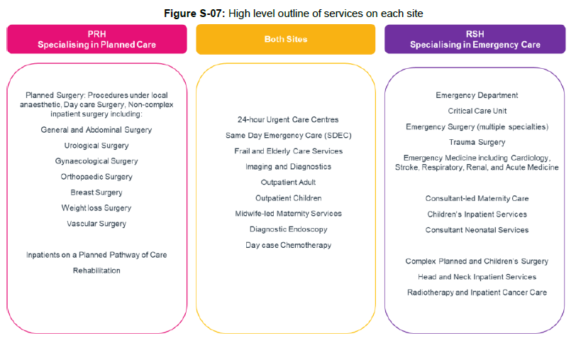
Key HTP deliverables

Year 1
- Complete phase 1 of the Emergency Department expansion and to prepare grounds and commence building of the new facility on RSH site
- Produce master delivery programme and commence pathway development work.
- Review workforce models and prepare for the Management of Change process.
- Continue with Stakeholder engagement with the support of communications and patient engagement team.
- Continue working collaboratively with the system partners to implement the Local Care Transformation Programme

Years 2-3
- Complete phase 2 of the Emergency Department expansion ready for the implementation of the new clinical model in 2028.
- Complete the clinical pathways for the new model of care on both sites.
- Complete the development of the 24 hour Urgent Treatment Centre (UTC) on both sites
- Communicate the UTC model with key stakeholders and public.
- Workforce model to be implemented and recruitment, retain and reform process completed.
- Complete transition plan to include transport model, and the safe transfer and occupancy of the healthcare facility at RSH

Year 4
- Complete Benefits realisation exercise to include patient experience, estate, clinical quality and safety and workforce benefits workforce.
- Post project evaluation to be completed 6 months after occupancy.
- Officially open the building at the end of Q3 2028

5.2 Local Care
Local Care is a system wide commitment to a range of community-based transformation programmes and initiatives that aim to reduce the need for unplanned health care, keep people safe, well, and independent at home, and contribute to improved population health and wellbeing.
Local Care involves:
- Integrating health and care at place and neighbourhood levels to deliver more joined up, proactive, and personalised care in local communities and in people’s homes
- Expanding the range of community-based services available to citizens
- Health and care professionals working together in a joined-up way across different settings focused on the person’s goals, needs, and wishes and as part of wider teams with partners including the Voluntary Sector
The programme consists of initiatives that will deliver more care in the community achieving improved outcomes and experiences for patients, while also helping to relieve pressure on our acute hospital services so that those services are able to deliver quality services when people need them.

The programme was established in 2022 and focused on three key initiatives:

- Implementing alternatives to hospital admission, providing 2-hour rapid response in the community
- Setting up of a Virtual Ward providing sub-acute care in the place people call home that would otherwise need to be provided in an acute hospital, thereby providing an improved experience for patients. Initially, there has been a focus on the frailty pathway including enabling referral to the Virtual Ward from care homes and rapid response teams.
- Implementing an integrated discharge team (IDT) to support timely and appropriate discharge from hospital with the necessary community support in place

The above services are now in place and in 2024 the Local Care Programme undertook a review to determine the scope of its next phase of initiatives. The outcome of this review was guided by the following:-

- In totality the community-based care agenda is too significant in breadth and depth to treat as a single traditional programme under single leadership and delivery arrangements
- Harness the opportunities for more ‘diverse and disperse’ leadership including clinical and professional leadership
- Delivery needs to recognise the role of multiple teams and organisations across the system architecture
- ICB new organisational structure enables a wider set of resources aligned to Place
- Both the Hospital Transformation Programme and Local Care are moving into next phase of pathway development – opportunity to align/join up

The next phases of Local Care consists of two elements:

Design of integrated clinical pathways
- aligned with the Hospital Transformation Programme
- initial focus on end-to-end pathway design for diabetes, cardiovascular and frailty;
- building a strong foundation of ‘NHS to NHS’ integration as part of the core service offering of Integrated Neighbourhood Teams
- Senior Responsible Officer: Community Trust Chief Executive, ICB Strategy and Development Team providing resource for programme and project management working with partners

Delivery through Integrated Neighbourhood Teams and wider neighbourhood approaches
- through ShIPP and TWIPP
- neighbourhood sub-groups continuing to provide the ‘engine room’ for delivery
- priorities for INT development
- Local Authority CEO leads, ICB resources aligned to place to ‘wrap around’ place resource; providing strategic and technical support to complement the role of Place.

Governance of the continued delivery of the objectives of the first phase of Local Care and the next phases described above is through a new group established in November 2024. The Hospitals and Care Models Transformation Programme brings together the Hospital Transformation Programme (excluding the build programme) and the Local Care Transformation Programme clinical models and pathway design work programme to ensure they align.

The role that our community hospitals play is front and central to the delivery of Local Care, providing crucial facilities in which to develop vibrant health and care hubs serving the local population’s needs in our rural communities. Whilst our ambition for the existing community hospital sites is clear and demonstrated with the reopening of Bishops Castle Community Hospital in 2024, the system recognises that there will be difficulties in terms of the lack of available capital and staffing challenges across both bed and community-based services and close working will be required with all stakeholders in designing services that are co-produced and sustainable moving forwards.

By delivering Local Care we will:
- Expand community-based services and provide suitable alternatives to hospital-based care.
- Support people with long-term conditions and those with a range of health and wellbeing needs to be empowered in the delivery of their care.
- Respond swiftly to those in crisis to avoid unplanned hospital admissions.
- Ensure a focus on proactive care and early intervention that promotes good health and wellbeing.
- Develop a deeper understanding of the needs of our population and make demonstrable progress in tackling health inequalities.
- Focus rehabilitation services to help people maximise their functional outcomes and independence, focusing on the personal goals that matter most to patients.

Enable our staff to work flexibly across organisational boundaries in more integrated and joined up ways that enables staff to deliver high quality care for their patients; thereby supporting staff wellbeing and job satisfaction.

5.3 Cardiovascular Disease (CVD)
CVD is the cause of a quarter of all deaths in the UK, and the largest cause of premature mortality in deprived areas. This is the single biggest area where the NHS can save lives over the next 10 years.
In January 2023, the ICB developed a Cardiovascular Disease (CVD) High-level Recovery Strategy which describes the current context behind health outcomes related to CVD in STW and identifies key priorities to recover and improve those outcomes.

STWs CVD Recovery Strategy further takes into account the high-impact objectives identified by the National CVD Prevention Recovery Plan 2023/24, to restore detection, monitoring and treatment of high-risk conditions. These are:

- Monitoring and targeting unwarranted variation in care and outcomes.
- System leadership to co-ordinate action to drive CVD recovery.
- Supporting general practice to recover the management of key risk factors in atrial fibrillation, hypertension, and hypercholesteremia.
- Accelerating making every contact count (MECC) interventions such as commissioning non-NHS providers, high street pharmacies and vaccination centres to undertake BP checks.

Around 66,000 people in STW are living with heart and circulatory diseases. These heart and circulatory diseases cause 110 deaths each month in Shropshire Telford and Wrekin. Around 81,000 people in Shropshire Telford and Wrekin have been diagnosed with high blood pressure and 13,000 with Atrial Fibrillation.

Moving forward our clinical priorities are:-
- CVD Prevention – embed and align system wide initiatives which identify at risk populations and support people to live a healthier lifestyle
- Cardiology Transformation – reduce non-elective heart failure presentations in acute settings, improve cardia rehabilitation services and explore out patient transformation.
- Stroke Improvement – ensure early and rapid diagnosis, best practice treatment and improve rehabilitation and life after stroke.

ICB Commissioning Ambition
- Enable people to live healthier longer lives through prevention and proactive management of CVD
- To provide high-quality integrated cardiology services for our patients, carers, and their families in the right place, at the right time, in the right location; delivering excellent patient experience.

Key Commissioning Intention Deliverables

Year 1

Recruit a CVD Clinical Lead

Relaunch of the Cardiology Transformation Programme to redesign integrated cardiology pathways & processes that are more effective and efficient with an initial focus on Cardiac Rehab and Heart Failure

Evaluation of the Heart Failure @ Home Pilot to inform further roll out

Years 1-3
- Deliver the CVD Prevention Strategy focusing on targeted case-finding and management interventions across all areas (Community Outreach, Primary Care and Secondary Care) to improve prevention and accelerate Make Every Contact Count (MECC) interventions.
- Continue embedding National programmes for Smoking (including a system wide approach to Smoke Free), Alcohol and Weight Management, including the initiation of the NHS Low Calorie Diet Programme and working with LAs to design connected community tobacco cessation pathways
- Enhanced use of digital technologies in prevention inclusively
- Improved pharmacological management of lipids​, heart failure rapid dose titration, atrial fibrillation anticoagulation management ​

5.4 Diabetes
One million people in UK with Type 2 Diabetes are currently undiagnosed. Prevention and early diagnosis is essential as complications such as neuropathy (nerve damage), nephropathy (kidney damage), retinopathy (eye damage) can begin 5-6 years before some people actually find out that they have diabetes.​

In January 2025, there were 34,322 registered diabetic patients in STW.

- 93% of those people have Type 2 Diabetes (T2D). T2D tends to happen later in life, as the ability to produce insulin declines at a time when the body becomes resistant to the effects of insulin, resulting in reduced glycaemic control.
- 7% of people those people have Type 1 Diabetes (T1D). T1D is an autoimmune condition that leads to the pancreas being able to produce little or no insulin. People with T1D rely on manufactured insulin to regulate their glycaemic control.

Outcomes for some patients with diabetes in Shropshire, Telford and Wrekin are significantly poorer than the rest of the country and there is unwarranted variation in outcomes across the county. In January 2025, we launched our Diabetes Transformation Programme which aims to ensure a consistent offer for every patient with, or at risk of diabetes wherever they live in STW, that is:
• Based on scientific evidence and best practice
• Aimed at empowering patients to take control of their health
• Easy to navigate, with support for those who may struggle
• Digitally enabled, with alternatives to prevent exclusion
• Focused on prevention as well as treatment
• Focused on outcomes as well as processes
• Delivered by one team, working across organisational boundaries

The programme will have 4 areas of focus:-

- Prevention of diabetes – identification of risk and a prevention offer
- Optimising care – Care process delivery, treatment targets achievement, medicines management, self management including digital assets
- Reduction in complications – prenatal/antenatal advice, CVD, Chronic Kidney Disease, Neurovascular, Ocular
- Collaboration – digital access to data for patients, professionals and commissioners, digital delivery/enablers, care navigation, peer networks.

This is a multi year programme delivered in phases. The prioritisation of the phases of the programme will be undertaken in Year 1.

ICB Commissioning Ambition
A consistent offer for every patient with, or at risk of diabetes wherever they live within STW which empowers people to manage their diabetes or risk of diabetes effectively, by making them aware, educated and able to access high quality and equitable care as close to home as possible.

Key Commissioning Intentions Deliverables

Year 1
- Strong foundation for management of diabetes in General Practice through revised commissioning arrangements
- Improved outcomes for diabetes patients through:-
- More patients receiving the nationally recommended 8 care processes, 3 treatment targets and an annual review
- Model for improved targeted services for young people in transition between CYP and Adult services
- Established Clinical Network
- Established Expert Patient Network
- Prioritisation of future phases of the programme

Years 1-2
- Implement the agreed model for services for young people in transition from CYP to Adult
- Transformation Programme Plan for Phase 3 and beyond

5.5 Musculoskeletal (MSK)
The population of STW continue to experience variation within the system and in comparison to other regions. For instance, a person from the most deprived quintile is 41% more likely to be readmitted as an emergency following surgery than a person from the most affluent quintile. We also know that there is an underrepresentation of specific population groups on our waiting lists and our rates for diabetic amputations are significantly higher than other regions. We have ambitions to improve safety and quality, integrate services, tackle health inequalities and access to care, and create a great place for staff to work. The ICS has an opportunity to demonstrate an efficient and sustainable way to fulfil these ambitions by taking a population-based approach to meet the needs of patients facing musculoskeletal (MSK) concerns.

Key Commissioning Intention Deliverables

Year 1
- Lead provider model in place in shadow form to implement one whole system MSST, Orthopaedic, Rheumatology and Pain Management service. Contract between NHS STW ICB and Robert Jones and Agnes Hunt Orthopaedic Hospital.

Years 1-2
- Full lead provider contract formally in place

5.6 Mental Health, Learning Disabilities and Autism
Our priorities include an ambition to prevent mental disorders in young people (and by default adults) through effective mental health promotion and prevention, as well as transforming current services to ensure they are accessible, integrated and reflect the best available evidence.

ICB Commissioning Ambition
- To enable adult and older adults with severe mental illness to have greater choice and control over their care and support.
- Through coproduction children and adults with LD&A have the right support locally to thrive

Key Commissioning Intention Deliverables

Year 1
- Implement the Assertive and Intensive Outreach programme
- Recommissioning of the TCP Management Oversight service
- Reduce patients requiring bed based care and support through delivery of a non clinical community crisis support team
- Development of a system all aged joint Neurodiversity pathway

Years 1-2
- Implement the approved programme of work to enable local repatriation of individuals receiving community rehabilitation away from their family and home area.
- Community Mental Health Rehabilitation - funds released from the above reinvested into community rehabilitation services.

Year 1-5
- Learning Disabilities and Autism (LDA) - Reduce reliance on inpatient care and address unwarranted variation/gaps in autism care.

5.7 Maternity services
Maternity transformation was highlighted as a key area at the establishment of the ICB in our System Development Plan, based on the findings of the first Ockenden report. We have already made significant improvements in the quality and safety of maternity care since then.
In March 2023, NHS England (NHSE) produced a three-year delivery plan for local maternity and neonatal services. The plan encompasses four themes:
- Listening to and working with women and families with compassion
- Growing, retaining and supporting our workforce
- Developing and sustaining a culture of safety, learning and support
- Standards and structures that underpin safer, more personalised, and more equitable care.
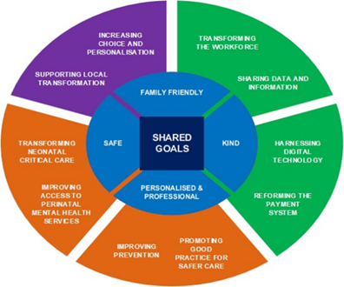
Based on this vision, we will, together with local transformation and partners across the system such as providers, commissioners and system users, deliver a plan to transform our Local Maternity Neonatal System (LMNS).
We will also work with ‘Maternity Voices’ to engage with parents and families about services to ensure co-production of services is at the heart of pathways.

5.8 Our approach to meeting the needs of Children and young people (CYP)
Our system is committed to focusing on the needs of children and young people in our population. We know that children need to live happy, healthy and fulfilled lives and the pandemic has impacted on them in many ways. Throughout this plan, we consider children and young people and their families and carers, including those children with complex needs and the support their families need. The offer starts before conception and through to adulthood. We are committed to engaging children and young people in the development, review and delivery of our service offer to them.
Some of the key priorities we have identified for children and young people are to:
- develop transformative care pathways for asthma, epilepsy, diabetes and obesity.
- work with partners in education, mental health, and safeguarding to ensure that, no matter how complex, our children’s needs are met.
- hear the voices of children as we plan and deliver their care.
- use Core20PLUS5 children’s model to drive improvement and reduce inequalities.
We will establish a CYP Joint Commissioning plan. Working collaboratively with partners, we will develop a joint commissioning plan that meets the needs of CYP and supports them to achieve their full potential. This will include SEND, mental and physical health, safeguarding and CYP with complex needs.
Specifically for CYP Mental Health services we will achieve a shared and coherent vision across our system, to drive forward our transformation programme, including a full review across a number of service elements, alignment of pathways, and expansion of services where needed.

ICB Commissioning Ambition
- That CYP get the right help at the right time to ensure they meet their potential, able to self-manage and are resilient

Key Commissioning Intention Deliverables

Year 1
- Via procurement a recommissioned Children and Young People Mental Health Service (CAMHS) ensuring the inclusion of our approach towards prevention and trauma informed care.
- A collaboratively developed CYP Joint Commissioning Plan that meets the needs of CYP at a local level and supports them to achieve their full potential, including SEND, mental and physical health, safeguarding and CYP with complex needs.

Years 1-5
- Using the national CYP Core20PLUS5 framework drive improvement action led by Place across CYP services; asthma, diabetes, epilepsy, oral health and mental health.

5.9 Our approach to Healthy Ageing and Frailty
Frailty is a loss of physical and mental resilience, leaving a person vulnerable to declining health and the inability to recover well from adverse events such as illness, injury or bereavement. Frailty is important because it compromises quality of life for the individual and increases the risk of death, disability, dementia, hospital admission, falls and the need for long-term care. The likelihood of frailty increases as we get older, but it is not inevitable, and at various stages along the spectrum it can be prevented, delayed, reversed and managed. Conversely, frailty can occur at a younger age for those with an accumulation of health risks, and the risk of early frailty is higher among those living in deprivation, some ethnic minorities and those with chronic health conditions.
Frailty is a national priority because the number of people at risk of frailty is growing, and with it an increase in the need for health and care services. Years – or decades – spent in ill health mean personal suffering, strain on families, and use of health and social care services. Delaying the onset of frailty, and managing frailty well, to slow progression and reduce the need for unplanned care, are crucial for the long term financial and environmental sustainability of health and care services.
In Shropshire, Telford and Wrekin we have a larger proportion of people aged over 65 than nationally (22% compared to 18% across England), along with significant numbers at risk of poor health in later life, such as people who live in deprivation and those from Pakistani and Bangladeshi communities. On average our residents live the final 17-22 years of life in poor health, and there is a gap of up to 12 years between the healthy life expectancy of the most and least deprived. Reducing the number of years lived in poor health, particularly for the most deprived who live the longest in poor health, is where the opportunity lies for improving quality of life for our residents whilst slowing the growth in health and care costs.
As an Integrated Care System, we have an urgent need to develop plans that reduce the impact of frailty on the quality of life of our population and on the demand for health and care services. This will be achieved through implementation of a strategy to delay the onset of frailty and deliver best-practice frailty management.

The ICB is developing a Healthy Ageing and Frailty Strategy for approval and implementation in the autumn of 2025. A multistakeholder Steering Group has been established to oversee the development and implementation of the strategy, chaired by the ICB Chief Nursing Officer.

This three-year system-wide strategy will comprise five pillars that reflect the trajectory of frailty: educate, prevent, identify, manage and care.

The diagram below shows how this strategy aligns with other system and ICB strategies:

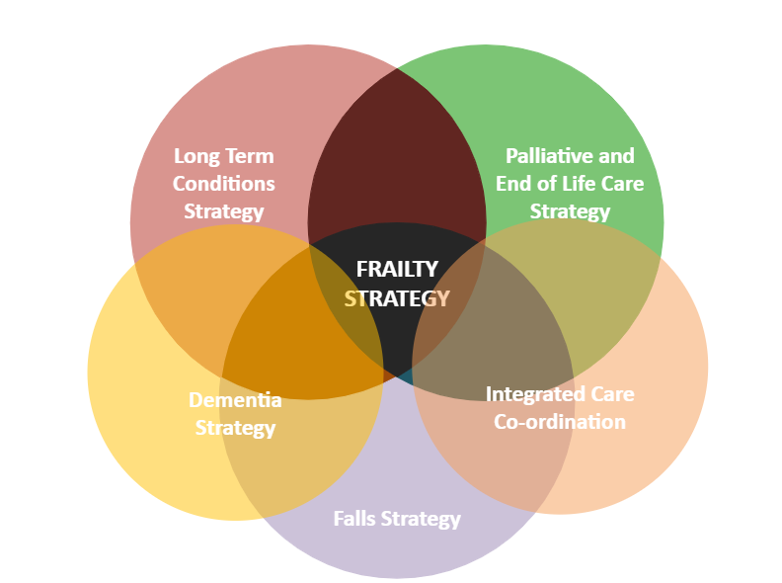

ICB Commissioning Ambition
- A fully integrated falls pathway focused on prevention
- deliver collaboratively with system partners the new dementia vision and service model which was developed and co-produced with people living with dementia and their carer’s

Key commissioning intention deliverables Ambition

Year 1
- Implementation of the Dementia Vision including multi-disciplinary teams, shared care model with patients receiving annual reviews and sufficient service capacity achievement of the national Dementia Diagnosis to Treatment rate (DDR)
- Improved performance in the national Dementia Diagnosis to Treatment rate (DDR)
- Approved Ageing Well and Frailty Strategy with supporting implementation plan
- Fully functional provider collaborative providing end to end falls pathway including a single point of referral
- Service in place for urgent response and assessment to a person who has fallen at home/in the community

Years 1-3
- Deliverables for Years 1-3 will be determined as part of the strategy development

5.10 Our approach to End-of-life care
It is the commitment of Shropshire, Telford and Wrekin (STW) ICS that people nearing the end of their life receive high-quality, compassionate care and are supported to live well and to die with dignity in a place of their choosing. Across STW, we know that this is provided for the majority of people. However, we also know that we can do more, particularly for those that do not access, or have difficulty accessing, services. We want to identify people in their last journey of life earlier and anticipate care needs that can be planned for in advance.

The National Ambitions for Palliative and End of Life Care states that caring for people at the end of their life is everyone’s responsibility and it is for this reason that our Providers are keen to develop a collaborative approach to care.

ambitions-for-palliative-and-end-of-life-care-2nd-edition.pdf

- The ICB will facilitate the developments needed to establish a Palliative and End of Life Care Provider Collaborative.
- The ICB will work with providers and the public to understand the anticipated requirements and impact of the Terminally Ill Adults (End of Life) Bill as it goes through the legislative phases.
- We will seek to ensure that safeguards and protections are in place to enable the statutory obligations of the bill and to support individuals rights and choice.

Babies, children and young people with life-limiting or life-threatening conditions

The number of babies, children or young people (BCYP) with life-limiting or life-threatening conditions in our region is, thankfully, low – with an average of 11 expected to die each year. The specific and often very complex needs for BCYP who require palliative and end-of-life care means that an all-age strategy is not appropriate, and the Shropshire, Telford and Wrekin Integrated Babies, Children and Young People Palliative and End of Life Care Strategy will be developed.

Key deliverables

Year 1
- Palliative and End of Life Care Provider Collaborative established
- Proposal and action plan agreed
- BCYP Strategy approved and implementation plan developed
- Plan in place to monitor progress of the Terminally Adults (End of Life ) Bill

Years 2-3
- Collaborative arrangements achieved for year one and refined for years 2 -3
- Adult PEoLC Strategy refresh
- Requirements of the Terminally Adults (End of Life) Bill implemented and monitored

Years 4-5
- Deliverables for years 4 -5 will be determined by Provider Collaborative arrangements and ICB statutory requirements

5.11 Our approach to medicines
Medicines play a crucial role in maintaining health, preventing illness, managing chronic conditions and curing disease. In an era of significant economic, demographic and technological challenge, it is crucial that patients get the best quality outcomes from the medicines that they are prescribed.
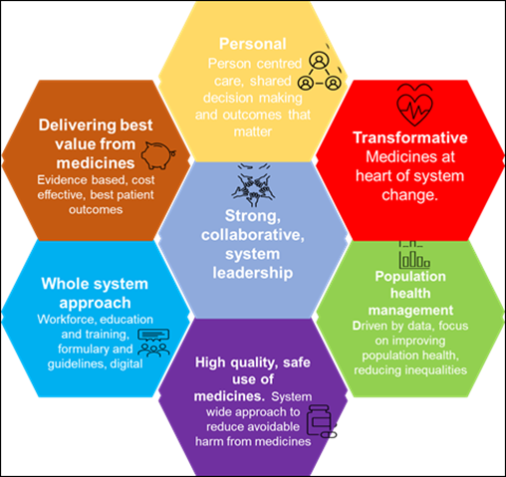
Our vision for medicines optimisation within STW ICS delivers a patient-focused approach to getting the best possible health benefits from the investment made in medicines. This requires a holistic approach, an enhanced level of person-centred care delivery, and partnership between clinical professionals and patients. Our aim is to ensure that the right patient gets the right medicine, at the right time. We will focus on wider health outcomes including improved clinical outcomes for patients, reducing avoidable hospital admissions related to medicines (HARMs), reducing health inequalities and utilising a population health management approach. A patient-centred approach will, in turn, ensure we get the best from our investment in medicines, and that patients live longer, healthier lives. It will also support the system to achieve its aims in
transforming care by improving capacity through admission avoidance, earlier discharge and supporting high-quality access to care in alternative settings.
Over the next five years, our strategy will focus on six key themes:

Person centred care
- Holistic approach to shared decision making
- High-quality prescribing to improve patient outcomes and reduce health inequalities. Currently, we have a focus on cardiovascular, diabetes and respiratory disease
- Equity of access to medicines and a standardised approach with shared guidelines to best practice in all settings
- Supporting patients to self-care where appropriate.

Delivering best value
- Making best use of available resources by:
- Shared system evidence-based and cost-effective formulary – 90% adherence in all settings
- Best value biologics (high-cost drugs) – 90% use of best value biologics
- Reduce prescribing of low-priority medicines
- Reduce waste
- Reduce environmental impact of medicines and inhalers (working towards NHS net zero in 2040)

Medicines Quality and Safety
- System approach to improving medicines safety across primary and secondary care. Aim to align incident report system across all providers, improving safety by reporting and learning from medication errors whilst encouraging an open culture
- Reducing hospital admissions related to medicines (HARMS) – World Health Organisation challenge to reduce this by 50%
- Improving performance against national and local targets – currently, our focus is anticoagulation, sodium valproate in pregnancy and prescribed dependence performing medicines (opioids)
- Deprescribing to reduce inappropriate polypharmacy
- System Antimicrobial Resistance Strategy by July 2023.
View the Medicines Strategy.

Key deliverables

Year 1
- Medicines and Waste Campaign
- Antimicrobial Stewardship - appropriate durations of antibiotic course lengths - appropriate antibiotic prescribing for children with acute respiratory tract infection (RTI)
- Review of Diabetes Optimal Treatment targets
- Pilot use of Continuous Glucose Monitoring (CGM) for Type 1 and Type 2 diabetes patients in one of the PCNs
- Medicines Governance Assurance Plan agreed
- Medicines Safety Plan agreed
- High-Cost Medicines (NICE) current compliance scoped
- Manage uptake of biosimilars and incentivise with gain share
- Tirzepatide implementation - plan agreed with providers
- Diabetes hybrid closed loop - plan agreed with providers

Years 1-2
- Following Year 1 review, optimising of all 3 diabetes treatment targets through the use of structured medication reviews, individualised care and annual diabetic reviews
- Implementation and rollout of CGM in Care setting following evaluation of pilot.
- Optimisation of anti-hypertensive therapy in line with NICE guidance to achieve the national ambition of 80%
- Enhanced lipid modification therapy for primary prevention to improve cardiovascular outcomes.
- Medicines Governance Assurance Plan consolidated
- Medicines Safety Plan consolidated
- High-Cost Medicines (NICE) - confirm and challenge report

5.12 Duty to address the needs of survivors of abuse
We have a duty to address the needs of survivors of abuse in our area. People can be survivors of a range of different types of abuse, such as domestic abuse, sexual abuse, child sexual exploitation (CSE), criminal exploitation, neglect, financial or emotional abuse. Our approach and actions to delivering this duty are summarised below.

Preventing abuse
- Effective multi-agency working though safeguarding partnerships
- Delivering the requirements of the Serious Violence Duty
- Commissioning services based on existing resources and robust population information
- Linking with the voluntary sector
- Linking local and NHSE commissioned services
- Participation in the Criminal Justice Partnership
- Engaging those with lived experience in our plans and actions, including co-production
- Implementing the Liberty Protection Safeguards in line with national timescale
- Engaging CYP and their carers in our plans and actions

Supporting those who have suffered abuse
- Listening to victims and their needs
- Implementing a trauma-informed approach to relevant commissioned services
- Building pathways based on knowledge and information about the effectiveness of interventions
- Focusing on the prevention of ill mental health
- Working with schools and education establishments
- Meeting the needs of looked-after children
- Engaging CYP in our plans
- Delivering the actions required in the Independent Inquiry into Child Sexual Exploitation in Telford (IITCSE).

How will we know our approach is working?
- Robust multi-agency datasets to triangulate crime, social care and health data
- Working with Healthwatch and those with lived experience
- Working in safeguarding partnerships to gain intelligence on changing themes in abuse and the prevention measures needed as a dynamic process
- Benchmarking with other areas and engagement in regional and national improvements
- Audit of services
- Gaining feedback from service users to ensure the approaches are working

Chapter 6:

Enablers

6.1 People
Our system workforce has been working collaboratively for many years, an approach underscored during the system’s response to the COVID-19 pandemic. During this time, relationships have formed between NHS, local authority, ICB (formerly CCGs), primary care, social care and voluntary sector partners to tackle the workforce pressures at a system level.

Our ICS People, Culture and Inclusion committee draws its membership from a broad range of stakeholder organisations and continues to build on our collaborative approach towards delivering the national guidance for ICB people functions to support a sustainable ‘One Workforce’ within health and care – creating a compassionate and inclusive culture and working collaboratively as a system to address our workforce challenges.

People Strategy
Our People Strategy sets out our ambition for the circa 23,000 people who work with us across health and social care. Our strategy is focused on the delivery of the NHS People Plan, underpinned by the NHS People Promise and the ambitions set out in the Future of NHS Human Resources and Organisational Development

Our refreshed People Strategy is designed to help bring our integrated care strategy and operational plan to life through the following strategic drivers:

- Improve outcomes in population health and healthcare.
- Tackle inequalities in outcomes, experience, and access
- Support broader social and economic development.
- Enhance productivity and value for money.

These strategic drivers are translated into a small but focused number of workstreams to deliver our commitments to those we serve through effective and efficient models of delivery. Our priorities include:

- the reduction of unavailability of substantive workforce
- continued reduction in use of agency and bank staff
- maximisation of national programmes such as the national bank
- enhanced career pathways through apprenticeship and T levels for hard to fill and scarce skill professions
- transformation of our UEC and elective care workforce to support pathway redesign
- move towards more integrated and collaborative corporate services

Working collaboratively with system partners we are identifying areas for improvement in how we can support and value diversity even further and create an inclusive workforce and culture. Our aim is to have a workforce profile that is more representative of the communities we serve. To support this we will expand apprenticeship opportunities, T-levels and alternative routes into a career in health and social care, and we will continue to develop more diverse leaders across the system through our involvement in schemes like the High Potential Scheme. Furthermore, we will work with system partners to ensure delivery of the six high impact actions to improve equality, diversity and inclusion throughout all that we do.

Finally, to prepare for the introduction of the national leadership and management competencies, we are investing in our leadership team to drive a culture of courage, compassion and continues improvement. These skills and knowledge will support the ICS to navigate the challenges and capitalise on the opportunities, as well as supporting the development of an engaged and motivated workforce who deliver high quality patient outcomes.

With the evolving landscape in terms of a new 10 year plan, annual operational planning guidance and the likelihood of a new People Operating Model being published we will refresh our priorities regularly in collaboration with system partners to ensure they remain relevant to the context within which we are operating.

Key deliverables

Year 1
- Delivery of commitments within the operational plan relating to workforce
- Development of an Equality Diversity and Improvement strategy / plan
- Engagement with cohort 2 of the high potential scheme

Years 2-3
- Delivery of efficiencies in corporate services

6.2 System procurement

National priorities
Nationally the NHS launched the NHS Commercial Portfolio and the Strategic Framework for NHS Commercial during 2023. This outlines how the NHS and government functions will work together to transform public procurement. The NHS Commercial Portfolio has seven main service offerings:
- People and Community
- Technology and data
- Commercial strategies
- Governance, assurance, and processes
- Sourcing and management
- Commercial capability/best practice
- Sustainability and innovation.
The Strategic framework builds on several of the national commercial function service offers but goes further to provide a centrally driven blueprint for whole system commercial and supply chain transformation across four thematic areas.
- Our People
- Digital and Transparency
- How we work
- Influence and scale

The introduction of the 2023 Procurement Act in October 2024 will necessitate significant changes to NHS procurement practices.

Local governance
The System Director of Procurement chairs a bi-monthly Procurement Working Group encompassing NHS and local authorities within STW which will enable future collaboration within procurement. A monthly System Product Evaluation Group has been introduced to look at standardisation of products and suppliers linked to patient pathways. Standardised use of products will assist with better knowledge and safer usage of products leading to a better patient experience. Other benefits include efficiencies, standardised training, and equity for patients.

Local function
The Shropshire Healthcare Procurement function has focussed on training to support the demands of the changing ICS landscape and has embedded several apprenticeship positions to grow our own procurement workforce.

The function has developed and matured over recent years and is well advanced in terms of partnership working as an ICS with proactive engagement to deliver as a system.

The procurement function has embedded the use of national benchmarking tools (Spend Comparison) and workplan pipeline (Artamis) to enable the system to understand system spend profiling, transparency of expenditure and to assist with identifying opportunities.

Key Deliverables

Year 1
- Procurement awareness and training
- Review strategic supplier management options
- Identify collaborative Trust project opportunities
- Increase procurement profile in trusts
- Clinical Nurse Procurement Speicalists
- Review and reduce the use of waivers
- Review e-procurement strategy and progress against it
- Income generation supplying GPs
- Review of items held in stores and cost improvement opportunities
- System procurement key areas: workforce/estates/digital

Years 2-3
- All procurement via one department ICB/SATH/SCHT/RJAH
- All contactive via procurement – digital/estates/pharmacy/GP
- One supply chain and logistics service for all providers
- Manage key suppliers to drive reciprocal benefits and gain share
- Reduce number of products and suppliers used within the Trust
- Totally electronic P2P system impelemented and managed by procurement
- Update e-procurement strategy in line with national guidance
- Increase supply to GPs/voluntary organisations

Years 4-5
- Drive efficiencies and saving via full contract
- Collaboration across Shrosphire and West Midlands where appropriate
- Demonstrate best value for money for all strategic products
- Reivew logisitics provision
- Hospital Transformation Programme review procurement and logistics implications
- Tender transport logistics provision
- Review procurement structure/skill mix and succession planning
- Review procurement strategy/1-5 year plan

6.3 Digital as an enabler of change
Digital transformation is fundamental to improving service delivery, addressing health inequalities, and enhancing patient outcomes across STW ICS. The latest NHS England 2025/26 Operational Planning Guidance prioritises digital as a key enabler for elective recovery, UEC reform, and tackling inequalities, aligning national expectations with our local strategic objectives. The ICS continues to embed a digital-first, but not digital-only approach, ensuring equitable access to services while supporting digital inclusion efforts.

To support elective recovery, we will maximise digital tools such as the NHS App, Patient Initiated Follow-Ups (PIFU), and virtual wards, reducing unnecessary outpatient visits and enabling self-management of care where clinically appropriate. Enhanced use of Shared Care Records (ShCR) will ensure seamless information sharing across providers, improving efficiency in clinical decision-making. Additionally, OrderComms and digital diagnostics will streamline test ordering and results management, accelerating diagnostics and triage. The modernisation of PACS (Picture Archiving and Communication Systems) will further enhance access to imaging, reducing delays and improving clinical workflows.

In urgent and emergency care, we will drive the Electronic Patient Record (EPR) rollout programmes at the acute trusts, ensuring that clinicians have real-time access to patient information, improving decision-making, and reducing duplication. The implementation of the Federated Data Platform (FDP) will enable system-wide data integration, allowing for better resource allocation, operational efficiency, improved patient flow across care settings, and enhanced population health insights.

Reducing health inequalities remains a core objective, with efforts focused on mitigating digital exclusion through initiatives such as loaned digital devices, digital literacy training, and local authority partnerships. Expanding remote monitoring and econsultation services will improve access for underserved communities, particularly in rural areas, while ensuring that those unable to engage digitally have alternative pathways.

STW ICS will continue to align its digital portfolio with national funding opportunities, ensuring sustainability in Microsoft 365 adoption, Windows 11 implementation, cybersecurity enhancements, and supplier management. The integration of AI-driven tools such as NHS Copilot will streamline administrative processes, freeing up clinical capacity and supporting workforce efficiency.

By embedding digital solutions into every aspect of care delivery, STW ICS is committed to achieving a modern, efficient, and patient-centred healthcare system, addressing the critical challenges outlined in the Elective Recovery, UEC Reform, and Health Inequality frameworks.

Our current position and the future desired state of our ICS are described below:

Current position
- A ‘digitally immature’ system with variation in digital capabilities across organisations.
- Digital inclusion across communities is worse than the national average, limiting access to digital health services.
- Ageing IT infrastructure and estate, including outdated hardware and software across community hospitals, primary care, SaTH, and local authorities.
- Fragmented and siloed digital services, with each organisation managing digital projects in isolation.
- Limited system-wide interoperability, leading to delays in data sharing and decision-making.
- Inconsistent use of Microsoft 365 tools, limiting collaboration and efficiency.
- Cybersecurity risks due to legacy systems and inconsistent compliance measures

Desired future state
- A digitally enabled ICS that meets national expectations and delivers against local priorities through strategic investment and system-wide collaboration.
- Proactive digital inclusion initiatives supporting patients and staff, including loaned digital devices, training programmes, and local authority partnerships to bridge the gap.
- Upgraded IT estate with Windows 11 deployment, modern network infrastructure, and cloud-based services, ensuring a future-proofed digital environment.
- A unified digital strategy underpinned by the Federated Data Platform (FDP), Shared Care Records (ShCR), and system-wide governance, enabling better coordination and resource sharing.
- Full integration of EPR systems at acute trusts, OrderComms and digital diagnostics, EPMA, and modernised PACS, ensuring seamless access to patient data across all care settings.
- Optimised Microsoft 365 adoption, including Copilot AI integration, improving productivity and automating routine tasks for staff.
- Enhanced cybersecurity framework, ensuring compliance with NHS DSPT standards, threat monitoring, and proactive risk management across all ICS organisations.
- Streamlined supplier management with a structured digital investment plan, ensuring cost-effective procurement and maximised return on digital investments.

Our Digital Pledges
To deliver our ambitions and pledges, we will embed sustainable ways of working to ensure we are best set up to successfully deliver our digital portfolio.
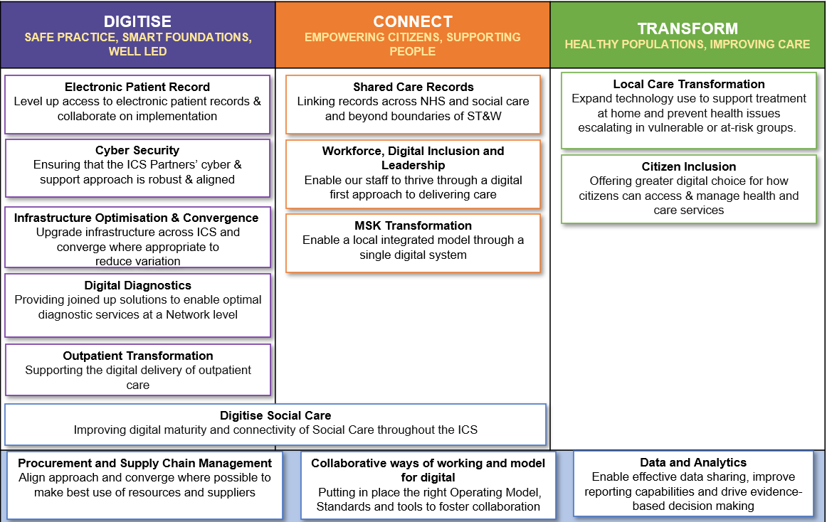

ICB Commissioning Ambition
To drive digital transformation across STW, ensuring technology is a key enabler of improved health outcomes, equity of access, and operational efficiency. This includes digital inclusion, interoperability, and local and integrated care pathways.
Key deliverables

Year 1
- Electronic Patient Record (EPR) rollout at acute trusts
- Shared Care Record (ShCR) enhancement
- Windows 11 transition across ICS organisations

Years 2-3
- Federated Data Platform (FDP) implementation
- OrderComms and digital diagnostics implementation
- Copilot AI deployment
- PACS
- EPMA
- Virtual Wards Remote Monitoring

6.4 Data and Information
There is an ambition to develop a system-wide approach to the management and visibility of linked data in place to inform Strategic Commissioning and outcome-based approaches to pathway redesign.
Our reliance on data to inform and drive decisions is becoming more inherent to our everyday needs along with the ability to make decisions and support our development of a Population Health Management approach to health and care commissioning and a coordinated reduction in the Health Inequalities across our population.

We are developing a system data strategy which will allow us to drive the necessary improvement in both the quality and coordination of our data across all partners. This will enable us to make better informed decisions which are key to supporting the delivery of our strategic aims.

There have been several publications over the recent years including the Hewitt Review, What Good Looks Like Framework and Data Saves Lives to name a few. Contained within these it is evident that we need good quality, timely and accurate data to inform data driven decision making.

The data strategy will support the development of a record level linked dataset for secondary uses by all system partners and include datasets from all system partners. This will be used to identify areas of poor outcomes and allow us to monitor their improvement over time.

The strategy will also look into how we can include advanced tools and techniques to support strategic analytics. This will include, for example, the use of innovative coding languages like “R” and advanced forecasting techniques through machine learning. This will be heavily dependent on the investment of upskilling our current workforce and linking with digital colleagues.

Critical to the success of our system will be allowing our analytical workforce to grow and thrive. Working with the developing recognition nationally of analysts, we will look to implement the benefit of the National Competency Framework as well as using APHA (Association of Professional Health Analysts and FEDIP (Federation for Informatics Professionals in Health and Care) to professionalise the analytical community.

Key deliverables

Year 1
- Data Strategy developed and agreed by all system partners.
- Aims of national planning guidance delivered

Years 2-3
- Adoption of the Federated Data platform
- Agree and implement governance to support system wide working
- Review partner infrastructure for reporting
- Develop workforce in line with national competency framework

Years 4-5
- Adopt Machine Learning tools and techniques
- Apply Data Science principles

6.5 Estates – System Physical Infrastructure, Estates Strategy and Planned Delivery
In line with NHSE requirements, all ICSs need to draft their Estates and Physical Infrastructure Strategies. This process will need to be fully integrated into all system, clinical and non-clinical workstreams. The development of the strategy will aid system thinking and alignment across the infrastructure components and core objectives, and must fully integrated with all elements of the forward plan. We aim to deliver an estate which is fit for purpose and provides high-quality care environments which enable the safe delivery of services for our communities. This means an estate which is compliant and functionally suitable, environmentally sustainable, accessible, flexible, and designed around changing service needs.

ICS Estates and Physical Infrastructure Strategies will be used to inform future NHS Treasury Funding.

The Estates and Physical Infrastructure Strategy will be comprised of the following components:

- Estates physical infrastructure with specific focus on the shift from acute to community and from treatment to prevention.
  - Primary care estate
  - Community estate
  - Acute
  - Mental health
- Other physical infrastructure including analog to digital to support estate utilisation priorities.
  - Energy
  - IT physical infrastructure
- Medical equipment
- Zero carbon roadmap.

The strategy will also support the system priorities of the Hospital Transformation Programme, Local Care Programme, MSK Transformation and Outpatient Transformation as well as existing physical infrastructure workstreams and projects like Community Diagnostic Centres, Community Hubs including Integrated Neighbourhood Teams and non-clinical estates rationalisation.

Key deliverables

Year 1
- Implement Strategic Estates Group and associated Governance
- Finalise ICS Infrastructure Strategy
- 10 year capital investment plans that underpin delivery of the Strategy

Years 2-3
- Creating integrated and flexible clinical estate
- Improving utilisation and sharing of estate non clinical and clinical
- Integrating digital access and workforce as key enablers to supporting estate utilisation

Years 4-5
- Reduction in VOID space
- Reduction in Critical Infrastructure Backlog Maintenance
- Increased Primary Care Estate to support expected population growth

6.6 Financial sustainability
The Shropshire, Telford and Wrekin system has a significant underlying financial deficit which is one of the reasons that we are part of the Recovery Support Programme (RSP). The system and ICB is therefore subject to significant scrutiny around finances and financial decisions, with a specific requirement to develop an approach to recovering and making sustainable our financial position.

A system financial framework was therefore developed in 2020/21 and agreed by all organisations and all system partners, working closely together to deliver a roadmap for financial recovery.
All organisations have:
- approved the approach of ‘one model, one consistent set of assumptions’ and recognise that the position of each organisation will evolve and change transparently
- agreed to mobilise and deliver the plan to enable the development and delivery of the financial strategy and Financial Improvement Framework as part of an Integrated System Strategy
- ensured that the transparent and agile approach to financial planning and management continues across the system
- recognised the initial financial control totals in the Financial Improvement Framework with a commitment to agree organisational control totals within that
- agreed to work together to use our resources flexibly and effectively, to deliver the system vision.

To ensure that all decision-making is open and changes are understood and approved by all, the system has been operating under the ‘triple-lock’ process and using a principle of ‘moving parts.’ This means that decisions are made at local, ICS and regional NHS England level (triple lock) and that new expenditure can only be committed if it is backed by new income, productivity or efficiency (‘moving parts’). The principles are designed to ensure decisions are owned by each organisation and at system level, with oversight from NHSE. All investment decisions are made using a system-wide Strategic Decision-Making Framework to ensure allocative efficiency and that all decisions take into account the ICS core aims - Improving outcomes in population health and healthcare, tackling inequalities in outcomes, experience, and access, enhancing productivity and value for money and helping to support broader social economic development.
The System Integrated Improvement Plan provides the mechanism by which the ICB will come out of NHSE oversight level NOF 4. Delivery against monthly milestones within the plan is reported to ICB and ICS Executives through the System Transformation Group and System Finance Committee. Evidence of delivery is collated and submitted to NHSE, and then formal progress is presented at our national Recovery Support Meeting which are quarterly. Formal changes to the RAG status of our exit criteria are agreed at the regional NHSE Recovery Support Oversight group (RSOG). The formal sign off of exit criteria is agreed through the national Quality and Performance Committee based on the recommendations from the regional RSOG.
In 2023/24, the impact of the first-year strategies have supported the delivery the 2023/24 £129m underlying exit deficit.
In 2024/25, the impact of the second-year strategies have reduced the underlying exit recurrent deficit to an expected £115m.
For 2025/26+ the financial planning principles adopted are as follows:
- Year on year improvement in the recurrent underlying position.
- Total efficiency targets including productivity of between 4-6%.
- Prioritisation of limited growth funding and investments, unless essential for generating income, delivering productivity or efficiency or meeting agreed waiting time targets
- Workforce monitoring and controls, reducing agency spend and escalation costs
- Controls on expenditure through the Triple Lock process for transactions of £10k across the system
- Reviewing cost pressure drivers to ensure effective controls and monitoring systems are in place
- A system-wide approach to efficiency, transformation, and productivity.

The medium to long term plan has been developed during 2024/25 setting out the recovery trajectory for the system showing the route to breakeven, including a detailed multi-year revenue and capital (strategic and operational), workforce, efficiency, and transformation plan.
A system-wide approach to efficiency and transformation is in place. We use a project management approach to ensure effective monitoring of achievement using business intelligence data and financial analysis. System-wide transformation programmes address the key system excess spend drivers and productivity opportunities and include Continuing Healthcare, Urgent and Emergency Care, Workforce including Temporary Staffing and Corporate Services, Local Care Programme and Elective Care which includes MSK and Outpatient transformation.
All ICB contracted services will be reviewed to ensure value for money is achieved. Where this is not the case, decommissioning and disinvestment will be considered alongside any ‘Hard Decisions’, using the Strategic Decision-Making Framework to further support allocative efficiency.

Key deliverables

Year 1
- Improvement in the underlying recurrent financial performance
- Refresh of the System Financial Strategy and Medium-Long Term Plans

Years 2-3
- Delivery of the Medium Term Financial Plan Capital and Revenue inclusive of the Recovery Plan via the System Transformation Programmes

Years 4-5
- Delivery of the remaining Medium Term Financial Plan Capital and Revenue priorities including the Hospital Transformation Programme and Local Care Programme

6.7 Productivity
A system productivity oversight group has been in place since June 2023 and meets monthly to coordinate and oversee delivery of the system level improvement in productivity and efficiency. It will work with regional leads to ensure our systems and processes are aligned to regional and national priorities and allow all parts of the system to share ideas and best practice for improvement. Intelligence on the opportunities for productivity will be drawn from benchmarking sources NHS Futures, Model Hospital, GIRFT, NHS England productivity reports and local benchmarking with other ICB’s and providers. The productivity oversight group will be supported by system resources across finance, business intelligence, clinical and operational leadership and project management to ensure the delivery of productivity improvements. Providers will have their own individual plans, but the impact and learning will be shared at the oversight group to ensure our plans are delivering the required improvement. It reports to the System Finance, Productivity and Planning Group and into the System Finance Committee.

The Hewitt review of ICSs outlined the need to focus on the creation of health value and implementation of innovative financial flows and payment mechanisms. As the system matures, opportunities to understand the cost of whole care pathways and intelligence through population health management approaches will allow consideration of resource allocation to provider collaboratives and places.

ICBs have been notified that baseline running cost allowances (allocations to fund the running costs of an ICB) will reduce by 30% in real terms by 2025/26, with at least 20% to be delivered by 2024/25. This provides us with an opportunity to review how we deliver the core business of the ICB alongside the development of our models for provider collaboratives and place.

In 2024/25 NHS England commercial directorate produced standardised productivity packs for all ICB’s setting out efficiency opportunities for Continuing Healthcare and Prescribing. Provider packs detailed productivity and efficiency opportunities in Corporate Services, Temporary Staffing, Urgent and Emergency Care, Elective and Outpatients, Medicines and Commercial opportunities. These productivity and efficiency opportunities will form a key part of the financial recovery plan aligned the medium-term financial plan.

Key deliverables

Year 1
- Validation of ICB and Provider efficiency and productivity opportunities.
- Development of efficiency plans to deliver productivity and efficiency opportunities

Years 2-3
- Delivery of agreed productivity and efficiency improvement plans to support cash releasing efficiencies and performance improvements

Years 4-5
- Delivery of agreed productivity and efficiency improvement plans to support cash releasing efficiencies and performance improvements.

6.8 Our commitment to research and innovation

Duty in respect of research
The ICS developed a research and innovation strategy agreed through the Staffordshire and Stoke-on-Trent, Shropshire Telford and Wrekin Health and Care Research Partnership (SSHERPa) – signed off at the STW ICS Research and Innovation Committee in November 2023.

The key pillars of the research strategy are as follows:
- Developing collaborative integrated research that addresses the health and care priorities of our region, expanding the range and diversity of research undertaken in our region
- Fostering a culture of collaborative research and innovation with strong leadership championing the strategy
- Developing the capacity and capability for evidence-based health and care
- Increasing the opportunity for our region’s population to engage in research
- Developing a collaborative infrastructure for research and innovation in our region to support and grow an increased research portfolio
- Supporting the implementation of best evidence into practice – commissioning and provision of services.

Our strategic objectives provide the framework for how we will achieve our vision and realise our principles through:

Workforce Development
- Championing a research culture where everyone is valued and able to contribute to, and benefit from, research
- Developing innovative career pathways, embedding research into health and care professional roles
- Sharing knowledge and expertise, developing research professional roles across the partnership

People, Places and Communities
- Creating opportunities for inclusive research across diverse communities
- Enhancing the opportunity for people to shape research, reducing health inequalities across our diverse urban and rural geography
- Enhancing the opportunities to engage in research – championing the people and teams that support this
- Developing infrastructure that supports wider engagement in research

Impact
- Creating an eco-system where research outputs can be rapidly adopted into practice/policy
- Developing co-production strategies that support the mobilisation of knowledge
- Transforming health and care through high quality research
- Supporting sustainability through new approaches to health and care research delivery
- Supporting economic development through income generation

All of the above supported by high quality research, empowering all to engage, improving outcomes through partnership and leadership.

Executive leadership and hosting of SSHERPa is now in place along with a provider executive sponsor and programme management support. We have a dedicated ICB lead for research (Chief Medical Officer) who provides senior leadership between SSHERPa and the ICB.

Work has also continued to develop and enhance partnerships across the health, care and the VCSE sector to advance research and innovation to support the four core purposes of the ICS. Development of our research engagement activities to reach wider communities has been supported through the establishment of voluntary and community sector research coordinators and the development of a research connector’s network across our region. These links provide routes by which we can engage with under-served communities by taking research to those who do not currently have the opportunity to engage in research.

As part of developing the local research infrastructure, members from the voluntary, community and social enterprise (VCSE) sector are now key partners of SSHERPa and a dedicated patient, public and community involvement and engagement work stream is in place. This draws together those working in public engagement across all settings and community engagement with VCSEs, to ensure that new studies are in development, and established NIHR portfolio studies are shared across the widest population. Since February 2024, just under 5,000 people have been recruited to take part in a research study in NHS Shropshire Telford and Wrekin ICS, and through our community networks we are seeking ways in which we can extend these opportunities further.

Through working with communities, we have established voluntary and community sector research coordinators, hosted by the VCSE and funded through the NHSE REN programme, developed a research connectors network across our region and supported individual community research champions. We will continue to work with all health and care research partners to seek ways in which we can engage with under-served communities by taking research to those who do not currently have the opportunity to engage in research. Partners include NHS trusts, local authorities, VCSE organisations, universities, National Institute for Health and Care Research (NIHR), Clinical Research Network West Midlands (CRN WM) and the West Midlands Health Innovation Network.

Developing collaborative integrated research addressing the health and care priorities of our region: Examples of how we are supporting this agenda include the successful application to be part of a national programme around dementia biomarkers, developing applications to establish a NIHR Mental Health Research Group (led by Keele University but with VCSE as co-applicants) and the development of a dementia study across rural locations.

We were delighted to secure NHSE research engagement network funding and to have delivered the NHSE Touchpoints programme as part of SSHERPa, where more than 11,000 people were directed to the NIHR Be Part of Research website. We work closely with our university partners to support ‘home grown’ research, and work with our NIHR CRN WM to ensure portfolio studies come to our region. Our priority is to work with partners to better understand how participation in these programmes can influence evidence-based service transformation in our region.

On a regional level, SSHERPa partners form part of West Midlands Secure Data Environment (WM SDE) Network workstreams, and have strong links with local research infrastructure and stakeholders to ensure that we support staff, organisations and our local population to be involved in research to support health and care priorities. We are working closely with NIHR CRN WM as it transitions to the new NIHR Regional Research Delivery Network to understand implications for support for wider settings including primary care and community settings.

Across our ICS research partners, we are driving collaborative working, actively sharing best practice. We have an established research governance work stream whereby we are streamlining processes with the aim of establishing one ‘SSHERPa’ check for studies that operate across organisational boundaries. Through this, workstream organisations are sharing knowledge and expertise to support organisations without research and development infrastructure – for example, VCSE. SSHERPa partners work closely to share training and workforce opportunities (STARs and research practitioners), develop research engagement approaches targeting different health and care professionals (for example, evidence based practice groups such AHP/GPNs, CENREE, NMAHP, LENSE, criminal justice settings, SCREEN for social care, PRIDE for public health); and seek innovative ways to build the capacity and capability for research, through joint clinical academic appointments, shared training opportunities and innovative research and innovation roles.

We were delighted that our work in driving research and innovation through SSHERPa, and the progress we have made in embedding research within the ICS, was recognised at the NIHR CRN WM annual awards 2023, with SSHERPa winning the ‘Shining Research Star’ award.

Innovation
We want to be an innovative and learning healthcare system to help improve the lives of patients. On this basis, we will work with a range of partners, including primarily the local Academic Health Science Network (AHSN), which is the innovation arm of the NHS. The voluntary and community sector can be a particularly rich source of innovation and new ideas.

Key deliverables

Year 1
- Research collaboration between system partners established
- Research Strategy co-designed

Years 2-3
- Shared approach to research governance and infrastructure developed
- Development of collaborative funding bids for research infrastructure and grants
- Development of partnerships with HIWM

Years 4-5
- Embedding of collaborative approach to research infrastructure and bids
- Increased number of successful collaborative research bids
- Increased participation in research across all communities
- Implementation of innovations relating to clinical priorities in partnership with HIWM

Appendix A:

Schematic of the delivery governance

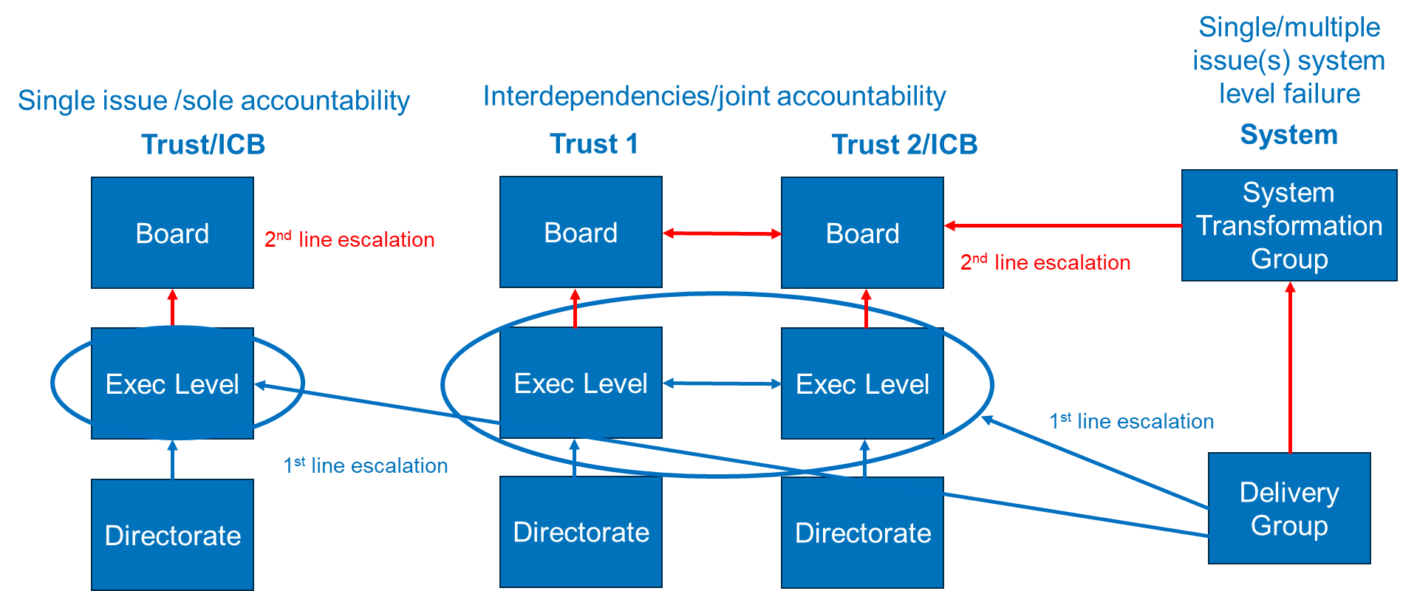

Schematic of Assurance governance:-

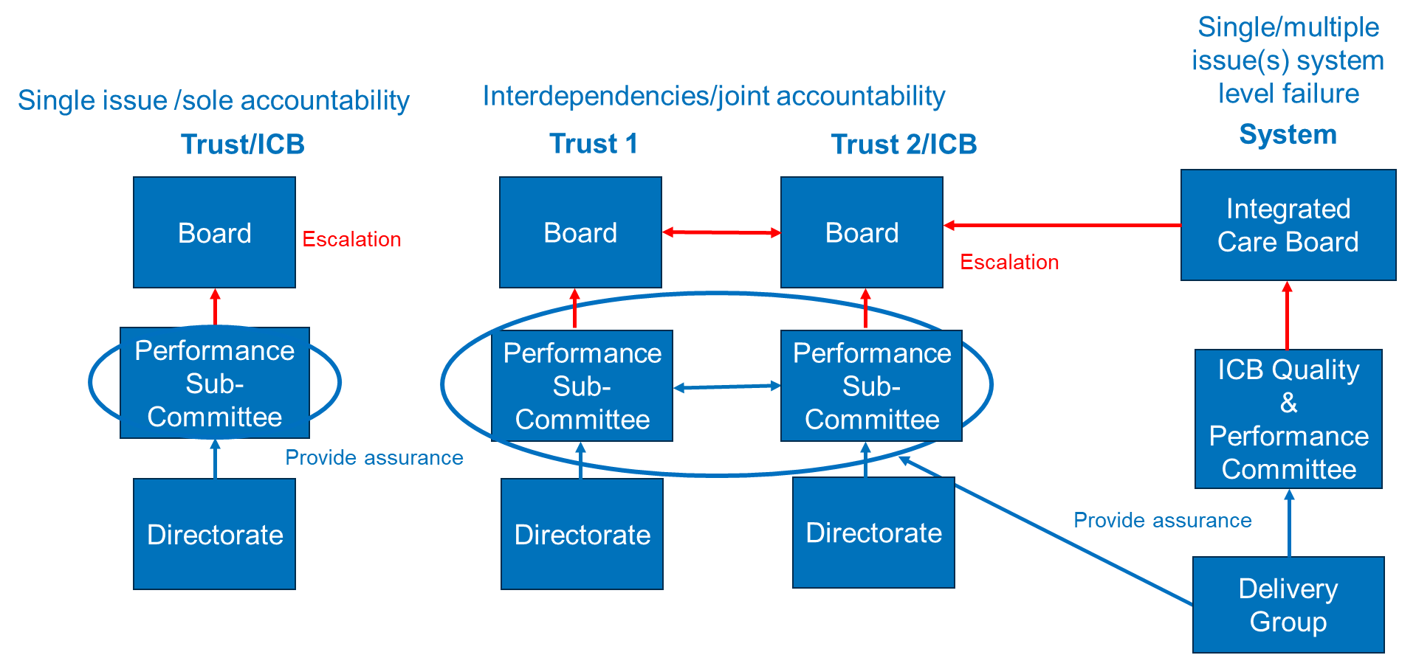

Appendix B

Duty to offer patient choice

As standard ongoing practice, processes are in place to ensure NHS STW honours its statutory obligations in ensuring patient choice, as per the National Choice Framework set out by the Department of Health and Social Care (DHSC).

While GPs and referring clinicians can offer choice by utilising the e-Referral Service (eRS) at the point of referral, in STW we have a Referral Interface Service which processes all routine and urgent referrals. This means the majority of the choice conversation with patients, and ensuring the provision of patient choice, is provided by this team. It is an embedded standard working practice for this team to offer a minimum of five possible provider options to choose from when a patient has been referred into consultant-led care.

Mapping of referral pathways, whether in their current or future state, also forms a standard part of any review, redesign and transformation of services, service change or development. This would always include the need to ensure the provision of patient choice as part of that commissioned pathway.

Even with the recent move towards developing and implementing direct referral pathways as per the GP Access Recovery Plan, and areas of innovation like the implementation of electronic eyecare referrals from optometry to secondary care, we are still ensuring pathways are in place and that the referral goes via the Referral Interface Service to ensure patients are informed, involved and empowered in their own care, options and decision making.

Although patient rights and the National Choice Framework are already well established, further work is happening currently in STW to enhance public and staff communications and awareness. The aim of this work is to raise the profile of these statutory rights, and what patients should expect, through various communications tools. These include the development of a public-facing Choice Policy Statement that will be published on the ICB and ICS website, use of posters, leaflets, and social media channels to promote the messaging, as well as providing links to the national ‘easy read’ leaflets around these patient rights.

An Integrated Impact Assessment was completed on our patient choice work and supported by the Equalities and Involvement Committee, the outputs from which informed a bolstered range of public FAQs for publishing.

There is a local communications plan in place, aligned with the national communications toolkit on patient choice which was made available in December 2023. This plan was developed to inform and raise awareness and understanding among key stakeholders including staff from provider trusts, primary care and the ICB, along with the public, Healthwatch, MPs and councillors.

Strategically over the coming year, we will be working with primary care and provider colleagues as part of all transformation and service programmes, to start working towards encouraging patients to be more actively involved and manage their own appointment choices through things like My eRS and the NHS App.

Work is underway on the development of a robust accreditation framework and process for the listing of other providers, which will broaden the range of provider options that can be made available to patients to choose from. This work will be completed in the coming months.

Finally, as per the request issued by central Government in May 2023, the ICB actively participates in the national rollout of Patient Initiated Digital Mutual Aid. Through this, and aligned with the national phased rollout programme, long waiting patients are proactively identified and validated, before being offered the opportunity of changing to an alternative provider who has a shorter waiting time than where they are currently.

The national toolkit suggested that minimal communications were required as patients will be contacted directly where they have been identified as eligible to change provider, however we continue to ensure patients are aware of their right to choose.

Appendix C

Our Neighbourhoods

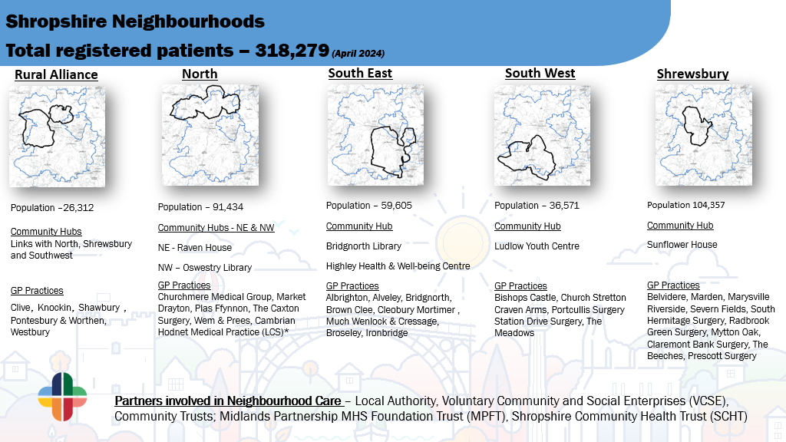

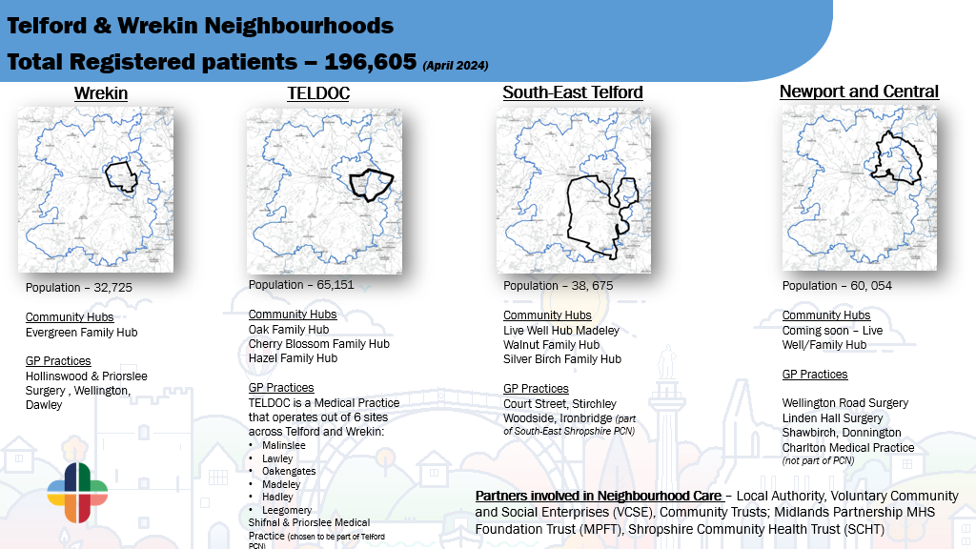

Appendix D: List of acronyms
Acronym | Meaning | Acronym | Meaning
BAF | Board Assurance Framework | MH | Mental Health
ACE | Adverse Childhood Experience | MIU | Minor Injury Units
AHP | Allied Health Professional | MOU | Memorandum of Understanding
AHSN | Academic Health Science Network | MPFT | Midlands Partnership University NHS Foundation Trust
ARC | Academic Research Council | MSK | Musculoskeletal
BAME | Black, Asian and minority ethnic | MSST | Musculoskeletal Service Shropshire and Telford
BAU | Business as Usual | MTAC | Maternity Transformation Assurance Committee
BCYP | Babies, Children or Young People | NHSE | National Health Service England
BI | Business Intelligence | NIHR | National Institute for Health and Care Research
BCF | Better Care Fund | NHSI | National Health Service Improvement
BTI | Big Ticket Items | NQB | National Quality Board
CCG | Clinical Commissioning Group | OD | Organisational Development
CDC | Community Diagnostic Centre | ODG | Operational delivery Group
CDH | Community Diagnostics Hub | ORAC | Ockenden Report Assurance Committee
CDOP | Child Death Overview Panel | PCN | Primary Care Network
CEO | Chief Executive Officer | PHM | Population Health Management
CL | Clinical Lead | PL | Programme Lead
CQC | Care Quality Commission | PMO | Project Management Office
CRN | Clinical Research Network | POD | Primary, Optometry and Dental
CVS | Council for Voluntary Service | PSIRF | Patient Safety Incident Response Framework
CYP | Children and Younge People | QIP | Quality Improvement Plan
DHCS | Department of Health and Social Care | QSC | Quality and Safety Committee
DTOC | Delayed Transfers of Care | RJAH | The Robert Jones and Agnes Hunt Orthopaedic Hospital NHS Foundation Trust
ED&I | Equality, Diversity and Inclusion | ROS | Readiness to Operate Statement
FREED | First Episode Rapid Early Intervention for Eating Disorders | ROP | Recovery Oversight Programme
G2G | Getting to Good | RSP | Recovery Support Programme
HARMs | Hospital Admissions Related to Medicines | SaTH | Shrewsbury and Telford Hospital NHS Trust
HBPOS | Health Based Place of Safety | SDP | System Development Plan
HCSW | Health Care Support Worker | SEEDS | Support and Education on Eating Disorders
HI | Health Inequality | SFH | Sherwood Forest Hospitals NHS Foundation Trust
HTP | Hospital Transformation Programme | ShIPP | Shropshire Integrated Place Partnership
IAPT | Improving Access to Psychological Therapies | SCHT | Shropshire Community Health NHS Trust
ICB | Integrated Care Board | SMI | Severe Mental Illness
ICP | Integrated Care Partnership | SOAG | SaTH Safety Oversight and Assurance Group
ICS | Integrated Care System | SOF4 | Segment 4 of the System Oversight Framework
IDC | Integrated Delivery Committee | SOP | Standard Operating Protocols
IG | Information Governance | SRO | Senior Responsible Officer
IITCSE | Independent Inquiry into Child Sexual Exploitation in Telford | SSHERPa | Staffordshire and Shropshire Health Economy Research Partnership
INT | Integrated Neighbourhood Teams | STW | Shropshire, Telford and Wrekin
JHWBB | Joint Health and Wellbeing Board | TWC | Telford and Wrekin Council
JSNA | Joint Strategic Needs Assessment | TWIPP | Telford and Wrekin Integrated Place Partnership
KLOE | Key Lines of Enquiry | UEC | Urgent and Emergency Care
LCTP | Local Care Transformation Programme | UHNM | University Hospitals of North Midlands NHS Trust
LDA | Learning Disability and Autism | UTC | Urgent Treatment Centres
LeDeR | Learning from Life and Death Reviews of people with a learning disability and autistic people | VCSE | Voluntary, Community and Social Enterprise
LMNS | Local Maternity and Neonatal System | VCSA | Voluntary and Community Assembly
LTP | NHS Long Term Plan | WMAHSN | West Midlands Academic Health Science Network
LTP | Local Transformation Plan | WMAS | West Midlands Ambulance Service
MDT | Multi-Disciplinary Team

Appendix E: How we engaged our different stakeholders
To inform our Joint Forward Plan, we launched the Shropshire, Telford and Wrekin Big Health and Wellbeing conversation programme of engagement with our communities, staff, and partners. It was essential that our engagement activity was accessible and as visible as possible, using all established methods of communication and engagement such as a range of printed materials, online and face-to-face contact through a variety of meetings and events, as well as embarking on new channels of digital engagement.
Partnerships were formed with VCSE organisations, Healthwatch and local media organisations to maximise reach and raise awareness about the activity. Activity was tailored to ensure it is appropriate for the local population and those with specific protected characteristics. New technology and social media were used to communicate and engage with citizens.
Our approach was to collaborate extensively with local people who use health and care services, their families and any carers, local political stakeholders as well as members of the public, including seldom heard groups to ensure that our residents help inform our decisions.

Listening Events
To launch the Big Health and Wellbeing conversation, we organised six listening events for the public and our stakeholders. Locations for the public events were selected based on the intelligence of our partners and stakeholders, based on current local issues and existing activity. Six locations in Shropshire, Telford and Wrekin were identified. These were:
- Telford – Sutton Hill
- Bishops Castle
- Telford Centre
- Ludlow
- Market Drayton
- Shrewsbury.
Those that attended the sessions were taken through a short presentation about the Shropshire, Telford and Wrekin ICS, the challenges that exist within the system, and how their feedback would feed into the development of the Joint Forward Plan.

Big conversation survey
An online survey was launched to support the ‘conversation,’ enabling us to capture qualitative and quantitative data. We encouraged people to complete the survey, as well as capturing important demographic data and data for future engagement and follow up.

STW citizen pledges
A large part of the ‘conversation’ emphasised the need for people to take more personal responsibility for their own health and wellbeing and promoting community resilience.
Citizens were given information about pressures that exist in the system and the small things they can do to improve things; for example, the impact of attending A&E for a non-emergency and the benefits of accessing their local pharmacy versus a GP.

We used this opportunity to promote the STW pledges. The public were asked to suggest some pledges, things they could do to improve their own wellbeing or changes to the way they currently use health and care services which could help address some of the challenges faced in the system.

Community outreach
A community engagement team conducted on-street, opportunistic engagement at prime locations within communities, such as supermarkets, GP practices and outpatient clinics. Street teams focussed on areas of high deprivation and targeted groups of people who would not normally contribute to engagement activity.

Stakeholder engagement
A series of stakeholder engagement sessions were held throughout the period, including with primary care, hospital clinicians, councillors, MPs, VCSE colleagues and Healthwatch to ensure they have an opportunity to be part of the ‘conversation’ and the design process. This also meant they had an early opportunity to view our priorities and proposals.

Stakeholders were provided with opportunities to:
- Input and share ideas about how they, or their organisations, could contribute to local delivery
- Describe what they would like to see in the health and care system over the next five years
- Identify ways we could transform, plan or commission services differently to increase access and reduce inequalities.

Establishing a people’s network
We have been recruiting a system-wide citizen network of local residents to enable us to gather public views and opinions on a wide variety of topics, allowing members of the public to get involved in shaping the future of local health and care services. The panel will form a large, representative group of local residents who are able and willing to be engaged on a wide range of local issues and offer their opinions.

Engagement with community groups
We attended several existing community groups and meetings to engage with protected characteristics and equality groups. The format depended on the demographics and needs of the group. The aim of this engagement was to gain insight into the experiences of marginalised groups in order to improve access and reduce inequality.

Our community group outreach work approach has included:
- Ethnic minority groups
- Faith groups
- Families
- Veterans
- Ex-offenders
- Carers
- Patient groups
- Older people
- LGBT communities
- Substance misusers
- Looked-after children
- Children and young people
- Farmers’ groups
- Parent groups
- Homeless/rough sleeping people
- People with long-term conditions
- Disability groups
- People experiencing domestic abuse
- People living in deprived areas
- People living in rural communities

PR and media engagement
We launched a proactive PR campaign to help us reach a large audience without the expensive cost of traditional advertising and marketing. This increased the viability of the ICS and the engagement exercise.

Digital activity
To ensure maximum reach, we needed our digital campaign to be varied and wide ranging. The digital campaign consisted of a mixture of interactive website content, social media sharing and interaction, consistent and frequent e-newsletters to staff in all partner organisations, and utilising existing channels. Photo and video content generated during the outreach activity was also shared on social media.

Wicked issues – A problem that is difficult or impossible to solve because of its complex nature

