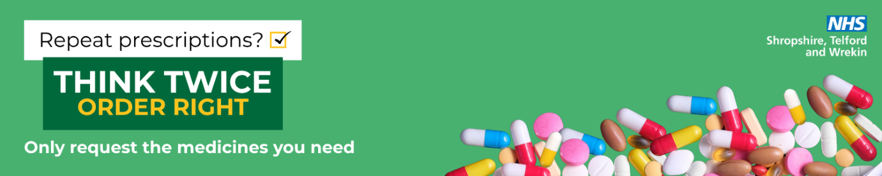

Script – Think Twice, Order Right
Hello! Just to let you know, we’re supporting a new NHS campaign called Think Twice, Order Right.
It’s all about helping reduce medicine waste and keeping medicines available for those who need them.
When you're ordering repeat prescriptions, it’s a good idea to check what you already have at home and only order what you actually need.
This simple step can really help reduce waste, protect NHS resources, and support patient safety.
If you ever have questions about your medicines or how to order, feel free to ask us or the pharmacy team – we're happy to help!
To find out more: www.ThinkTwiceOrderRight.co.uk
Optional reminder for regular patients
Just a reminder — before you order your next repeat prescription, please take a moment to check what you already have at home. Only order what you need.
This helps reduce waste and keeps medicines available for everyone.
Prompt Card
Think Twice, Order Right – Quick Reminders:
- Encourage patients to check what they already have at home before ordering repeats.
- Remind them to only order what they need right now.
- Help explain that reducing medicine waste helps protect NHS resources and ensures medicines are available for others.
- Direct patients to: www.ThinkTwiceOrderRight.co.uk

Short Script for busy times
Hi — just a quick reminder: when ordering repeats, please check what you already have at home and only order what you need. Thanks for helping reduce NHS medicines waste!

