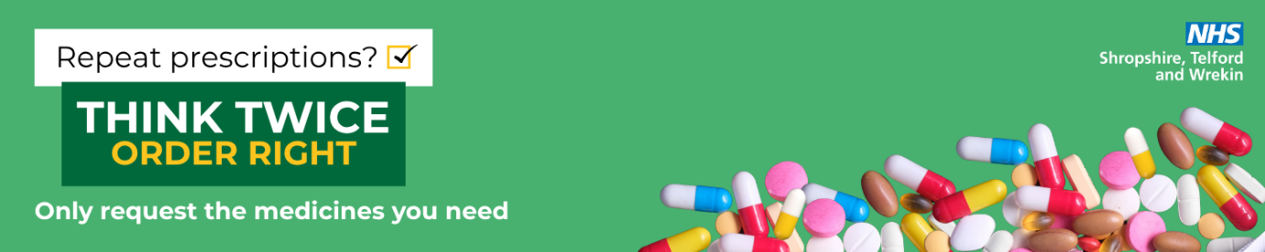

Script – Think Twice, Order Right
Hello! Just to let you know, we’re supporting a new NHS campaign called Think Twice, Order Right.
It’s all about helping reduce medicine waste and keeping medicines available for those who need them.
Before you leave today, could I please ask you to take a moment to check your prescription bag — right here in the pharmacy?
If there’s anything in your bag that you don’t actually need right now, just hand it back before you leave. That way, it can be reused safely.
If you have any questions about your medicines, or if you’re unsure about what’s in your bag, we’re here to help.
Thanks for helping reduce waste and support our NHS!
To find out more: www.ThinkTwiceOrderRight.co.uk
Optional reminder for regular patients
And just a reminder for next time: before you order your repeat prescription, please check what you already have at home, and only order what you need.

Prompt Card
Check before you leave!
Before you leave the pharmacy, please take a moment to check your prescription bag.
- If there’s anything you don’t need, hand it back — we can reuse it.
- This helps reduce waste and protect NHS resources.
- Unsure about anything? Just ask your pharmacy team — we’re happy to help!
Thank you for supporting your NHS.
Find out more: www.ThinkTwiceOrderRight.co.uk

Short Script for busy times
Hi — before you go, could you check your bag? If there’s anything you don’t need, just hand it back so we can reuse it. Thanks for helping reduce waste!

