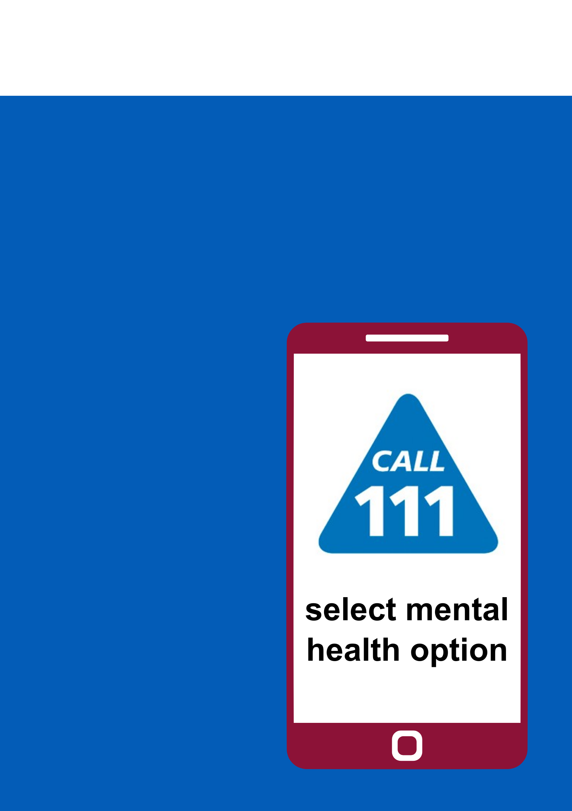

Just call 111 and select the mental health option to speak to a mental health professional in Shropshire, Telford and Wrekin.

**Need urgent support for your mental health?**