

Shropshire Telford and Wrekin Integrated Care Strategy
Contents
Foreword
Chapter 1 - Overview of Our Integrated Care System
Chapter 2 - Integrated Care Partnership purpose and vision
• Vision and objectives
• Integrated Care Strategy: Purpose
• Integrated Care Strategy Priorities
Chapter 3 - Improving outcomes in population health and health care.
Chapter 4 - Tackle inequalities in outcomes, experience and access

Chapter 5 - Support broader social and economic development
• Enablers
Chapter 6 - Enhance productivity and value for money.
• The Left Shift – Preventive approach
Chapter 7 - Performance monitoring and scrutiny
• Outcome focus – potential high-level outcomes
• Next steps
• Comms and engagement plan for next steps

Foreword
We want to make sure that everyone in Shropshire, Telford and Wrekin has a fair opportunity to have a great start in life and live happy, healthy, and fulfilled lives. The existing inequalities are simply not good enough, and many of these can only be addressed by partners working together.
Improved health and wellbeing will be achieved through better support and high-quality services, as well as by preventing people from becoming unwell and supporting them to live well in their communities. We recognise that we need to look beyond health and care services to understand the barriers and opportunities to living a healthier life and are committed to working with people and communities to address them.
Shropshire, Telford and Wrekin has a strong history of joint working across our Local Authorities, NHS Partners, the Voluntary and Community Sector and wider partners. Most recently our Health and Wellbeing Boards, Health Scrutiny, COVID-19 and Cost of Living responses demonstrate what can be achieved through collaboration. We continue to build the relationships needed to support our residents in enjoying the highest quality health and wellbeing for themselves, their families, and their communities.
This Integrated Care Strategy is built upon the priorities of each place’s Health & Wellbeing Strategies and the findings of our ‘Big Conversation’. Residents have raised concerns about difficulties in getting appointments, long waiting times, and trouble contacting services over the phone, with some areas highlighting accessing GPs. Transport and digital exclusion have also been raised as concerns. Residents told us there was a lack of awareness of how and where to get the right support for their needs. Overall, residents told us we need to work better together.
Partners within the Shropshire, Telford and Wrekin Integrated Care Partnership have heard these messages and are committed to thinking and working differently with each other and with our communities. Today, we have a unique opportunity to achieve this through joining up our services and taking a more preventative approach. That’s what this Shropshire, Telford and Wrekin Integrated Care Strategy is all about.
We look forward to working with all our communities to make Shropshire, Telford and Wrekin a place where everyone has the chance to live a long and healthy life. We know that more needs to be done to give everyone the very best start and every chance to live a long and healthy life. This includes working with partners in the wider economy to create good jobs and increase everyone’s prosperity with investment in skills, housing, culture, and infrastructure. To have the best chance of achieving this, we need to think and work differently with each other and with our communities.
A greater emphasis on prevention is crucial to improving the quality of people’s lives and the time they spend in good health. We recognise that not everyone has an equal chance of a happy, healthy long life and therefore we need to do more to tackle inequalities, including health inequalities.
As a Partnership, we are embracing our communities and community partners in our conversations, listening to what local people and our staff have to say, so that everyone in Shropshire, Telford and Wrekin is part of our shared purpose.

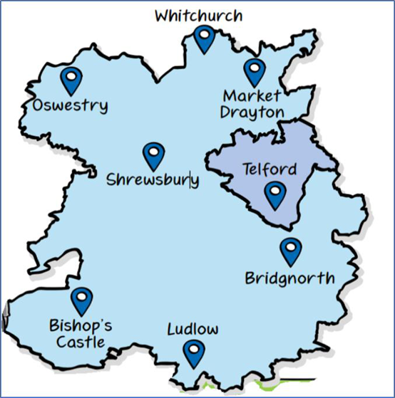
Chapter 1 - Overview of Our Integrated Care System
The Integrated Care System (ICS) brings together the health and care organisations in Shropshire, Telford and Wrekin to work together more closely. Our ICS is called Shropshire, Telford and Wrekin Integrated Care System (ICS). The ICS is responsible for planning health and care services in the local area and is made up of an Integrated Care Board (ICB) and an Integrated Care Partnership (ICP), which work in tandem to meet the needs of their population.
Shropshire, Telford and Wrekin ICS includes the following partners:
- NHS Shropshire, Telford and Wrekin Integrated Care Board (ICB)
- Shropshire Council (our Shropshire Place)
- Telford & Wrekin Council (our Telford and Wrekin Place)
- Shrewsbury and Telford Hospital NHS Trust
- Shropshire Community Health NHS Trust
- Robert Jones and Agnes Hunt Orthopaedic Hospital NHS Foundation Trust
- Midlands Partnership University NHS Foundation Trust
- West Midlands Ambulance Service NHS Foundation Trust
- Primary Care Networks (PCNs):9 PCN’s (4 in Telford and Wrekin, 5 in Shropshire)
- General Practice, Pharmacy, Optometry and Dentistry
- Healthwatch Shropshire and Healthwatch Telford &Wrekin
- Voluntary, community and social enterprise organisations across the county
We are an ambitious Integrated Care System, dedicated to making a real difference to the lives of local people.

We have previously engaged with our residents, patients, health and care staff, our local system partners, and the voluntary, community and social enterprise (VCSE) sector. Using this insight, we have developed ten pledges that will serve as the guiding principles for all our work.

Our pledges
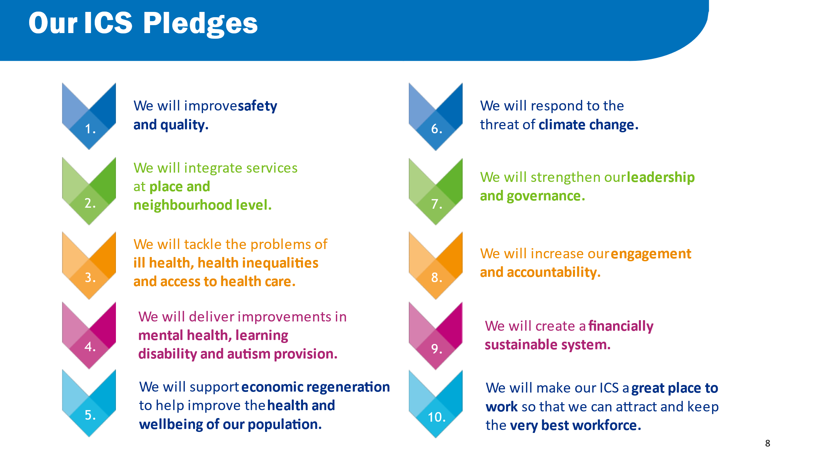
The Integrated Care Partnership (ICP) operates as a statutory committee. Made up of partners from across the local area, including VCSE organisations and independent healthcare providers, as well as representatives from the ICB board. Our ICP is responsible for bringing together our system partners to develop a plan to address the broader public health, health and social care needs of our local populations and tackle health inequalities.
Our ICP aims to make home and the community the hub of care, ensure that services are person-centred and seamless, empower patients, promote health, and prevent illness where possible.
The ICP provides a forum for NHS leaders and local authorities to come together, as equal partners, with key stakeholders from across the system and community. Together, the ICP has produced this Integrated Care Strategy to improve health and care outcomes and experiences for the populations. This strategy is underpinned by a co-produced integrated 5-year plan called the Joint Forward Plan (JFP). The JFP informs our operating model, strategic commissioning intentions and operational annual plans.

Chapter 2 - Integrated Care Partnership (ICP) purpose and vision
(Our Vision is currently draft and will be developed and committed to in 2024/25)
Integrated Care vision and objectives
We want everyone in Shropshire, Telford and Wrekin to have a great start in life and to live healthy, happy and fulfilled lives.
We will work together with our communities and partners to improve health and wellbeing by tackling health inequalities, encouraging self-care, transforming services, and putting people at the heart of all we do.
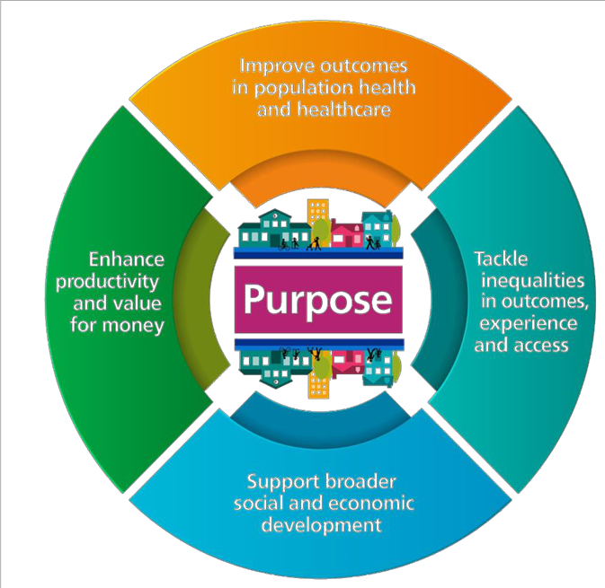
Our ambition is to provide our communities across Shropshire, Telford and Wrekin with safe, high-quality services and the best possible experience from a health and care system that is joined up and accessible to all.
By transforming how and where we work, improving access to services, and using our resources in the very best way for our communities, we will meet the needs of our population now and in the future.
We will focus on our places and our communities to create truly integrated care, including working across our boundaries and borders.
Joining up health and care is not new – a lot of work has already been done towards this and we will build on this work. This includes building on the positive joint working we saw in the system throughout the Covid-19 pandemic.

Our four strategic objectives
Our cycle of development
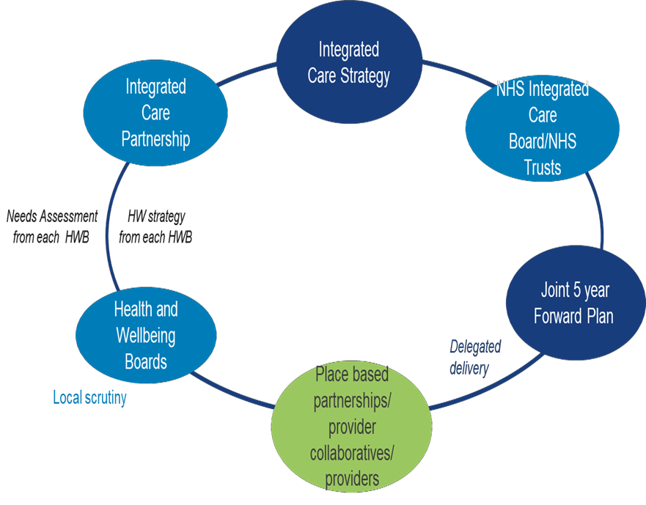
This Integrated Care Strategy development through the ICP is a key step in setting out the high-level needs assessment and long-term health and wellbeing priorities for Shropshire, Telford and Wrekin. A clear governance, planning, and delivery cycle exists to support partnership working across the system. This development cycle will be complemented by a comprehensive consultation and engagement process to ensure co-design.

Integrated Care Strategy Priorities
(from JSNA’s to inform the HWB strategies and the Joint Forward Plan)
communities
•
Children and Young people physical
SEND
supported holistically
their communities
Practice, Pharmacy, Dentists and
•
Urgent and Emergency care access
14
Health and Care Priorities
• Proactive approach to support
independence
• Person
–
centred integrated within
• Best start to end of life (life course)
and mental health and a focus on
• Mental, physical, and social needs
• People empowered to live well in
• Primary care access (General
Opticians)
•
Clinical priorities e.g MSK, respiratory, diabetes

Inequalities Priorities
• Wider determinants:
• Homelessness
• Housing
• Cost of living
• Inequity of access to preventative
health care:
• Cancer and cancer screening
• heart disease & screening
• diabetes
• Annual health checks for Severe
Mental Illness & Learning
Disabilities and Autism
• Vaccinations and immunisation
• preventative maternity care
• Deprivation and Rural Exclusion
• Digital exclusion
Population Health Priorities
• Best start in life
• Healthy weight
• Mental wellbeing & mental health
• Dementia
• Preventable conditions
–
hypertension, heart disease and
cancer
• Reducing impact of drugs, alcohol
and domestic abuse

Chapter 3 – Improve outcomes in population health and healthcare
Each Health and Wellbeing Board (HWBB) has a statutory duty to publish a Joint Strategic Needs Assessment (JSNA) to inform the development of the Health and Wellbeing Strategies.
The Telford & Wrekin Health & Wellbeing Strategy refresh proposals have been developed based on JSNA intelligence and informed by engagement, including about 3,000 residents contributing through a telephone survey and focus groups in 2022, as well as a resident survey in 2020 completed by about 5,500 residents. Further engagement and community consultation on the proposed health & wellbeing refresh priorities were undertaken in 2023.
The Shropshire Health and Wellbeing Strategy has been developed at a community level by engaging with the residents and local Town Councils using the data from the JSNA.
The ICP has consolidated the available intelligence from the HWBB strategies the system to inform the priorities for the interim Integrated Care strategy.
The JSNAs and population health intelligence, along with the interim Integrated Care Strategy, should guide system partners on areas of need, such as health and social needs, and the inequalities in our communities.
The Integrated Care Strategy has been developed with stakeholders through engagement into a five-year plan to support the commissioning and provision of services that meet the needs of the population.
The intelligence in this section shows the key themes and headlines from the JSNAs and the population health priorities for our places and our system.

Demographic and socio-economic headlines

Telford & Wrekin
Fastest population growth in the West Midlands (2011-2021 = 11.4% growth) and 2nd fastest growth nationally in 65+ years population (35.7%)
Population changing - becoming more diverse & ageing (median age now same as West Midlands at 39.6 years)
27% Telford & Wrekin residents live in 20% most deprived areas in England – circa 45,100 people (this is referred to as NHSE CORE20), significantly higher than the England average and just over a fifth (21%) of children and young people are living in poverty.
Life expectancy at birth & at age 65 for men and women is significantly worse than England average and there are significant inequalities gaps.

Shropshire
139,000 households - predicted to increase 28% by 2043.
23% of the population +65 years (18.5% England Age)
26% increase in Looked After Children (LAC) 2019/20 to 2020/21
44,969 people are 30 minutes or more by public transport to the closest GP.
An estimated 3,740 people are currently living in care home settings in Shropshire, with this figure likely to increase in the future.
The relatively affluent county masks pockets of deprivation, growing food poverty, health inequalities and rural isolation, with the county overall having a low earning rate.

Shropshire, Telford and Wrekin (STW) Area
Total Population in 2020 506, 737 (Shropshire 325,415 Telford 181,322). Male 49.5 % Female 50.5%. Across a total geographical area 3,487 square kilometres.
Average Annual Births 4,600 and Deaths 4,920.
Shropshire is predominately 66% rural (101 people/sq km) and Telford and Wrekin is predominantly urban (620 people/sq km).
By 2043 there will be an estimated 589,330 people in STW - 30% will be over 65 (currently 21%).
There are over 155 care homes in the area with more than 4,320 beds.
Across STW there are 88,000 people with a long-term limiting illness (18%).

Population health priorities
Using evidence from our Joint Strategic Needs Assessments (JSNA) and our two Health & Wellbeing Strategies, the following shared priorities emerged:
- Give every child the best start in life (including healthy pregnancy).
- Encourage healthier lifestyles with a priority focus on unhealthy weight.
- Improve people’s mental wellbeing and mental health.
- Reduce the impact of drugs, alcohol, and domestic abuse on our communities.
Key headlines from Shropshire, Telford and Wrekin’s JSNA’s
At a national level, the trend in ever increasing life expectancy noted throughout the 20th century, aided by improvements in public health approaches as well as advanced in treatment and medicine, gradually slowed, stalled and in some places declined over course of 21st century. While there were improvements seen in 2019, these were mostly undone by the COVID-19 pandemic, which caused life expectancy to fall sharply in 2020.This pattern is also evident across Shropshire, and Telford & Wrekin, with male life expectancy in both areas, and female life expectancy in Telford & Wrekin, appearing to peak in 2014. The latest 3-year figures (2020-2022) indicate that both females (82.1 years) and males (78.0 years) can expect to live a significantly shorter life than the national averages (females 82.8 years, males 78.9 years), and around two years shorter than their neighbours in Shropshire (females 83.9 years, male 79.8 years), who themselves can expect to live a similar length of life to the average person in England.
Healthy life expectancy provides insight into the burden of ill health within an area and shows the number of years a person can be expected to live in good health without disability or long-term illness. The latest figures (2018-20), again highlight the inequalities between two areas and between the different genders, with females in Telford & Wrekin expected to live just 60.3 years in good health, almost seven years fewer than their Shropshire neighbours (67.1 years) and three years fewer than the national average (63.9 years). For males, again, it is Telford & Wrekin that finds itself an outlier, with men expected to live just 57.6 years in good health, five years fewer than men from Shropshire (62.8 years) and the national average (63.1 years).

- The gap in life expectancy is driven by mortality from cardiovascular disease, followed by cancers, with Telford & Wrekin found to have significantly higher rates of premature (under-75) mortality from cardiovascular diseases and cancers considered preventable than the national average.
- Excess weight is the most significant lifestyle risk factor in the population, with over two thirds of adults living within both areas estimated to be overweight. Telford & Wrekin found to have significantly high levels of childhood excess weight and obesity.
- The level of alcohol related-hospital admissions in both areas significantly above the national average.
- Adult smoking rates in routine and manual groups in both Shropshire and Telford & Wrekin are a key driver of inequalities.
- Smoking in pregnancy is a particular issue for Shropshire and Telford & Wrekin, with levels of maternal smoking at birth significantly worse than
England overall average. The highest levels are seen amongst younger mothers and those living in deprived communities.
- Mental Health is a key cause of poor health amongst our communities, with levels of poor mental health in children and younger people increasing.
- The physical health of adults with Serious Mental Illness is also a cause for concern, with both Shropshire and Telford & Wrekin
having high rates of excess mortality in this group compared to the national average.

Wider determinants of health

HI 5 key clinical areas: Maternity
Long Term Plan NHS prevention priority: healthy weight

HI 5 key clinical areas: Maternity
Long Term Plan NHS prevention priority: healthy weight

Overarching Health Inequalities Outcomes

HI 5 key clinical areas: Early cancer diagnosis

HI 5 key clinical areas: hypertension case finding
LTP accelerate diabetes and CVD prevention programmes
Long Term Plan NHS prevention priority: healthy weight

Long Term Plan NHS prevention priority: NHS Tobacco Dependency programme

Long Term Plan NHS prevention priority: Alcohol Care Team

HI 5 key clinical areas: Chronic respiratory disease

HI 5 key clinical areas: Severe Mental Illness

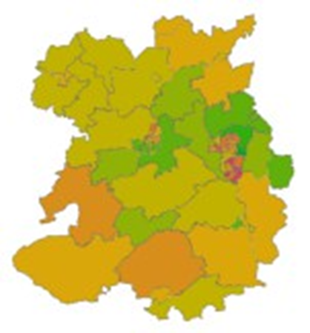
Deprivation, ethnicity and access to services

Deprivation - IMD 2019 Decile (IMD- Index of Multiple Deprivation)
Deprivation:
- Shropshire is a relatively affluent county which masks pockets of high deprivation, growing food poverty, and rural isolation.
- More than 1 in 4 people in Telford and Wrekin live in the 20% most deprived areas nationally and some communities within the most deprived in the country.

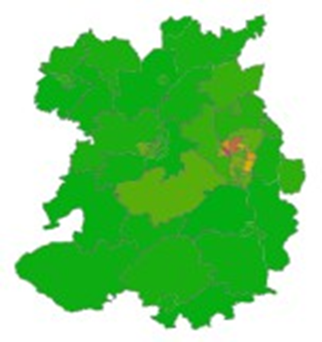

Ethnicity - % BAME 2011 Census (BAME- Black, Asian and Minority Ethnic)
Ethnicity:
- In Shropshire, in 2011 there were approximately 14,000 people (5.6%) from BAME and other minority ethnic groups. Data suggests this has increased particularly in Eastern European populations.
- In Telford and Wrekin 10.5 % of the population from BAME and other minority ethnic groups, however more recent estimates, including the school census and midyear estimates suggest the percentage is closer to 17%.

Access- IMD 2019 Decile
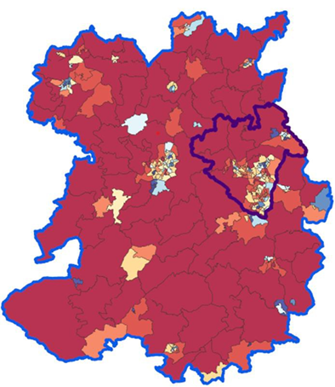
Access:
- The access domain highlights significant areas of Shropshire, Telford and Wrekin that have the lowest level of access to key services including GP services, post office and education.

Cost of Living:
- The Cost of Living Vulnerability Index is 1,203 for Shropshire and 1,348 for Telford and Wrekin – both in the highest quartile of local authorities nationally.

What our residents have told us
As an ICS we understand the importance of developing our health and care services based on the views of our local population, alongside the evidence on population health.
Our residents have said they wanted ‘A person-centred approach to our care,’ and this is central to all the work we are doing.
People are at the heart of everything we do and by delivering joined up services in both the acute and community settings we can give everyone the best start in life, creating healthier communities and helping people to age well.
The top 10 statements from all respondents for the Shropshire, Telford & Wrekin questionnaire which described the measures were the most important to our residents:
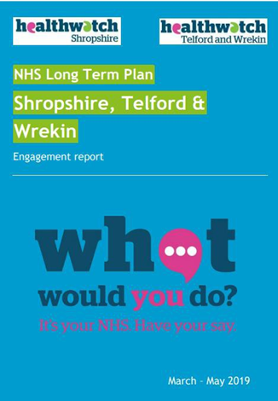
1. “Professionals that listen to me when I speak to them about my concerns.”
2. “Access to the help and treatment I need when I want it”.
3. “I want to be able to stay in my own home for as long as is it is safe to do so”.
4. “I want my family and me to feel supported at the end of life”.
5. “Choosing the right treatment is a joint decision between me and the relevant health and care professional”.
6. “I want there to be convenient ways for me to travel to health and care services when I need to”.
7. “Easy access to the information I need to help me make decisions about my health and care”.
8. “Having the knowledge to help me to do what I can to prevent ill health”.
9. “Communications are timely”.
10. “I have to consider my options and make choices that are right for me”.
Those who had long term conditions told us to focus on:
  - Getting help and communications
  - Impact of having more than one conditions
  - Waiting Times
  - Access to ongoing care and support
  - Transport and Travel
When asked what our residents would do to, to be supported to live a healthier life? What can services do to provide you with better care and make it easier for you to take control of your health and wellbeing?
People told us that several things are important and should be priorities:
- Access and timely intervention e.g., local services that people know about, that are available when people need them (including 24 hour) and that they can get to easily, including services that can help people to live healthy lives such as affordable gyms and social groups.
- Tackling isolation and loneliness e.g., Making sure socially isolated people know what support is available to them and how to access it, including homeless people and people who do not have a named GP or relationship with services.
- Consistent and reliable information and education for all ages e.g., reducing confusion by giving clear and consistent information that can be trusted, including information about services such as available appointments, and giving people a single point of contact to improve consistency, including appropriate signposting and offering information and advice (e.g., advice about medication).
- Services working together, including information sharing and a flexible approach to working e.g., ensuring staff know what other services are out there and talking to each other, improved referral processes, social services and the NHS working together.
- Building strong communities and investment in local people e.g., supporting and promoting local groups to enable and encourage people to get together, e.g., walking groups, dementia groups.
What our partners have told us
Together with the views of our partners, clinicians, staff and service users we can identify what is working well, what can be improved and what is important to them. This will enable us to plan, design and deliver health and social care services that are right for our local population of Shropshire, Telford & Wrekin.
Our clinical priorities identified through the HWBB consultations and engagement:
- Cancer
- Cardiac including hypertension.
- Respiratory
- Urgent and Emergency Care
- Diabetes
- Orthopaedics
- Mental Health

Chapter 4 - Tackling inequalities in outcomes, experience and access
Our approach
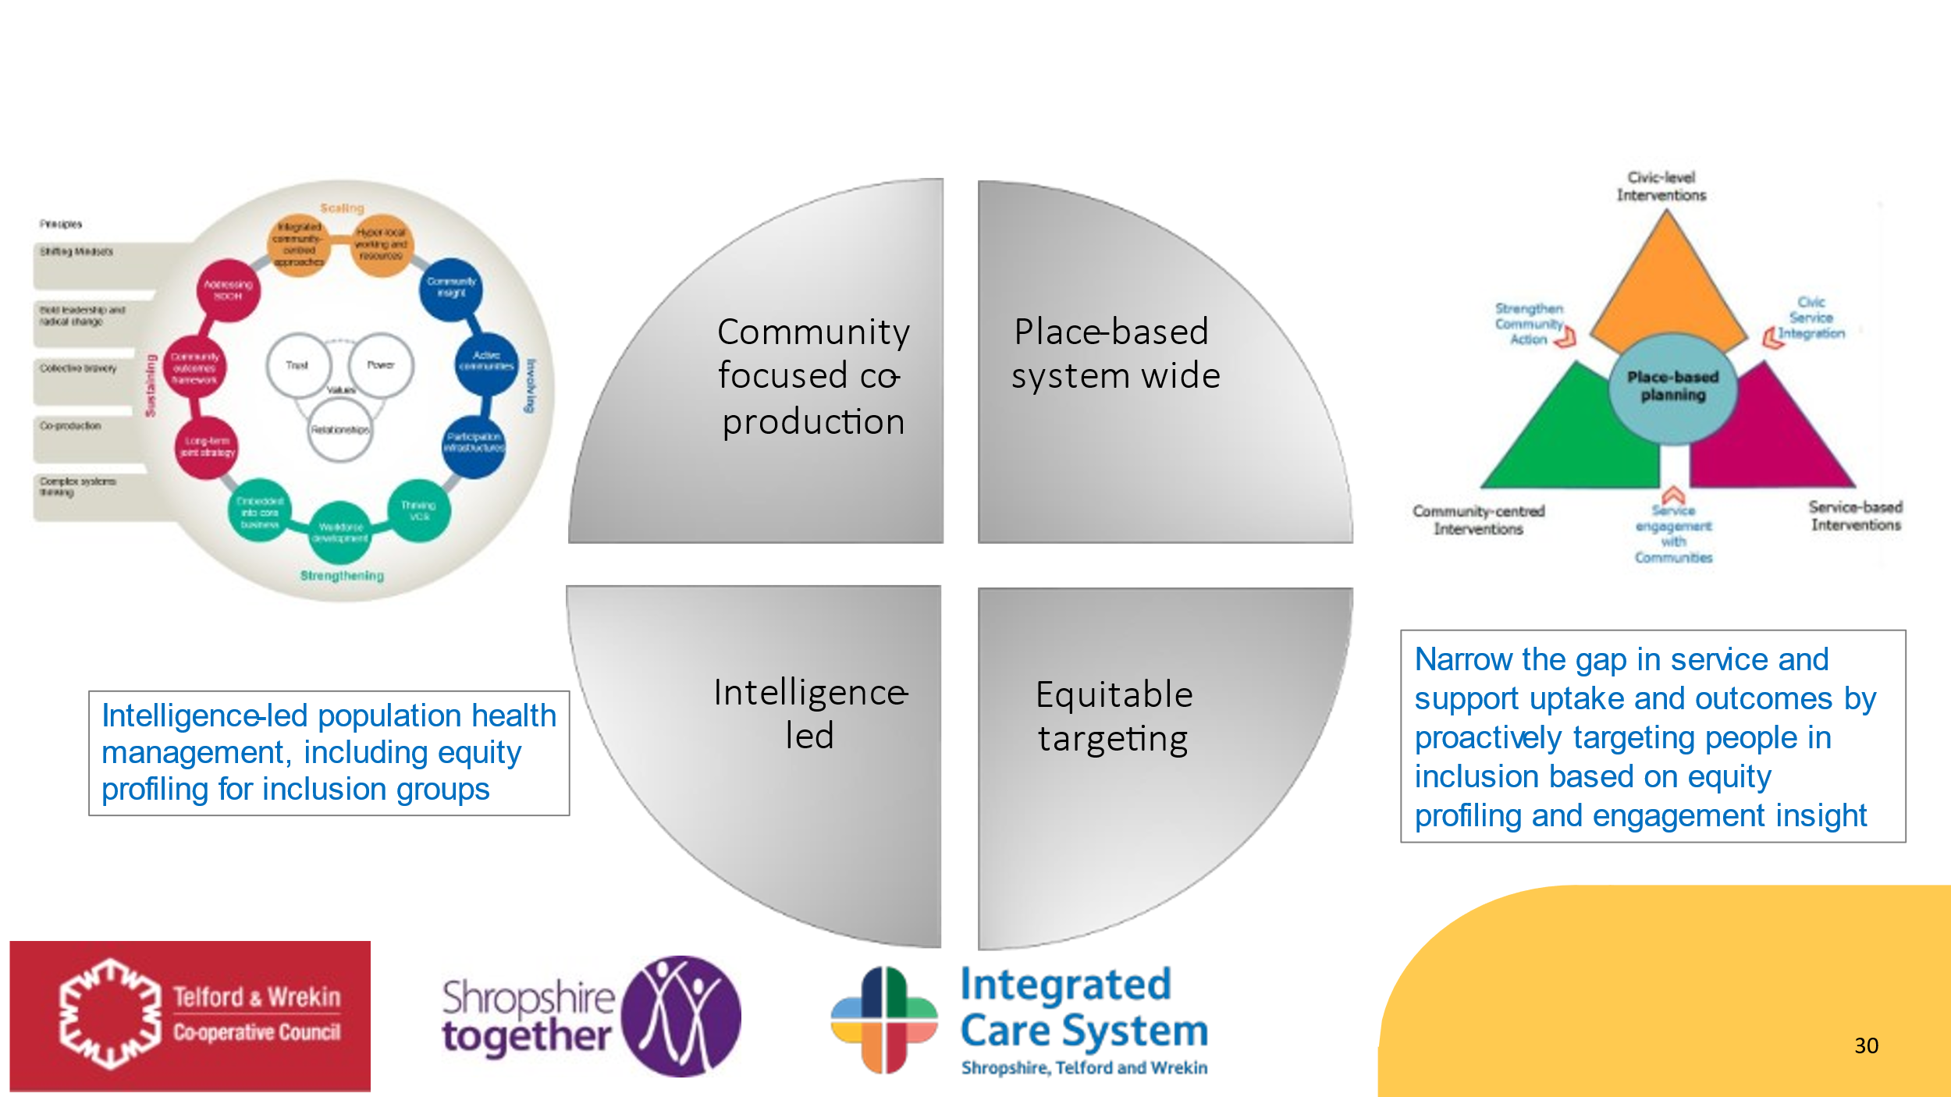

Inequalities and health inequalities
Inequalities in the wider determinants of health (such as housing, education, cost of living and access to green space) translate into health inequalities.
Health inequalities are unfair, systematic, and avoidable differences in health. Therefore, reducing health inequalities requires action to improve outcomes across all the factors that influence our health.
Approximately 10% of our health is impacted by the healthcare receive.

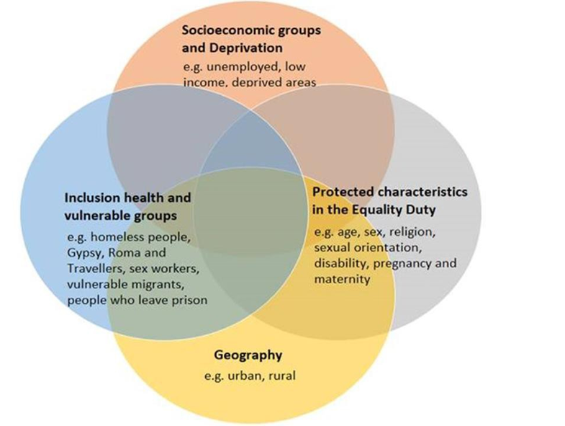
Inclusion groups
Clear focus where outcomes are poorest for people and families who are:
- from black and minority ethnic groups
      - living in deprived communities, including rurally deprived
- affected by alcohol and drugs, including prescribed and OTC.
- victims and survivors of domestic abuse
- experiencing poor emotional and mental health
- living with physical disabilities, learning disabilities and autism
- living with sensory impairment
- within Equality Act protected characteristic groups
- at risk of exploitation
- LGBTQ+
- service personnel and veterans
- looked after children and care leavers.
- asylum seekers and refugees

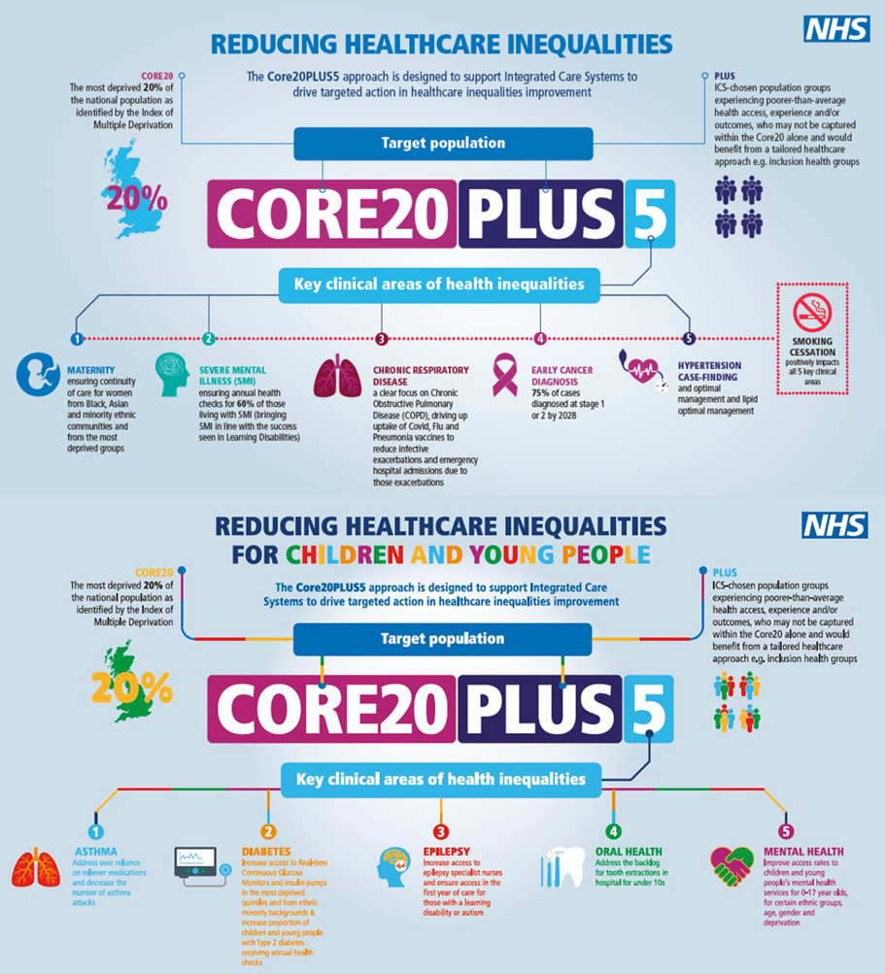
Overview of tackling in equalities
- Wider determinants of health, cost of living crisis, heat and fuel poverty, housing, employment, education and rurality.
- Inclusive, connected, healthy and sustainable communities.
- Healthy behaviours and lifestyles, with a focus on strengthening prevention.
- A person-centred approach that addresses holistic needs.
- Best start in life for EVERY child.

Health inequalities are widening, our partnership needs to focus on the root causes of health inequalities, the wider determinants, and address inequity of access to services for those most in need. We need to understand the multiple barriers people can face in accessing our services. We therefore commit to accelerate, targeted collaborative local action to reduce health inequalities, by the following priorities that tackle the wider determinants of health:
- Homelessness, healthy homes, poverty and cost of living, as well as positive work and employment.
- Ensuring every child has the best start in life by influencing a range of outcomes throughout the child’s life and into adulthood.
- Improving equity of access to healthcare for those living in our most deprived areas, including rurally excluded as well as other forms of exclusion (for example Core20 plus 5 programme and a focus on healthcare preventable diseases). For adults, this includes hypertension, early cancer diagnosis, health checks for SMI and LDA, vaccinations, continuity of carer in maternity. For children, this includes epilepsy, asthma, and diabetes.
Health and wellbeing board priorities
Telford and Wrekin
 | START WELL |  | LIVE WELL | AGE WELL
Population health & prevention | Excess weight & obesity
Population health & prevention | Mental & emotional health  INTEGRATION PRIORITIES
Population health & prevention | Impact of alcohol & other drugs
Population health & prevention | Preventable diseases (e.g CVD, diabetes, cancer, respiratory)
Inequalities | Marmot Borough
Inequalities | Cost of living crisis
Inequalities | Barriers to access (transport & digital)
Inequalities | Domestic abuse, alcohol, drugs & dual diagnosis
Inequalities | Healthcare inequalities (NHS restoration/CORE20PLUS5)
Inequalities | Homelessness, affordable housing & specialist accommodation
Health & care | - Healthy & safe pregnancy  - Parents/carers empowered to care for & nurture their children |  | - Community Mental Health Services Transformation | - Proactive prevention to maximise independence  - Control, choice & flexibility in care & support
Health & care | Strong integrated model of community-centred care (e.g local care programme)
Health & care | Integrated primary care in the heart of our communities
Enablers | Population  health management | Workforce |  |  | Sustainability  of resources

Shropshire
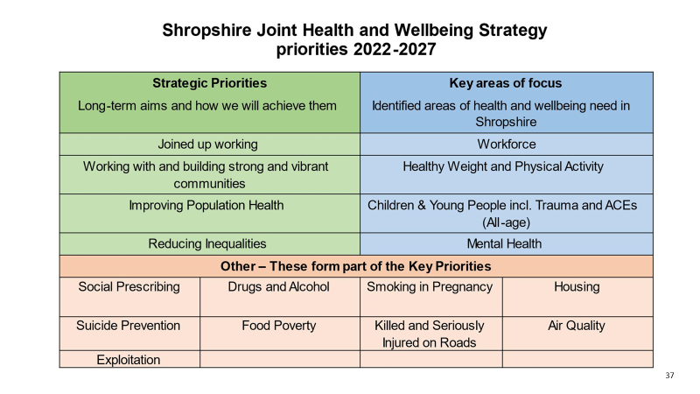

Inequality plan
Shropshire Inequality Plan
Wider Determinants | Healthy Lifestyles | Healthy Places | Integrated Health and Care
Marmot; (i) Create fair employment (ii) Ensure healthy living standard | Marmot; (iii) CYP and adults – maximise capability and control  (iva) Strengthen ill-health prevention (lifestyles) | Marmot; (i)v Create healthy and sustainable places and communities | Marmot; (vi) Give every child the best start in life  (ivb) Strengthen ill-health prevention (transformation/disease programmes)
Inequalities Work Programmes
Embed health in all policies | Smoking/tobacco dependency | Air pollution | Restore NHS services inclusively
Housing – affordable/specialist/supported | Healthy weight | Planning | Rurality
Economy and skills | Physical activity | Culture and leisure | Mitigate digital exclusion
Workforce |  | Licensing | Datasets complete
Education incl. SEND |  | Food Insecurity | Strengthen leadership and accountability
Early years |  |  | Population health management
Post 16 |  |  | Personalisation/personalised care
SEND |  |  | COVID and flu vaccination
LD&A/SMI |  |  | Annual health checks for people with:
Transports |  |  | Continuity of carer (Maternity)
 |  |  | Chronic respiratory disease
Social Inclusion Groups | Social Inclusion Groups (Continued) | PCN health inequality plans | Hypertension case-finding
Domestic abuse | Drug and alcohol misuse |  | Diabetes
Exploitation | Looked after children |  | Children and Young People
Homelessness | Ethnic minority groups |  | Trauma informed workforce
Learning disability | Prisoners and their families |  | Healthy Start
Autism |  |  | Oral health
Gypsy and traveller families |  |  | Best Start in Life
Asylum seekers/refugees |  |  | Children/families in need
Unpaid carers |  |  | Complex need
Physical disabilities |  |  | Mental Health (MH transformation plan)
LGBTQ+ |  |  | Suicide prevention
Services personnel and (families and veterans) |  |  | Social prescribing
 |  |  | Integrated Impact Assessment (IIA)

Person Centred approach
Person-centred care shifts away from professionals deciding what is best for a patient or service users, and places the person at the centre, as an expert of their own experience and lives. The person, and their family where appropriate, becomes an equal partner in the planning of their care and support, ensuring it meets their needs, goals, and outcomes.

With an emphasis on “doing with” rather than “doing to”, person-centred care runs through both individual and group settings, allowing users of services to be active not only in their own care but also in the design and delivery of services. This approach can improve both the experience and quality of care.

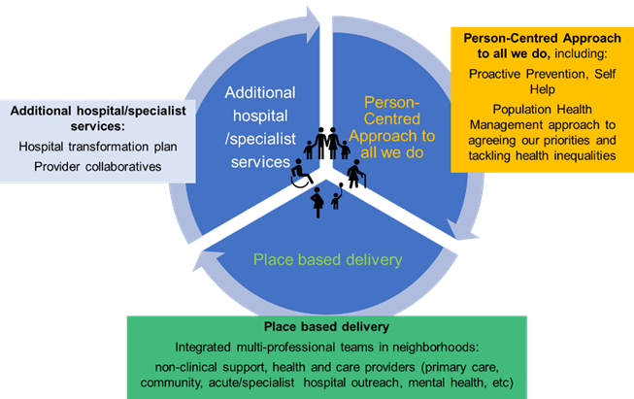
Key aspects of person-centred care include:

- Valuing people’s preferences and placing them at the centre of their care, considering people’s preferences, and chosen needs.
- Ensuring people are physically comfortable and safe.
- Providing emotional support involving family and friends.
- Ensuring access to appropriate care as needed, when and where they need it.
- Providing accessible information to empower individual to make informed decisions about their care and support.

Person-centred care also acknowledges the significant and proven link between non-clinical community support and improvement in health and wellbeing.

Chapter 5 – Support broader social and economic development
The Joint Forward Plan (JFP) integrates broader system collaboration. It outlines three key areas that system strategies must align with need to link to and show how they will under pin the priorities within the integrated strategy. The evolution of the ‘Places’ and provider collaboratives will have an impact on how services are delivered in the future, with enabling strategies clearly demonstrating how they will facilitate the system priorities. The JFP also illustrates how the system’s operating model will achieve the outcomes and impacts of the strategic commissioning intentions.

Key components of the JFP include:
  - Local planning and regeneration
  - Climate and green planning
  - Hospital Transformation Programme
  - Local Care Programme included integrated approach to neighbourhood teams

Enabling strategies encompass:
- Workforce:
  - Our local people plan outlines and supports our system response.
  - Initiatives to support and nurture our people.
  - Fostering a sense of belonging in STW.
  - Implementing new care delivery methods.
  - Futures workforce growth strategies, with a focus on Nursing and Health Care Support Workers (HCSW).
- Digital:
  - Approval of a comprehensive digital strategy for the system.
  - Implementation of a Shared Care Record system.
  - Integration of advanced care delivery systems.
  - Remote monitoring capabilities.
  - Utilization of Artificial Intelligence to enhance care delivery.

- Communications and Engagement:
  - Approval of a Communication and Engagement plan.
  - The STW JFP serves as the operational framework for delivering the ICP’s Strategy and its priorities, defining partnership narrative, approaches, methodologies, and key questions.
  - The Equalities Involvement Committee will guide and advise on ongoing dialogue and development.
  - Engagement with citizens will be enhanced through collaboration with Healthwatch and NHS/LA enabling workstreams.
- Population Health Management:
  - Development of a Population Health Management (PHM) Strategy to ensure accurate data, insights, and evidence to support system decision.
  - Establishment of an analytical ‘engine room’ to drive insighted and capacity building.
  - Grow analytical skills and capacity.
  - Implementation of a system-wide work programme grounded in the continuous development of JSNAs as foundation.
This structured approach ensures alignment across system-wide initiatives, fostering effective collaboration and strategic implementation of priorities to benefit our communities in Shropshire, Telford and Wrekin.
Provider Collaboratives
Provider Collaboratives will play an important role in enacting strategic priorities and delivering objectives commissioned for the healthcare system. These collaborations will build on a strong local commitment to partnership working and will develop to support specific areas of delivery where integration will produce better outcomes for the population. In particular collaborative delivery mechanisms will support providers of care to Add value to the ICS by:
- developing and delivering collaborative approaches to specific challenges within providers’ gift to resolve
- developing partnership relationships, strengthening communication between providers, sharing approaches to challenges and opportunities
- addressing efficiency, productivity and sustainability through collaborative working, integration or the consolidation of service delivery or corporate functions
- reducing inequalities of access and unwarranted variation, where provider collaboration can best achieve this
- adopting some commissioning responsibilities within the ICS where this will align better with operational delivery and transformation, improve decision making and accelerate change

The Provider Collaborative will act as a key conduit for providers to work together as a single unit under which a range of “collaborations” will be developed to deliver outcomes commissioned by the ICB. These collaborations may form between internal STW ICS partners or across ICS borders where this brings benefits to our population.

Voluntary and Community Sector involvement:

Chapter 6 – Enhance Productivity and Value for Money
Our Integrated Care Partnership (ICP) will explore whether needs can be better met through arrangements such as the pooling of budgets, under Section 75 of the NHS Act 2006. Section 75 is a crucial for enabling integration and will play a central role in delivering our Integrated Care Strategy.
The term “left shift” is used to describe a strategic direction that promotes delivering more care in lower-cost, out-of-hospital settings, ideally at home, while emphasizing prevention. The underlying premise is that acute care tends to be more expensive and may become the default option when preventive services aren’t optimal in either capacity, capability, or delivery.
According to a recent point prevalence audit, nearly 20% of patients in acute care on the audit day could have been treated appropriately in “left shift” settings such as community hospitals, care homes, or in their own homes with additional primary care and social care support. However, this finding requires further analysis and integration into the Joint Forward Plan (JFP) to ensure that appropriate integrated primary and community services are being developed to support the ‘left shift’.
‘Left shift’ also encompasses prevention and early support services that operate below primary, community and social care. However, transitioning to a “left shift” approach will not occur automatically; it requires a conscious effort by the system to embrace change and recognise that the costs and benefits of this shift will not vary across different parts of the system.
In summary, “Left shift” aims to:
- Close the Care and Quality Gap: By narrowing the gap between the highest and lowest standards of care and raising the overall quality standards for everyone.
- Close the Health Gap: Despite longer life expectancy, the majority of health issues premature deaths in our community stem from preventable diseases such as dementia, diabetes, certain cancers, and respiratory illnesses.
This strategic shift towards "left shift" is essential for improving healthcare efficiency, enhancing patient outcomes, and promoting healthier lives across our community.

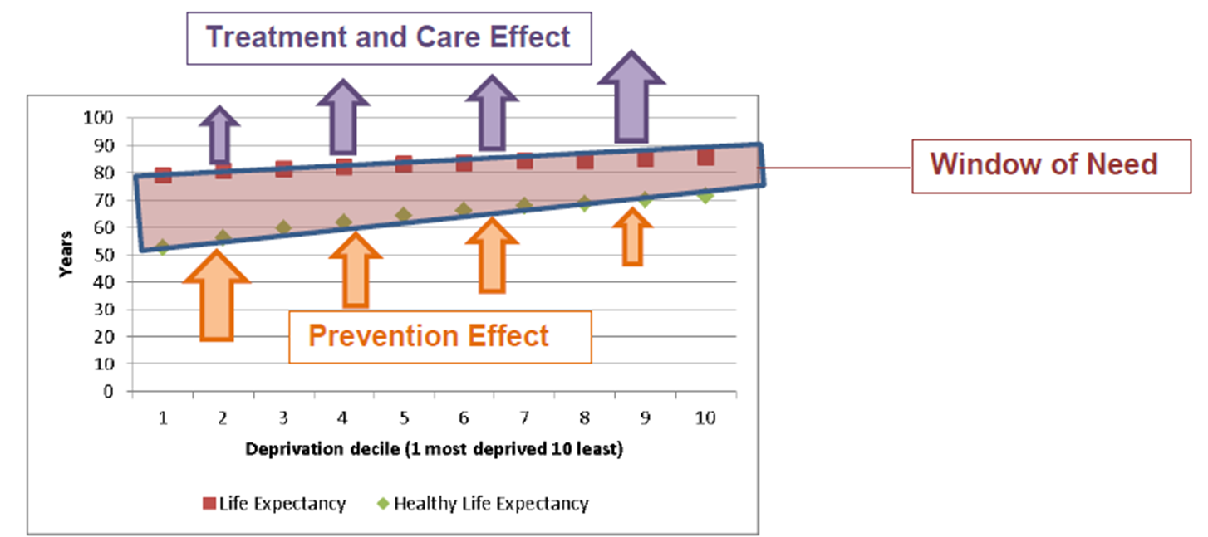
Focusing on Prevention/early intervention:
- Reduces/preventing demand
- Delays health and care service need
- Delivers better Outcomes by extending Healthy Life Expectancy
- Reduces inequalities

Chapter 7 – Performance Monitoring and Scrutiny
High level outcomes for the system are broadly agreed upon, though they may evolve further consultation and co-production, and will be integrated into our operational and Joint Forward Plan (JFP). The Integrated Care Strategy will continue to be developed collaboratively with residents, partners, and stakeholders on an ongoing basis. This iterative process will support and inform the strategic commissioning intentions and priorities.
The Joint Forward plan will be refreshed annually, with the first year guiding the operational planning process and its fifth year developed in collaboration with the Strategy and Development Directorate, Health and Wellbeing boards, and the Integrated Care Partnership (ICP). Oversight of plan delivery will be the responsibility of the Integrated Care Board, supported by assurance from the Places and Provider Collaboratives as they evolve within the system operating model.
Additionally, scrutiny of the high-level strategy and the JFP will also be overseen by the Joint Health Overview and Scrutiny Committee to ensure alignment and effectiveness.

High level outcomes
