Communication Toolkit 2025/2026

Think Vaccination this Winter: Flu and COVID-19
The ‘Think Vaccination’ campaign for Shropshire, Telford and Wrekin encourages all eligible groups to get their recommended vaccinations.
This Communications Toolkit is available for all communication leads across our health and care partnership to use adapt and encourage uptake of the flu and COVID-19 vaccination, in the recommended cohorts.
This toolkit covers all eligible vaccination groups including:
- people aged 65 years and over
- those aged 6 months to under 65 years in clinical risk groups (as defined by the Green Book, chapter 19 (Influenza))
- carers in receipt of carer’s allowance, or those who are the main carer of an elderly or disabled person
- close contacts of immunocompromised individuals
- pregnant women
- children aged 2 to 3 years (on 31 August 2025), school aged children (from Reception to Year 11) and children in clinical risk groups aged from 6 months to less than 18 years
And cohorts for COVID-19:
- those aged 75 years and over
- 18 years to 74 years in clinical risk groups (as defined by the Green Book, Influenza Chapter 19)

Download our campaign assets
All campaign assets for flu and COVID-19 vaccinations are now available to download on NHS Shropshire, Telford and Wrekin campaign get involved page: Think Vaccination Campaign Toolkits - NHS Shropshire, Telford and Wrekin
Once again, we are asking colleagues and partners across the region to join us and help to spread the word – Think Vaccination for the best protection against flu and COVID-19 this winter.
Not only that but by working together we know that our messages are stronger and can reach many more of our communities – which means more people get vaccinated and are then protected against flu and COVID-19 which can cause serious illness

So, how you can help?
Information and content in the campaign toolkit page can be used on websites, social media, or other communication channels. More content will be shared as we roll out the campaign. If there's something missing from the toolkit, or you would like something specific for your own organisation or channel - or simply have an idea on how we could better reach people or share our messages – then please get in touch.
Who are we targeting?
Our Think Vaccination campaign aims to reach out to all eligible groups, but we are specifically focusing on areas and groups of people where data has shown uptake has been lower in the past including:
- 2–3-year-olds (flu)
- Pregnant women (flu)
- People at high clinical risk (flu and COVID-19)
Your support in raising awareness with all eligible cohorts about the importance of getting the flu and COVID-19 vaccines this year is very much appreciated.
For further help or advice on using the toolkit or if you need support to tailor assets, please contact either: stw.communications@nhs.net

Who is recommended to have the flu and COVID-19 vaccines this winter?
Flu - In line with advice from the Joint Committee on Vaccination and Immunisation, those advised to have a flu vaccine this year include: | COVID-19 - In line with advice from the Joint Committee on Vaccination and Immunisation, those advised to have a COVID-19 vaccine this year include:
From 1 September – 31 March  - pregnant women  - all children aged 2 or 3 years on 31 August 2025  - primary school aged children (from Reception to Year 6)  - secondary school aged children (from Year 7 to Year 11)  From 1 October  - all children in clinical risk groups aged from 6 months to less than 18 years  - people aged 65 years and over  - those aged 6 months to under 65 years in clinical risk groups (as defined by the Green Book, chapter 19 (Influenza))  - people in long-stay residential care homes  - carers in receipt of carer’s allowance, or those who  are the main carer of an elderly or disabled person  - close contacts of immunocompromised individuals  - frontline health and social care workers  - people living with a learning disability | From 1 October – 31 January  - people aged 75 years and over  - people aged 18 years to 74 years in clinical risk groups (as defined by the Green Book, Influenza Chapter 19)  - people in long-stay residential care homes

Key messages COVID-19 (general)

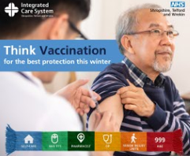
• COVID-19 is still with us and is still making people very ill.
• Those at increased risk from COVID-19, due to a health condition or medical treatment, are eligible for a seasonal vaccination for extra protection this winter, when viruses spread much more easily and can cause greater harm.
• This includes people who have a lung or heart condition, kidney or liver disease, problems with the brain or nerves, a learning disability, diabetes or a severe mental illness. It also includes people with weakened immune systems.
• If you’re not sure if you’re at increased risk, you can find out more at https://www.nhs.uk/vaccinations/covid-19-vaccine/
• If you are eligible, it is important to top up your protection even if you have had earlier vaccinations or have had the virus, as your immunity from these fades over time.
• It can take 14 days for the vaccination to take full effect, so everyone due a further dose is encouraged to get it as early as possible for maximum protection.
• COVID-19 vaccines and the flu vaccine can be co-administered. The NHS is making it easier to receive both of these seasonal vaccinations at the same time. However, if getting both vaccines together is not possible, you should get each vaccination as soon as you can for better protection ahead of winter, rather than waiting.
• You can have your seasonal COVID-19 vaccine if it's been at least three months since you had your previous dose.
• You can get your COVID-19 vaccine at any participating local pharmacy, by booking an appointment at your GP practice, online on the NHS website, using the NHS App or by calling 119.

Key messages flu (general)
• Flu can be very dangerous, even life threatening for some, particularly for people with certain health conditions. The flu vaccine is safe and effective, and it’s recommended every year to help protect people at risk of getting seriously ill from flu.
• If you’re eligible for a free vaccine, it’s important to get it every autumn because the viruses that cause flu change each year. This means flu (and the vaccine) this year may be different from last year.
• It takes 2-3 weeks for the vaccine to provide immunity and so early vaccination, when the vaccine is offered to you, is essential.
• The impact on health and social care services was significant and, through higher levels of vaccination of staff and patients/clients, more of the impact could have been avoided.
• You can get your flu vaccine at any participating local pharmacy, by booking an appointment at your GP practice, online on the NHS website, using the NHS App or by calling 119.

Website/newsletter copy

Long copy

Think Vaccination for the best protection against flu and COVID-19 this winter
Flu and COVID-19 are still serious illnesses. For some people, flu and COVID-19 can be unpleasant, but for others, especially older adults, pregnant women, and those with certain health conditions, they can be very dangerous or even life-threatening.
The NHS recommends flu and COVID-19 vaccines for anyone at higher risk from severe illness. Getting vaccinated helps protect you, your loved ones, and the wider community. It also helps reduce pressure on health and care services, keeping hospitals, GP practices, and community services available for those who need them most.
Across Shropshire, Telford and Wrekin, over 290,000 people are eligible for a free flu vaccine, with over 125,000 also eligible for COVID-19.
The flu vaccine has been available since 1 September 2025 for pregnant women, children aged 2 to 3, and school children from Reception to Year 11. From 1 October, eligibility widened to people aged 65 and over, those with long-term health conditions, carers, care home residents, people living with someone who has a weakened immune system, and frontline health and social care workers.
Free COVID-19 vaccines are available for people aged 75 and over, care home residents, and anyone with a weakened immune system.
How to get vaccinated
Adults can book a flu or COVID-19 vaccine using the NHS App, the NHS website, or by calling 119. Eligible individuals will also receive an invitation from their GP or the NHS.
Children aged 2 to 3, or 6 months and older with certain health conditions, can book through their GP. School-age children will be vaccinated at school or a community clinic, with parental consent required. Pregnant women can get the flu vaccine at their GP or during a routine antenatal visit.
Don’t forget! If you are pregnant, or if you are aged 75 to 79, you can also get an RSV vaccine. This vaccine protects children and older adults from bronchiolitis and pneumonia. If you're aged 75 to 79, your GP surgery will contact you about getting vaccinated. If you are 28 weeks pregnant or more, you can speak to your midwife or GP surgery about getting your RSV vaccination.

If you are pregnant, it is also recommended that you get your pertussis (whooping cough) vaccine after 16 weeks of pregnancy, from your GP or at a routine antenatal clinic.

Find out more, check eligibility, and book your vaccines at www.nhs.uk/wintervaccinations
Think Vaccination for the best protection this winter.

Short copy
Think Vaccination for the Best Protection This Winter
Flu and COVID-19 can be serious illnesses, especially for older adults, pregnant women, and people with certain health conditions. Vaccination is the best way to protect yourself and those around you this winter.
The NHS offers free flu and COVID-19 vaccines to people at higher risk of severe illness. Getting vaccinated not only helps keep you well but also reduces pressure on hospitals and GP services.
Who can get vaccinated:
- Flu: People aged 65+, those with long-term health conditions, pregnant women, carers, care home residents, frontline health and care workers, and children aged 2–3 or in school (Reception–Year 11).
- COVID-19: People aged 75+, care home residents, and those with weakened immune systems.
You may also be eligible for the RSV vaccine (ages 75–79 or 28+ weeks pregnant) and the pertussis (whooping cough) vaccine during pregnancy.
Book your vaccines through the NHS App, NHS website, your GP, or by calling 119.
Find out more: www.nhs.uk/wintervaccinations

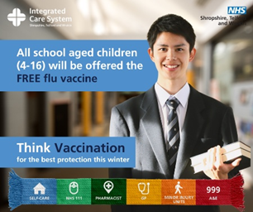
Key messages flu - children
- Children should get the flu vaccine as soon as possible to protect them and help stop the virus spreading to others.
- Flu can be a horrible illness in young children.
- The child flu vaccine reduces your child’s chance of needing hospital care for flu by around two thirds.
- Vaccinating your child helps protect them from flu and prevent it spreading among vulnerable family and friends
- The child flu vaccine is usually given as a quick and painless spray up the nose.
- Your child can get a flu vaccine if they are aged 2 years to school Year 11, or from aged 6 months with certain health conditions
- If your child is aged 2 or 3 years old or if they are aged over 6 months or older with certain health conditions, you can book a flu vaccination appointment at their GP surgery. From 1 October 2-3 year olds will be able to get a flu nasal spray from participating community pharmacies appointments will be available to book on the national booking system: www.nhs.uk/conditions/vaccinations/book-flu-vaccination
- We encourage you to book your child’s flu nasal spray as soon as the vaccine becomes available.
- If your child is of school age, you do not need to make an appointment. They will be vaccinated in schools or community clinics – make sure that you sign their consent form.

Newsletter copy children – flu

Don’t underestimate flu – protect your child with a free vaccine

Flu isn’t just a bad cold. It can be a serious illness, especially for young children, and can sometimes lead to complications such as bronchitis or pneumonia.

The child flu vaccine is quick, safe and effective. It’s given as a gentle spray up the nose and reduces the chance of your child needing hospital care by around two thirds. Vaccinating your child not only protects them but also helps stop flu spreading to vulnerable family members, friends and the wider community.

Children aged two and three will be offered the nasal spray vaccine at their GP surgery. Families can also choose to have it done at selected community pharmacies, with appointments bookable online at www.nhs.uk/conditions/vaccinations/book-flu-vaccination.

All primary school children and secondary school pupils up to Year 11 will be offered the vaccine in school or at a community clinic. Children with long-term health conditions aged six months and older can also receive the vaccine through their GP or their school immunisation team.

Parents and carers of school-age children will be sent a consent form, either online or on paper, which should be completed as soon as possible. If a consent form does not arrive, you can contact your child’s school immunisation team or GP to request one.

For children who cannot have the nasal spray, a flu injection may be offered as an alternative by the GP, practice nurse or school immunisation team.

The vaccine takes around two weeks to work fully. It helps protect your child, reduces the spread of flu, and means fewer days missed from school, work or family activities.

Protect your child, protect your family, and protect your community by making sure your child gets their free flu vaccine this autumn.

Think Vaccination for the best protection this winter

Key messages pregnancy (flu, RSV and whooping cough)
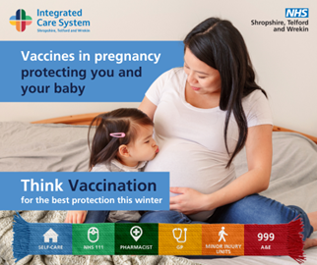
Vaccines in pregnancy protect you and your baby
- Vaccination is the safest way to protect both you and your baby from serious illness.
- Antibodies from vaccines are passed to your baby, giving protection during the first months of life.
- Pregnancy increases your risk of severe illness from flu, whooping cough, RSV, and COVID-19.
Recommended vaccines
- Flu:
  - Flu can be serious if you are pregnant, for you and your unborn baby.
  - If you have flu while you’re pregnant, it could cause your baby to be born prematurely or have a low birth weight.
  - Catching flu while pregnant may increase the need for admission to intensive care for you and your baby and may even lead to stillbirth or can be fatal.
  - If you catch flu whilst you are pregnant you and your baby are at higher risk of serious complications, such as bronchitis and pneumonia.
  - Getting vaccinated is the safest and most effective way for you to protect yourself and your baby against flu.
  - Getting the flu vaccine will mean you and your baby are less likely to experience complications if you catch the virus.
  - The flu vaccine helps to protect you and your baby from serious illness and provides your baby with protection for the first few months of life.
  - The flu vaccine is safe at any stage of pregnancy and while breastfeeding.
  - If you’re pregnant, get vaccinated against flu as soon as you are invited.
- Whooping cough – Given from 16 weeks to protect your baby in the first weeks of life. Recommended every pregnancy.
- RSV – Given from around 28 weeks to protect your baby from serious respiratory infections or breathing problems. RSV can lead to bronchiolitis or pneumonia. The vaccine also helps protect you.
- COVID-19 – If you have a weakened immune system, a COVID-19 vaccination will helps protect you and your baby from severe illness if eligible.
General guidance
- All vaccines recommended in pregnancy are safe and can be given together.
- Vaccination reduces the risk of hospitalisation and serious complications.
- Book your vaccines through your midwife, GP, or antenatal clinic.
- Speak to your midwife or GP for more information about recommended vaccinations.

Newsletter copy for pregnancy (flu, RSV, whooping cough and COVID-19)
Vaccines in pregnancy – protecting you and your baby
Vaccination during pregnancy is the safest way to protect both you and your baby from serious illness. When you are vaccinated, your body produces antibodies that are passed on to your unborn baby, helping to protect them during the vulnerable first months of life.
Pregnancy can weaken your immune system, making you more susceptible to serious complications from infections like flu, whooping cough, and RSV. Vaccination helps shield you from illness while giving your baby important early protection.
Recommended vaccines during pregnancy
- Flu vaccine: Recommended at any stage of pregnancy during flu season. The vaccine helps protect you and your developing baby from flu and its complications. It contains no live viruses and cannot give you or your baby flu. Protection lasts through your pregnancy and for at least three months after birth.
- Whooping cough (pertussis) vaccine: Offered from around 16 weeks of pregnancy. This vaccine is recommended every pregnancy and protects your baby from whooping cough in the first weeks of life. The earlier you get it, the better the protection for your newborn.
- RSV vaccine: Offered from around 28 weeks of pregnancy. Vaccination helps protect your baby against serious respiratory infections such as bronchiolitis and pneumonia. The best protection is achieved if the vaccine is given around 28 weeks, but it can still be offered later in pregnancy to protect you and reduce the risk of passing RSV to your baby.
- Other vaccines: If you have a weakened immune system, you may also be offered other vaccines such as the COVID-19 vaccine.
All vaccines recommended in pregnancy are safe, do not contain live viruses, and can be given together during the same appointment.
Talk to your midwife or GP to find out more and to arrange your vaccinations.
Protect yourself. Protect your baby. Think Vaccination for the best protection.

Short copy – religious questions
Some people have questions about whether the vaccines are suitable for them because of their religion. The government has published information on this to help people consider the options.

Follow this link if you want to know more.

Social media messaging

Join us on social media so we can remind eligible groups to #ThinkVaccination
Please tag NHS Shropshire, Telford and Wrekin in your social media posts and use #ThinkVaccination

Our social media handles are:
- Facebook - NHS Shropshire Telford and Wrekin
- X – @NHSSTW
- Instagram – nhsshropshiretelfordandwrekin
- Linked-In - @NHS Shropshire Telford and Wrekin
- YouTube - NHS Shropshire Telford and Wrekin or @nhsshropshiretelfordandwre8502

The following pages include social media visuals, messaging and videos for the flu and COVID-19 autumn/winter campaign 2025.
Assets are available to download from the campaign toolkit.

General flu and COVID-19 eligibility

Post | Visual | FB | Insta | X
Flu eligibility | 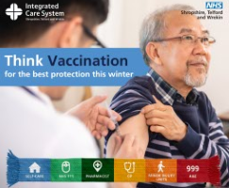 | Think vaccination!  Protect yourself and those around you by getting your COVID-19 and flu vaccines if you’re eligible.  💉 COVID-19 vaccine eligibility:  - Residents in a care home for older adults  - All adults aged 75 years and over  - Persons aged 6 months and over who are immunosuppressed  💉 Flu vaccine eligibility:  - All adults aged 65 or over  - Individuals aged 18–65 with certain long-term health conditions  - Anyone who is pregnant  - People living in a care home  - Those living with someone with a weakened immune system  - Carers (in receipt of carer’s allowance or main carer of an elderly/disabled person)  - Frontline health and social care workers  - Children aged 2–3 years, school-age children (reception to year 11), and those at clinical risk  Vaccination is the safest way to reduce your risk of serious illness this winter.  📅 Book your appointment through the NHS today: nhs.uk/vaccinations  #ThinkVaccination | Think vaccination!  Protect yourself and those around you by getting your COVID-19 and flu vaccines if you’re eligible.  💉 COVID-19 vaccine eligibility:  - Residents in a care home for older adults  - All adults aged 75 years and over  - Persons aged 6 months and over who are immunosuppressed  💉 Flu vaccine eligibility:  - All adults aged 65 or over  - Individuals aged 18–65 with certain long-term health conditions  - Anyone who is pregnant  - People living in a care home  - Those living with someone with a weakened immune system  - Carers (in receipt of carer’s allowance or main carer of an elderly/disabled person)  - Frontline health and social care workers  - Children aged 2–3 years, school-age children (reception to year 11), and those at clinical risk  Vaccination is the safest way to reduce your risk of serious illness this winter.  📅 Book your appointment today on the NHS website. Search “Book Vaccination”.  #ThinkVaccination | Think vaccination for the best protection this winter💉  COVID-19 jabs: care home residents, 75+, immunosuppressed  Flu jabs: 65+, long-term conditions, pregnant, carers, care homes, frontline staff & children  👉 Book now to stay protected: nhs.uk/vaccinations  #ThinkVaccination
Book your appointment now | 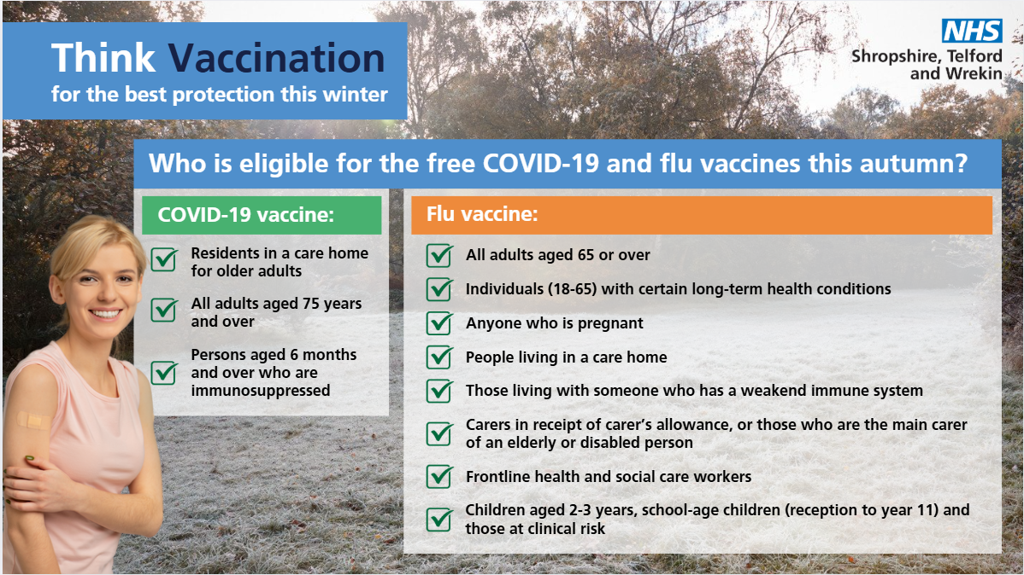 | Think vaccination! 💉  If you are eligible, book your FREE flu and COVID-19 vaccinations online or via the NHS App.  You don’t need to wait to be invited.  📅 Book your appointment through the NHS today: nhs.uk/vaccinations  #ThinkVaccination | Think vaccination! 💉  If you are eligible, book your FREE flu and COVID-19 vaccinations online or via the NHS App. You don’t need to wait to be invited.  📅 Book your appointment today on the NHS website. Search “Book Vaccination”.  #ThinkVaccination | Think vaccination! 💉If you are eligible, book your FREE flu and COVID-19 vaccinations online or via the NHS App. You don’t need to wait to be invited.  📅 Book your appointment through the NHS today: nhs.uk/vaccinations  #ThinkVaccination
Find out how to book | 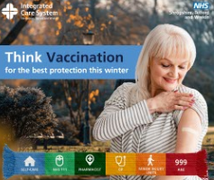 | Think vaccination!  Check if you’re eligible for a FREE flu & COVID-19 vaccine and book your appointment today nhs.uk/vaccinations  #ThinkVaccination | Think vaccination!  Check if you’re eligible for a FREE flu & COVID-19 vaccine and book your appointment today. Go to the NHS website and search “Book Vaccination”. | Think vaccination!  Check if you’re eligible for a FREE flu & COVID-19 vaccine and book your appointment today nhs.uk/vaccinations  #ThinkVaccination
Where to get a vaccine | 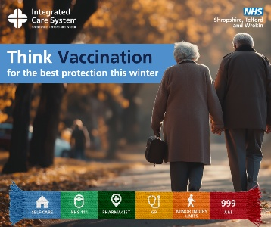 | Think vaccination! 💉  Protect yourself this winter with a FREE flu and COVID-19 vaccine.  Don’t delay – if you’re eligible, book now at:  - Your GP practice  - A community pharmacy  - On the NHS website  - The NHS App  - Call 119  Find out more➡️ nhs.uk/vaccinations | Think vaccination! 💉  Protect yourself this winter with a FREE flu and COVID-19 vaccine.  Don’t delay – if you’re eligible, book now at:  - Your GP practice  - A community pharmacy  - On the NHS website  - The NHS App  - Call 119  📅 Book your appointment today on the NHS website. Search “Book Vaccination”.  #ThinkVaccination | Think vaccination! 💉  Protect yourself this winter with a FREE flu and COVID-19 vaccine.  Don’t delay – if you’re eligible, book now at:  - Your GP practice  - A community pharmacy  - On the NHS website  - The NHS App  - Call 119  Find out more➡️ nhs.uk/vaccinations
Where to get a vaccine | 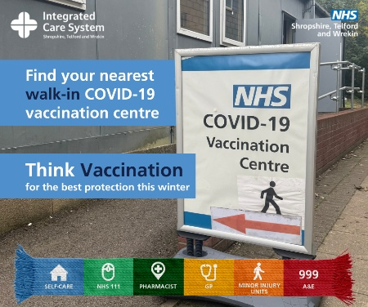 | 💙 Walk in for your vaccinations – no appointment needed!  Protect yourself and your loved ones this winter by getting your vaccination jabs at one of our local walk-in clinics across Shropshire, Telford and Wrekin.  It’s quick, easy and free if you are eligible – just turn up. 🙌  Find your nearest COVID-19 or flu clinic and opening times ➡️ https://bit.ly/483z3nl  #Getprotected #NHSSTW #ThinkVaccination | 💙 Walk in for your vaccinations – no appointment needed!  Protect yourself and your loved ones this winter by getting your jabs at one of our local walk-in clinics across Shropshire, Telford and Wrekin.  It’s quick, easy and free if you are eligible – just turn up. 🙌  Find your nearest clinic and opening times on our website.  #Getprotected #NHSSTW #ThinkVaccination | 💙 Walk in for your vaccination – no appointment needed!  It’s quick, easy and free if you are eligible – just turn up. 🙌  Find your nearest clinic and opening times ➡️ https://bit.ly/483z3nl  #Get protected #NHSSTW #ThinkVaccination
The importance of vaccination | 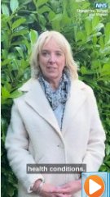 | Think vaccination for the best protection this winter💙  Vanessa Whatley, Chief Nursing Officer for NHS Shropshire, Telford and Wrekin, explains why getting your flu and COVID-19 vaccines is one of the best ways to protect yourself and your loved ones this season.  If you’re eligible, book your vaccines today through your GP, local pharmacy, the NHS App or www.nhs.uk/wintervaccinations  #NHSSTW #WinterVaccinations #Vaccination | Think vaccination for the best protection this winter💙  Vanessa Whatley, Chief Nursing Officer for NHS Shropshire, Telford and Wrekin, explains why getting your flu and COVID-19 vaccines is one of the best ways to protect yourself and your loved ones this season.  If you’re eligible, book your vaccines today through your GP, local pharmacy, the NHS App or by visiting the NHS vaccination website.  #NHSSTW #WinterVaccinations #Vaccination | Vanessa Whatley, Chief Nursing Officer for NHS Shropshire, Telford and Wrekin, explains why getting your flu and COVID-19 vaccines is one of the best ways to protect yourself and your loved ones this season.  #NHSSTW #WinterVaccinations

Children
Post | Visual | FB | Insta | X
School aged children | 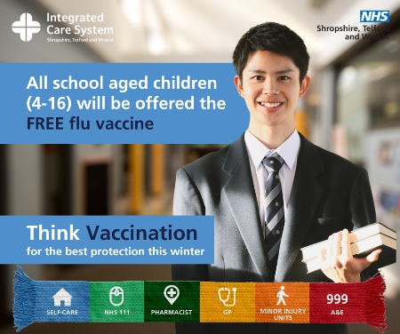 | Think Vaccination!  Flu season is coming! Give your child and family the best defence this winter  Sign the consent form today for your child to receive their free flu vaccination at school.  Painless nasal spray – no needles!  Visit: nhs.uk/vaccinations | Think Vaccination!  Flu season is coming! Give your child and family the best defence this winter  Sign the consent form today for your child to receive their free flu vaccination at school.  Painless nasal spray – no needles!  📅 To find out more about booking your child's vaccination, go to the NHS website and search “child flu vaccine”.  #ThinkVaccination | Think Vaccination!  Flu season is coming! Give your child and family the best defence this winter  Sign the consent form today for your child to receive their free flu vaccination at school.  Painless nasal spray – no needles!  Visit: nhs.uk/vaccinations
 | 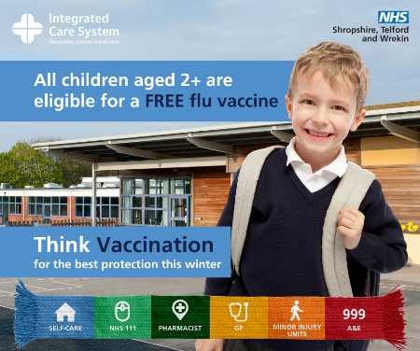 | Think Vaccination!  Did you know that winter vaccines can reduce the risk of your child getting very ill?  The flu nasal spray vaccine for children is quick, simple and effective – if your child is school-aged, look out for a consent letter.  If your child is aged 2 to 3 years, speak to your GP practice or book an appointment at a local pharmacy.  Book your appointment today nhs.uk/vaccinations  #Thinkvaccination | Think Vaccination!  Did you know that winter vaccines can reduce the risk of your child getting very ill?  The flu nasal spray vaccine for children is quick, simple and effective – if your child is school-aged, look out for a consent letter.  If your child is aged 2 to 3 years, speak to your GP practice or book an appointment at a local pharmacy.  📅 To find out more about booking your child's vaccination, go to the NHS website and search “child flu vaccine”.  #Thinkvaccination | Think Vaccination!  Did you know that winter vaccines can reduce the risk of your child getting very ill? 🤒 The flu nasal spray vaccine for children is quick, simple and effective – if your child is school-aged, look out for a consent letter.  ➡️ nhs.uk/vaccinations  #Thinkvaccination
2-3 year olds | 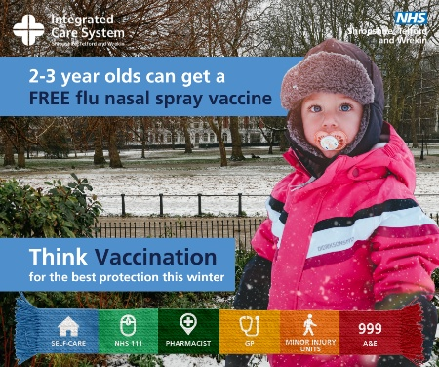 | Think Vaccination!  For the first time, parents can now get their 2 and 3 year olds vaccinated at local pharmacies.  It’s quick, safe and effective. Protect your child this winter.  Book now or find a local pharmacy offering walk-in appointments: nhs.uk/vaccinations | Think Vaccination!  For the first time, parents can now get their 2 and 3 year olds vaccinated at local pharmacies.  It’s quick, safe and effective. Protect your child this winter.  📅 To find out more about booking your child's vaccination, g tot he NHS website and search “child flu vaccine”. | For the first time, parents can now get their 2 and 3 year olds vaccinated at local pharmacies.  It’s quick, safe and effective. Protect your child this winter.  Book now or find a local pharmacy offering walk-in appointments: nhs.uk/vaccinations  #Thinkvaccination

Pregnant women
Post | Visual | FB | Insta | X
Flu in pregnant women | 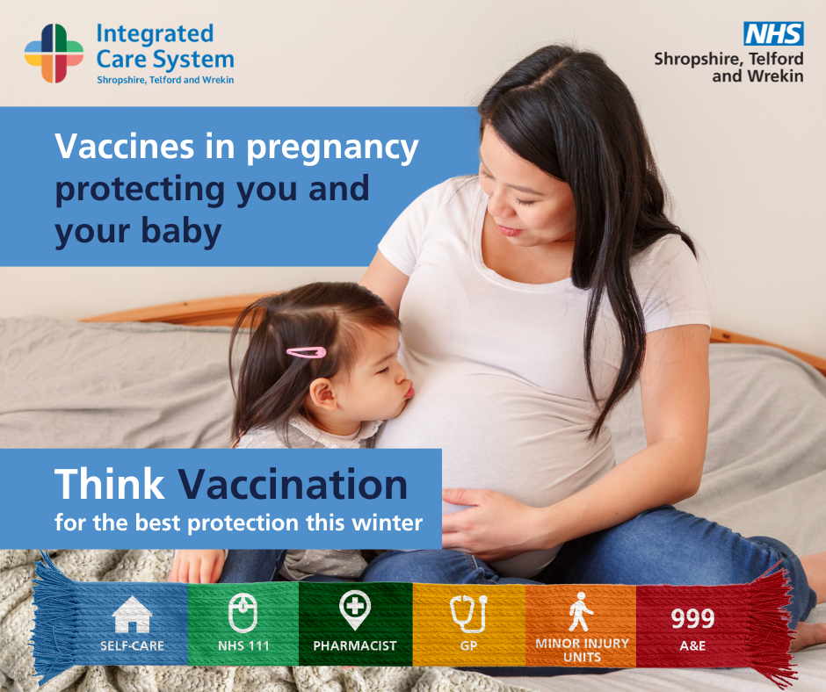 | Think Vaccination!  As flu season approaches, the NHS in Shropshire, Telford and Wrekin is urging pregnant women to get their flu vaccination to protect themselves and their babies.  Flu can lead to serious complications, but the flu vaccine offers the best protection.  For more details visit: https://www.shropshiretelfordandwrekin.nhs.uk/your-health/where-to-get-advice-and-help/vaccinations/  #ThinkVaccination | Think Vaccination!  As flu season approaches, the NHS in Shropshire, Telford and Wrekin is urging pregnant women to get their flu vaccination to protect themselves and their babies.  Flu can lead to serious complications, but the flu vaccine offers the best protection.  📅 Book your appointment today on the NHS website. Search “Book Vaccination”.  #ThinkVaccination | As flu season approaches, the NHS in Shropshire, Telford and Wrekin is urging pregnant women to get their flu vaccination to protect themselves and their babies. Flu can lead to serious complications, but the flu vaccine offers the best protection  ➡️ https://www.shropshiretelfordandwrekin.nhs.uk/your-health/where-to-get-advice-and-help/vaccinations/  #ThinkVaccination
 |  | Think Vaccination!  If you’re pregnant, get your flu vaccine. Vaccination against common illnesses like flu helps to protect you and your baby.  Speak to your midwife or GP Practice for more information and to receive your vaccination.  ➡️ https://www.shropshiretelfordandwrekin.nhs.uk/your-health/where-to-get-advice-and-help/vaccinations/  #ThinkVaccination | Think Vaccination!  If you’re pregnant, get your flu vaccine. Vaccination against common illnesses like flu helps to protect you and your baby.  Speak to your midwife or GP Practice for more information and to receive your vaccination.  📅 Book your appointment today on the NHS website. Search “Book Vaccination”.  #ThinkVaccination | If you’re pregnant, get your flu vaccine. Vaccination against common illnesses like flu helps to protect you and your baby.  Speak to your midwife or GP Practice for more information and to receive your vaccination.  ➡️ https://www.shropshiretelfordandwrekin.nhs.uk/your-health/where-to-get-advice-and-help/vaccinations/  #ThinkVaccination

People at high risk
Post | Visual | FB | Insta | X
FLU | 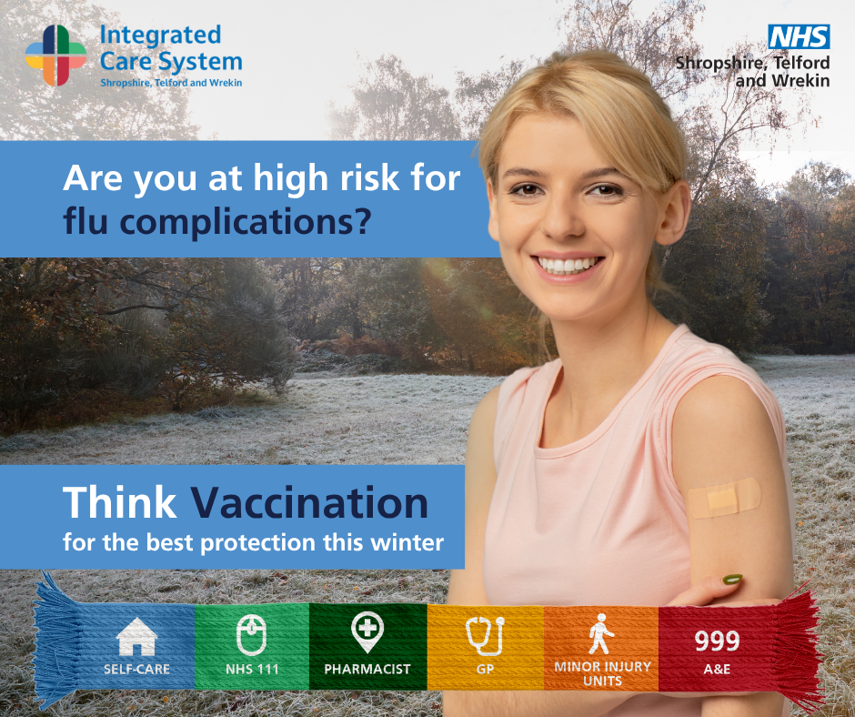 | Think Vaccination for the best protection this winter ❄️  Did you know? Anyone can catch the flu — but for some people, it can be much more dangerous. You’re at higher risk of serious complications if you have:  - Breathing problems (asthma needing steroid treatment, COPD, cystic fibrosis)  - Heart conditions (coronary heart disease, heart failure)  - Neurological conditions (Parkinson’s, multiple sclerosis, cerebral palsy)  - Diabetes or Addison’s disease  - A weakened immune system (HIV, AIDS, chemotherapy, steroids)  - Are very overweight (BMI 40+)  …plus other long-term conditions like kidney or liver disease, spleen problems, or a learning disability.  The good news? You can protect yourself.  ✅ The free flu vaccine helps keep you safe and reduces your risk of hospital visits.  📅 Don’t wait – book today!  👉 Find out more and book here: nhs.uk/vaccinations  #ThinkVaccination | Think Vaccination for the best protection this winter ❄️  Did you know? Anyone can catch the flu — but for some people, it can be much more dangerous. You’re at higher risk of serious complications if you have:  - Breathing problems (asthma needing steroid treatment, COPD, cystic fibrosis)  - Heart conditions (coronary heart disease, heart failure)  - Neurological conditions (Parkinson’s, multiple sclerosis, cerebral palsy)  - Diabetes or Addison’s disease  - A weakened immune system (HIV, AIDS, chemotherapy, steroids)  - Are very overweight (BMI 40+)  …plus other long-term conditions like kidney or liver disease, spleen problems, or a learning disability.  The good news? You can protect yourself.  ✅ The free flu vaccine helps keep you safe and reduces your risk of hospital visits.  📅 Don’t wait – book today!  To book your appointment visit the NHS website and search “Book Vaccination”.  #ThinkVaccination | Did you know? Anyone can catch the flu. You’re at higher risk of serious complications if you have breathing, heart or neurological conditions, diabetes, weakened immune system a MBI 40+ …plus other long-term conditions. Find out more 👉 nhs.uk/vaccinations #ThinkVaccination
Covid-19 and flu  Are you at risk of flu or covid complications? | 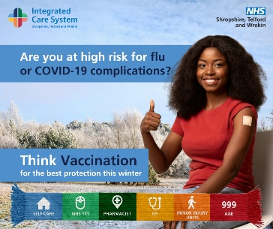 | Think vaccination!  If you have a weakened immune system, you can now book your flu and COVID-19 vaccinations online or via the NHS App.  You don’t need to wait to be invited.  To find out more: https://www.shropshiretelfordandwrekin.nhs.uk/your-health/where-to-get-advice-and-help/vaccinations/  #ThinkVaccination | Think vaccination!  If you have a weakened immune system, you can now book your flu and COVID-19 vaccinations online or via the NHS App.  You don’t need to wait to be invited.  To book your appointment visit the NHS website and search “Book Vaccination”.  #ThinkVaccination | Think vaccination!  If you have a weakened immune system, you can now book your flu and COVID-19 vaccinations online or via the NHS App.  You don’t need to wait to be invited.  To find out more: https://www.shropshiretelfordandwrekin.nhs.uk/your-health/where-to-get-advice-and-help/vaccinations/
Covid-19 and flu  Are you at risk of flu or covid complications? | 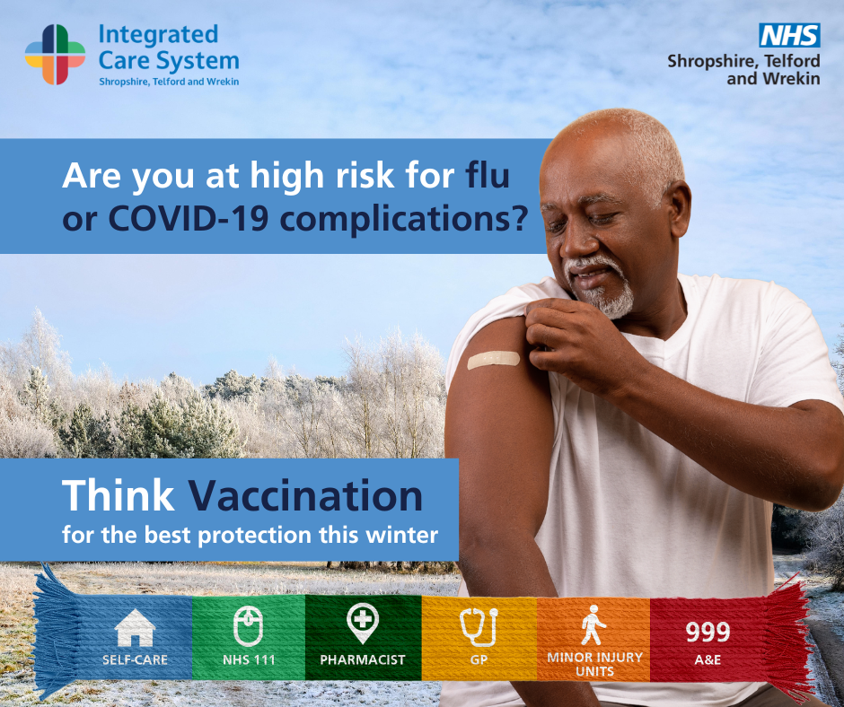 | Think vaccination!  Anyone can catch the flu or COVID-19 — but for some, the risks are much greater.  If you or someone you love has:  - Blood cancer (like leukaemia, lymphoma, or myeloma)  - Had an organ, bone marrow, or stem cell transplant  - HIV or a genetic immune disorder (like SCID)  - Recently had chemotherapy, radiotherapy, or biological therapy  - Is taking steroids or long-term immunosuppressive treatment for conditions like lupus, rheumatoid arthritis, IBD, scleroderma, or psoriasis  …then you may be at higher risk of serious complications.  Protect yourself this winter by getting both your flu and COVID-19 vaccines. It’s one of the best ways to stay safe and avoid hospital visits.  Learn more and book here: https://www.nhs.uk/vaccinations/flu-vaccine/  #ThinkVaccination | Think vaccination!  Anyone can catch the flu or COVID-19 — but for some, the risks are much greater.  If you or someone you love has:  - Blood cancer (like leukaemia, lymphoma, or myeloma)  - Had an organ, bone marrow, or stem cell transplant  - HIV or a genetic immune disorder (like SCID)  - Recently had chemotherapy, radiotherapy, or biological therapy  - Is taking steroids or long-term immunosuppressive treatment for conditions like lupus, rheumatoid arthritis, IBD, scleroderma, or psoriasis  …then you may be at higher risk of serious complications.  Protect yourself this winter by getting both your flu and COVID-19 vaccines. It’s one of the best ways to stay safe and avoid hospital visits.  To book your appointment visit the NHS website and search “Book Vaccination”.  #ThinkVaccination | Anyone can catch flu or COVID-19. If you or someone you love has: Blood cancer, an organ, bone marrow, or stem cell transplant, recently had chemotherapy, as well as other conditions, then you may be at higher risk of serious complications ➡️ https://www.nhs.uk/vaccinations/flu-vaccine/

Close contacts of immunosuppressed (flu only)
Post | Visual | FB | Insta | X
Immunosuppressed protect the ones you love | 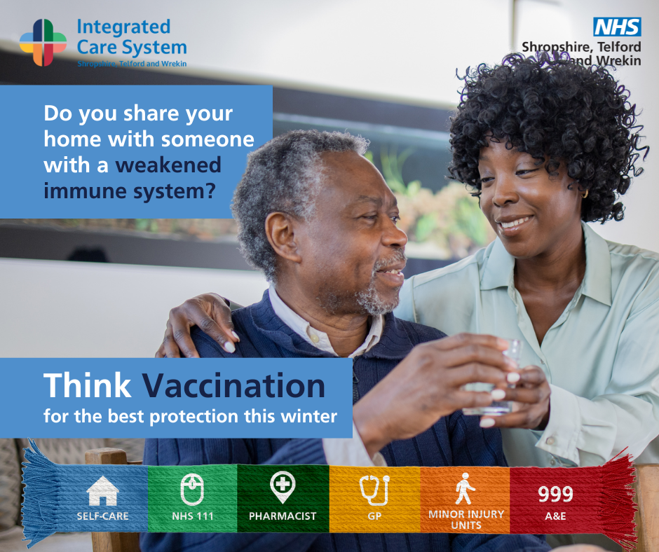 | 💙 Think Vaccination: Protect the ones you love  Do you share your home with someone whose immune system is weakened by illness or treatment?  You can play a vital role in keeping them safe this winter.  👉 Getting your free flu vaccine helps reduce the risk of passing flu on to them.  📅 Book your vaccine today at your GP, local pharmacy, on the NHS website, NHS App, or by calling 119.  Find out more: nhs.uk/vaccinations/flu-vaccine/  #ThinkVaccination | 💙 Think Vaccination: Protect the ones you love  Do you share your home with someone whose immune system is weakened by illness or treatment?  You can play a vital role in keeping them safe this winter.  👉 Getting your free flu vaccine helps reduce the risk of passing flu on to them.  📅 Book your vaccine today at your GP, local pharmacy, on the NHS website, NHS App, or by calling 119.  To find out more visit the NHS website and search “Book Vaccination”.  #ThinkVaccination | 💙 Think Vaccination  Live with someone who has a weakened immune system?  Protect them — get your free flu vaccine today.  Book via GP, pharmacy, NHS App, website or call 119.  👉 nhs.uk/vaccinations/flu-vaccine  #ThinkVaccination

Carers
Post | Visual | FB | Insta | X
Carers | 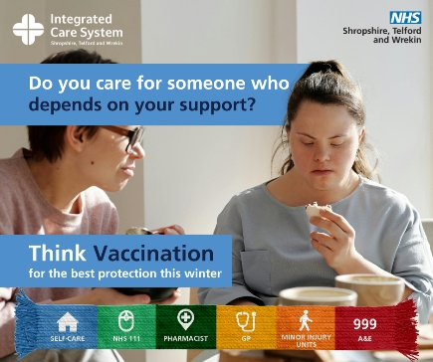 | 💙 Think Vaccination!  Are you a carer for someone who depends on your support? Flu can hit hard and being unwell makes it harder to care for others.💉Protect yourself and the person you care for by getting your free flu vaccine this winter.  Find out more: nhs.uk/vaccinations/flu-vaccine/  #ThinkVaccination | 💙 Think Vaccination!  Are you a carer for someone who depends on your support? Flu can hit hard and being unwell makes it harder to care for others.💉Protect yourself and the person you care for by getting your free flu vaccine this winter.  📅 Book your vaccine today at your GP, local pharmacy, on the NHS website, NHS App, or by calling 119.  #ThinkVaccination | Are you a carer for someone who depends on your support? 💙 Flu can hit hard & being unwell makes it harder to care for others.💉Protect yourself and the person you care for by getting your FREE flu vaccine this winter. Find out more: nhs.uk/vaccinations/flu-vaccine/ #ThinkVaccination
Carers case study | 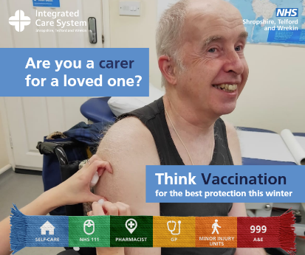 | Think Vaccination: Jayne’s Story 💙  Every day, Jayne lovingly cares for her husband. For both of them, staying well isn’t just important - it’s essential.  👉 “It’s so much easier to have the flu vaccine than to have the flu.”  If you’re a main carer or receive carer’s allowance, you can get a free flu vaccination at your GP practice. It’s a simple step that helps protect you and the person you care for.  Talk to your doctor or pharmacist today about getting your flu vaccine. 👉 Find out more: nhs.uk/vaccinations/flu-vaccine/  #ThinkVaccination | Think Vaccination: Jayne’s Story 💙  Every day, Jayne lovingly cares for her husband. For both of them, staying well isn’t just important - it’s essential.  👉 “It’s so much easier to have the flu vaccine than to have the flu.”  If you’re a main carer or receive carer’s allowance, you can get a free flu vaccination at your GP practice. It’s a simple step that helps protect you and the person you care for.  📅 Book your vaccine today at your GP, local pharmacy, on the NHS website, NHS App, or by calling 119.  #ThinkVaccination | #ThinkVaccination: Jayne’s Story 💙 Every day, Jayne lovingly cares for her husband. For both of them, staying well isn’t just important - it’s essential. “It’s so much easier to have the flu vaccine than to have the flu.”  Talk to your doctor or pharmacist today about getting your flu vaccine👉nhs.uk/vaccinations/flu-vaccine/

National Assets
Asset | Link | Visual
A guide to the autumn COVID-19 vaccination | https://assets.publishing.service.gov.uk/media/68b8a19fb0a373a01819fdce/UKHSA_COVID- 19_patient_leaflet_autumn_2025_programme_WEB.pdf | 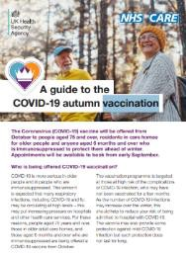
Information on COVID-19 easy read guide | https://www.gov.uk/government/publications/covid-19-vaccination-easy-read- resources/information-on-covid-19-vaccination-easy-read-guide | 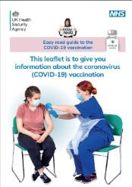
Flu | Easy read posters and leaflets on flu  Simple text flu leaflets for adults and children | 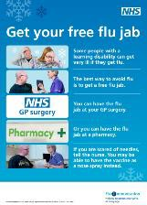
British Islamic Flu Vaccination Guidance | BIMA Flu Vaccination Guidance | British Islamic Medical Association | 